UNITED  NATIONS |  | E
 | Economic and Social  Council | Distr.  GENERAL  ECE/TRANS/WP.5/2007/7/Add.5  6 July 2007  ENGLISH ONLY
ECONOMIC COMMISSION FOR EUROPE

INLAND TRANSPORT COMMITTEE

Working Party on Transport Trends and Economics

Twentieth session
Geneva, 13-14 September 2007
Item 6 of the provisional agenda

Replies to the questionnaire on transport developments

Addendum
Submitted by the Government of Bulgaria*

I. GENERAL TRANSPORT POLICY ASPECTS
- The extension of the political, economic and cultural cooperation of the Republic of Bulgaria with the countries from the European Union, the Balkan’s, CIS, the Black Sea region and TRACECA is amongst the main priorities of the policy of our country after our successful accession to the European Union.
2. The favourable geographical location of the Republic of Bulgaria provides great opportunities for its transformation into a transport bridge between Western and Central European countries, the Middle East, Western and Central Asia and along the north-south direction.
_________
* The UNECE Transport Division has submitted the present document after the official document deadline due to resource constraints.
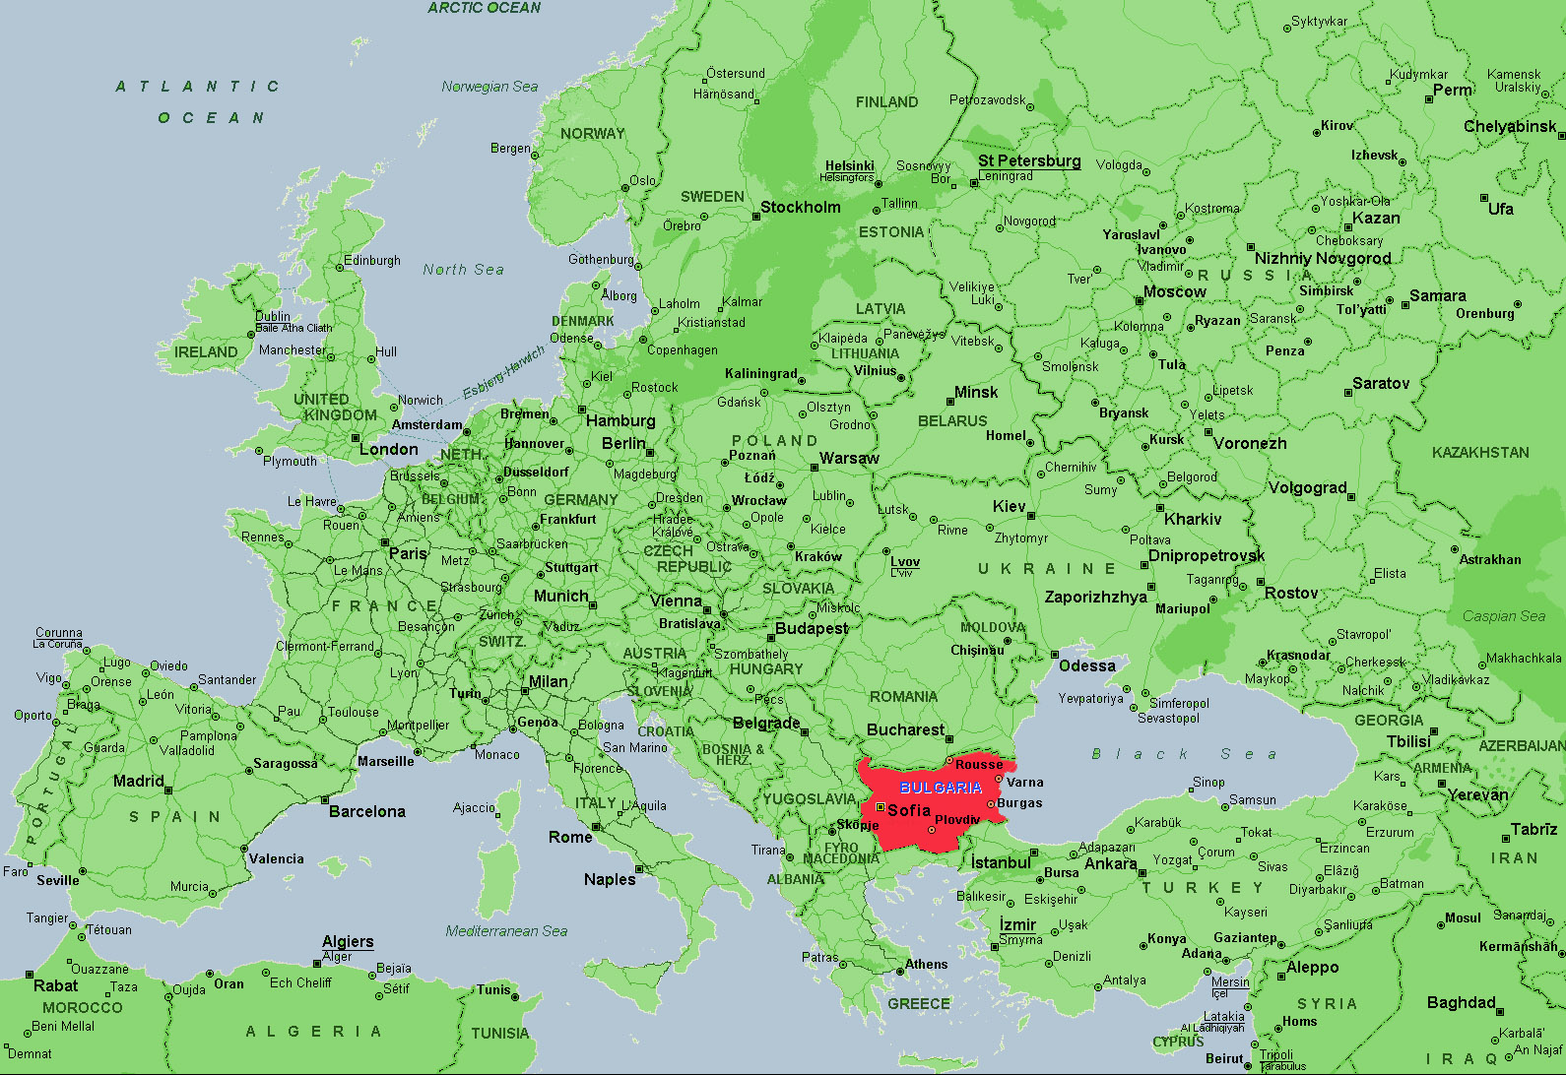

3. The sustainable development of the transport sector in Bulgaria should create the necessary conditions for the economic and social development of our country, provide efficient and sustainable transport, support the balanced regional development, and speed up the country’s integration into the European economic area.

4. The strategic goals of the transport policy are: development of sustainable transport; integration of the national transport network into the EU transport network and balance between the transport modes. Achievement of these goals is the precondition for sustainable and balanced long-term economic growth. Efficient and safe transport infrastructure will increase the volume of the traded goods between the different regions.

5. On the basis of these goals we have identified the following transport policy priorities:
(a) Safety and security of the transport system;
(b) Modernization of the transport system;
(c) Acceleration of the implementation process of the projects financed by the pre-accession funds of the EU;
(d) Improving the quality of the transport services for the population;
(e) Strengthening the relations with the branch organizations in the transport sector.
6. Furthermore, development of the five Trans-European transport corridors that cross the territory of Bulgaria: ІV, VІІ, VІІІ, ІХ and Х will also contribute to achieve integration of the national markets into the EU markets.
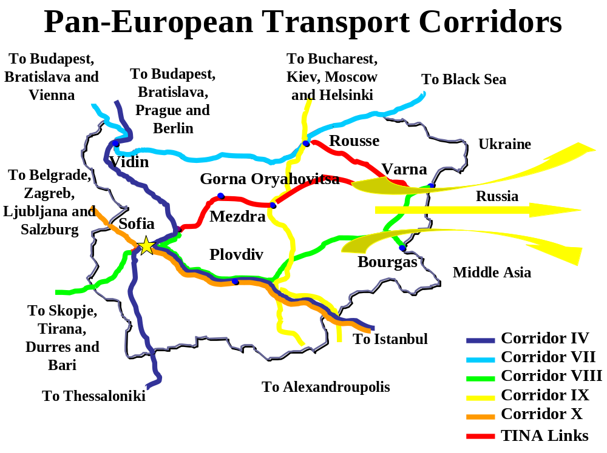
7. In the course of the identification of priority directions, the process of development of the Trans-European Transport Network is of the greatest importance. In 2003, the High Level Group Van Miert (HLG) for the updating of the development guidelines for the Trans-European Transport network specified two priority axes for the EU territory to cross the territory of Bulgaria: Vidin-Sofia-Kulata (Corridor IV) and the river Danube (Corridor VII) with the following priority projects: Modernisation of the Vidin-Sofia-Kulata Railway Line and Improvement of the Navigation on the River Danube.
8. At the end of 2004, the European Commission established High Level Group II chaired by Ms Loyola di Palacio to identify the extension of the main Trans-European axes to countries and regions neighbouring the European Union and to identify the priority projects for their development. Five main transport axes have been approved: Northern, Central, South-eastern and South-western, as well as the Main Sea Lines.

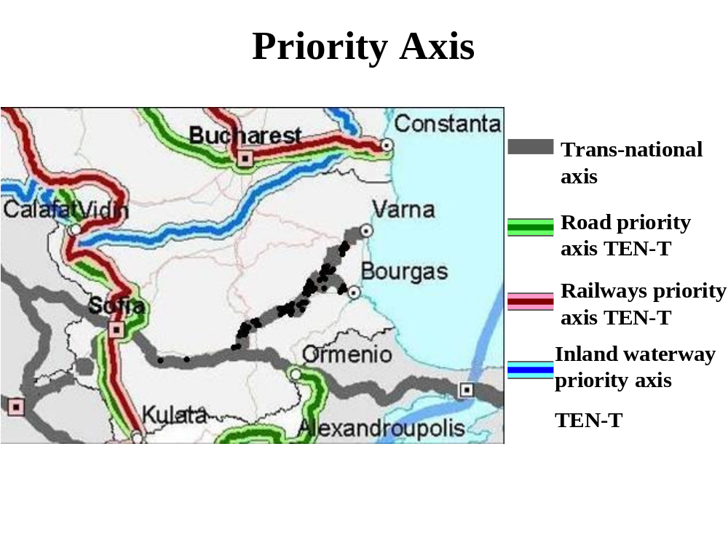
9. The territory of Bulgaria is crossed by the South-eastern main axis connecting the European Union via the Balkans and Turkey to the Caucasus and the Caspian Sea, as well as to Egypt and the Red Sea. Connections are envisaged with Albania and Macedonia, Iran, Iraq and the Persian Gulf. The main multi-modal connections via the territory of Bulgaria are as follows:
(a) Pan-European Transport Corridor X–Branch С, connecting Belgrade–Nis–Sofia and from there along the route of Pan-European Transport Corridor IV–Istanbul–TRACECA;
(b) Pan-European Transport Corridor VIII – starting from the Italian ports of Bari/Brindisi and going via Durres/Vlora–Tirana–Skopje–Sofia–Bourgas/Varna;
(c) The river Danube–the river Sava.

10. The Motorways of the Sea concerning Bulgaria are those in the Black Sea and its connection to the Mediterranean, including: the links of the ports of Varna and Bourgas to the ports in Ukraine, Russia, Georgia and Turkey.

11. The Republic of Bulgaria is interested in the development of these transport connections. The development of the related transport infrastructure will create political and economic prerequisites for commercial and industrial prosperity and democratic market-oriented development of the countries in the region. Taking into account the fact that the European Commission will concentrate its resources on the development of the main axes as defined by the two High Level Groups, Bulgaria will focus its efforts on the preparation and implementation of projects along these axes.
Organization
12. The Ministry of Transport executes State policy in the transport sector and is organized into 19 directorates – www.mt.government.bg
(a) The National Road Infrastructure Fund (NRIF) carries out the general management of the road activities in the country in fulfilment of the State policy on planning and construction of the road infrastructure – www.nrif.bg

(b) The Executive Agency “Road Administration” executes the regulatory and control functions of the State in the field of road transport – www.rta.government.bg.
(c) The Executive Agency “Railway Administration” executes the regulatory and control functions of the State in the field of railway transport – www.railbg.com.
(d) The National Company “Railway Infrastructure” (NRIC) ensures the usage of the railway infrastructure by licensed operators on equal conditions and performs different activities concerning the development, repair, maintenance and exploitation of the railway infrastructure – www.rail-infra.bg.
(e) BDZ EAD is the National Railway Operator in the Republic of Bulgaria, owning a license for carriage of both passengers and freight – www.bdz.bg.

(f) The Executive Agency “Port Administration” executes the regulatory and control functions of the State in the field of ports – http://www.port.bg.

(g) The Executive Agency “Maritime Administration” executes the regulatory and control functions of the State in the field of the shipping in the sea spaces and inland waterways – http://www.marad.bg.
(h) The Executive Agency “Exploration and maintenance of the Danube River” carries out the entire range of supporting activities for the maintenance of the waterway, aquatory of the ports and the winter camps for providing a secure ship sailing in the Bulgarian section of the river – http://www.appd-bg.org/bg.
(i) The “Port Infrastructure” State Company manages the infrastructure of the public transport ports of national importance – http://www.bgports.bg.
(j) The Directorate “General Civil Aviation Administration” executes the regulatory and control functions of the State in the field of civil aviation – http://caa.gateway.bg.
II. ECONOMIC, TECHNOLOGICAL AND OPERATIONAL ASPECTS
A. General
13. The transport sector is a key sector for the Bulgarian economy (as well as for the economy of every other country), due to its binding role regarding the other sectors of the economy and its own contribution to gross added value and employment.

14. The objective of the sustainable transport policy is to bear responsibility for the economic, social and ecological needs of society. The effective transport systems have significant influence on economic growth, social development and the environment.
15. The activities of the Ministry during the last years were focused on the implementation of the big infrastructural projects. In 2006 the implementation of the current projects has been accelerated and started the preparation of new large-scale infrastructural projects which are of significant importance for the modernisation of infrastructure and the optimal acquirement of European funds. ISPA Financial Memoranda on the elaboration of six new railway projects along the most important directions of our country have been signed. The project on the construction of a new passenger terminal and a new airstrip system at the Sofia Airport has already been finalised.
16. Acceleration of the implementation of the Programme, ensuring the access of people of limited mobility to means of conveyance and transport infrastructure for all modes of transport is on the agenda.
17. The trend towards integrated logistic companies should be combined with public policies which makes possible the optimal use and the combination (intermodality) between the modes of transport. This may include activities for the elimination of regulatory obstacles to intermodality, for the promotion of training and the exchange of good practices within the framework of the EU and the improvement of operative compatibility (interoperability).
18. Measures for the improvement of education and the level of qualification of the leading transport professions and for the overcoming of the shortage of personnel in the whole transport system have been undertaken. We will develop and coordinate the administrative capacity involved in the preparation and the implementation of the exams of the candidates for driving licenses, as well as to control in the companies and on the road.
19. The commitment of the State to the future development of sustainable transport is considered with the growing concern on environmental protection, which consists in the promotion of the development of ecologically-friendly modes of transport as opposed mostly to road carriers.
20. The decrease of the negative impact on the environment of the modes of transport and the provision of high level of safety, are among the basic priorities of the Ministry.
21. One of the problems, requiring measures in all subsectors, is that of security. From this year Bulgaria is an outer border of the EU, which obliges us to extend additionally the significance of security for our transport policy.
22. As a whole, our efforts are directed at the improvement and meeting the international standards on administrative servicing and control for all modes of transport, at the planning and organising the preparation of the human recourses and the technical means for crisis management, actions on rescuing and restoring in an emergency situation.
23. The work of the Ministry of Transport on solving local and municipal transport problems will continue. The realization of meetings for the affiliation of municipal structures will also continue.
24. By carrying out this policy in the transport sector we are aiming at the achievement of the following synergy effects:
(a) Development of a sustainable transport sector;
(b) Achievement of high economic effectiveness;
(c) Improvement of the compatibility of the Bulgarian transport system;
(d) Integration of the Bulgarian transport system in the European and confirming its priority role in the region;
(e) Creation of appropriate conditions for sustainable growth of internal and international transport;
(f) Improvement of the conditions providing for loyal competition between and within the modes of transport;
(g) Provision of transport services for the public at reasonable prices;
(h) Coordinated development of the transport sector and regional development
(i) Reduction of the negative impact of transport on the environment;
(j) Promotion of the energy efficiency in the transport sector;
(k) High level of safety and security of the transport system;
(l) Enhancement of the administrative and professional capacity of the personnel in the transport sector.

B. Specific, by modes of transport
25. The public road transport in the Republic of Bulgaria is private-owned. According to the requirements of the European Union in order to gain access to the profession, the enterprises which carry out transportation of passengers and freights, have to be licensed. Licensing is processed in fulfilment of all requirements of the EU Directives and regulations. As far as the road enterprises are private-owned, both their development and investment programmes depend mainly on market conditions.
26. Among the priorities of the State, concerning the road transport sector, are the issues of safety and ecology and ensuring access to transport services for the population.
27. The Bulgarian legislation has adopted all social and technical requirements of the European Union related to safety and security of road transport. The technical equipment to perform preliminary and road control of the vehicles is being improved as well as the administrative capacity.
28. Transport as a whole, and mostly, road transport, has negative affect on the environment, contaminating the air in the atmosphere in residential areas, changing global climate, landscape and agricultural land and making noise and waste. In order to reduce the harmful influence of road transport, measures have been undertaken by the State, including those giving preferential permits for ECO cars, construction of bypass roads around the residential areas, introduction of systems for traffic control, etc.
29. Coordinated policies have been carried out by the Bulgarian Ministry of Transport and by the local authorities in order to: establish automated systems for traffic management and control; improve the physical and financial access to the basic infrastructure; develop the infrastructure and route networks of new destinations to more remote residential areas.
30. A National strategy for improvement of the road safety in the Republic of Bulgaria in the period 2007-2010 has been adopted by the Council of Ministers. Its main aim is the permanent decrease the number of road accidents and the number of killed and injured.
31. Sofia, the capital city, as an agglomeration with the biggest concentration of people and provided that the traffic capacity on the main streets and crossings in rush hours is exhausted, causes serious difficulties to passengers. The implementation of the project for the extension of the Metro is in progress in order to resolve these problems. After its completion the travelling time from the suburban areas to the city centre in rush hours from 50-60 minutes will be reduced to 12-15.
32. The railway sector priorities are aimed at the development of sustainable transport system in compliance with the transport policy of the EU and the requirements for interoperability, improvement of the status of railway infrastructure and implementation of an active, technological and trade policy on satisfying the needs of railway services and ensuring increase of the railways activities on the transport market, being the most ecological and safe mode of transport.
33. The modern development of the European railway transport is characterised by a trend towards harmonization of the railway systems. The European requirements in the sphere of railway transport were introduced of by the Railway Transport Law, in force since 1 January 2002, and its amendments.
34. The reforms in the railway sector, carried out in conformity with the EU policy and in compliance with the legal basis, are aimed at improving the effectiveness and competitiveness of the this transport sector – the former state company Bulgarian State Railways – BDZ was divided into National Company Railway Infrastructure (the current infrastructure manager – 100% public State ownership) and BDZ EAD (a railway undertaking for passenger and freight services).
35. There two private railway undertakings in Bulgaria – Bulmarket DM and Bulgarian Railway Company – are licensed to perform freight transport services.
36. In the sphere of passenger transport BDZ EAD experimentally introduces combined transport of passengers – train-route taxis (early in the morning and late in the evening) between the Central Railway Station in Sofia to the residential districts of the city.
37. Another goal is to improve and extend the transport services, including those for people of limited mobility. Provision of transport services to people with reduced mobility in the railway stations in Sofia, Plovdiv, Stara Zagora, Burgas and Varna and of trains with specialized cars for people in wheelchairs and their assistants is being introduced.
38. The envisaged policy, regarding the railway infrastructure, is aimed at: renovation and modernization of the network; reaching integrity and operative compatibility with the Pan-European railway system; elaboration of a plan and preparation for ERTMS installation and development of infrastructure, necessary for the implementation of intermodal transportation.
39. The policy, carried out regarding the railway transportation, is aimed at reaching a guaranteed quality of this mode of transport and at protecting customers' interests, as well as at achieving higher level of safety and security of the transportation process. Actions are taken for the renovation of the rolling stock and improvement of its state, so as to fulfil the requirements for ecology, safety and transport servicing quality, which is a necessary prerequisite for the improvement of compatibility of railway transport.
40. A main measure to improve the profitability and productivity of transport operations is the development of intermodal transport. It is the central provider of logistic relations between the different transport modes. Transit freight is transported by several European operators, while transit block-trains of the International association for combined transport Intercontainer – Interfrigo has the biggest share.
41. Experimental trips of Ro-La trains from Wels (Austria) through Bulgaria to Halkali (Turkey) and backwards have been carried out in 2006. The Bulgarian party is interested in the continuation and extension of this service, because it will reduce congestions in border-crossing points, road accidents and environmental pollution.
42. The project “Development of strategy for integration of the Bulgarian railway infrastructure in the European network of intermodal transport”, financed by PHARE funds, aims at the development of logistics transport connections and appropriate infrastructure.
43- In order to improve the shipping in the Bulgarian section of the Danube, our inland waterway, the elimination of “bottlenecks” along the lower course of the river, in compliance with the EU policy the inland waterways, has become a transport policy priority.
44. The government policy on development of port infrastructure along the river Danube included in the Draft National Programme on development of public transport port infrastructure has the following basic goals:
(a) Development of the ports along the river Danube as basic logistic centres along Corridor VII;
(b) Optimal use of the existing infra- and substructure of river ports;
(c) Development of tourist transport links through creating conditions for cruise ships servicing;
(d) Liberalization of port services – port terminals’ through concessions;
(e) Creation of conditions for environmental protection, security and safety in regard of the port services.
45. The safety promotion and diminution of the negative impact on the environment are among the basic guidelines which the State authorities follow in their activity. A River Information System project (the BulRis) for the Bulgarian section of the river is being developed in order to provide for a safe and effective process.
46. An organisational structure has been set up to coordinate the development and control the operational suitability of ports and ships traffic.
47. Air transport develops rapidly and the managing civil aviation institutions increasingly face complex challenges when promoting safety and security of flights, which protect the customers and maintain the progress of the industry.
48. Of national importance is the responsibility for the high-quality air traffic management and the strategic airports’ development.
49. A main goal is the improvement of the airport infrastructure, thus, together with the airport administrations, has been adopted an approach of increasing the capacity and comfort of the Bulgarian airports. This will contribute to the improvement of services rendered to customers, passing through the airports, facilitation of passing through numerous institutions and procedures, as well as for the ensuring of a normal working rate for all institutions, related to servicing.
50. Another specific aim is to reduce the time, necessary for the servicing of passengers, through the installation of new technologies and registration of passengers via SMS, “HPBP” (Home Printed Boarding Pass) boarding cards, self-processing machine – Self check in, the use of new technologies for sorting and distinguishing the luggage on the basis of the RFI (Radio Frequency Identification) radio communication, new biometrical security systems, adaptation to airport environment of wireless technologies, leading to decrease of servicing time and increase of work effectiveness.
C. Energy efficiency in transport
51. In Bulgaria the share of transport in the final energy consumption registered growth from 21.8 to 28.5% in the period 1997–2005. Transport consumption of energy enhances increasingly and ranks second after industry.
52. Taking into account the fact that about 32% of the final energy consumption in the EU is due to transport and about 50% increase of freight carriages is expected for the period 2000–2020, our country is convinced in the need of improving the energy efficiency and the use of alternative fuels in transport.
53. The Republic of Bulgaria defined as priority the improvement of the energy efficiency in transport and the provision of its favourable impact on climate. In this respect, the policy of the Ministry of Transport on energy efficiency is focused on the following:
(a) Improvement of transport infrastructure;
(b) Renovation of the transport fleet;
(c) Improvement of organization and extension of the scope of the intermodal haulages;
(d) Stimulating the increase of the share of the energetically effective modes of transport (railway, inland waterway and maritime);
(e) Stimulating the use of public transport;
(f) Improvement of organisation and regulation of traffic in built-up areas;
(g) Stimulating the use of biofuels;
(h) Improvement of professional skills of the motor vehicles' drivers.
54. In accordance with the requirements of the Energy efficiency law (EEL) special annual programmes on the implementation of measures, concerning energy efficiency are under preparation (such programmes are adopted for the years 2007 and 2008 ), the financing of which is provided by national budget funds, depending on the existing resources.
55. Areas of priority for the improvement of energy efficiency in road transport, which has negative influence upon the environment, contaminates and deteriorates the quality of the air and changes global climate, are the intelligent transport systems, including communication, navigation and automation, motive technology, giving higher fuel efficiency and promoting the use of alternative and inexhaustible fuels.
56. The main measure to promote a rational use of energy in the more friendly to the environment railway transport is the increase of the portion of electrified railway lines on the territory of the country and optimisation of the performed transport services by rail. The share of the electrified lines in Bulgaria is 67% of the whole length of the railway network, which is 4,904 km out of 7326 km total length. In comparison with the other countries in Eastern Europe, Bulgaria occupies the second place in terms of electrification of the railway network and even supersedes some of the countries in Western Europe in this respect.
57. In the field of aviation the efforts to improve energy efficiency are aimed at the assessment of technical and economic potentialities for the use of alternative fuels, including the aviation in the European emissions trading scheme, introduction of a Single European Sky and the SESAR Programme for the optimisation of air routes and the air traffic management.
58. Being both energy effective and fully corresponding to ecological requirements, maritime and inland waterway transport may still contribute to the progress of energy efficiency in the sector of freight transport. The accent will fall on the decrease of air contamination by NOX and CO², use of fuel with limited sulphur content in conformity with the provisions of Annex VІ to the International MARPOL Convention, introduction of ships’ fuel standards, corresponding to the need of security and environmental protection, as well as the introduction of an Integrated European Action Programme for Inland Waterway Transport – the NAIADES Programme (Navigation and Inland Waterway Action and Development in Europe).
III. INFRASTRUCTURE ASPECTS
59. A long-term framework for integrated development of the transport sector have been elaborated and adopted by the Council of Ministers – the National Strategy for Integrated Development of the Technical Infrastructure, which summarises the intentions, objectives and priorities of the Government’s investment policy over the period 2006-2015. The Action Plan for the implementation of priority projects reflects the political will of our Government to prepare and carry out specific projects, conforming to the objectives and priorities as set out in the Strategy, taking into account the existing opportunities for financing from various sources.
60. The main objective of this long-term framework is to identify the policy and guidelines for accelerated development of these facilities of strategic importance. The public private partnership policy will be an integral part of this policy as an alternative way to provide the financial resources needed for long-term development, reconstruction, modernisation and maintenance of the transport infrastructure.
61. The objective of the Sectoral Operational Programme on Transport 2007–2013, which is still being finalized, is the development of the railway, road, waterborne and combined transport infrastructure in conformity with the transport policy of the European Union and the established requirements for development of the Trans-European transport network in order to achieve sustainability of the Bulgarian transport system.
62. Detailed information on the elaborated analysis, including the SWOT analysis, the defined priorities, the applied methodologies and the criteria, used for the selection of the priority projects, as well as the planned investments and the major transport infrastructure projects, is available at the web site of the Ministry of Transport in the transport part of the National Strategy for Integrated Development of the Technical Infrastructure and the Draft version of the Sectoral Operational Programme on Transport
Figures reflecting the planned or anticipated qualitative developments with regard to some key elements in the inland transport sector:
63. The National Statistical Institute, the official statistical body in the Republic of Bulgaria – www.nsi.bg, provides the following data:
Employment by economic activity – Transport, storage and communications, annual average
Years | Total | Public sector | Private sector
2002 | 217373 | 106211 | 111162
2003 | 213041 | 100149 | 112892
2004 | 212990 | 75173 | 137817
2005 | 211159 | 74241 | 136918
2006 | 217087 | 73386 | 143701
Source: National Statistical Institute

Volume of passenger transport by mode of transport, million passengers-km
Mode of transport | 2002 | 2003 | 2004 | 2005 | 2006
Land transport | 19583 | 16918 | 15433 | 16077 | 15364
Waterway transport | 0 | 0 | 0 | 1 | 0
Air transport | 1835 | 3005 | 3048 | 3626 | 3833
Urban electrical transport | 1176 | 1206 | 1109 | 1085 | 1055
Total | 22594 | 21129 | 19590 | 20789 | 20252
Source: National Statistical Institute.
Volume of freight transport by mode of transport, million tonne-km
Mode of transport | 2002 | 2003 | 2004 | 2005 | 2006
Land transport | 14950 | 16024 | 18203 | 21521 | 20820
Waterway transport | 61385 | 59096 | 69351 | 69628 | 65056
Air transport | 6 | 21 | 33 | 26 | 23
Total | 76341 | 75141 | 87587 | 91175 | 85999
Source: National Statistical Institute.

Length of railway lines (km)
Railway lines | 2002 | 2003 | 2004 | 2005
Running track | 4318 | 4316 | 4259 | 4154
Normal (1 435 mm) of which: | 4073 | 4071 | 4031 | 4029
Double tracks | 967 | 969 | 948 | 957
Electrified lines | 2847 | 2871 | 2854 | 2880
Narrow (760 mm) | 245 | 245 | 228 | 125
Platforms | 2066 | 2042 | 1979 | 1871
Railway lines, supplied with automatic block system | 1121 | 1121 | 1666 | 1694
Running track per 1 000 sq. km. territory | 38.9 | 38.9 | 38.4 | 37.4
Total | 6384 | 6358 | 6238 | 6025
Source: National Statistical Institute.

National road network by road category (km)
 | 2002 | 2003 | 2004 | 2005 | 2006*
Motorways | 328 | 328 | 331 | 331 | 394
Category I roads | 3012 | 2961 | 2961 | 2969 | 2969
Category II roads | 3827 | 4012 | 4012 | 4012 | 3989
Category III roads | 12113 | 11964 | 11972 | 11976 | 11475
Total | 19280 | 19265 | 19276 | 19288 | 18827
Source: National Statistical Institute.
* Preliminary data.
64. The density of total road network per 1,000 sq. km. territory is 173.8.

Urban transport
 | 2002 | 2003 | 2004 | 2005 | 2006
Length of urban bus lines, thousand km. | 4.4 | 4.3 | 7.3 | 6.4 | Data are still not available
Length of coach lines, thousand km. | 259.8 | 264.5 | 398.0 | 463.3 | 448.9
Urban tramway transport Length of operated tramlines, km. | 144 | 141 | 144 | 154 | 154
Urban trolleybus transport Route length of lines, km. | 637 | 596 | 589 | 579 | 562
Underground transport  Route length of lines, km. | 8 | 10 | 10 | 10 | 10
Source: National Statistical Institute.
Inland waterways (Danube River) length – 470 km
Transport equipment, number
Means of transport | 2002 | 2003 | 2004 | 2005 | 2006
Lorries | 255412 | 268098 | 296001 | 311038 | 208295
Special vehicles | 43241 | 44408 | 34597 | 35736 | 24012
Road tractors | 24446 | 25389 | 21680 | 22828 | 17797
Buses | 43172 | 43687 | 36000 | 37161 | 22130
Passenger cars | 2174081 | 2309343 | 2438383 | 2538092 | Data are still not available
Motorcycles and mopeds | 530262 | 535669 | 137955 | 146697 | Data are still not available
Railcars and trolleybuses of urban electrical transport | 1091 | 1051 | 1014 | 994 | 1014
Sea cargo ships | 86 | 80 | 78 | 79 | 73
Sea passenger ships | 1 | 2 | 2 | 4 | 4
Inland waterways non-self propelled vessels | 167 | 163 | 161 | 152 | 159
Tugs and pushers | 34 | 35 | 35 | 34 | Data are still not available
Inland water passenger vessels | 7 | 5 | 6 | 6 | 4
Passenger aircrafts | 42 | 47 | 48 | 50 | Data are still not available
Source: National Statistical Institute.

Passengers carried and passenger-km performed by domestic air transport
Description | 2001 | 2002 | 2003 | 2004 | 2005 | 2006
1. Passengers carried –  Number  - growth - %  2. Passenger-kilometres  performed – thousand  - growth - % | 25 716  -  10 112,4  - | 24 544  - 4,6  9 057,05  - 10,4 | 45 855  86,8  17 258,4  90,5 | 48 119  4,9  17 338,0  0,5 | 52 150  8,4  18 862,0  8,8 | 58 285  17,2  22 118,5  17,3
Source: Civil Aviation Administration.
Road transport fleet
Type | 2002 |  | 2003 |  | 2004 |  | 2005 |  | 2006
Type | Licenses, number | Units, number | Licenses, number | Units, number | Licenses, number | Units, number | Licenses, number | Units, number | Licenses, number | Units, number
International  freight | 4103 | 14207 | 4214 | 15308 | 4438 | 16846 | 4500 | 17000 | 3673 | 17355
International passenger | 356 | 1099 | 372 | 1170 | 410 | 1320 | 432 | 1390 | 423 | 1612
Domestic freight | 3176 | 14310 | 2558 | 19407 | 2756 | 11322 | 2796 | 11457 | 3026 | 1278
Domestic passenger | 2402 | 11965 | 2554 | 12856 | 2471 | 13923 | 1730 | 11933 | 1627 | 11976
ECE/TRANS/WP.5/2007/7/Add.5
page 15

Source: Executive Agency “Road Administration”
-----

Source – the Energy Efficiency Agency – http://www.seea.government.bg.
http://www.mt.government.bg/page.php?category=93&id=2022.
http://www.mt.government.bg/page.php?category=173.

