UNITED  NATIONS |  | E
 | Economic and Social  Council | Distr.  GENERAL  ECE/TRANS/WP.5/2007/7/Add.9  3 October 2007  ENGLISH/FRENCH ONLY
ECONOMIC COMMISSION FOR EUROPE

INLAND TRANSPORT COMMITTEE

Working Party on Transport Trends and Economics

Twentieth session
Geneva, 13-14 September 2007
Item 6 of the provisional agenda
REPLIES TO THE QUESTIONNAIRE ON TRANSPORT DEVELOPMENTS

Addendum

Note by the Government of Belgium*

I. GENERAL TRANSPORT POLICY ASPECTS

A. Developments with regard to your Government's policy objectives for inland transport as a whole and for special sectors (road, rail, inland waterway, urban transport, etc.) as well as external objectives (land use planning, regional development, etc.) to the extent they are related to transport

1. Focus on transport and logistics as an element of economic growth:

(a) the importance of the sector of transport and logistics due to o.a. the geographical situation of the country;

(b) the importance of the port of Antwerp and the other maritime ports as main gateways to Europe;
________
* The secretariat reproduces this document in its original form without official editing by UNECE.
(c) the acquired expertise in transport and logistics as a small but very open economy
(75% of the production of goods and services are exported).

2. Special attention to safety and security in all modes.

3. More stringent land use due to the exiguity of the territory.

4. Strong trend towards administrative simplification and paperless customs.

5. Attempts at a more sustainable transport system;

Specification for the legislature 2003-2007 –policy aspects

6. Years characterized by the implementation of the new transport and mobility, a policy that aims at surpassing the cleavages between the different transport modes – rail, road, air, inland waterways and maritime transport - and is based on the principles of a more sustainable development and the right to mobility for all. The new criteria are: safety and security, environmental concerns, protection of the health and living conditions of the populations living in the vicinity of transport infrastructure

Passenger traffic in general

7. As car ownership remains among the highest in the world (+-5 mio cars for 10,5 mio inhabitants), congestion - still mild by international comparison - is getting worse around the cities. Air pollution, especially PM, remains a matter of concern, the more so as the ‘dieselisation’ of the cars in Belgium has gone over the 50%-mark. Belgium must also make major efforts to reduce the CO2-emissions of transport, which have risen by around 30% between 1990 and 2005.

8. The persistent growth of passenger traffic can be explained by the following elements:

(a) the growing sub-urbanization;
(b) the development of the service sector, combined with weaker polarization of built up areas, especially shopping and industrial areas;
(c) higher living standard and more leisure time of households;
(d) fiscal legislation which has until now remained fairly favourable towards the acquisition of company cars and fuel bonuses;
(e) the development of Brussels as the national capital and seat of the European institutions, generating employment, but also commuter traffic;
(f) the growing complexity of mobility trips;
(g) high degree of car ownership.

9. However, due to attempts at a more sustainable mobility of the authorities, all modes of public transport are growing steadily. Continual growth in the number of rail passengers, as in other forms of public transport, due to Government efforts at a modal shift for commuters and a more attractive commercial attitude of the rail road company NMBS/SNCB. Between 2000 and 2006 the number of train passengers on domestic connections grew by 34%: from 139,9 to 187,5 million. In 2006 the total number of rail passengers grew by 6,3% and climbed to a record number 204 mio, of which 189 mio were transported within Belgium and 15 mio in international traffic (mostly Thalys:6,15 million and Eurostar:3.9 million passengers, up 4,8%).

10. Record numbers of passengers were also registered for the Brussels metro, bus and tramway-operator MIVB/STIB: between 1996 and 2006 the Brussels public transport company saw the number of its passenger soar from 161,8 million to 269,4 million, up 67 % in a decade. The same goes for the regional bus and tramway-operator De Lijn in Flanders: between 1996 en 2006 the number of passengers doubled from 214,9 million to 463 mio; the pace of growth was still 3% in 2006. For the Walloon public transport operator TEC the growth over the past decade was substantial, but more modest than in the 2 other regions.

11. The sale of motorized two-wheeled vehicles is up and the cycling culture keeps going strong in the northern part of the country, while there is a growing interest in Brussels and Wallonia.

Freight transport in general

Transport de marchandises : principaux modes de transport (1999-2005)
Mode de transport | 1999 | 2000 | 2001 | 2002 | 2003 | 2004 | 2005 | 2005/2004
Quantités transportées (en 1.000 tonnes) | 591.486 | 684.235 | 668.561 | 676.655 | 680.077 | 691.840 | 696.077 | +0,6%
Navigation intérieure | 110.309 | 120.944 | 128.561 | 135.115 | 137.755 | 147.765 | 168.093 | +13,8%
Chemin de fer | 59.149 | 61.279 | 57.050 | 57.198 | 55.732 | 58.454 | 60.976 | +4,3%
Transport routier (a) (b) | 422.028 | 502.012 | 482.950 | 484.342 | 486.590 | 485.621 | 467.008 | -3,8%
- trafic intérieur | 267.490 | 320.494 | 297.596 | 306.290 | 299.199 | 274.580 | 271.903 | -1,0%
- entrées | 61.661 | 74.905 | 74.092 | 72.710 | 73.317 | 78.828 | 75.234 | -4,6%
- sorties | 74.387 | 90.556 | 92.740 | 87.936 | 86.836 | 88.977 | 81.568 | -8,3%
- transit sans transbordement | 18.491 | 16.057 | 18.521 | 17.406 | 27.237 | 43.236 | 38.303 | -11,4%
Tonnes-kilomètres prestées (en millions tkm) | 56.061 | 65.754 | 67.296 | 66.646 | 66.743 | 71.006 | 69.387 | -2,3%
Navigation intérieure | 6.455 | 7.313 | 7.732 | 8.150 | 8.302 | 8.459 | 8.720 | +3,1%
Chemin de fer | 7.392 | 7.674 | 7.080 | 7.298 | 7.293 | 7.691 | 8.130 | +5,7%
Transport routier (a) (b) | 42.214 | 50.767 | 52.484 | 51.198 | 51.147 | 54.856 | 52.537 | -4,2%
- trafic intérieur | 19.033 | 23.539 | 24.681 | 24.491 | 23.038 | 23.200 | 23.272 | +0,3%
- entrées | 9.249 | 11.236 | 11.114 | 10.906 | 10.998 | 11.824 | 11.285 | -4,6%
- sorties | 11.158 | 13.583 | 13.911 | 13.190 | 13.025 | 13.346 | 12.235 | -8,3%
- transit sans transbordement | 2.774 | 2.409 | 2.778 | 2.611 | 4.086 | 6.485 | 5.745 | -11,4%
Transport belge et étranger par route avec des véhicules immatriculés en Belgique et dans l'Union européenne, par eau et par rail sur le territoire belge.
(a) Transport effectué à l'aide de véhicules d'au moins 1 tonne.
Source (mention obligatoire) : Direction générale Statistique et Information économique et SNCB.
12. Due to the geographical situation of the country - at the heart of major European markets - and its expertise in transport and logistics, goods transport in Belgium is expanding at a steady rate in all modes. Overall traffic volumes are up in 2006 and - given the growth in the world economy (e.g. in China, Brazil, India) - volumes are expected to continue to grow.

13. Containerisation of freight continues at a steady pace, resulting in impressive traffic growth in the seaports of Antwerp and Zeebrugge.

14. Growth in inland transport demand remains primarily attracted towards road haulage (modal share of +-75%): because of the advantages it still offers in terms of flexibility, reliability and price it is favoured over railroad (+-11%) and inland navigation (+-14%). Due to efforts by the authorities and the private sector alike, goods transport over railroad and inland waterways is steadily expanding however.

Road transport

15. The modal share of road transport in the total is rather high, compared to other European countries: 75% in tonnes-km, with 52, 5 billion ton-km in 2005. This share is slightly decreasing since 1999 (-4%) due to the success of transport by inland waterways. Belgian road haulage firms feel the fierce competition from Eastern European countries and lose market share. (In reality there is delocalisation of the truck fleet and a turnaround of part of Belgian transport businesses towards logistics management because of higher profitability.)

16. Though its modal share is under pressure, road haulage is expected to continue to grow fast; this is mainly but not exclusively due to:

(a) The choice of Belgium as European Distribution Centre for the logistics of a great number of multinationals (already over 450 EDC’s in 2006) on the grounds of the exceptional location, road network and logistics-know how of the country;

(b) The fast expansion of the seaports of Antwerp and Zeebrugge, main gateways to the richest European markets for (container) goods coming from overseas.

Rail freight

17. After still mitigated results in rail cargo in 2005 (+1,6%), turnover grew by 6,6% in 2006 to 61,6 mio tonnes. Calculated in tonnes-kilometers the expansion of rail cargo is even more promising: traffic climbed from 8,11 to 8,56 billion, generating a financial turnover of 385,5 mio euro (+15,5 %). So at last efforts to increase the part of railroad transport in the modal split paid of in 2006 and previously poor profitability of operations improved. Lack of traceability of goods in the supply chain remains a weak point for rail cargo.

18. In 2006, interesting further public and private initiatives were taken, mainly in the field of international rail cargo. The liberalisation of the domestic market as of the 1 January 2007 is not expected to have enormous impact immediately on traffic volumes, but the first results are promising.

19. Intermodal transport: remains rather marginal, though the trend is positive:

(a) Rail: for the years 2005 to 2007 financial aid has been organized by the authorities for railroad stretches intended for intermodal rail cargo initiatives. In 2005 this resulted in a consolidation of existing traffic.

(b) Air: the interface air cargo/inland transport remains monopolised by road haulage. However, a study is underway in the Walloon Region with operators of Aéroport de Paris on the feasibility of HST/Freight-feedering.

Inland navigation

20. With a modal share in tonnes-km of 12,5% inland navigation is significant in Belgium; expressed in tonnes of goods inland navigation even had a share of 24% in 2006. Somewhat more than 168 million tonnes of goods were transported over the inland waterways (on a total of 696 million tonnes) of which almost 100 million in the Region of Flanders. Inland navigation is the fastest growing transport modus in Belgium.

21. By the end of 2005 the number of vessels in Belgian inland navigation was 1.600 with an average loading capacity of 1.186 tonnes, to be compared with an average of 840 tonnes in 1991.

22. In 2006 inland navigation was characterized by consolidation of the number of tonnes-kilometres at 5.6 billion, though in some segments there was steady growth.

23. Thanks to infrastructure works by regional governments and new industrial opportunities, stimulated a.o. by European incentives such as the Marco Polo and Naîades-programmes, further growth is expected. Without such measures and major infrastructure works, further growth would be hampered.

24. Due to globalisation of the world economy and the explosion of container traffic in the seaports the relationship between the seaports and the inland ports has changed; their activity seems to be more intertwined; inland navigation is seen as a major solution to keep the Belgian seaports congestion free.

25. Traffic at the 13 inland container terminals – of which 3 dedicated terminals in the seaports - grew steadily (tenfold growth over the last decade).

26. The inland ports of Liège and Brussels (4,2 mio tonnes, up 40%) flourish as they are gradually turned into multi-modal hubs.

27. The new estuary traffic of river-sea going vessels at the port of Zeebrugge is expected to give a further boost to inland navigation in 2007.

28. 2006 saw the ratification of the CMNI-treaty and a whole range of initiatives for administrative simplification.

29. Investment in CCRII-motors is encouraged in the Naïades-context.
30. Bundling of traffic should improve efficiency and profitability, as should further improvement of professionalism.

B. Organizational developments with regard to measures for achieving transport policy objectives, e.g. the structure, functioning and competence of the public administration responsible for transport policies and the relationships of this administration with other administrations (national, regional, local) and with transport enterprises

31. The federal government is responsible at the level of Belgium for:

(a) transport and mobility legislation;
(b) including safety and security of transport;
(c) fiscal policy;
(d) international agreements and reporting;
(e) transposition in Belgian law of European legislation;
(f) the Belgian federal government is also in charge of the national railroad company and railroad infrastructure.

32. The regional governments of Flanders, Wallonia and the Region of Brussels Capital Area are responsible for:

(a) infrastructure (all modes, except railroad);
(b) international agreements on infrastructure and exploitation of infrastructure;
(c) part of the fiscal policy;
(d) transport and mobility policy and exploitation of infrastructure in their own region.

33. The municipal authorities are responsible for local transport and mobility policy but depend from the regional governments for most major infrastructure.

34. Depending on the question they are confronted with transport enterprises must address themselves to one or more of the above-mentioned authorities.

C. Action taken and provisions made by public authorities to promote a rational use of available transport capacity (e.g. to give a better distribution of traffic between collective and individual transport) including measures carried out to encourage the use of urban public transport and to reduce the use of individual motor vehicles in urban areas

35. In conformity with the Second Federal Plan for Sustainable Development 2004-2008 (2ème plan fédéral de développement durable), the Federal Ministry of Transport (SPF Mobilité et Transports) has launched an action plan with the following priorities:

(a) containment of transport demand;
(b) modal shift;
(c) improve the offer of public transport for persons and freight;
(d) improve expertise on transport and mobility.

D. Measures to promote a rational use of energy in transport
36. Fiscal pressure on car owners is kept very high and the fuel consumption of the vehicle is a criterium; the deductability of car and fuel costs for employers has a perverse effect however:
(a) There are pollution limits for vehicles;
(b) There are fiscal advantages for cars with low CO2-emission;
(c) Public transport enjoys government help: civil servants enjoy free public transport for their professional and commuting trips;
(d) The three regional governments partly subsidize the exploitation of the local public transport companies and build cycling infrastructure;
(e) Municipal authorities increasingly develop ‘mobility plans’ to reduce car traffic in the centre of cities and towns;
(f) At all levels (federal, regional, municipal) attempts are made to encourage cycling;
(i) The regional governments heavily invest in inland waterways and have a quay-program for waterbound industrial sites. Fees are offered for a faster renewal of the fleet.
Consommation d'énergie dans le secteur du transport, selon le mode de transport (1997-2004)
en 1.000 ton huile équivalent | 1997 | 1998 | 1999 | 2000 | 2001 | 2002 | 2003 | 2004
Total | 9.195 | 9.574 | 9.597 | 9.671 | 9.451 | 9.613 | 10.135 | 10.201
Chemin de fer | 168 | 180 | 184 | 183 | 181 | 156 | 171 | 170
Transport routier | 7.285 | 7.504 | 7.596 | 7.819 | 7.981 | 7.986 | 8.162 | 8.488
Navigation intérieure | 400 | 299 | 263 | 145 | 135 | 220 | 256 | 116
Transport aérien | 1.342 | 1.591 | 1.554 | 1.524 | 1.154 | 1.251 | 1.546 | 1.427
Source : Eurostat

II. ECONOMIC, TECHNOLOGICAL AND OPERATIONAL ASPECTS

A. Major, technological developments, with regard to existing infrastructures, transport equipment. traffic control, etc., including in particular traffic control measures in urban areas
37. As road security is a priority, a great number of measures have been taken these last few years: renewal of road infrastructure, cameras; electronic traffic management;

38. Major safety and security measures in all ports.

B. Measures to improve the profitability and productivity of transport operations

39. (The last) missing links in the road system are being solved, with a priority for the hinterland of the seaports of Antwerp, Zeebrugge and Ghent (regional governments).

40. Major investments and infrastructural projects are realized in the 3 seaports, the 3 inland ports, the 15 multimodal waterbound container terminals(regional governments).

41. Transport and logistics are spearpoints of the economic development plans of the regional governments; the shift towards logistics of many former transport operators is encouraged because of higher added value.

42. The historic debt of the railway company NMBS/SNCB was taken in charge by the federal government in order to prepare it for the opening up of the railway market.

C. Progress achieved with regard to integrated services of different transport modes for passengers and goods (car-carrying passenger trains, containerisation, palletization, piggy-back), and improved efficiency for transfer operations (commuting, links with airports, collection, handling and distribution of freight at ports and other major centres)

43. Car-carrying passenger trains: abolished some years ago (mainly international tourist trains to the south of France or to the Alps);

44. containerization: yes, palletization: yes, piggy-back: yes.

Efficiency for transfer operations:

45. commuting: stimulated

Gradual Ticketing integration: yes

46. Links with airports: improved

47. Collection, handling and distribution of freight at ports and other major centers: state–of–the art.

48. Generally speaking the Belgian authorities have made major efforts to promote intermodal transport of freight; examples

(a) participation in the NAIDES and MARCO POLO-programs;
(b) better accessibility of Brussels Airport through the realisation of the DIABOLO-railway project (finished 2007);
(c) better accessibility of the port of Antwerp through the further expansion of the railway network (work started in 2007);
(d) subsidies for combined freight transport.

D. Urban and sub-urban transport plans and the problems arising in relation to the interaction between them

49. All major municipalities develop “mobility plans” and some pay for free public transport for some age groups, like youngsters and elderly people.

50. Regional governments endorse massive investment in local public transport systems (bus, tramway and metro) and tip the bill for the exploitation losses of public transport in their respective regions.

E. Identification and localization of permanent traffic impediments (bottlenecks, saturation of certain roads, operational difficulties)

51. Some congestion at peak hours around Brussels and Antwerp; projects are under way to remedy to the situation. Frequent weekend congestion on the E40 to the seaside.

E. Research activities in the field of economics which might be of significance to other member countries

52. The situation of Belgium is too specific.

III. INFRASTRUCTURE ASPECTS

A. Developments with regard to the planning or realization of major transport infrastructure projects (road, rail, inland waterway, pipeline, domestic or international) as well as improvements to existing infrastructure

53. Nothwithstanding the already very extensive road network the filling in of some missing links is being planned.

(a) disenclavement of the hinterland of the port of Zeebrugge through construction of a new road is planned;
(b) the Oosterweel-connection to complete the Antwerp Ring is planned;
the Antwerp Ring itself was entirely refurbished in 2006 (highest road traffic density of the country: up to 256.000 vehicles a day in 2005);
(c) part of the Brussels Ring will be brought from 6 to 10 lanes in the coming years (140.000 vehicles a day in 2006);
(d) some missing links in the international highway network on Belgian territory belong to the past, especially since the A18- E40 between Antwerp and Le Havre was completed in 2000; the need for this stretch of highway is illustrated by the traffic figure of 22.000 vehicles a day at the French-Belgian border of which 45% cat.C trucks (UN ECE).

54. Due to the impressive growth of turnover in most Belgian ports over the past few years, major transport infrastructure projects were realized or are being planned in the ports and in the hinterland of the ports:

(a) major infrastructure works were realized and are further planned in the seaports of Antwerp, Zeebrugge, Ghent and Ostend;
(b) in 2006 the Deurganckdok in the port of Antwerp came into operation (major multi-modal containerhub, where a huge part of the incoming stream of containers is shifted to inland waterways, rail and road, in order to avoid the congestion problems the port of Rotterdam is facing); the opening of the Deurganckdock in the port of Antwerp means an extra 600.000 TEU /year);.
(c) a huge new containerterminal and gasterminal came into operation at the port of Zeebrugge;
(d) further disenclavement of the hinterland of the port of Zeebrugge through construction of new inland waterways is being planned;
(e) the inland ports of Brussels and Liège are being turned into multi-modal hubs; this is not only important for the development of the local industry but also very important with respect to the huge flow of containers coming from the port of Antwerp;
(f) there is a extensive program for the construction of new quays at waterbound industrial sites (already 50 of 119 planned terminals are operational);
(g) the dredging of the Westerscheldtto a drought of 13,5 m is planned to ensure the entry of the port of Antwerp to ever larger ships;
(h) In the context of the EU –TEN Projects, the connexion of the Belgian and French inland waterways through the expansion of the Canal du Centre has received priority status (Seine –Nord Europe-project).

55. New investment in railroad transport and public transport in general is under construction or planned:

(a) The density of the Belgian railway network remains amongst the highest in the world; still the firm option has been taken to upgrade the main rail connections that are part of the Trans-European Network and to fill in some missing links. Moreover the decision by Infrabel – responsible for rail infrastructure - to put in place the ETCS for the main railroad network is expected to heighten the capacity and the safety of rail traffic from 2012 onward; work has already started on the HST-lines;

(b) Amongst the new railroad infrastructure taken into service in 2005-2006 there is “the bypass of Leuven”, seriously reducing travelling time for train passengers coming from the eastern part of the country to Brussels Airport, the capital itself and the western part of the country;

(c) The correspondance to Luxembourg has been improved by the reopening of the Virton-Athus-Arlon crossing;
(d) In order to speed up the construction of the 18 km long missing railroad link “Liefkenshoektunnel” to new multi-modal container terminals in the port of Antwerp, the Flemish government made the necessary budgetary reservations in 2006 so that the work can start. Realisation is planned for 2011 instead of 2015 in view of the expected exponential growth of container traffic in the hinterland of the port;

(e) the work has started at the Diabolo-railway linking Brussels Airport to the E19 highway to Antwerp;

(f) now that the Netherlands have lost the international Arbitrage on the reopening of the Iron Rhine-railroad, linking the port of Antwerp to the German Ruhr area, some refurbishing of the railway will take place, also on Dutch territory;

(g) The recent option by the Regions to promote and expand plant sites with a rail siding ought to contribute to the growth of railroad cargo and multi-modal transport as multimodal hubs are being created around the ports and some main logistic centers;

(h) Building of a network of regional express trains around Brussels, with higher frequency and news rail stations. The construction has already started, but the network won’t be achieved before 2012; this regional express railroad (RER/GEN) is being built around Brussels in order to allow even more commuters than now to join the capital by train;

(i) due to the growth of passenger traffic and - to a lesser degree - goods traffic, the Belgian railway authorities are investing heavily in new transport material and in the refurbishing and security in the major railway stations;

(j) equally due to the impressive growth of passenger traffic, the Brussels public transport authority STIB/MIVB is steadily expanding the bus, tram and metro-network and investing in new material;

56. Multi-modal hubs are being created on major industrial sites.

57. Major extension of the airports of Charleroi and Liège-Bierset are planned.

58. Renewable energy: a parc of eolean turbines is planned on the Thornton–bank in the Northsea.

B. Methodological developments with regard to criteria for establishing priorities and programmes or infrastructure investment projects

59. Priorities:

(a) full focus on transport and logistics (10% of BNP), hence the investment in ports infrastructure and missing road links by the Regional governments and in rail connections by the federal authorities;
(b) missing links, especially missing links in the highway-, railroad or inland waterways connecting Belgium to its neighbour countries;
(c) avoid or reduce the congestion around Antwerp and Brussels (still mild by international standards);
(d) some choices for sustainable mobility: investment in public transport and measures against CO2-emission and other pollutants;

C. Developments with regard to arrangements for financing infrastructure projects (e.g. road. rail, inland waterway, pipeline, urban transport infrastructure), particular modalities possibly envisaged (e.g. by introducing global or specific financing resources, allocation of infrastructure costs)

Financing infrastructure projects

60. Until now most infrastructure was financed with public funds. A new development is the financing of major infrastructure works through public/private financial constructions. Belgium and especially the Flemish Region envisage the financing of a number of huge projects through PP-constructions. Examples:

(a) the Oosterweel-connection at the Antwerp Ring (Flemish Region);
(b) extension of the public transport network of De Lijn(busses, trams, lightrail) in Flanders (Flemish Region);
(c) The Diabolo-railway linking Brussels Airport to the E19 highway to Antwerp (the State-owned railway company NMBS-Holding.

Road pricing
61. In December 2005 the regional governments - who are responsible for infrastructure policy - took the option to make an end by 2009 to the toll free use of Belgian’s highways; the reasons are both environmental (internalisation of costs) and financial (40% of truck traffic is international transit);

62. For the moment Belgium still adheres to the Eurovignette-agreement.
IV. Where available, provide figures reflecting the planned or anticipated qualitative developments with regard to some key elements in the inland transport sector, e.g.:

A. Total employment, if possible broken down by mode of transport:

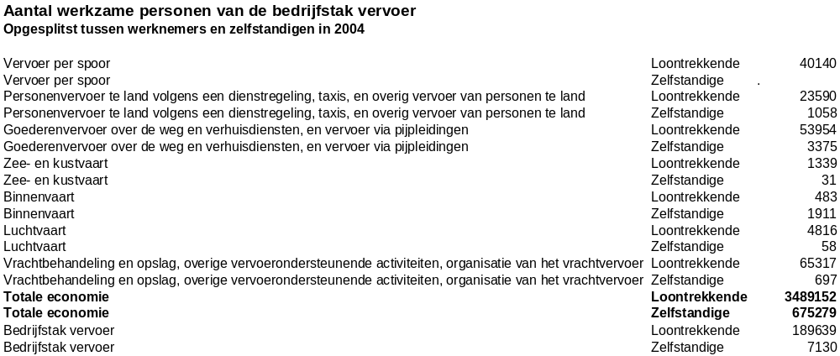
Source: Nationaal Planbureau

B. Total investment in the transport sector (amount and percentage of total domestic capital formation) with regard to infrastructure as well as equipment, if possible broken down by mode of transport (road, rail, inland waterway, pipeline, container transport equipment and urban transport facilities (by major urban agglomerations))

63. Not available.

C. Volume of passenger transport broken down by road transport (collective and individual transport), rail transport (making a distinction where appropriate for urban transport) as well as domestic air transport, growth percentage and the breakdown by modes of transport or passenger/km estimate

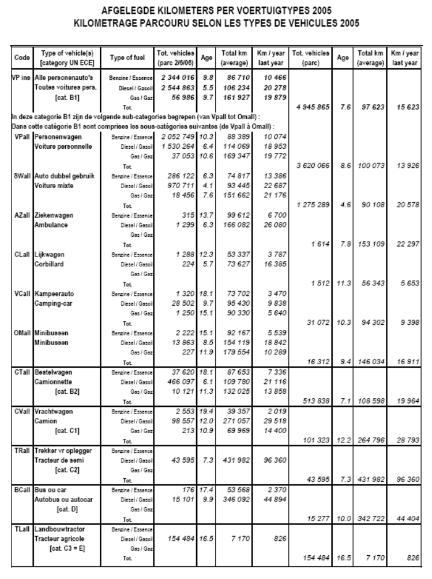

Evolution of the number of vehicle km/ passenger cars (BVRI): an average of 15.000 km/year ever since 1998
Year | BVRI | Average yearly km/ Belgian passenger cars
1975  1998  1999  2000  2001  2002  2003  2004  2005 | 100  132,60  134,58  133,21  133,18  133,53  133,26  133,60  132,53 | 11.285  14.964  15.187  15.032  15.029  15.069  15.039  15.077  14.956

64. The BVRI index dropped to 132,53 in 2005, namely 14.956 km/year –corresponding to the level of 1998 - as the growth of traffic on the motorways and other numbered roads did not keep pace with the growth of the number of cars.

65. Passenger /km 2005: 110,77 billion km (-0,2% over 2004), of which 103,23 by Belgian cars.

D. Volume of freight transport (growth percentage and breakdown of traffic according to mode of transport or ton/km volume) for road transport, rail transport, inland waterway transport and pipeline transport
Transport de marchandises : principaux modes de transport (1999-2005)
Mode de transport | 1999 | 2000 | 2001 | 2002 | 2003 | 2004 | 2005 | 2005/2004
Quantités transportées (en 1.000 tonnes) | 591.486 | 684.235 | 668.561 | 676.655 | 680.077 | 691.840 | 696.077 | +0,6%
Navigation intérieure | 110.309 | 120.944 | 128.561 | 135.115 | 137.755 | 147.765 | 168.093 | +13,8%
Chemin de fer | 59.149 | 61.279 | 57.050 | 57.198 | 55.732 | 58.454 | 60.976 | +4,3%
Transport routier (a) (b) | 422.028 | 502.012 | 482.950 | 484.342 | 486.590 | 485.621 | 467.008 | -3,8%
- trafic intérieur | 267.490 | 320.494 | 297.596 | 306.290 | 299.199 | 274.580 | 271.903 | -1,0%
- entrées | 61.661 | 74.905 | 74.092 | 72.710 | 73.317 | 78.828 | 75.234 | -4,6%
- sorties | 74.387 | 90.556 | 92.740 | 87.936 | 86.836 | 88.977 | 81.568 | -8,3%
- transit sans transbordement | 18.491 | 16.057 | 18.521 | 17.406 | 27.237 | 43.236 | 38.303 | -11,4%
Tonnes-kilomètres prestées (en millions tkm) | 56.061 | 65.754 | 67.296 | 66.646 | 66.743 | 71.006 | 69.387 | -2,3%
Navigation intérieure | 6.455 | 7.313 | 7.732 | 8.150 | 8.302 | 8.459 | 8.720 | +3,1%
Chemin de fer | 7.392 | 7.674 | 7.080 | 7.298 | 7.293 | 7.691 | 8.130 | +5,7%
Transport routier (a) (b) | 42.214 | 50.767 | 52.484 | 51.198 | 51.147 | 54.856 | 52.537 | -4,2%
- trafic intérieur | 19.033 | 23.539 | 24.681 | 24.491 | 23.038 | 23.200 | 23.272 | +0,3%
- entrées | 9.249 | 11.236 | 11.114 | 10.906 | 10.998 | 11.824 | 11.285 | -4,6%
- sorties | 11.158 | 13.583 | 13.911 | 13.190 | 13.025 | 13.346 | 12.235 | -8,3%
- transit sans transbordement | 2.774 | 2.409 | 2.778 | 2.611 | 4.086 | 6.485 | 5.745 | -11,4%
Transport belge et étranger par route avec des véhicules immatriculés en Belgique et dans l'Union européenne, par eau et par rail sur le territoire belge.
(a) Transport effectué à l'aide de véhicules d'au moins 1 tonne.
Source (mention obligatoire) : Direction générale Statistique et Information économique et SNCB.

66. Pipelines:

(a) very important in Belgium, but for reasons of safety and security few information on the network or its capacity is public;

(b) most important networks departing from the port of Antwerp (second petro-chemical center in the World , after Houston in Texas) and the port of Zeebrugge (second largest gasterminal in the EU; in the period to 2014 capital investments to the tune of at least 500 million EUR are needed for the gas pipeline network linked to this gasterminal).

E. Length of networks (in thousand kilometres or percentage increase) broken down by road (making a distinction, if possible, between roads and motorways), rail and inland waterways (making a distinction, if possible, among the major categories) and pipelines

Length of the Belgian road network in km at 1 January
2005 | Motorways | Regional roads | Local roads
 | 1.747.4 | 13.880 | 135.745

67. These last few years the direct link between traffic growth and GDP-growth seems to loosen, though the traffic on the motorways is still structurally increasing but not at the same pace as the growth of the economy. Traffic on the regional and local roads is slightly but structurally decreasing. The latter phenomenon is explained by the cost of fuel for families and commuters in the presence of attractive alternatives now that the offer and quality of public transport has improved.

Length of the electrified Belgian railroad network:
3.500 km= 340 km/million inhabitants
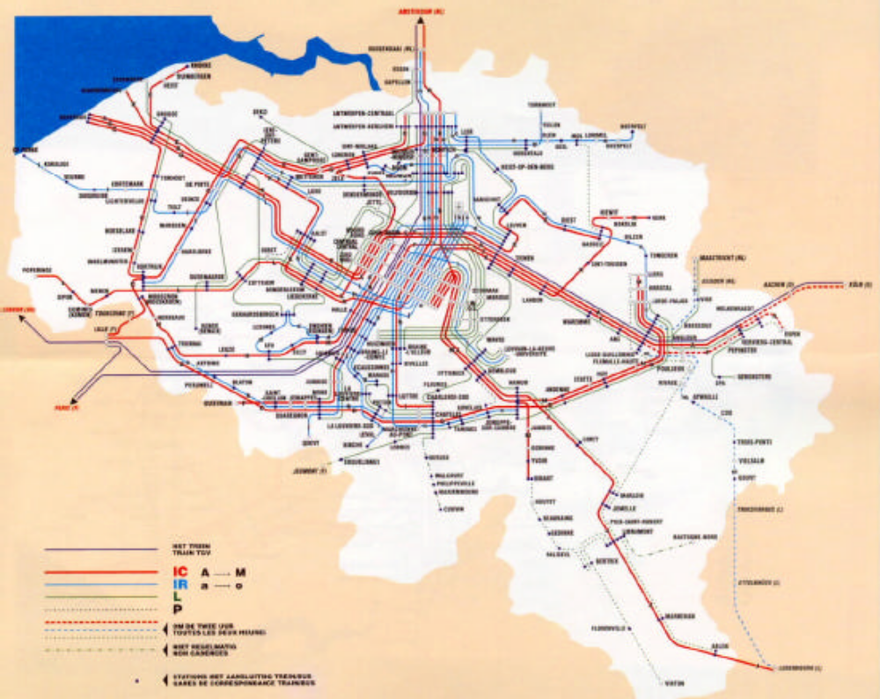

68. Length of the Belgian network of inland waterways:

2004: 1.532 km of commercial inland waterways + 317 km non-commercial waterways;

F. Transport equipment:

69. Capacity of railway rolling stock:

(a) number of passenger carriages:

total number of seats and sleeping-berths;
number and total capacity of goods vehicles).

(b) capacity of inland waterway fleets:

See above.

(c) number of private passenger cars:.

See above.

V. OTHER INFORMATION

70. In 2006 the Walloon region launched a pilot project whereby fast bus services could make use of adapted stretches of the emergency lane on the highway to Brussels; an evaluation of this project is expected in the near future. A similar project in the Antwerp region by the Flemish Region has been continued.

-----

