UNITED  NATIONS |  | E
 | Economic and Social  Council | Distr.  GENERAL  ECE/TRANS/WP.29/GRSG/2008/19  7 August 2008  Original: ENGLISH  ENGLISH AND FRENCH ONLY
ECONOMIC COMMISSION FOR EUROPE
INLAND TRANSPORT COMMITTEE
World Forum for Harmonization of Vehicle Regulations

Working Party on General Safety Provisions
Ninety-fifth session
Geneva, 21 - 24 October 2008
Item 3(a) of the provisional agenda

REGULATION No. 107
(M₂ and M₃ vehicles)

Proposal for further amendments

Proposal for draft amendments to Regulation No. 107

Submitted by the expert from Spain /

The text reproduced below was prepared by the expert from Spain, in order to clarify the definitions in the Regulation. It is based on informal document No. GRSG-94-26 distributed during the ninety-fourth session of the Working Party on General Safety Provisions (GRSG) (ECE/TRANS/WP.29/GRSG/73, para. 11). The modifications to the current text of the Regulation are marked in bold characters.
A. PROPOSAL

Paragraph 2.15., amend to read:

"2.15. "Gangway" means the space providing access by passengers from any seat or row of seats or each special area for wheelchair users to any other seat or row of seats or each special area for wheelchair users or to any access passage from or to any service door or intercommunication staircase and any area for standing passengers; it does not include: "

Annex 8, paragraph 3.6.1., amend to read:

"3.6.1. For each wheelchair user provided for in the passenger compartment there shall be a special area at least 750 mm wide and 1300 mm long. The longitudinal plane of the special area shall be parallel to the longitudinal plane of the vehicle and the floor surface of the special area shall be slip resistant and the maximum slope in any direction shall not exceed [2 per cent].

In the case of a wheelchair space designed for a forward facing wheelchair, the top of preceding seatbacks may intrude into the wheelchair space if a clear space is provided as shown in Annex IV, Figure 22. "

B. JUSTIFICATION

To guarantee the appropriate access of all passengers or crew members to each wheelchair user's specific area, in order to, for example, give special care or attention, help with the wheelchair anchorage system, etc. (see FIGURE 1.1 and FIGURE 1.2 attached).

Nowadays, there's no specific maximum slope in the special reserved areas for wheelchair users. This proposal intends to ensure the wheelchair user's right stability (see FIGURE 2 attached).

Paragraph 3.6.1. mentions a reference to Annex IV, Figure 23. It must be Figure 22, which is the one that gives us the maximum intrusion into the wheelchair space.

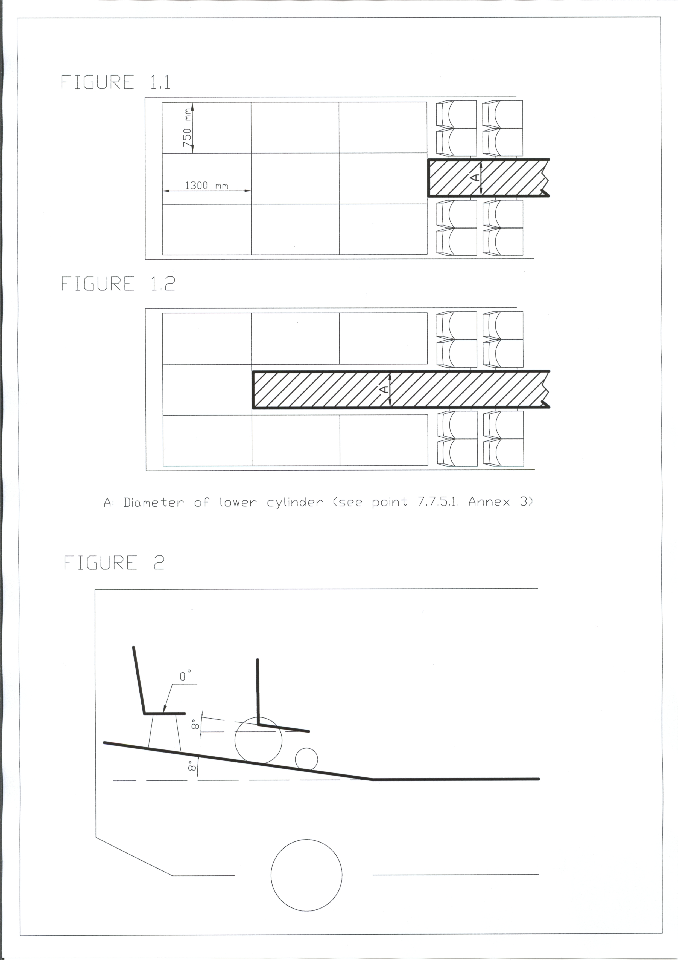

- - - - -

/ In accordance with the programme of work of the Inland Transport Committee for 2006-2010 (ECE/TRANS/166/Add.1, programme activity 02.4), the World Forum will develop, harmonize and update Regulations in order to enhance performance of vehicles. The present document is submitted in conformity with that mandate.

