UNITED NATIONS |  | ST
 | Secretariat | Distr.  GENERAL  ST/SG/AC.10/C.4/2009/1  2 April 2009  Original: ENGLISH

COMMITTEE OF EXPERTS ON THE TRANSPORT OF

DANGEROUS GOODS AND ON THE GLOBALLY

HARMONIZED SYSTEM OF CLASSIFICATION

AND LABELLING OF CHEMICALS

Sub-Committee of Experts on the Globally Harmonized
System of Classification and Labelling of Chemicals

Seventeenth session

Geneva, 29 June – 1 July 2009

Item 3 of the provisional agenda

HAZARD COMMUNICATION ISSUES

Comments on the use of the pictogram for “gases under pressure”

Transmitted by the European Industrial Gases Association (EIGA)

Introduction

1. The GHS pictogram for the hazard class “gases under pressure” (the gas cylinder symbol) is meant to be affixed on packagings containing gas under pressure.

2. Packagings containing gases are pressure receptacles (cylinders, tubes, drums, pressure drums, cryogenic receptacles and bundles of cylinders) and articles containing gases under pressure (e.g. gas cartridges and aerosols dispensers).

3. Pressure receptacles are at the same time the packagings for use and the packagings for transport and therefore need to be labelled according to both the relevant transport regulation and the regulation that implements the GHS.
4. The GHS is being implemented in Europe and the gas industry is currently determining the layout and content of the labels to be affixed on the approx. 250 millions pressure receptacles in use.

5. EIGA is of the opinion that the “gas cylinder” pictogram needs not to be affixed where the packaging is labelled for transport with a Class 2 label: 2.1, 2.2 or 2.3.

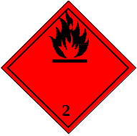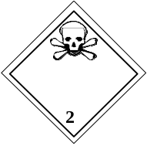

Justification

6. Pressure receptacles (see illustrations in Annex I) are dedicated packagings with specific openings and closures for the safe transport and use of gases. They cannot be mistaken with conventional receptacles for liquids.

7. In international transport regulations, gases are allocated to a specific transport class, class 2, that is clearly identified with the figure 2 on the transport labels.

8. The GHS “gas cylinder” pictogram is derived from the Transport of dangerous goods symbol (Transport label No 2.2) that is restricted to non-flammable, non-toxic gases. It would be confusing to have this symbol mixed with transport symbols for toxic and/or flammable gases.

9. The “gas under pressure” pictogram should only be necessary on receptacles or articles containing gases not labelled with class 2 pictograms (e.g. gas cartridges transported in an outer packaging labelled for transport).

Proposal

10. EIGA proposes the following amendments to Chapter 2.5 and Annex 1 of the GHS.

(a) Amendments to Chapter 2.5

Add the following new note under Table 2.5.2 as follows:

NOTE: “The pictogram needs not to be affixed on packagings labelled for the transport of class 2 gases. “

(b) Amendments to Annex 1

Amend the table for gases under pressure to read as follows:

Gases under pressure
Compressed gas | Liquefied gas | Refrigerated  liquefied gas | Dissolved gas | Notes
  Warning  Contains  gas under pressure; may explode if heated | Warning  Contains  gas under pressure; may explode if heated | Warning  Contains refrigerated gas; may cause cryogenic burns or injury | Warning  Contains  gas under pressure; may explode if heated | (see note 1)
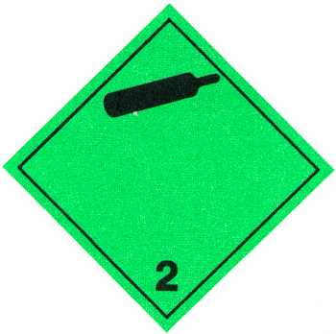 |  |  |  | (see note 2)
Notes:
(1) [(new note)]: The pictogram needs not to be affixed on packagings labelled for the transport of class 2 gases.

(2) [(existing note)]: Under the UN Recommendations on the Transport of Dangerous Goods ,Model Regulations, pictogram elements:
- Not required for toxic or flammable gases;
- The symbol, number and border line may be shown in white instead of black. The background stays green in both cases.

Annex I

Types of pressure receptacles

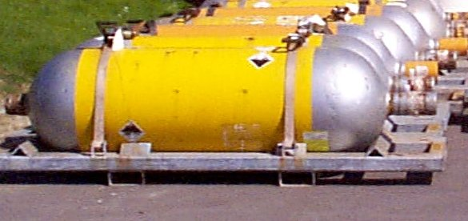
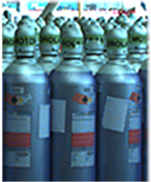

“cylinder”= limited to 150 L “tube”= seamless receptacle, between 150 L and 3000 L

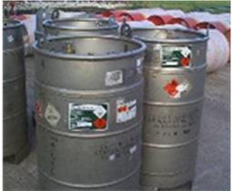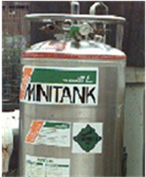

“pressure drum” = welded receptacle, cryogenic receptacle
between 150 L and 1000 L

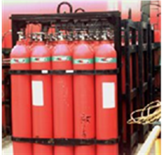

bundle of cylinders= up to 3000 L

__________________

In accordance with the programme of work of the Sub-Committee for 2009-2010 approved by the Committee at its fourth session (refer to ST/SG/AC.10/C.4/32, Annex II and ST/SG/AC.10/36, para. 14)

