UN/SCETDG/37/INF.54
UN/SCEGHS/19/INF.23
Committee of Experts on the Transport of Dangerous Goods 17 June 2010
and on the Globally Harmonized System of Classification
and Labelling of Chemicals
Sub-Committee of Experts on the Transport of Dangerous Goods  Thirty-seventh session  Geneva, 21 – 30 June 2010  Item 10 of the provisional agenda  Issues relating to the Globally Harmonized System of classification and Labelling of chemicals (GHS) | Sub-Committee of Experts on the Globally Harmonized  System of Classification and Labelling of Chemicals  Nineteenth session  Geneva, 30 June – 2 July 2010  Item 2 (a) of the provisional agenda  Physical hazards
Test results on desensitized explosives
Transmitted by the Expert from Germany
Introduction
- During the last meeting of the Working Group on Explosives (working document ST/SG/AC.10/C.3/2009/11) the experts were asked to give test results about typical desensitized explosives to the Working Group on Explosives.
- The BAM Federal Institute for Material Research and Testing as the competent authority of Germany for the classification of desensitized explosives has tested some typical desensitized explosives, which are covered by the UN No 2556, Nitrocellulose with alcohol (not less than 25 % alcohol by mass and not more than 12.6 nitrogen, by dry mass).
- The tested samples contained 70 % nitrocellulose (nitrogen content between 10.7 % and 12.2 %) and 30 % isopropanol.
- The BAM has tested the samples according to the classification procedure as described for Class 1 in the UN Manual of Tests and Criteria and would like to present the following test results.
Procedure for provisional acceptance in Class 1
- The following test results are obtained by testing according to test series 1 and 2.
Sample | UN Test  1(b)/2(b)  (Koenen test) | UN Test 1(c)(i)/2(c)(i)  (Time/pressure test) | UN Test A.1*  (BAM 50/60 steel tube test) | UN Test 2(a)  (UN gap test)
1 | 4.0 mm | 51 ms  43 ms  40 ms | Tube was fragmented completely. | No fragmentation; witness plate was not holed
2 | 2.5 mm | 68 ms  57 ms  64 ms | Fragmentation length of the tube was 45 cm. Borderline between “partial” and “Yes” | No fragmentation; witness plate was not holed
3 | 3.0 mm | 74 ms  69 ms  42 ms | Tube was fragmented completely | No fragmentation; witness plate was not holed
4 | 4.0 mm | 53 ms  48 ms  93 ms | Tube was fragmented completely | No fragmentation; witness plate was not holed
* In the past the UN Test A.1 was listed in the UN Manual of Tests and Criteria as UN Test 1 (a) (i). A 50 g booster was used. A positive result in this test will give comparable results in the sense of the current UN Test 1(a) with a 160 g booster.
- The samples are explosive substances in the sense of test series 1 of the UN Manual of Tests and Criteria.
- The samples are not too insensitive for acceptance in Class 1 in the sense of test
series 2 of the UN Manual of Tests and Criteria.
- The samples are thermally stable (see annex DSC) and based on experience of BAM not too dangerous for transport.
Procedure for assignment to a Division of Class 1
- The major hazard of the tested substances is radiant heat and/ or violent burning (experience of BAM with similar preparations). The samples packed in fibre drums (1G) each with 95 kg of the nitrocellulose preparation were tested according to the UN test 6(c) of the UN Manual of Tests and Criteria.
Sample  (mass 100 kg) | Burn time (s) | Flux (15 m) | Flux (5m)
1 | 337** | 1.5 kW/m² | 11.5 kW/m²
2 | 267 | 1.5 kW/m² | 13.8 kW/m²
3 | 204 | 1.2 kW/m² | 7.0 kW/m²
4 | 95 | 2.6 kW/m² | 15.8 kW/m²
**The burning time is > 330 s but nevertheless the flux is > 4 kW/m² (5 m)
- The comparative thermal flux values for varying masses (table 16.2 of the UN Test Manual of Tests and Criteria) are as follows:
 | 1.3/1.4 |  | 1.4/1.4S
Mass (kg) | Flux (15 m) | Burn time (s) | Flux (5 m) | Burn time (s)
20 | 1.36 kW/m² | 21.7 | 1.36 kW/m² | 195
50 | 2.5 kW/m² | 29.6 | 2.5 kW/m² | 266
100 | 4.0 kW/m² | 35.0 | 4.0 kW/m² | 330
200 | 6.3 kW/m² | 46,3 | 6.3 kW/m² | 419
Hazard Classification according to GHS
11. Based on the test results the tested samples would have to be classified in the Hazard Class “Explosive”, Division 1.4 of the GHS – at least as long as no specific hazard category for desensitized explosives is introduced. The label elements would therefore currently be the symbol “Exploding Bomb”, the signal word “Warning” and the hazard statement “Fire or Projection Hazard”.
12. Moreover the hazard classification according to GHS has only been verified for the packages as tested. If the packaging will be changed e.g. to steel drums (1A), this is not included in the test results as shown above, because a mass explosion in the UN Test 6(c) may not be excluded.
Discrepancies between classification for Transport and GHS
13. Currently the tested samples are covered by the UN No 2556, packing instruction P406, Division 4.1 “Solid desensitized explosives”. The applicable dangerous goods label is the one for flammable solids only.
14. The received test results indicate that the correct classification of the tested samples is depending on the packaging used.
15. Based on Globally Harmonized System of Classification and Labelling of Chemicals the tested samples currently would have to be classified in the Hazard Class “Explosives”, Division 1.4 with a symbol for explosives of class 1.4 and related hazard information – at least until a separate hazard class for desensitized explosives is introduced in the GHS in future.
Further action
16. The Working Group on Explosives is invited to discuss the issue and decide about further action as appropriate. The case as documented clearly shows a need for the introduction of a hazard class for desensitized explosives in the GHS; but such a hazard class may only be applicable to a desensitized explosive as packaged (e.g. for transport and storage).
17. Whenever a packaging of a desensitized explosive is opened and the substance is used, the conditions for suppressing the explosive properties may no longer be maintained and the suppressed explosive hazard may return. This should be considered when laying down requirements for hazard communication for such substances.
18. Industry and members of the working group should be invited to carry out tests for other desensitized explosives as currently listed in the UN Model Regulation to permit a better data base and a common understanding about the dangerous properties of such products.
Annex
Differential-Scanning-Calorimetry (DSC)
 | Trial no. | Sample mass | Heat of  decomposition | ONSET-temperature  (extrapolated)
Sample 1 | 1 | 1.33 mg | 3151 J/g | 195 °C
Sample 1 | 2 | 1.68 mg | 3417 J/g | 195 °C
Sample 2 | 1 | 1.77 mg | 2674 J/g | 188 °C
Sample 2 | 2 | 2.09 mg | 2856 J/g | 196 °C
Sample 3 | 1 | 1.96 mg | 2933 J/g | 189 °C
Sample 3 | 2 | 1.38 mg | 2900 J/g | 190 °C
Sample 4 | 1 | 1.96 mg | 2984 J/g | 191 °C
Sample 4 | 2 | 1.95 mg | 3311 J/g | 192 °C
UN Test A.1 and UN Test 2(a):
 | UN Test A.1 | UN-Test 2(a)
Sample 1 | 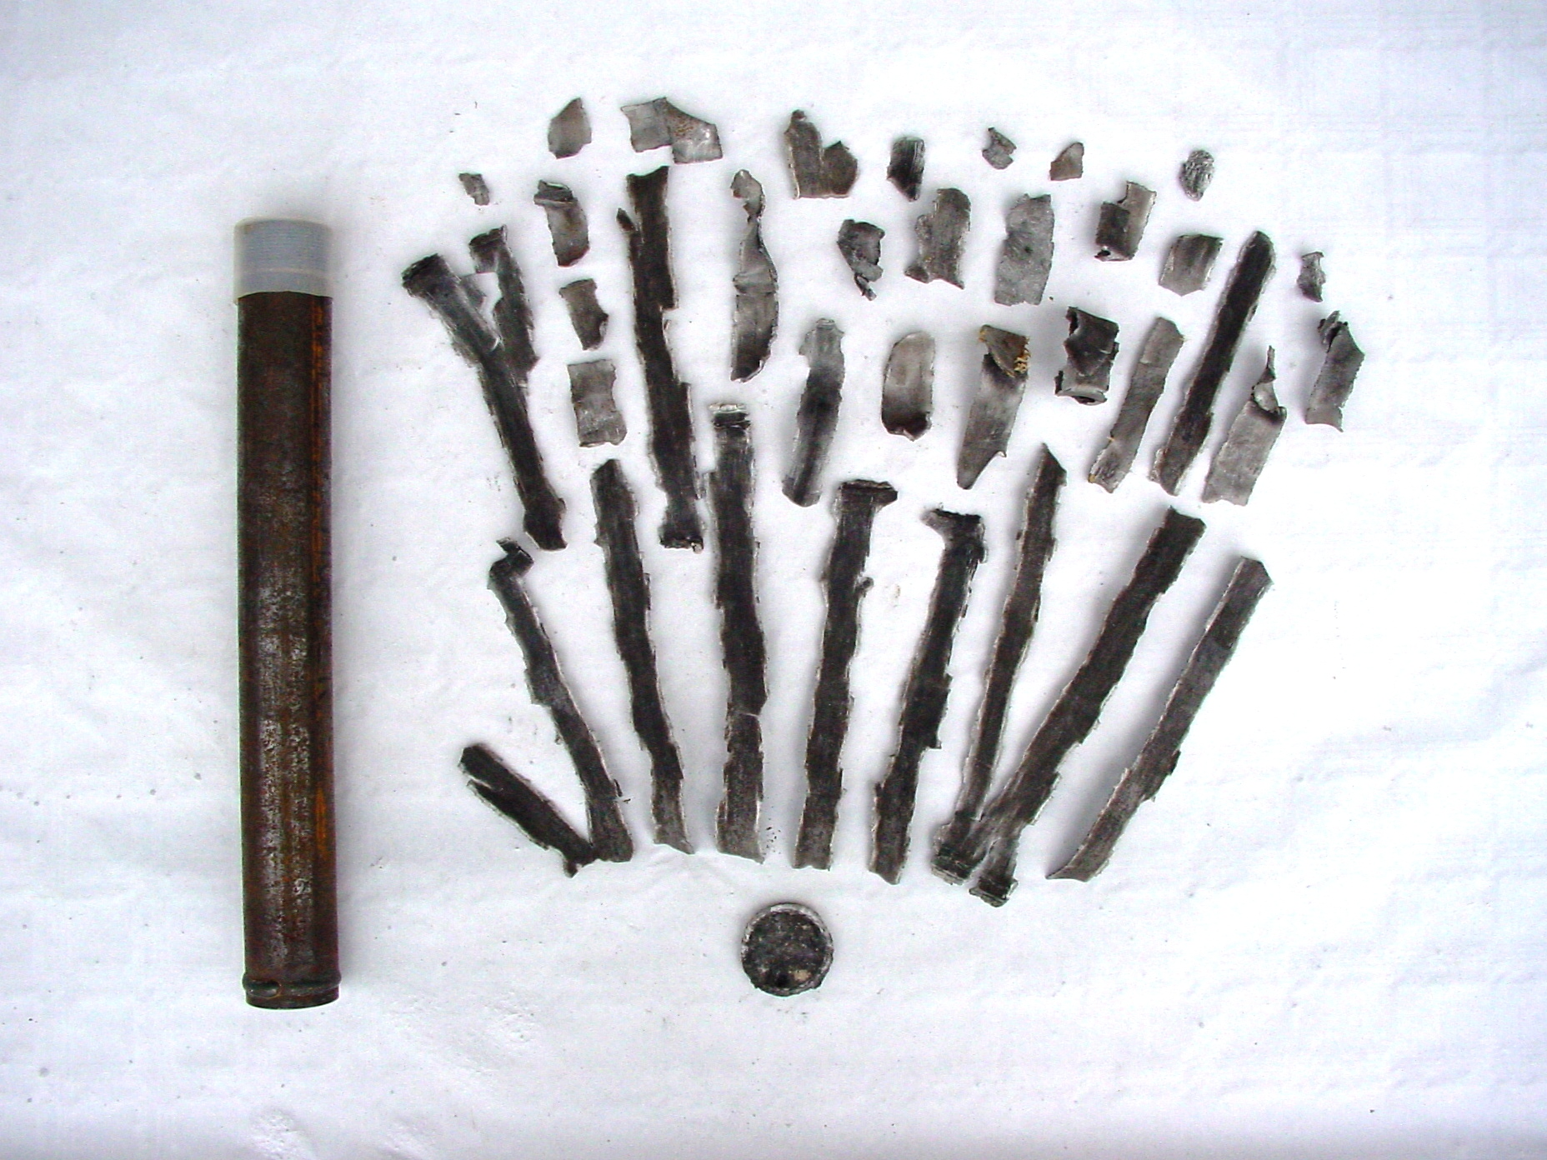 | 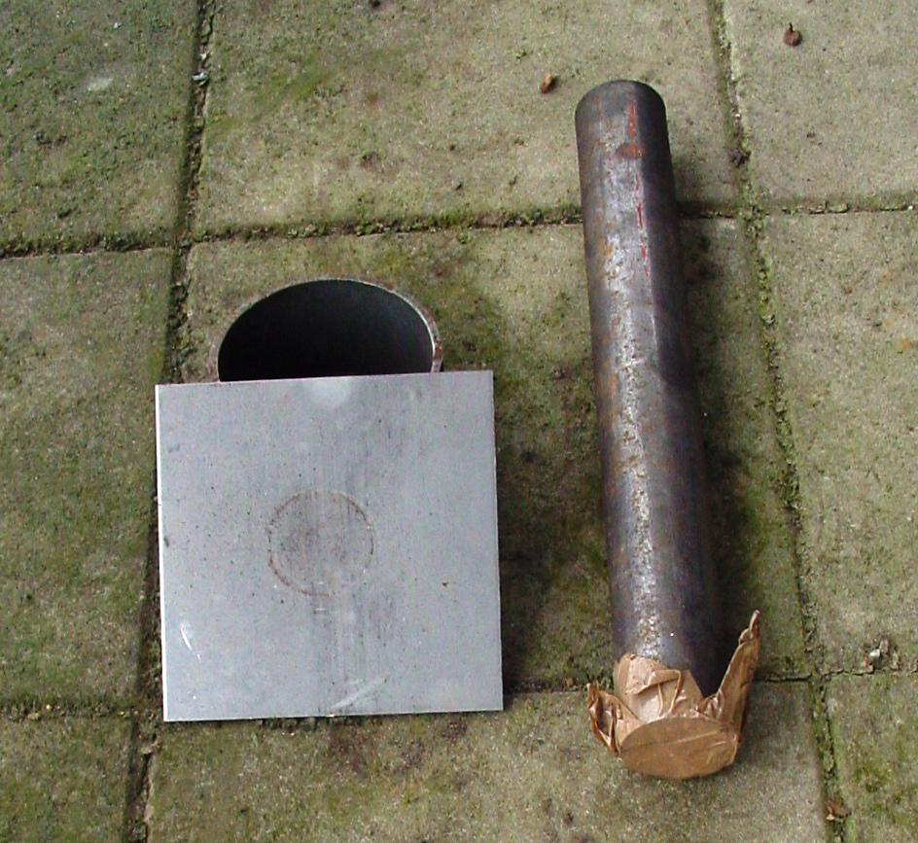
Sample 2 | 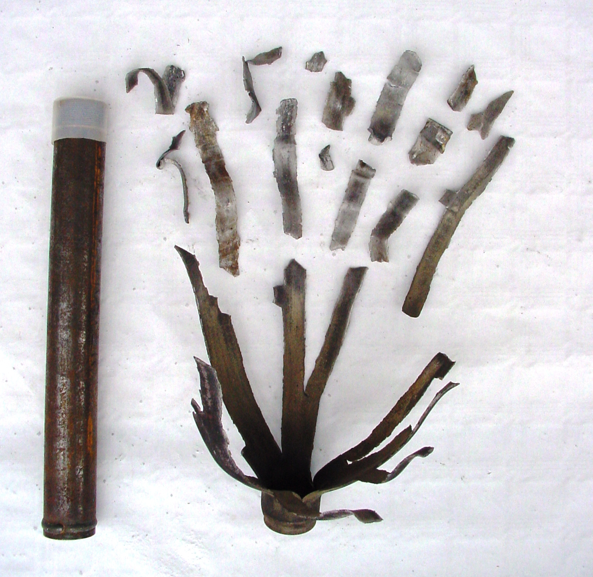 | 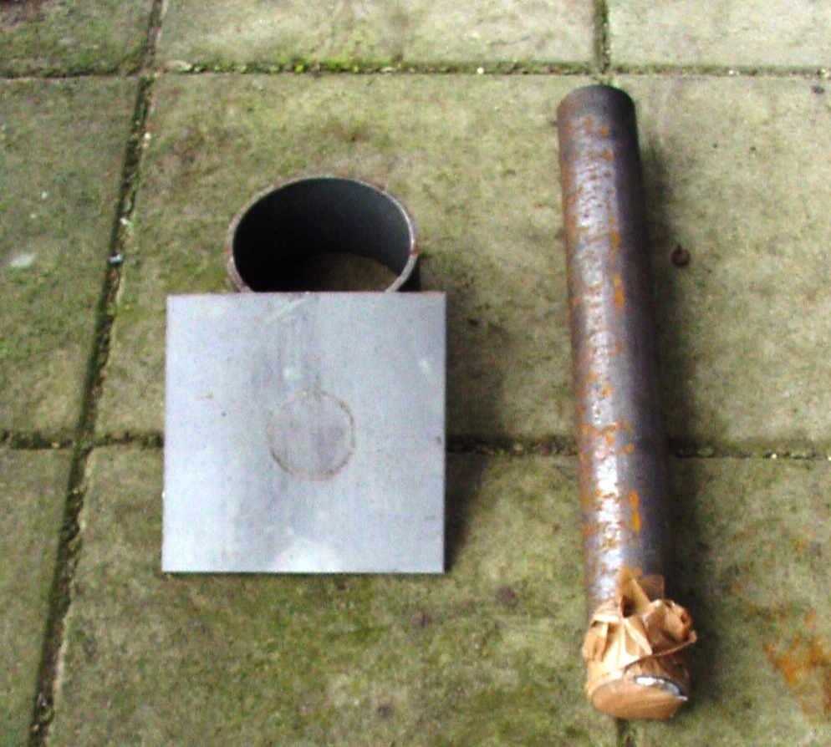

 | UN Test A.1 | UN-Test 2(a)
Sample 3 | 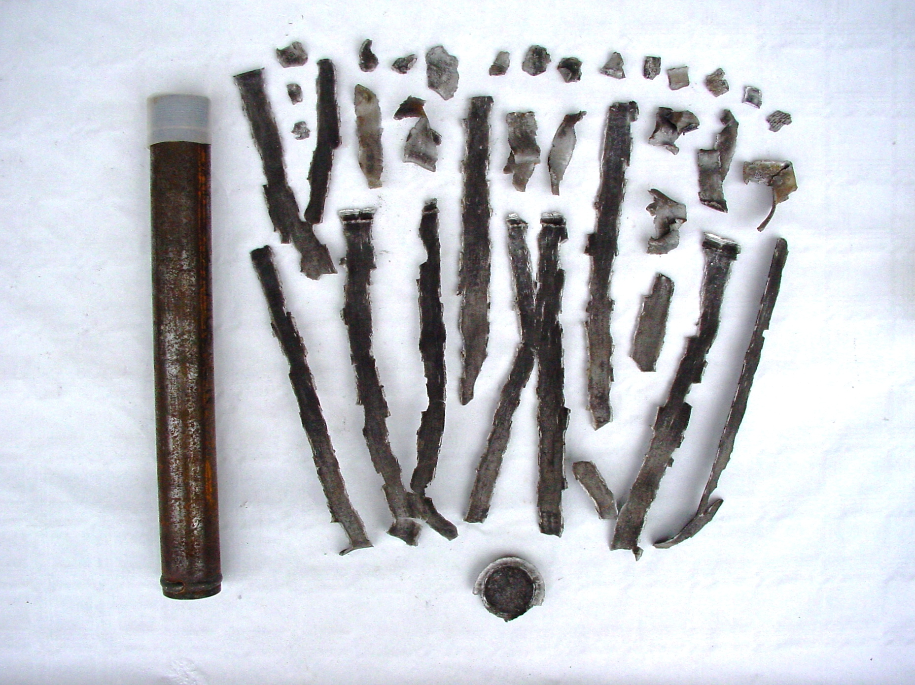 | 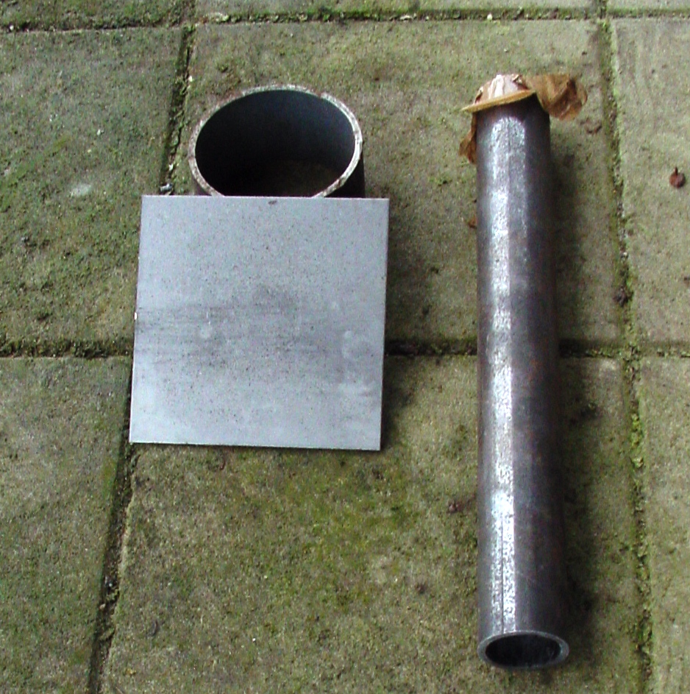
Sample 4 | 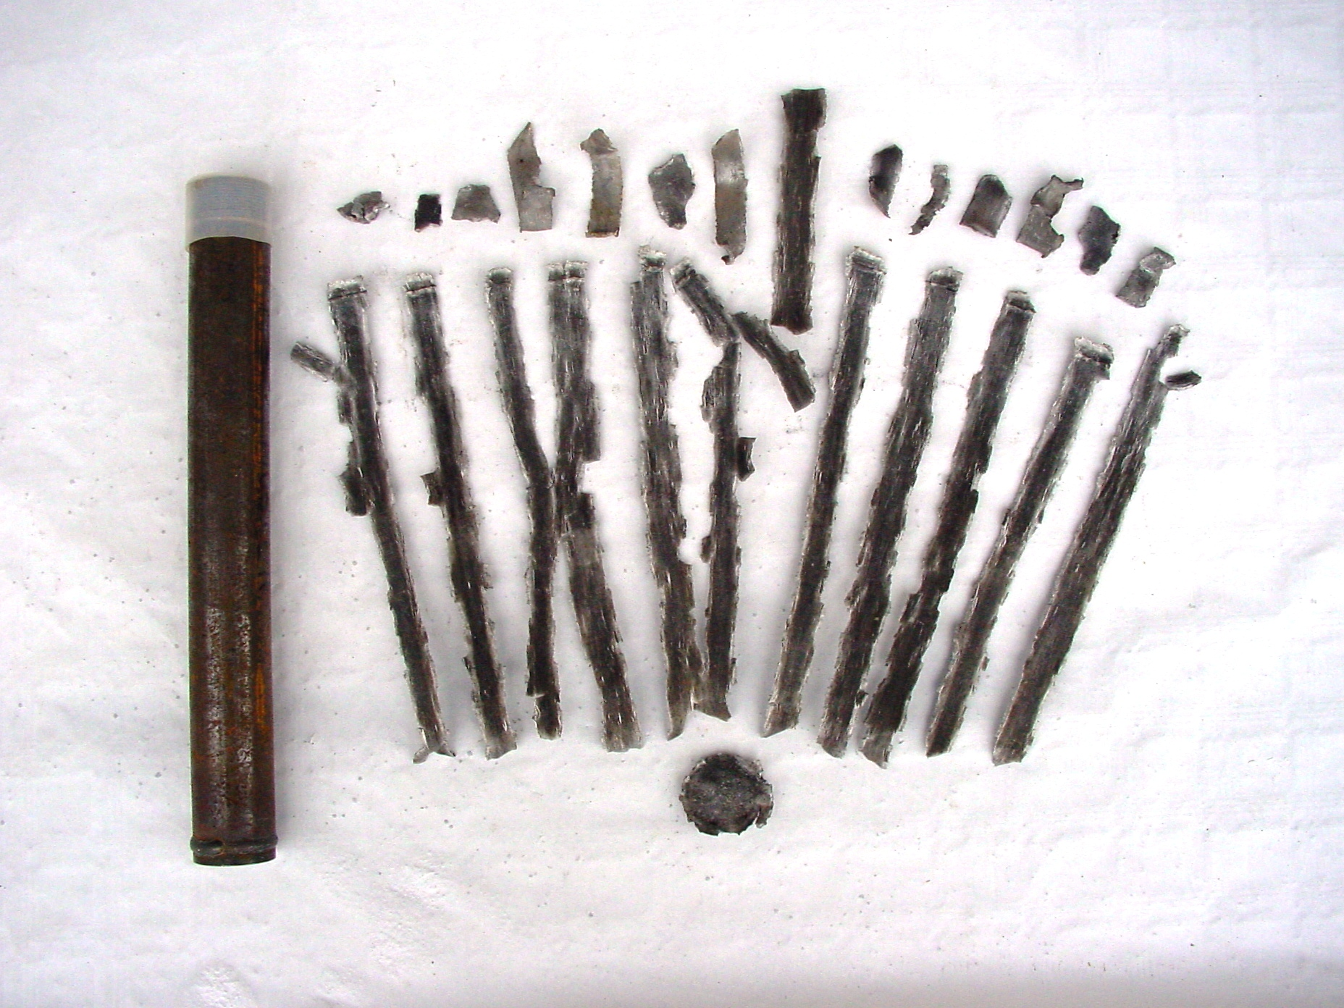 | 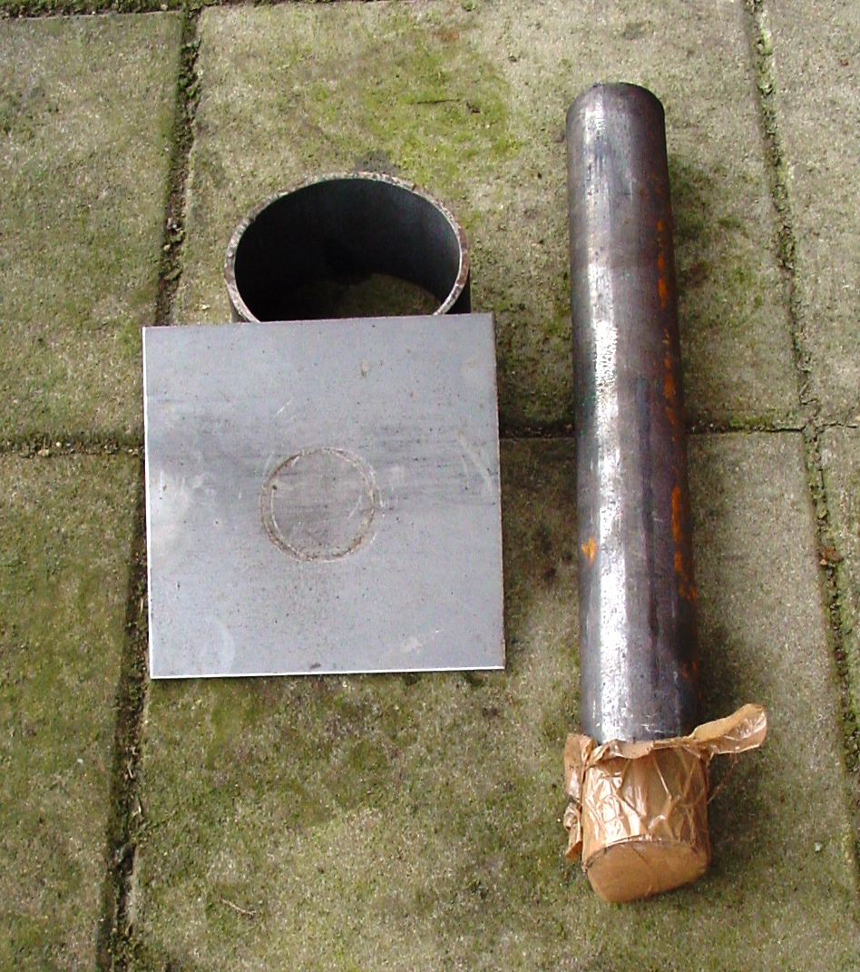

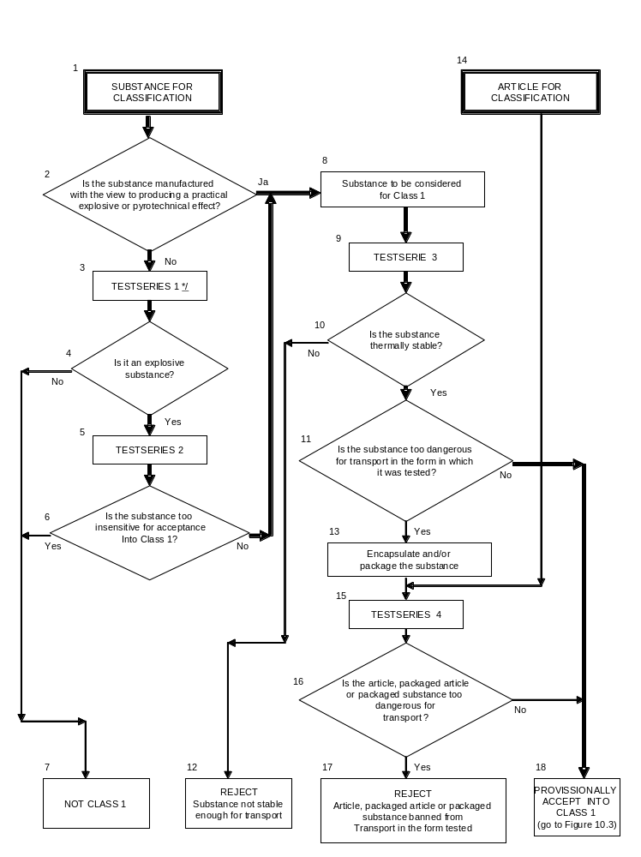Procedure for provisional acceptance of the tested sample in class 1
Procedure for assignment of the tested samples to a Division of Class 1


