 | United Nations | ST/SG/AC.10/C.3/2011/36
 | Secretariat |  | Distr.: General  7 September 2011  Original: English
Committee of Experts on the Transport of Dangerous Goods
and on the Globally Harmonized System of Classification
and Labelling of Chemicals
Sub-Committee of Experts on the Transport of Dangerous Goods
Fortieth session
Geneva, 28 November – 7 December 2011
Item 4 (c) of the provisional agenda
Miscellaneous proposals of amendments to the Model Regulations
on the Transport of Dangerous Goods: marking and labelling
Marking of the date of manufacture with packagings of types 1H and 3H
Transmitted by the International Confederation of Plastics Packaging Manufacturers (ICPP)
Introduction
- With document ST/SG/AC.10/C.3/2011/17 ICPP had submitted a proposal to align the current practice with the Model Regulations regarding the marking of the production date for packaging types 1H and 3H. This proposal was basically supported by the Sub-Committee; however several editorial suggestions were made to improve the amended text in 6.1.3.1 (e). ICPP has much appreciated these suggestions and submits an amended proposal for the future marking of the production date of drums and jerricans as follows. For the sake of completeness the justification for the proposal in ST/SG/AC.10/C.3/2011/17 is added again.
Background
2. The marking of the month of manufacture of packaging types 1H and 3H according to 6.1.3.1 (e) has proved to be acceptable in practice. During recent times many manufacturers have added to this clock the year of manufacture.
3. The use of a clock showing the month and the year of manufacture for packaging types 1 H and 3 H has become more and more established and was practised with and without the admission of national competent authorities.
4. It was reported that for example some port authorities objected occasionally to this kind of marking it is not fully in line with the method described in 6.1.3.1 (e). ICPP is of the opinion that both kinds of marking should be admitted in the Regulations. However, when using a clock indicating also the year of manufacture it must be the same as the date in the type approval marking.
Proposal
Amend 6.1.3.1 (e) beginning with the last sentence as follows:
“Appropriate examples are:
A) B)
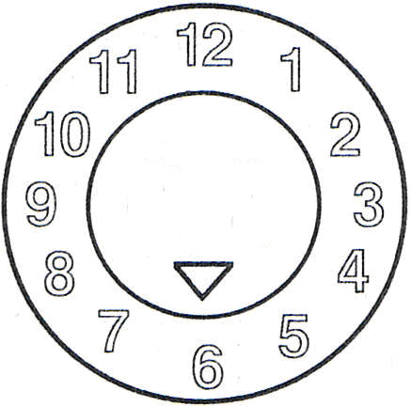 | or | 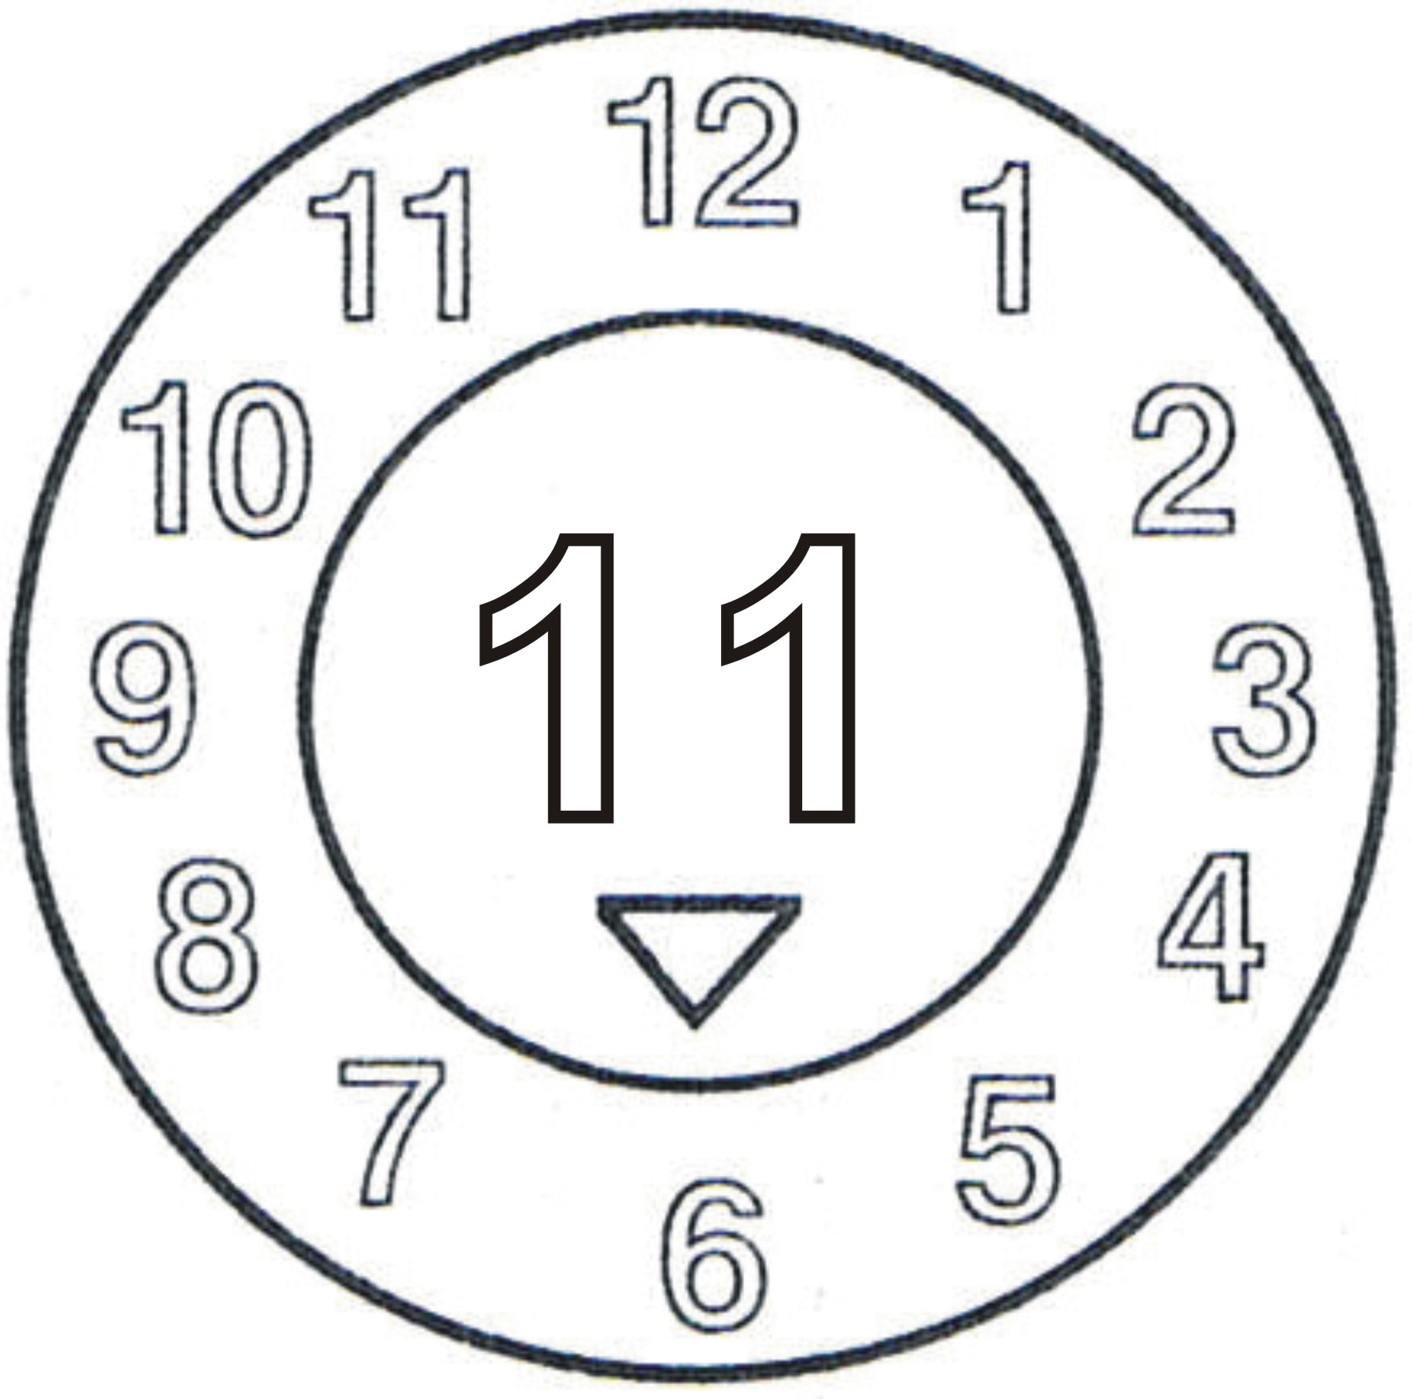
5. If the B-version is used, the two digits of the year in the type approval marking and in the inner circle of the clock shall be identical. Other methods that provide the minimum required information in a durable, legible and visible form are also acceptable.”

? In accordance with the programme of work of the Sub-Committee for 2011-2012 approved by the Committee at its fifth session (refer to ST/SG/AC.10/C.3/76, para. 116 and ST/SG/AC.10/38, para. 16).

