UNITED  NATIONS |  | E
 | Economic and Social  Council | Distr.  GENERAL  ECE/TRANS/WP.29/1080  14 December 2009  ENGLISH  Original: ENGLISH AND FRENCH
ECONOMIC COMMISSION FOR EUROPE

INLAND TRANSPORT COMMITTEE
World Forum for Harmonization of Vehicle Regulations

1958 AGREEMENT

Amendments to Annex 3 Part 7 of Regulation No. 48
(Installation of lighting and light-signalling devices)

Note by the secretariat

This document contains amendments to Annex 3, Part 7 to Regulation No. 48 adopted by the Administrative Committee of the 1958 Agreement at its forty-third session (11 November 2009) following the recommendations of the World Forum at its 149th session (10-13 November 2009) (ECE/TRANS/WP.29/1079, paras. 55 and 89). It modifies ECE/TRANS/WP.29/2009/91, Annex 3. In accordance to the provisions of Article 12 of the 1958 Agreement the amended proposal shall be transmitted to the Secretary-General for its legal adoption.

Annex 3, Part 7, amend to read:

"PART 7 EXAMPLES TO ENABLE A DECISION REGARDING THE RECIPROCAL INCORPORATION OF TWO FUNCTIONS

In the case with a textured outer lens and a wall in between:

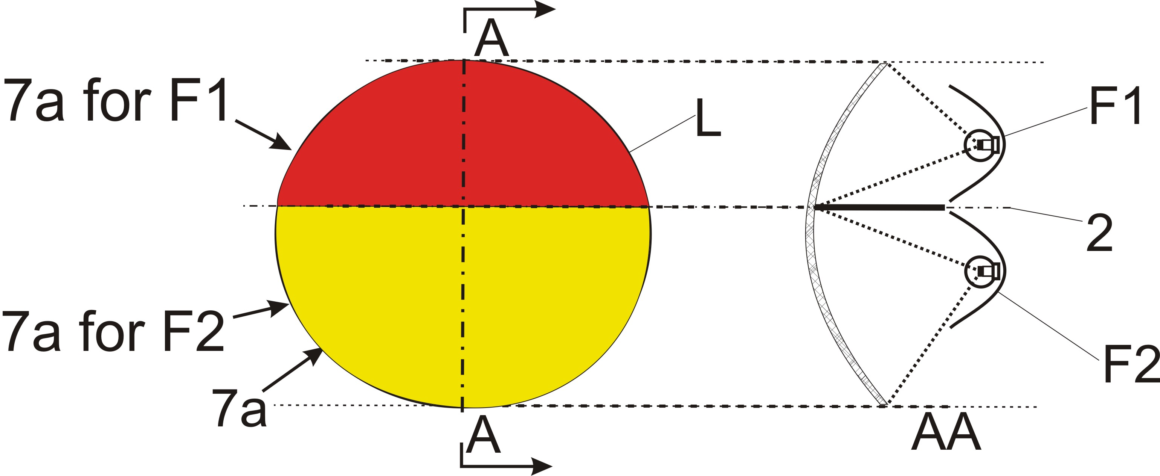
Not reciprocally incorporated

====================================================================

In the case with a textured outer lens:

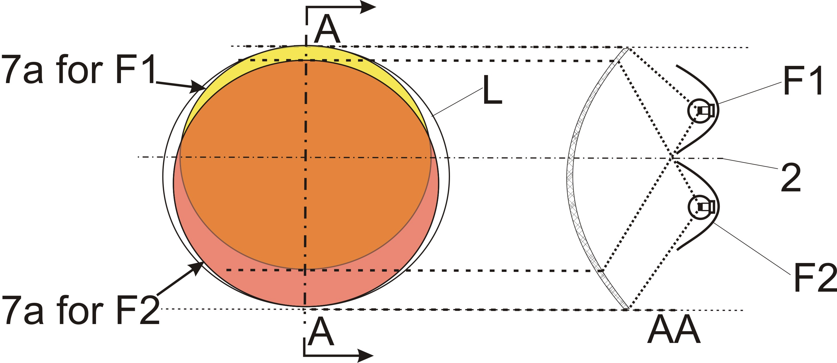
Reciprocally incorporated

====================================================================

In the case where the non-textured outer lens is excluded:

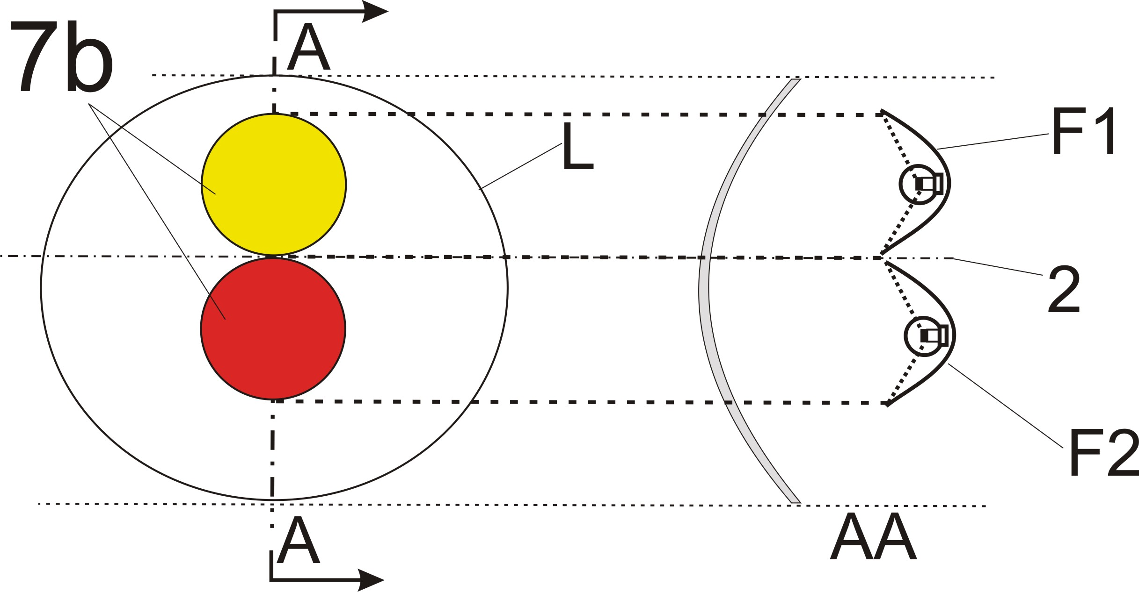
Not reciprocally incorporated

===================================================================

In the case where the non-textured outer lens is excluded:

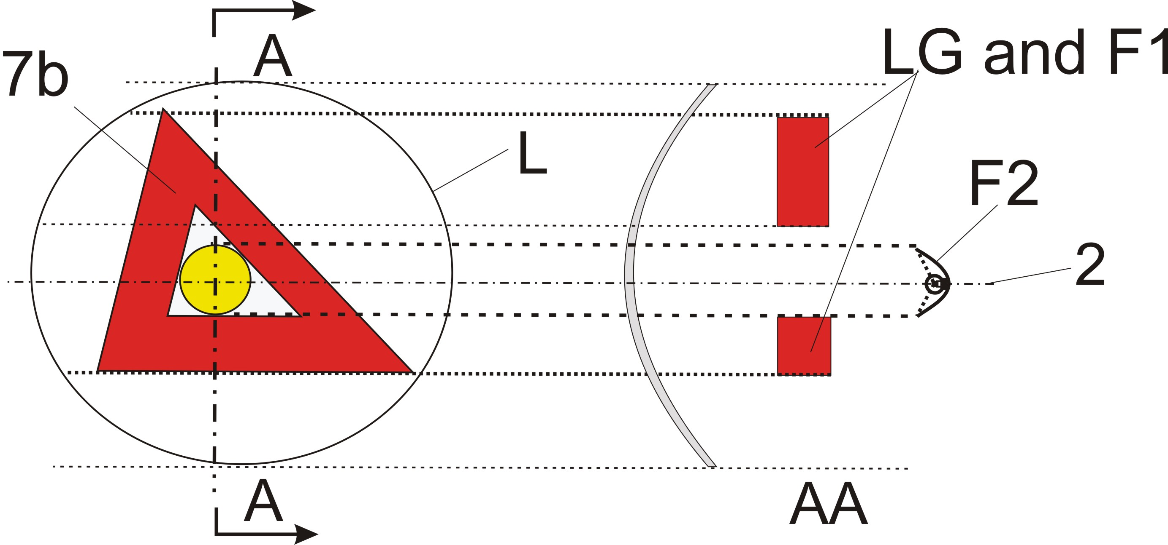
Not reciprocally incorporated
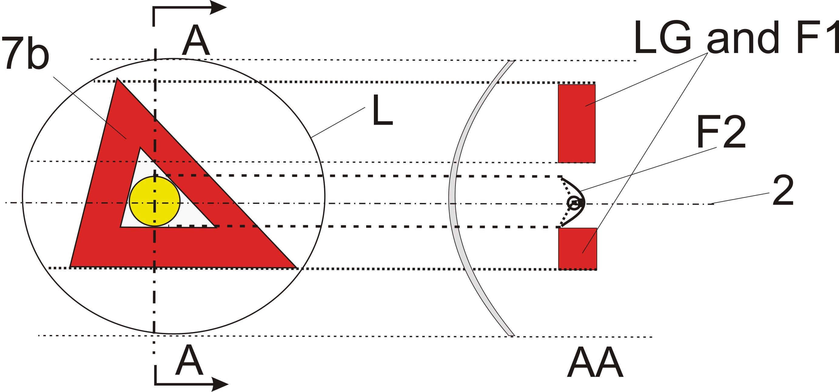
Not reciprocally incorporated

In the case where the outer lens (textured or not) is included:

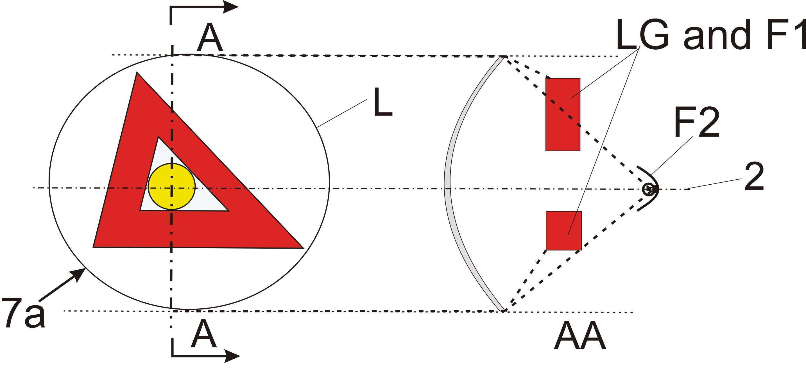
Reciprocally incorporated

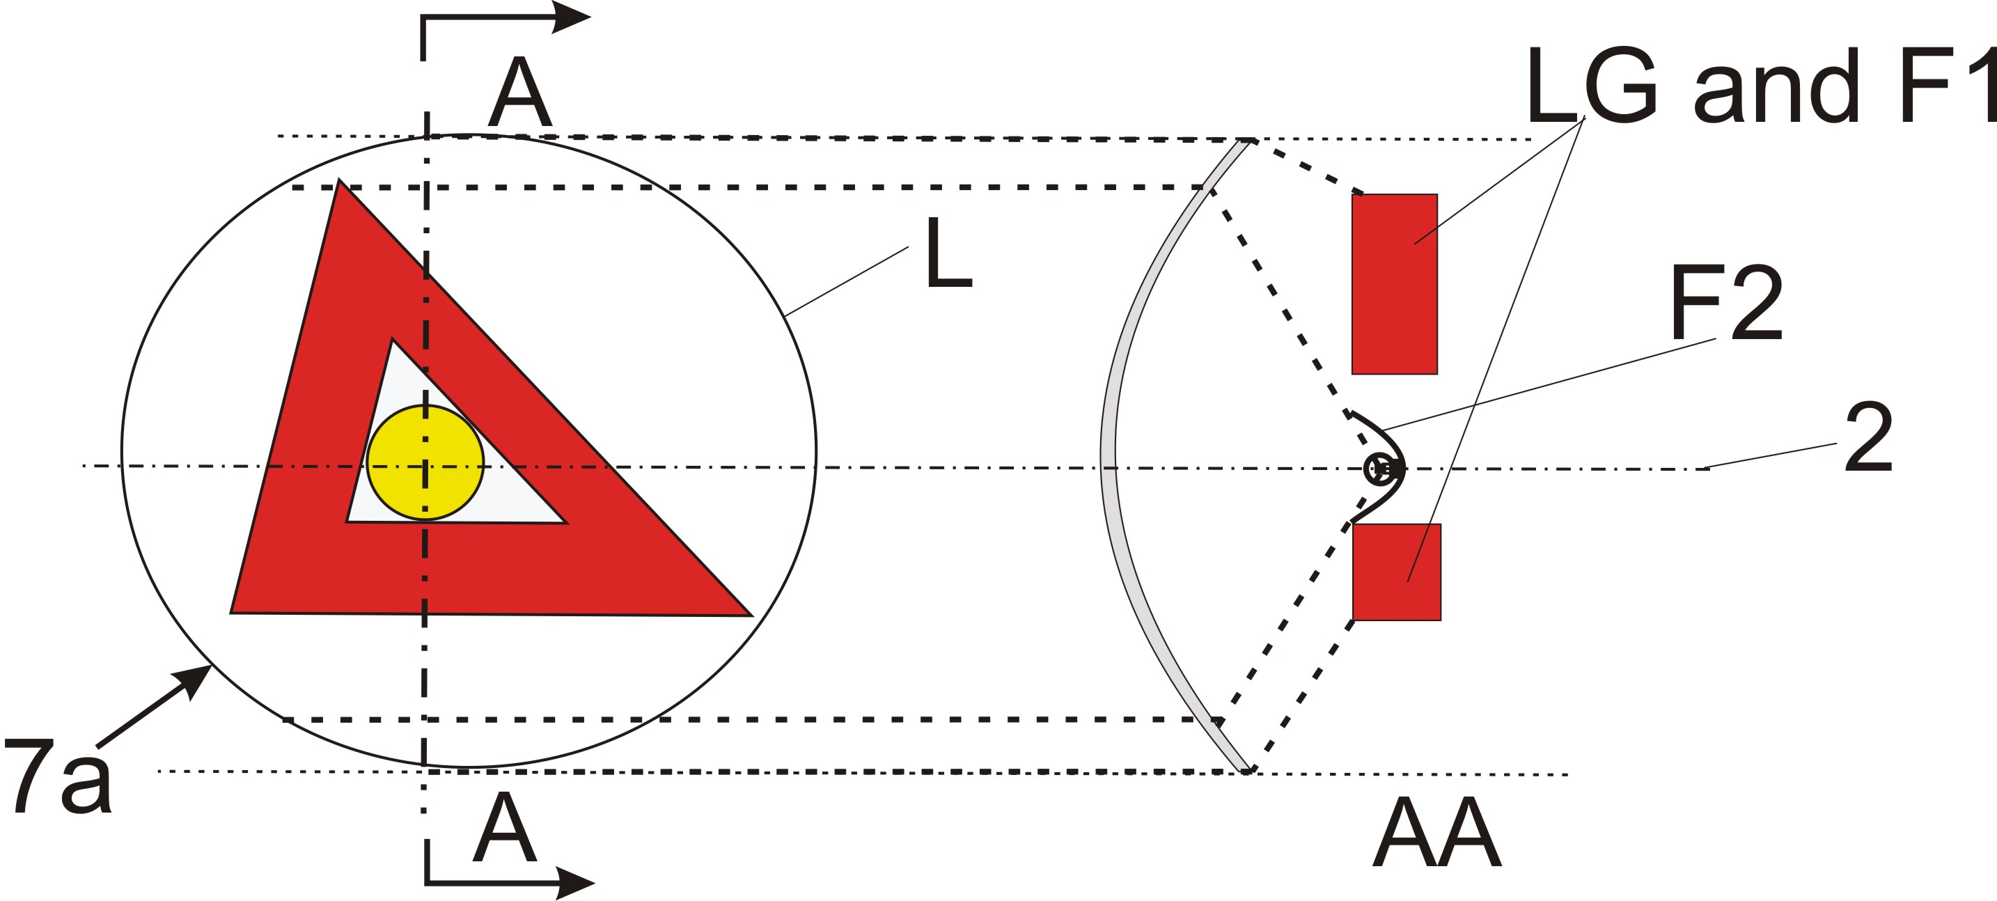
Reciprocally incorporated
====================================================================
In the case where the outer lens (textured or not) is included:
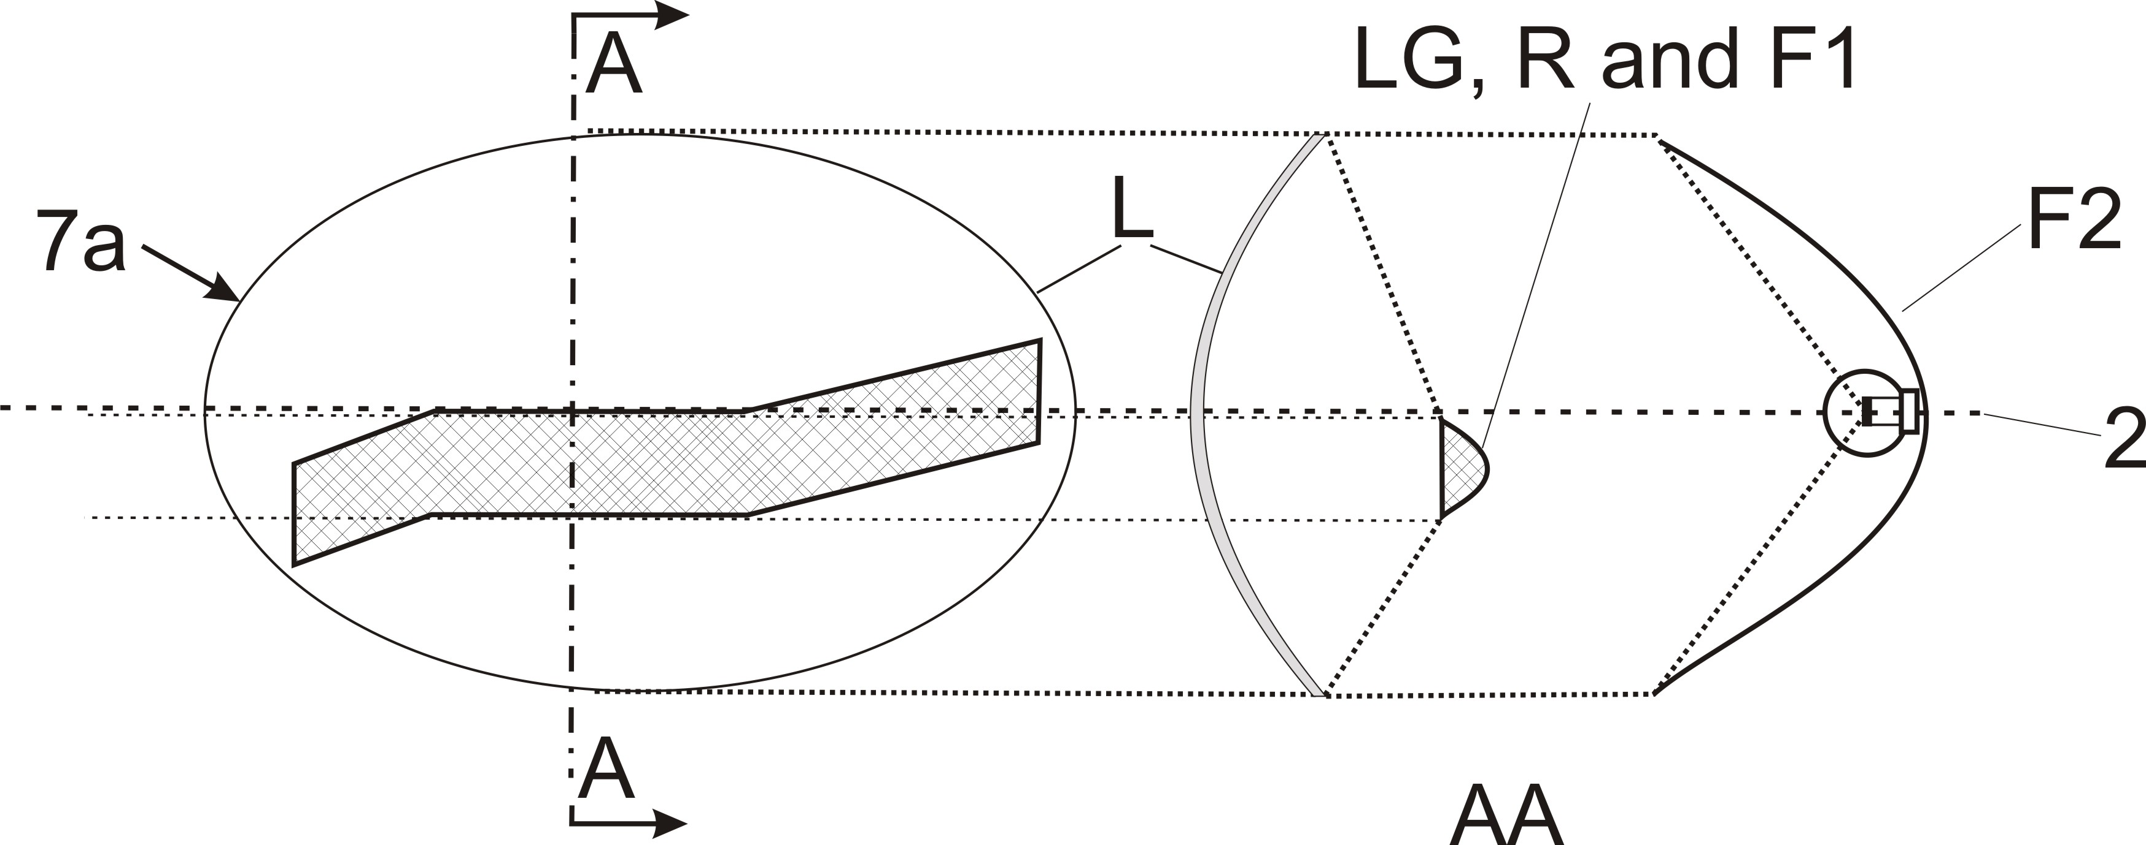
Reciprocally incorporated
====================================================================
In the case where the non-textured outer lens is excluded, "7b" is the apparent surface according to paragraph 2.8 and F1 shall not be transparent to F2:

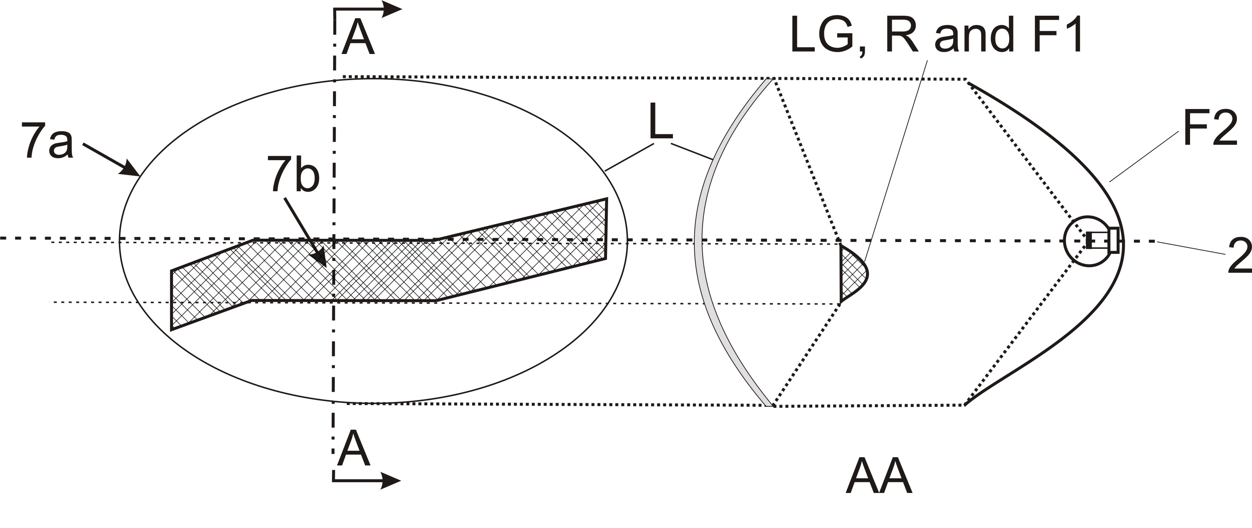
F1 is not reciprocally incorporated with F2
====================================================================
In the case where the non-textured outer lens is excluded or not:

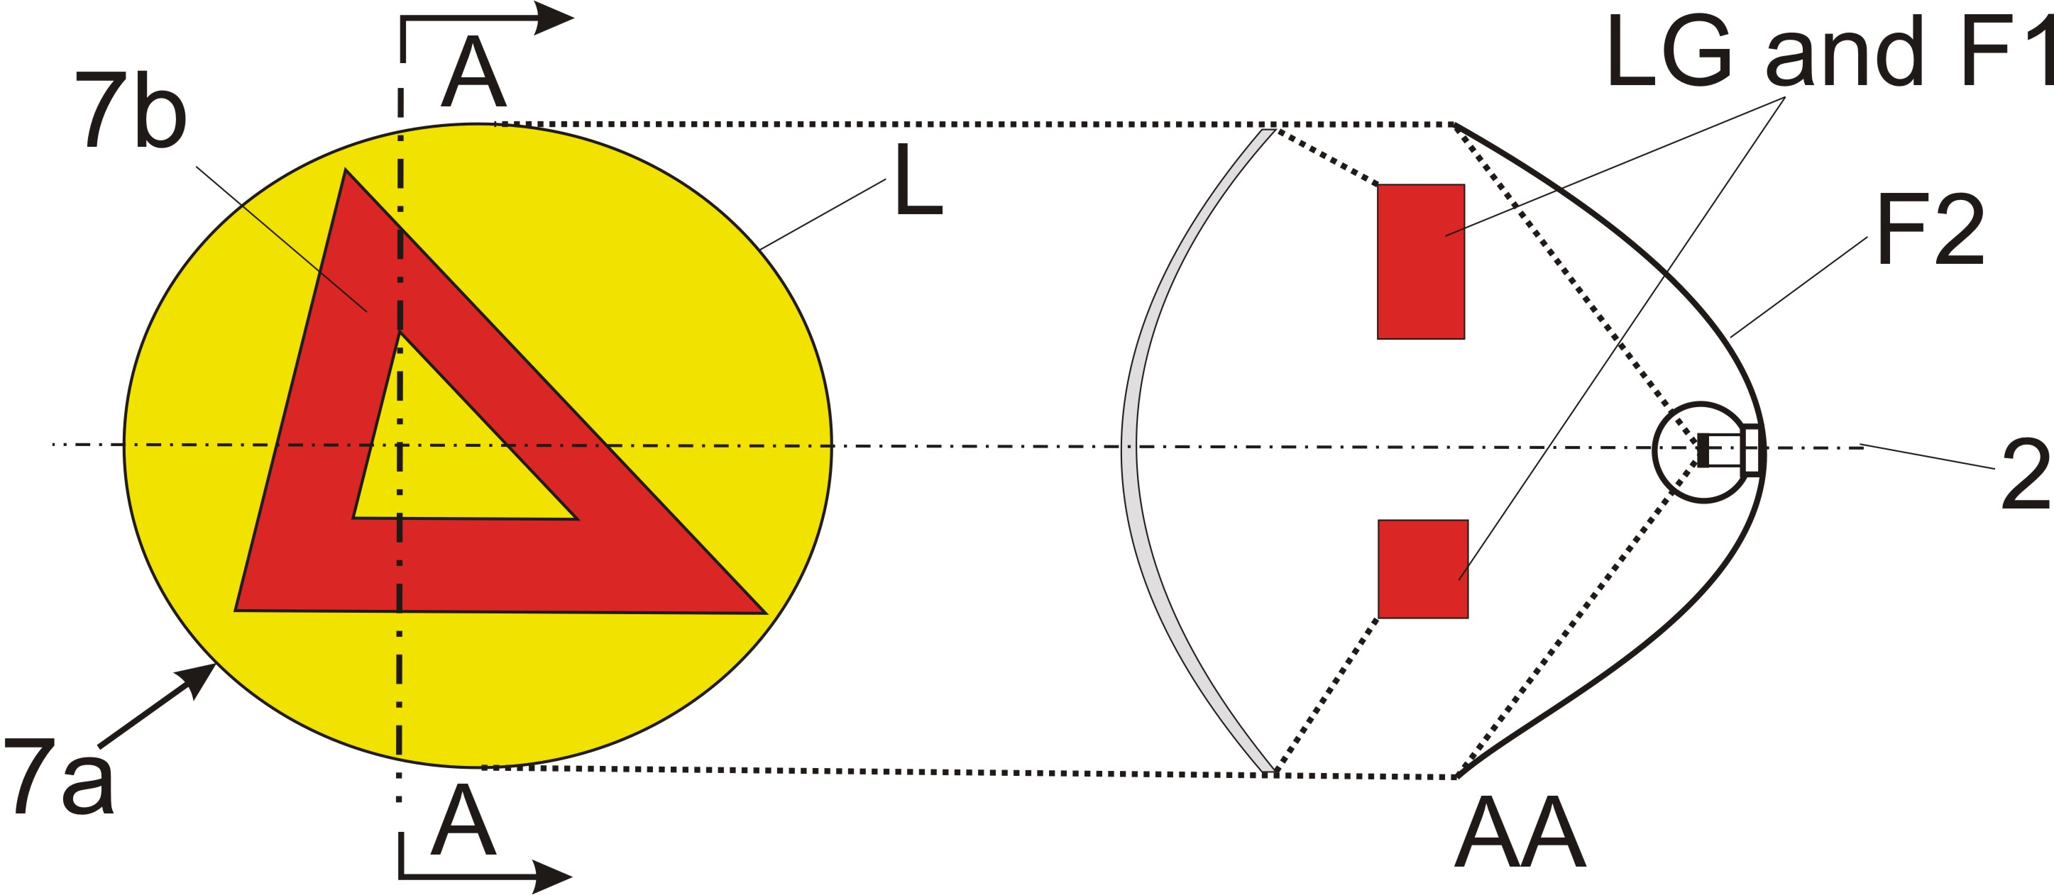
Reciprocally incorporated

====================================================================
"

-----

