 | United Nations | ECE/TRANS/WP.15/2012/1
 | Economic and Social Council |  | Distr.: General  1 February 2012  English  Original: French
Economic Commission for Europe
Inland Transport Committee
Working Party on the Transport of Dangerous Goods
Ninety-second session
Geneva, 7–11 May 2012
Item 6 (c) of the provisional agenda
Proposals for amendments to Annexes A and B of ADR:
New proposals
Exemptions for machinery and equipment permanently fixed to vehicles
Transmitted by the Government of Switzerland
Summary
Executive summary: To bring the exemption under special provision 363 for road transport into line with exemptions for other modes of transport by exempting vehicles with permanently fixed machinery or equipment and apply the exemption of special provision 363 to vehicles not exempted under 1.1.3.3.
Action to be taken: Create a new special provision for ADR.
Introduction
1. The exemption in the UN Model Regulations in special provision 363 was adopted in November by the Working Party to read as follows:
“363 This entry also applies to liquid fuels, other than those exempted according to paragraphs (a) or (b) of 1.1.3.3, above the quantity specified in column (7a) of Table A of Chapter 3.2, in means of containment integral to equipment or machinery (e.g. generators, compressors, heating units, etc.) as part of their original design type. They are not subject to other provisions of ADR if the following requirements are met:
(a) The means of containment are in compliance with the construction requirements of the competent authority of the country of manufacture;
(b) Any valves or openings (e.g. venting devices) in the means of containment containing dangerous goods are closed during carriage;
(c) The machinery or equipment is loaded in an orientation to prevent inadvertent leakage of dangerous goods and secured by means capable of restraining the machinery or equipment to prevent any movement during carriage which would change the orientation or cause it to be damaged;
(d) Where the means of containment has a capacity of more than 60 litres but not more than 450 litres, the machinery or equipment is labelled on one external side in accordance with 5.2.2 and where the capacity is greater than 450 litres but not more than 1,500 litres the machinery or equipment is labelled on all four external sides in accordance with 5.2.2; and
(e) Where the means of containment has a capacity greater than 1,500 litres, the machinery or equipment is placarded on all four external sides in accordance with 5.3.1.1.1, the requirement of 5.4.1 applies and the transport document includes the following additional statement: ‘Carriage in accordance with special provision 363’.”
2. Vehicles exempted under 1.1.3.3 cannot be exempted under special provision 363.
3. We would like the Working Party to endorse an interpretation according to which vehicles carrying liquid fuel and not exempted under 1.1.3.3 may be exempted under special provision 363. This concerns vehicles containing liquid fuel intended to run equipment situated on the vehicle and that cannot be exempted under 1.1.3.3 because they do not meet its conditions. Two cases may arise:
(a) The fuel is contained in tanks that are not fixed and are not directly connected to the auxiliary equipment of the vehicle;
(b) The quantity carried exceeds 1,500 litres per transport unit, or 500 litres in the case of trailers.
In case (a), if the conditions of special provision 363 are met, the fuel may be exempted.
In case (b), when the amount exceeds 1,500 litres per transport unit or 500 litres in the case of trailers, the exemption set out in special provision 363 may be claimed.
4. Another question that we invite the Working Party to address is the following:
According to (c) of special provision 363 “the machine or equipment is loaded”. This loading requirement does not cover the following examples:
1 | 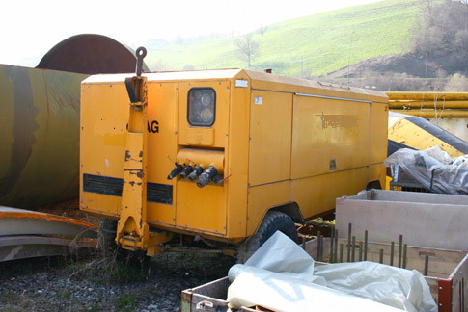 | Compressor  Vehicle, trailer  Liquid fuel, UN Nos. 1202  and 1203  Quantity: 2,000 litres
2 | 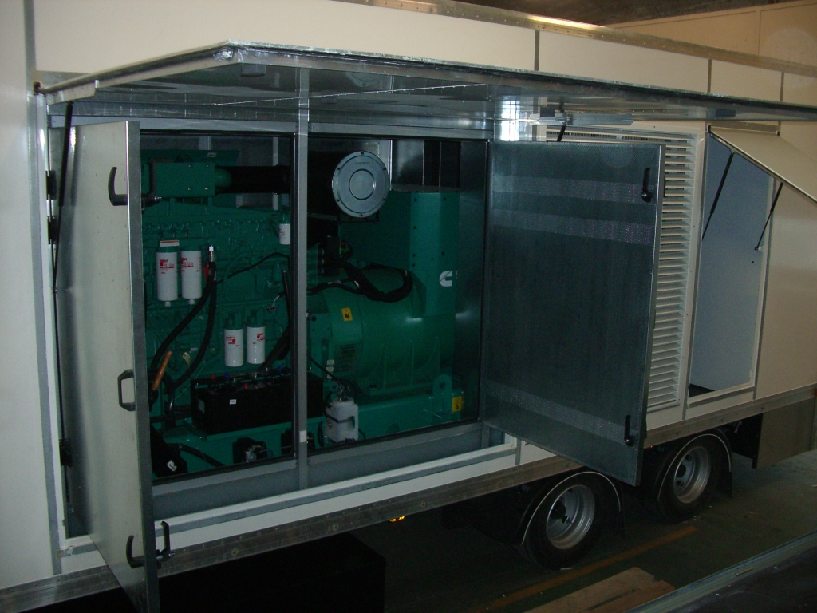 | Mobile generator set  Vehicle, tri-axle trailer  Liquid fuel, UN No. 1202  Quantity: 1,900 litres
3 | 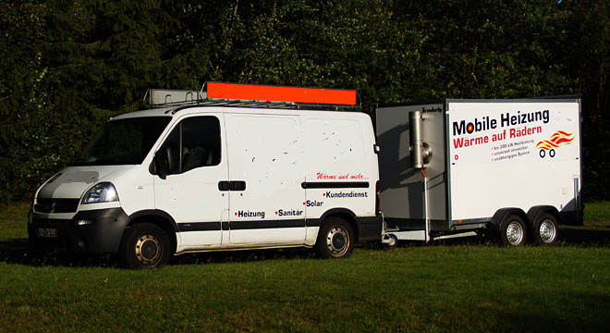 | Heating equipment  Vehicle, trailer  Liquid fuel  Heating oil, UN No. 1202  Quantity: 100–300 litres
5. In all these cases, the machine is not “loaded” onto the vehicle, but is an integral part of it. Such machines can be exempted in two ways:
- Under special provision 363 if they are not part of the vehicles themselves and are loaded in the cargo space of the vehicles.
- Under exemption 1.1.3.3 (b) for cases 1 and 2 when the trailer is loaded onto another vehicle, because it exceeds the limit of 500 litres of fuel set in 1.1.3.3 (a) for trailers. However, since trailers are approved for towing, that would involve undue complication. There is no safety benefit from loading a trailer onto another vehicle.
6. Case 3 is not yet dealt with by special provision 363 or by the exemptions set out in 1.1.3.3. It involves mobile auxiliary heating devices permanently attached to a vehicle and used for example for substitute heating during repairs to boilers in residential buildings. This case is not covered by the current 1.1.3.3 because the fuel used cannot be regarded as fuel for operating a device. It also cannot be exempted under special provision 363 because the devices in question are not “loaded” in the vehicle cargo space, but permanently attached to the vehicle. Special provision 363 concerns only devices transported as cargo, as we explain below. The only possible exemption would be under 1.1.3.1 (b), but it would be applicable only for devices permanently attached to the vehicle. The same heating device not permanently attached to a vehicle but instead loaded onto one can be exempted only under special provision 363 and cannot be exempted under 1.1.3.1 (b); there is no justifiable reason for this to be the case.
7. The term “loaded” that appears in subparagraph (c) of special provision 363 does not pose a problem for other modes of transport, because the above-mentioned vehicles must of course be loaded onto the respective modes of transport (train, boat or plane) and can thus be covered by the exemption. As the agreed wording does not raise any difficulty for the other modes of transport, it would not be appropriate to try to have these texts amended by the United Nations Sub-Committee of Experts or the RID/ADR/ADN Joint Meeting; the problem is specific to road transport. To obtain the same exemption for road transport, such vehicles would also have to be “loaded” and secured on another vehicle. Clearly, such a requirement is excessive and senseless in the case of these trailers. These vehicles are intended to be towed on roads, not loaded onto vehicles. Special provision 363 should apply in the same way regardless of the mode of transport. To make this the case, the exemption for road transport must also apply to machinery and equipment permanently attached to vehicles. The exemption under special provision 363 should also be applicable to vehicles with permanently attached devices. For this purpose, and to avoid having to amend the texts applicable to all modes of transport, we believe one way to obtain the same level of exemption for road transport as for the other modes of transport would be to create a new special provision, along the lines set out below.
Proposal
8. Add the following new special provision:
“XYZ Special provision 363 is also applicable in the following cases:
- By derogation from special provision 363 paragraph (c), the machinery or equipment is not loaded onto the vehicle, but is permanently attached to it
- For vehicles carrying liquid fuels in means of containment integral to equipment or machinery as part of their original design type, which are not exempted under paragraphs (a) or (b) of 1.1.3.3”
9. Assign special provision XYZ to UN Nos. 1202, 1203, 1223, 1268, 1863 and 3475.
Justification
10. The first indent makes it possible to exempt a vehicle whose machinery or equipment is permanently attached to it (cases mentioned in para. 3). This first indent also covers vehicles with backup heating devices (example 3, under para. 4), thus using fuels other than liquid fuels, which by definition cannot be exempted under 1.1.3.3. Unless there is a special provision XYZ, such systems may be exempted only under 1.1.3.1 (b); such an exemption was originally to be replaced by the new special provision 363.
11. The second indent allows for the exemption under special provision 363 of vehicles that for one reason or another do not meet the conditions for exemptions under 1.1.3.3. Such exemptions may involve:
- Quantities exceeding 500 litres per trailer
- 1,500 litres per transport unit
- Whose means of containment are not directly connected to the auxiliary equipment of the vehicle
12. In the case of liquid fuels, only vehicles that cannot be exempted under 1.1.3.3 (a) are actually affected by new special provision XYZ, as loaded vehicles carried as loads according to 1.1.3.3 (b) are already exempted regardless of the quantity carried; they therefore no longer need to be exempted by special provision 363.

? The present document is submitted in accordance with paragraph 1 (c) of the terms of reference of the Working Party, as contained in document ECE/TRANS/WP.15/190/Add.1, which provides a mandate to “develop and update the European Agreement concerning the International Carriage of Dangerous Goods by Road (ADR)”.
? For example, compliance with the relevant provisions of Directive 2006/42/EC of the European Parliament and of the Council of 17 May 2006 on machinery, and amending Directive 95/16/EC (Official Journal of the European Union No. L 157 of 9 June 2006, pp. 24–86).

