 | United Nations | ST/SG/AC.10/40/Add.2
 | Secretariat |  | Distr.: General  15 February 2013  English  Original: English and French
Committee of Experts on the Transport of Dangerous Goods
and on the Globally Harmonized System of Classification
and Labelling of Chemicals
Report of the Committee of Experts on the Transport of Dangerous Goods and on the Globally Harmonized System of Classification and Labelling of Chemicals on its sixth session
held in Geneva on 14 December 2012
Addendum
Annex II
Amendments to the fifth revised edition of the Recommendations on the Transport of Dangerous Goods, Manual of Tests and Criteria (ST/SG/AC.10/11/Rev.5)
Section 1
1.6.1 At the beginning of the fifth sentence, insert the following text: “Unless otherwise specified,”.
Part I
Section 17
Amend 17.5.1.2 (b) to read:
“(b) 95 mm diameter by 95 mm long pellet with a density of 1 600 kg/m3 ± 50 kg/m3 of either 50/50 pentolite or 95/5 RDX/WAX;”.
Amend 17.5.1.2 (c) to read:
“(c) Tubing, steel, seamless, with an outer diameter of 95.0 ± 7.0 mm, a wall thickness of 9.75 ± 2.75 mm and an inner diameter of 73.0 ± 7.0 mm, and with a length of 280 mm;”.
Amend 17.5.1.2 (e) to read:
“(e) Polymethyl methacrylate (PMMA) rod, of 95 mm diameter by 70 mm long;”.
Amend 17.5.1.2 (f) to read:
“(f) Mild steel plate, 200 mm × 200 mm × 20 mm;”.
Delete 17.5.1.2 (g) and renumber current 17.5.1.2 (h) to be 17.5.1.2 (g).
Section 18
18.4.1.2.5 Amend the formula to read as follows: “L = ln 2 × (C_{p} / t_{1/2})”.
18.4.1.2.6 Amend to read as follows:
“18.4.1.2.6 Dewar vessels filled with 400 ml of inert substance, with a heat loss of 100 mW/kg.K or less are suitable.”.
18.5.1.2.1 Amend (b) to read as follows:
“(b) 95 mm diameter by 95 mm long pellet with a density of 1 600 kg/m³ ± 50 kg/m³ of either 50/50 pentolite or 95/5 RDX/WAX;”.
18.5.1.2.1 Amend (c) to read as follows:
“(c) Tubing, steel, seamless, with an outer diameter of 95.0 ± 7.0 mm, a wall thickness of 9.75 ± 2.75 mm and an inner diameter of 73.0 ± 7.0 mm, and with a length of 280 mm;”.
18.5.1.2.1 Amend (e) to read as follows:
“(e) Polymethyl methacrylate (PMMA) rod, of 95 mm diameter by 70 mm long. A gap length of 70 mm results in an incident shock pressure at the ANE interface somewhere between 3.5 and 4 GPa, depending on the type of donor used (see Table 18.5.1.1 and Figure 18.5.1.2);”.
18.5.1.2.1 Amend (f) to read as follows:
“(f) Mild steel plate, 200 mm × 200 mm × 20 mm;”.
Delete 18.5.1.2.1(g) and renumber current 18.5.1.2.1(h) to be 18.5.1.2.1(g).
Amend Table 18.5.1.1 as follows:
In the “PENTOLITE 50/50 DONOR” column, revise the “Barrier Pressure Value” for the 55mm gap length entry to read “4.91” instead of “4.76”.
In the “PENTOLITE 50/50 DONOR” column, revise the “Barrier Pressure Value” for the 60mm gap length entry to read “4.51” instead of “4.31”.
Part II
Section 20
Amend figure 20.1 (b) to read as follows:
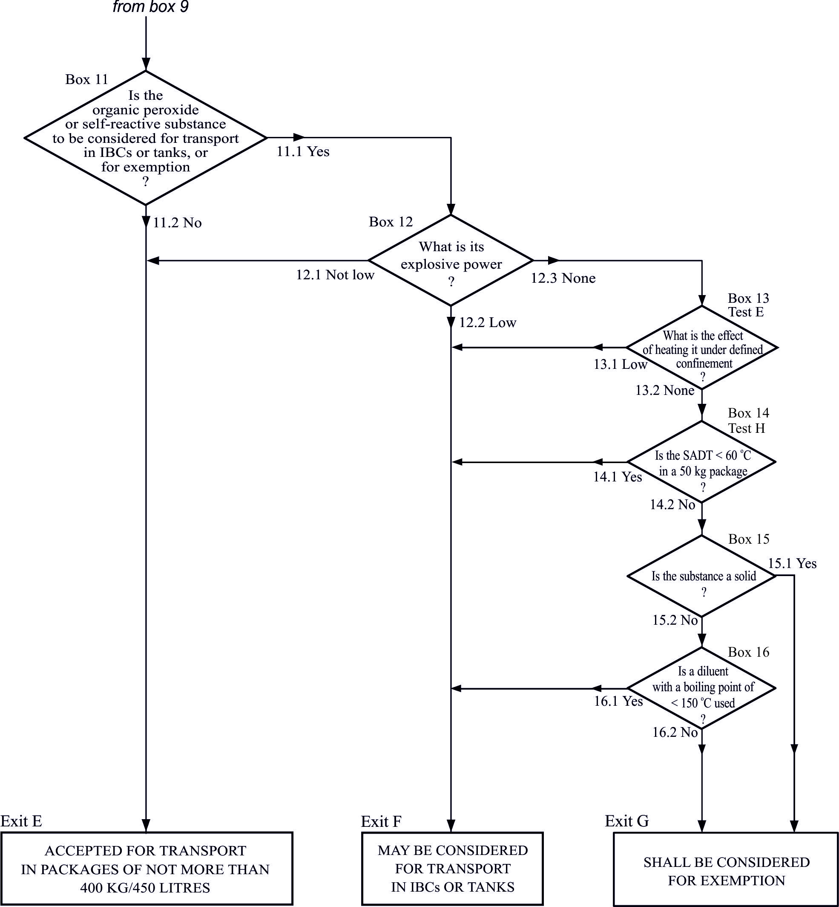
20.3.3.3 In the first sentence, delete “and exothermic decomposition energy”. Add the following new second sentence: “Exothermic decomposition energy may be estimated using a suitable calorimetric technique such as differential scanning calorimetry.”.
Section 28
28.3.5 Amend the formula to read as follows: “L = ln 2 × (C_{p} / t_{1/2})”.
Part III
In the Table of Contents of Part III, in Note 2, at the beginning, insert “Unless otherwise specified,”.
In the Table of Contents of Part III , at the end of Section 34 insert:
“34.4.3 Test O.3 Gravimetric test for oxidizing solids (UN)”.
Section 32
32.3.1.4 to 32.3.1.7 Delete.
Section 34
34.3.1 In the second sentence, replace “test method is given” by “test methods are given”.
Insert the following new sub-section 34.4.3:
“34.4.3 Test O.3: Gravimetric test for oxidizing solids
34.4.3.1 Introduction
This test method is designed to measure the potential for a solid substance to increase the burning rate or burning intensity of a combustible substance when the two are thoroughly mixed. Tests are conducted on the test substance to be evaluated mixed with dry fibrous cellulose in mixing ratios of 1:1 and 4:1, by mass. The burning rates of these mixtures are compared to the reference mixture of calcium peroxide and cellulose in a mixing ratio of 1:2, by mass. The mass loss of the mixtures during combustion is determined using a balance connected to a suitable data recording system, and is recorded as a function of time. If the burning rate (g/s) is equal to or greater than the burning rate of the reference mixture for Packing Group III, it is then compared to the burning rate of the reference mixtures for Packing Group I or II (see table in 34.4.3.4).
The United Nations Globally Harmonized System of classification and labeling of chemicals (GHS), also refers to this test for classification within the hazard class Oxidizing Solids. For the ranking according to oxidizing power, the GHS uses three categories which correspond exactly to the Packing Groups used within the transport of dangerous goods regime. The GHS categories 1, 2 and 3 thus correspond directly to Packing Groups I, II and III, respectively.
It is useful to have preliminary information on any potentially explosive properties of the substance before performing the test, screening procedures can be found in Appendix 6. This test is not applicable for substances which are explosive or flammable and also not for organic peroxides.
34.4.3.2 Materials
34.4.3.2.1 Technically pure, finely powdered calcium peroxide with a concentration of 75 % ± 0.5 % is required as the reference oxidizer. The concentration of impurities such as chlorides or compounds which generate water during combustion should be low, as they may impact on the burning behavior of the reference piles. Calcium peroxide meeting the specification below can be used without further pretreatment.
CaO₂: 75 % ± 0.5 %
Ca(OH)₂: 20 % to 25 %
CaCO₃: 0 % to 5 %
Chloride: max 500 ppm
Particle size: min 99 % < 75 µm, and thereof
min 50 % < 20 µm
34.4.3.2.2 Dried fibrous cellulose with a fibre length between 50 µm and 250 µm and a mean diameter of 25 µm is used as the combustible material. It is dried to constant mass (for a minimum of 4 hours), in a layer no more than 25 mm thick, at 105 °C and kept in a desiccator (with desiccant) until cool and required for use. The water content should be less than 0.5 % by dry mass. If necessary, the drying time should be prolonged to achieve this. The bulk density of the cellulose used for the test should be such (sufficiently high) that the test mixture for Packing Group III (30.0 g ± 0.1 g) can be completely accommodated in the conical funnel.
34.4.3.2.3 The test-substance, in the form in which it will be presented, should be inspected for any particles less than 500 µm in diameter. If that powder constitutes more than 10 % (by mass) of the total, or if the substance is friable, then the whole of the test sample should be ground to a powder of less than 500 µm before testing, to allow for a reduction in particle size during handling and transport. Because the particle size influences the oxidizing properties of a substance, a coarse oxidizer may be classified as Packing Group III, while a finer grade of the same material may show a faster burning rate and may result in different GHS classifications and assigned transport Packing Groups for different forms of the same material.
34.4.3.3 Apparatus
34.4.3.3.1 An appropriate balance is required, with a suitable range, accuracy and data transfer capability, equipped with an interface (e.g. USB or RS232) to allow data acquisition. The required data (time, mass) are recorded, preferably with a frequency of at least 5 data per second. Any suitable software capable of recording the output of the balance may be used. It is recommended to check the time frequency of the software and the monitoring of time by a stopwatch maybe useful.
34.4.3.3.2 An ignition source is required, comprising an inert metal wire connected to an electrical power source capable of maintaining the power dissipation specified below. The electrical resistance depends on the wire material. It is recommended to use Nickel/Chromium or AluChrom wire as follows:
(a) Length = 30 cm ± 1 cm;
(b) Diameter below 1 mm;
(c) Electrical power dissipated in the wire = 150 W ± 7 W.
The wire should be shaped as shown in figure 34.4.3.2. It is very important that the power connection to the heating wire is flexible enough to avoid any influence on the proper operation of the balance.
34.4. 3.3.3 A 60° funnel, with an internal diameter of 70 mm and sealed at the narrow end, is required to form the mixtures into a truncated conical pile with a base diameter of 70 mm on a cool, impervious, low heat conducting plate.
34.4.3.3.4 An insulating test plate is needed to avoid loss of energy by thermal conduction. A 150 mm by 150 mm test plate with a thickness of at least 6 mm and a thermal conductivity at 0 °C of 0.23 W*m⁻¹*K⁻¹ or less is suitable. Other plates with a similar conductivity may be used. In order to increase the lifetime of the test plate, it may be covered with a thin ceramic sheet with the same low thermal conductivity.
34.4. 3.3.5 A fume cupboard or other suitably ventilated area is required but the air stream velocity should be 0.5 m/s or less. The fume extraction system should be capable of capturing all toxic fumes.
34.4. 3.3.6 To construct the support for the burning trial on the balance a base plate of solid material (steel or other suitable material), a positioning plate of fire resistant material (the same material as test-plate is recommended) and guide bars are required.
34.4. 3.3.7 The air stream of the ventilation must be prevented from affecting the balance and thereby altering the test result. A windshield protecting the complete test equipment against draughts from the ventilation or environment is the preferred means.
34.4. 3.3.8 It is mandatory that the burning conical pile is always placed at the centre of the balance. It is also important to protect the balance from heat and burning particles during the test. To achieve this, the following general configuration is recommended (the letters in brackets refer to figure 34.4.3.1):
(a) Two plates are used to ensure always the same position on the balance and to protect the balance. The base plate (H) is larger than the balance and made of solid material. It is recommended to use some buffers fixed to the lower side to reduce vibrations from the environment. 2 to 4 metal guide bars (G) are fixed on the bottom plate as shown in figure 34.4.3.1 to ensure always the same positioning of the positioning plate (F) and test plate (C) on the balance during testing. The base plate should be rigid enough to keep the guide bars always in a stable position (e.g. 4 mm steel or 16 mm polyamide). The balance has to be placed always at the same central position on the base plate;
(b) The positioning plate (F) is made of fire resistant low conductivity material, similar in properties to the test plate (see 34.4.3.3.4). The holes drilled in the positioning plate for the bars should be about 8 mm larger in diameter than the bars themselves;
(c) The bars always have to be positioned in the center of the holes to prevent any contact between the positioning plate (F) and the bars, in order not to affect the operation of the balance. Some check marks should be fixed on the positioning plate (F) to position the test plate (C) in the correct position in the center of the balance;
(d) The electrical connection between the power supply and the heated wire must be flexible enough to avoid interfering with free movement of the balance pan due to resistance or movement. This can be achieved by using a flexible wire and a support close to the test plate. Coiling of the wire between the support and the test plate will provide additional flexibility;
(e) The windshield (D) can be integral with the bottom plate or placed around the complete test equipment. The windshield should have no gaps at the bottom. The windshield itself should be closed and about 10 cm higher than the equipment to prevent air streams from the top.
34.4.3.4 Procedure
The following samples are required:
Sample | Components | Mixing ratio by mass
Test substance mixture 1:1 | Test substance and cellulose | 1:1
Test substance mixture 4:1 | Test substance and cellulose | 4:1
Reference mixture for Packing Group I | Reference substance  and cellulose | 3:1
Reference mixture for Packing Group II | Reference substance  and cellulose | 1:1
Reference mixture for Packing Group III | Reference substance  and cellulose | 1:2
34.4.3.4.1 30.0 g ± 0.1 g of each of the reference mixtures and 30.0 g ± 0.1 g of both mixtures of the test substance are prepared. Each mixture should be mixed mechanically as thoroughly as possible for at least 1 minute, but without excessive stress. Each mixture should be prepared individually, used as soon as possible, and not taken from a batch.
34.4. 3.4.2 Using the conical funnel, the mixture should be formed into a truncated conical pile with a base diameter of 70 mm. Form the pile by tapping the funnel slightly after filling; cover the funnel with the test plate -including the sheet (if any)- and invert both. Tap slightly on the funnel before removing. The pile should now cover the looped ignition wire resting on test plate. The test should be performed at atmospheric pressure with an ambient temperature of 20 °C ± 5 °C and a relative humidity below 60 %, to reduce absorption of moisture by the cellulose during handling.
34.4. 3.4.3 The balance, placed in the ventilated area as mentioned above is set to zero. Power is applied to the ignition wire and is maintained for the duration of the test, or for three minutes if the mixture does not ignite and burn. Data collection should start a few seconds before the power supply is switched on, and should proceed until the reaction ends or the mass loss over 1 minute is less than 1 g. If the heating wire breaks, the test should be repeated to ensure that early breakage of the wire does not influence the test result.
34.4.3.5 Test criteria and method of assessing results
34.4.3.5.1 The results are assessed on the basis of:
(a) The comparison of the mean burning rate with those of the reference mixtures;
(b) Whether the mixture of the test substance and cellulose ignites and burns.
34.4.3.5.2 The combustion of the conical pile can be divided into three periods:
(a) Start period: between 0 % and 20 % of the total mass loss;
(b) Main combustion period: between 20 % and 80 % of the total mass loss; and
(c) End of the reaction: between 80 % mass loss and the end of the reaction.
In the main combustion period the mass loss per unit time is quite constant. For this reason a linear regression (based on the least square approach) can be used to check the quality of the data collected.
34.4.3.5.3 The burning rate (BR) depends on the burning intensity and the amount of cellulose in the mixture. It is therefore defined as the quotient of 60 % of the total amount of cellulose in the conical pile and the main combustion time t20-80. The time t20-80 is the time between 20 % and 80 % of the total mass loss. The total mass loss is the difference in mass before ignition and at the end of the main reaction, defined as a rate of mass loss rate of less than 1 g per minute.
The burning rate BR20-80 is therefore calculated by the following equation:
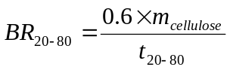
where:
BR₂₀₋₈₀ = burning rate between 20 % to 80% in g/s
m_{cellulose} = mass of cellulose in mixture in gram
t₂₀₋₈₀ = burning time between 20 % to 80 % of total mass loss in seconds
The profile of each burning test has to be examined by plotting the mass loss as a function of time. The graph can also be used for decision making and should be used in case of doubt. The coefficient of correlation (R²) of the mass curve of each burning test should be at least 0.95 between 20 % to 80% mass loss, otherwise the burning trial has to be repeated. Five valid tests should be performed with each reference and test substance mixture. The standard deviation of the burning rates within these five tests should not exceed 10 % in total.
34.4.3.5.4 The test criteria for determining transport Packing Groups on basis of the oxidizing properties of the substance are:
Packing Group I: Any substance which, in the 4:1 or 1:1 sample-to-cellulose ratio (by mass) tested, exhibits a mean burning rate greater than the mean burning rate of a 3:1 mixture, by mass, of calcium peroxide and cellulose.
Packing Group II: Any substance which, in the 4:1 or 1:1 sample-to-cellulose ratio (by mass) tested, exhibits a mean burning rate equal to or greater than the mean burning rate of a 1:1 mixture (by mass) of calcium peroxide and cellulose and the criteria for Packing Group I are not met.
Packing Group III: Any substance which, in the 4:1 or 1:1 sample-to-cellulose ratio (by mass) tested, exhibits a mean burning rate equal to or greater than the mean burning rate of a 1:2 mixture (by mass) of calcium peroxide and cellulose and the criteria for Packing Groups I and II are not met.
Not Division 5.1: Any substance which, in both the 4:1 and 1:1 sample-to-cellulose ratio (by mass) tested, does not ignite and burn, or exhibits mean burning rates less than that of a 1:2 mixture (by mass) of calcium peroxide and cellulose.
For substances having other risks, e.g. toxicity or corrosivity, section 2.0.3 of the Model Regulations applies.
In GHS terminology, the test criteria for determining the classification due to the oxidizing properties of a solid substance are analogous to those used in transport:
Category 1: Any substance which, in the 4:1 or 1:1 sample-to-cellulose ratio (by mass) tested, exhibits a mean burning rate greater than the mean burning rate of a 3:1 mixture (by mass) of calcium peroxide and cellulose.
Category 2: Any substance which, in the 4:1 or 1:1 sample-to-cellulose ratio (by mass) tested, exhibits a mean burning rate equal to or greater than the mean burning rate of a 1:1 mixture (by mass) of calcium peroxide and cellulose and the criteria for Category 1 are not met.
Category 3: Any substance which, in the 4:1 or 1:1 sample-to-cellulose ratio (by mass) tested, exhibits a mean burning rate equal to or greater than the mean burning rate of a 1:2 mixture (by mass) of calcium peroxide and cellulose and the criteria for Category 1 and 2 are not met.
Not an Oxidizing Solid: Any substance which, in both the 4:1 and 1:1 sample-to-cellulose ratio (by mass) tested, does not ignite and burn, or exhibits mean burning rates less than that of a 1:2 mixture (by mass) of calcium peroxide and cellulose.
34.4.3.5.5 If a false positive result is suspected, the results obtained when testing the substance mixed with an inert material and/or when testing under an inert atmosphere should also be considered when interpreting the results.
34.4.3.5.6 If the shape of the mass loss curve indicates the test is invalid, the mixing procedure or test set-up affecting free movement of the balance pan should be examined.
34.4.3.6 Example of results
NOTE: The results given in this table should be understood as illustrative examples since the results obtained with a particular oxidizer will depend on the particle size etc. The test results of the examples are not intended to form the basis for classifications (see also 2.14.4.2.1 of Chapter 2.14 in Part 2 of the GHS and 2.5.2.1.1 of Chapter 2.5 in the Model Regulations, respectively).
Substance | Particle size, median value (D50 [µm]) | Resulting Packing Group
Ammonium dichromate | 300 | III¹
Calcium nitrate (tetra hydrate) | 1050 | III¹
Cobalt nitrate (hexahydrate) | 1200 | Not 5.1¹
Nickel nitrate | 1200 | Not 5.1¹
Potassium nitrite | 200 | I^{2,a}
Potassium perchlorate | 220 | II¹
Potassium perchlorate | 30 | II²
Potassium permanganate | 200 | I^{1,2,a}
Sodium chlorate | 220 | I^{2,a}
Sodium nitrite | 320 | II^{1,b}
Sodium nitrate | 200 | II^{1,b}
Strontium nitrate (anhydrous) | 250 | Not 5.1¹
ª Currently PG II
^{b} Currently PG III
¹Solvay
²BAM

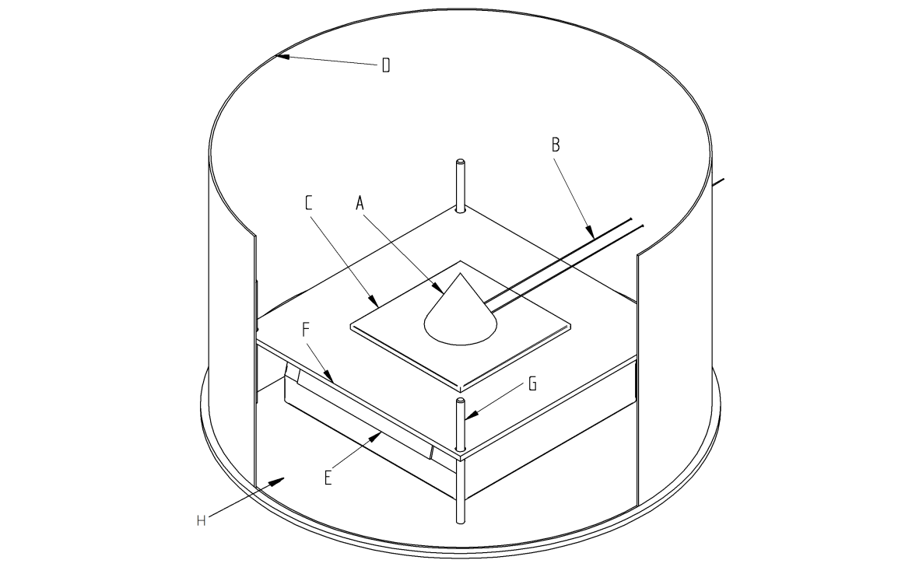

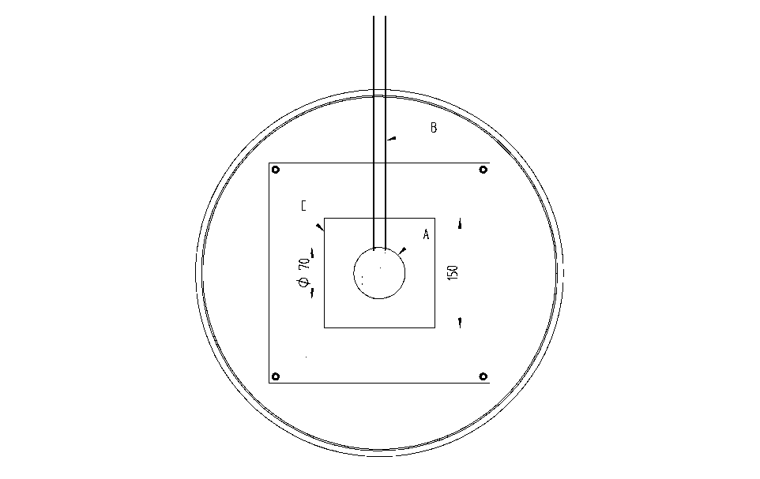
_____________________________________________________________________
(A) Conical pile
(B) Heating wire
(C) Test plate
(D) Wind shield
(E) Balance with interface
(F) Positioning plate
(G) Bars to fix positioning plate (F) and test plates (C) at defined location on balance
(H) Base plate
_____________________________________________________________________
Figure 34.4.3.1: Scheme of UN O.3 Test configuration
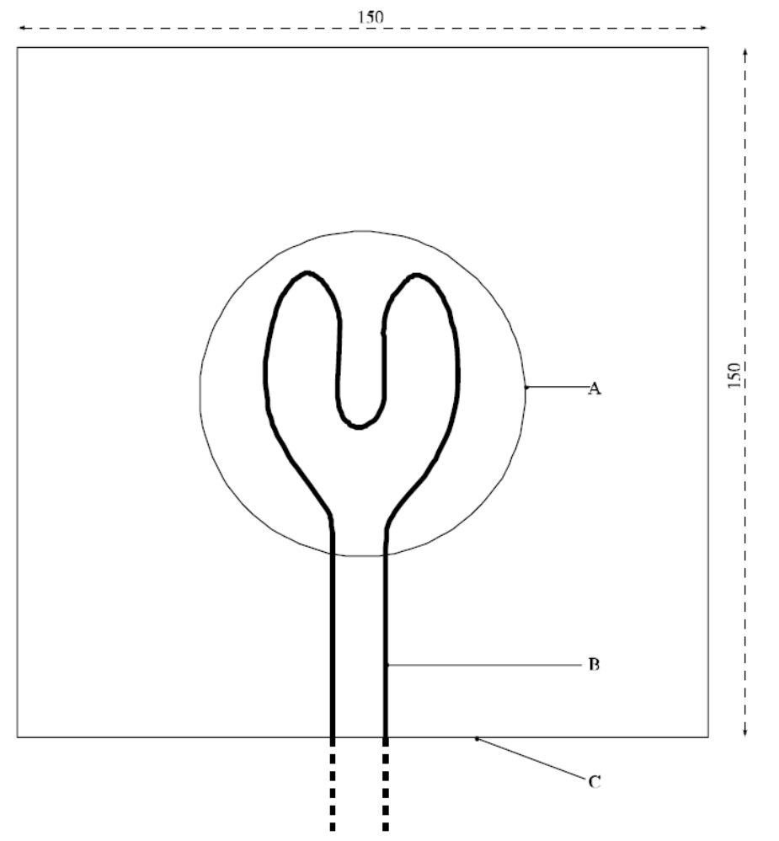

(A) Conical pile (base)
(B) Heating wire
(C) Test plate

Figure 34.4.3.2: TEST PLATE AND IGNITION WIRE”.
Section 38
38.3.4.6.2 In the heading, replace “greater than 20 mm in diameter” with “not less than 18.0 mm in diameter”.
38.3.4.6.3 In the heading, replace “not more than 20 mm in diameter” with “less than 18.0 mm in diameter”.
After the heading in 38.3.4.6.2 and 38.3.4.6.3 add a new Note to read as follows:
“NOTE: Diameter here refers to the design parameter (for example the diameter of 18650 cells is 18.0 mm).”.

Obtainable from the national contact for test details in Germany (see Appendix 4).
Technical information about a suitable design and video training are obtainable from the national contact for test details in Germany (Appendix 4)

