 | United Nations | ECE/TRANS/WP.29/1074/Rev.4/Amend.1
 | Economic and Social Council |  | Distr.: General  14 June 2013  English only
Economic Commission for Europe
Inland Transport Committee
World Forum for Harmonization of Vehicle Regulations
One-hundred-and-sixtieth session
Geneva, 25-28 June 2013
Item 7.1 of the provisional agenda
1997 Agreement (Periodical Technical Inspections) -
Status of the Agreement
Status of the 1997 Agreement and of the Rules annexed to it
Revision 4 – Amendment 1
Note by the Secretariat*
This document contains information as available to the secretariat, concerning the situation at 14 June 2013. Relevant additional information will be circulated for the other two sessions of the World Forum in 2013 in order to bring this document up to date.
Paragraph 6, insert a new sub paragraph D, to read:
"6. Technical Inspection Certificates which are in use in the Contracting Parties as an alternative to the model of Appendix 2 of the Agreement (para. 4 Appendix 2)
In accordance with Appendix 2, paragraph 4 of the 1997 Agreement, the following Contracting Parties have transmitted an example of the periodical technical report used in this country, which should be considered as an alternative to the International Technical Inspection Certificate. The examples are reproduced below.
….
D. Notification by the Republic of Ukraine
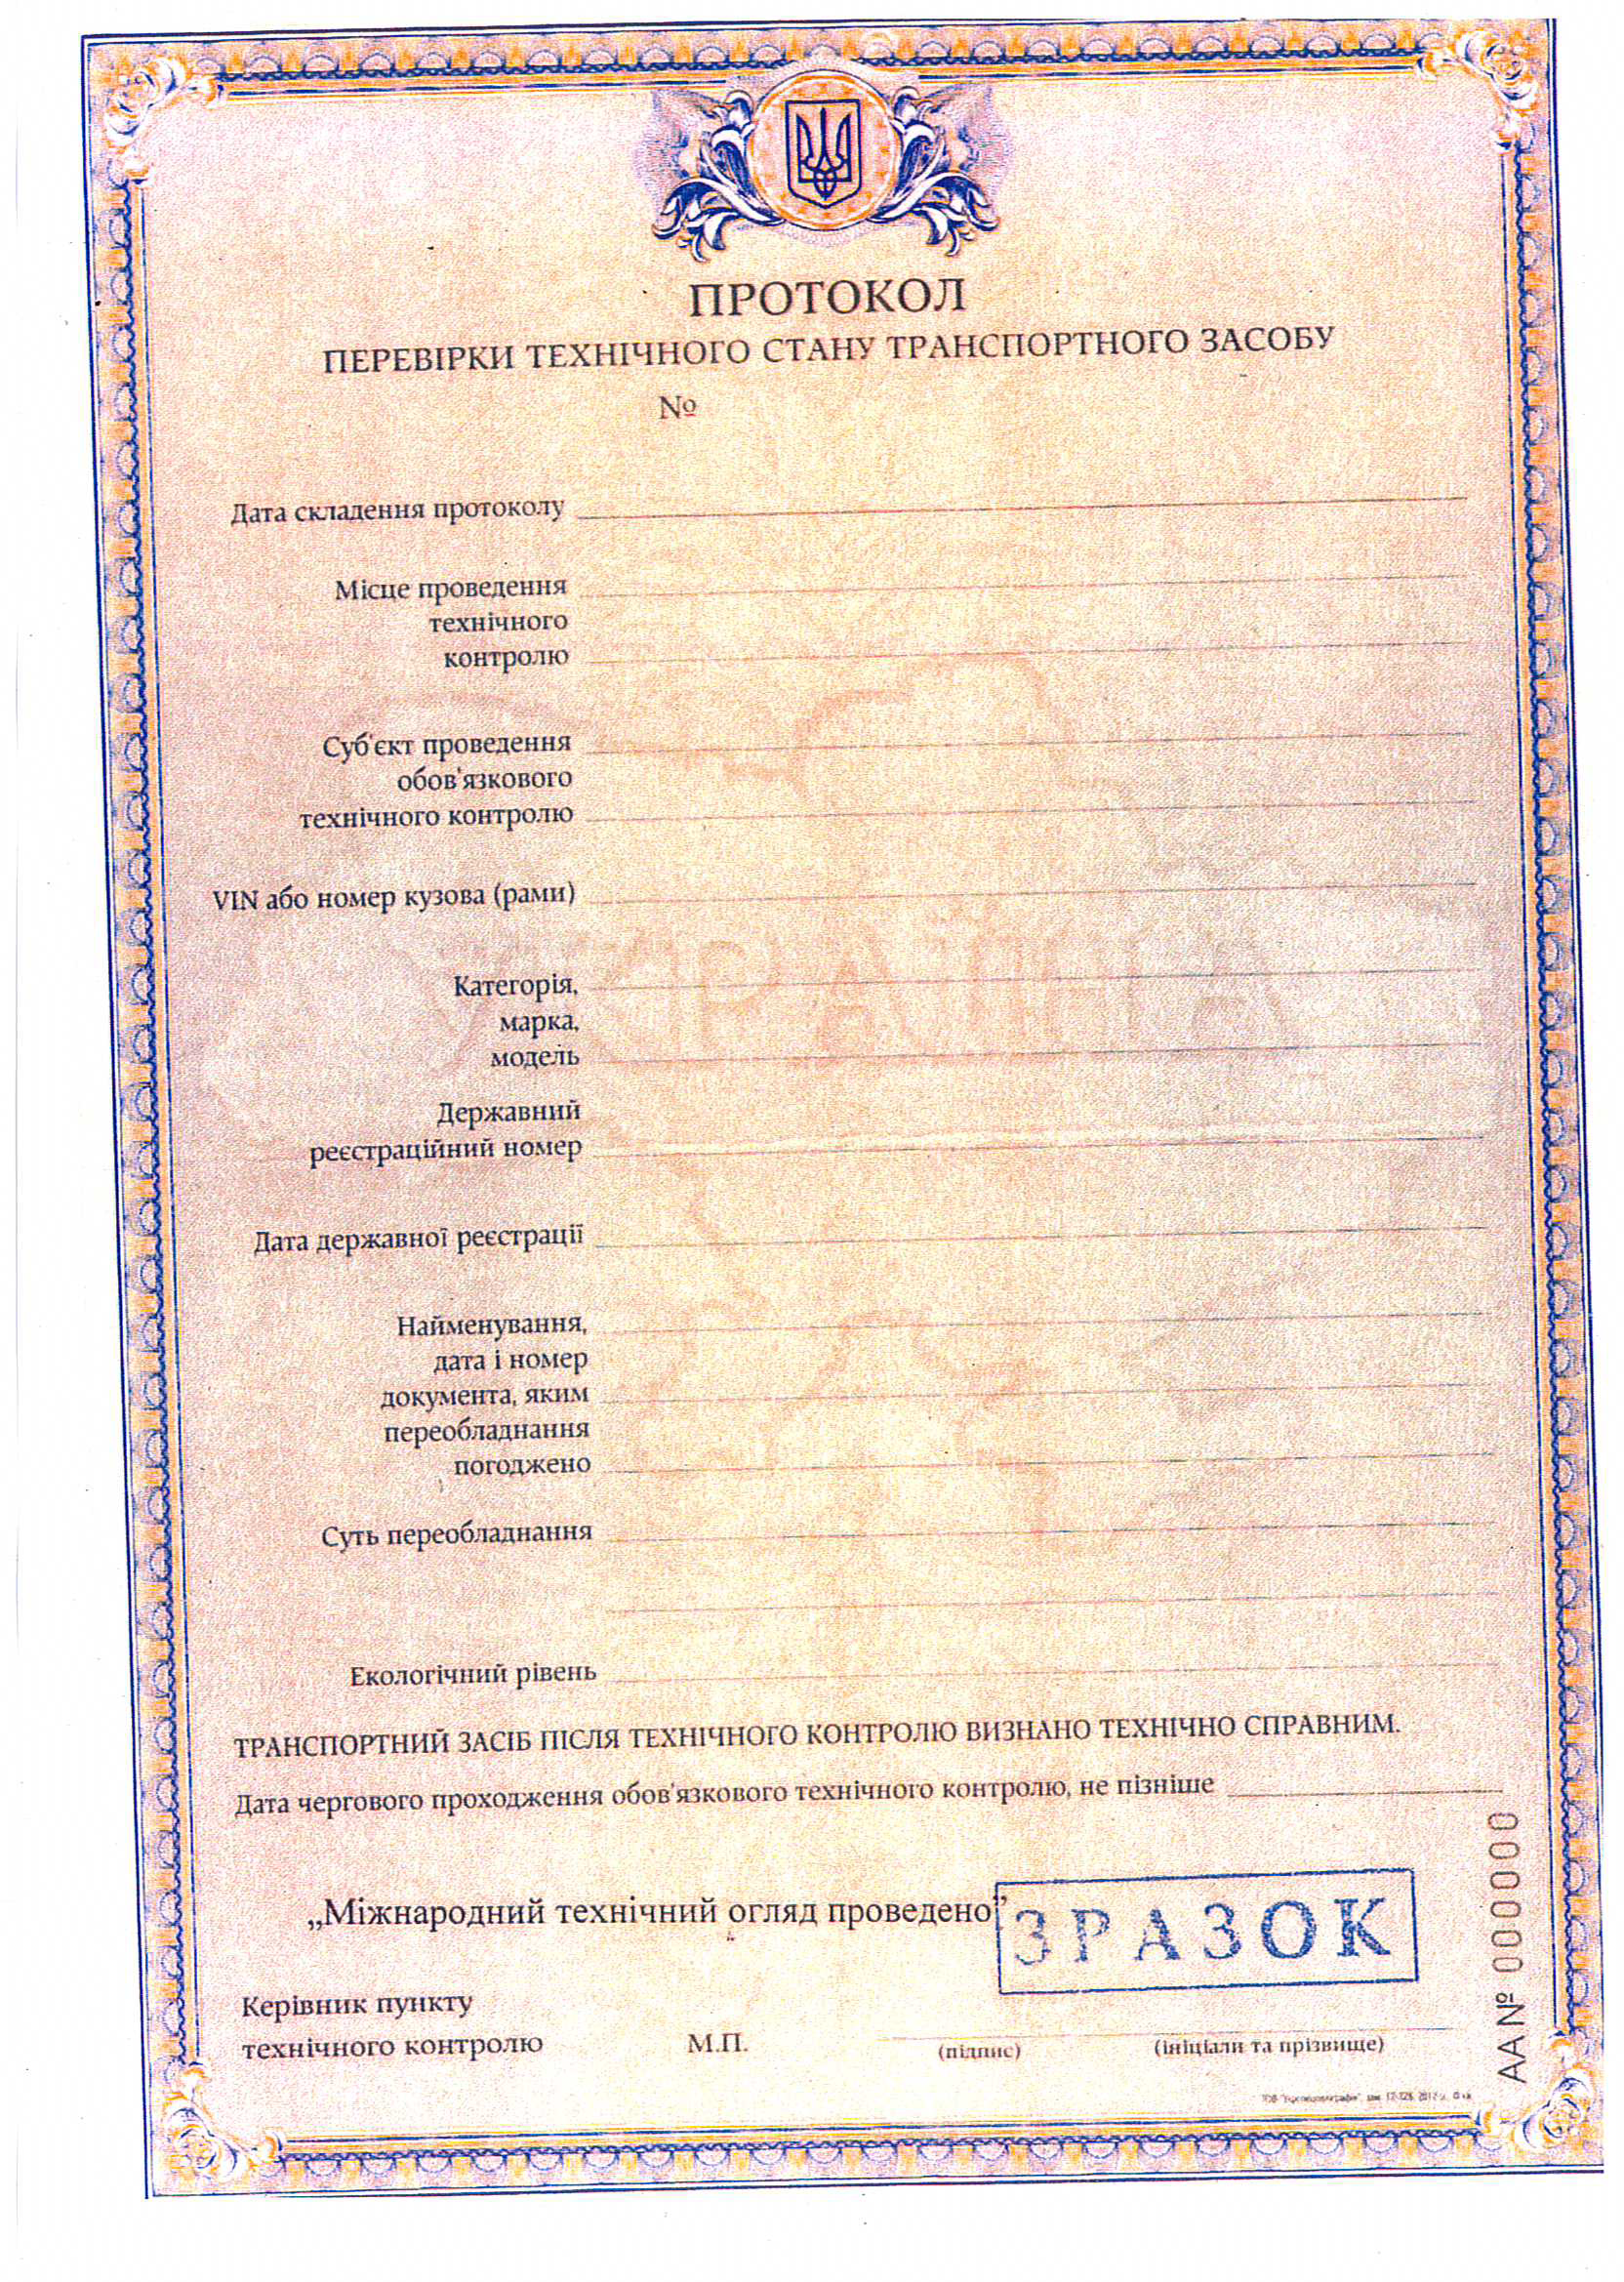
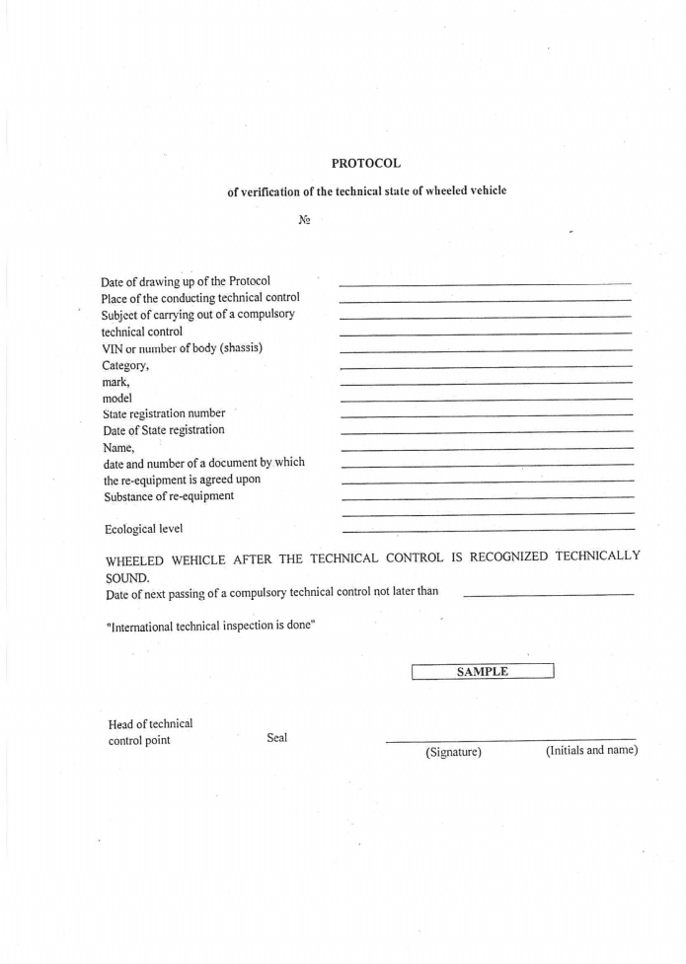"

* * In accordance with the programme of work of the Inland Transport Committee for 2010–2014 (ECE/TRANS/208, para. 106, ECE/TRANS/2010/8, programme activity 02.4), the World Forum will develop, harmonize and update Regulations in order to enhance the performance of vehicles. The present document is submitted in conformity with that mandate.

