INF.23
Economic Commission for Europe
Inland Transport Committee
Working Party on the Transport of Dangerous Goods
Joint Meeting of the RID Committee of Experts and the
Working Party on the Transport of Dangerous Goods 28 February 2014
Bern, 17–21 March 2014
Item 5 (b) of the provisional agenda
Proposals for amendments to RID/ADR/ADN:
new issues
Raising the 100 Wh limit for the packaging and labelling requirements of small excepted Lithium-Ion batteries under SP 188/ADR
Transmitted by RECHARGE, the European Association for Advanced Rechargeable Batteries
RECHARGE is submitting this proposal to the Joint Meeting in order to gather their opinion before tabling a formal proposal.
Introduction
1. The current European regulation for the transport of Dangerous Goods by Road and Rail provides under SP188 an exception from full regulation on packaging and labeling for Lithium-ion batteries (UN3480 & UN3481) with a rating up to 100 Wh. The 100 Wh energy content limit was set some years ago when most consumer-type Lithium-Ion batteries contained much less energy.
2. In the hand held cordless power tool, garden and forestry product market, most Lithium-Ion battery packs offered for transport under UN3480 & UN3481 still have an energy content lower than 100 Wh but rapid cell and battery pack development are leading to a significant percentage of high power professional batteries exceeding 100 Wh. Lithium-Ion battery technology is developing fast both in energy to weight and reduced cost as illustrated in Annex 1.
3. Lithium-Ion batteries with an energy content of 100 to 300 Wh per battery are used typically for cordless power tools and garden / forestry equipment. In comparison, Lithium-Ion batteries used for Laptops (50 – 80 Wh), Tablets (30 – 50 Wh) and Mobile Phones ( 10 – 14 Wh) have a lower energy content while Lithium-Ion batteries used for E-bikes have an energy content well above 400 Wh per unit.
4. The US Department of Transportation anticipated this technical evolution by authorizing the transport by road of Lithium-Ion batteries (UN3480 & UN3481) under a lighter regime for packaging and labelling similar to what is currently required under Special Provision 188 of the ADR. The U.S. Hazardous Materials Regulations in its 49 CFR § 172.102, Special Provision 189, authorizes the transport of Lithium-Ion batteries and cells (UN3480 & UN3481) under which the packaging and labelling of Lithium-Ion batteries up to 25 grams equivalent lithium content (approximately 320 Wh) and cells up to 5 grams equivalent lithium content (approximately 60 Wh) are exempted from the regulation for shipments by road and rail. A copy of the Special Provision189 is provided in Annex 2 below. Transport Canada has a very similar provision for LithiumIon batteries and cells in its Transport of Dangerous Goods Regulations (TDGR) which is found in Special Provision 34 -
See http://wwwapps.tc.gc.ca/Saf-Sec-Sur/3/sched-ann/schedule2.aspx.
5. When considering the safety aspects linked to the transport of such Lithium-Ion cells and batteries with an increase energy content, the following elements need to be considered:
5.1 Cells used in battery pack manufacture are tested in accordance with the requirements of Chapter 38.3 of the UN Manual of Test and Criteria.
5.2 Battery pack manufacturers will retest the battery packs using the certification protocol of the cell manufacturer and conduct the battery pack test of IEC 62133, which is necessary for the qualification of the whole system including tool and charger. In addition the tests T1-T8 of Chapter 38.3. of the Manual of Tests and Criteria will be conducted and a written confirmation on the successful passing of these tests are provided on demand from Competent Authorities.
6. Currently up to 30 kg of cells with an energy content lower than 20 Wh can be shipped without being fully regulated. By comparison, an equivalent packaging containing power tools batteries rated at 216 Wh per unit must be transported fully regulated even if the cells used in the cordless power tool battery contained in the packaging have an energy content lower or close to 20 Wh per unit.
Considering the energy embarked in a packaging containing individual cells or batteries used in cordless tools, it appears that the energy density of packaging containing cordless power tools batteries is lower than the energy density of packages containing individual cells. Please refer to Annex 3 for illustration.
7. This statement is illustrated in Table 1.
7.1 For a given reference of e.g. 30 kg net weight of standard Lithium-ion cells, the energy content of a package filled with 600 individual cells of 50 g/unit and 7.2 Wh per cell reaches 4.3 kWh – Case 1.
7.2 Within an equivalent package, one could ship 25 Lithium-Ion batteries of 1200 g and an energy content of 108 Wh per unit (Case 2). In this case, the total energy embarked in the packaging would reach 2.7 kWh which represents an amount of energy equivalent to 63 % of the energy content of a packaging filled with individual cells as described in § 7.1. above.
7.3 In a comparative example, one could transport 16 Lithium-Ion batteries of 1800 g and an energy content of e.g. 216 Wh per unit (Case 3). In this case, the total energy embarked in the packaging would reach 3.5 kWh which represents an amount of energy equivalent to 80 % of the energy content of a packaging filled with individual cells as described in § 7.1. above.
Table 1
Packaging of Lithium-ion cells and batteries: comparison of technical parameters of individual cells and batteries used in cordless power tools
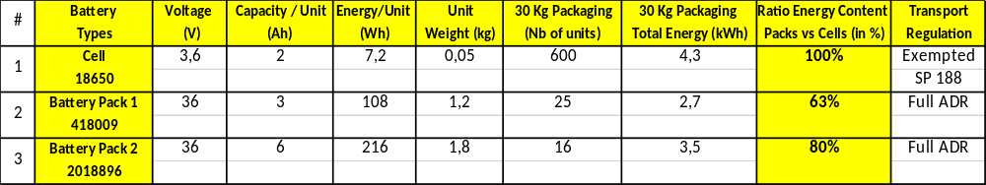
8. As a conclusion, our proposal is aimed at excepting lithium ion batteries up to 300 Wh for road and rail transport as currently provided for under SP188 of the ADR for Lithium-Ion batteries rated up to 100 Wh.
Proposal
9. On the basis of the above discussion, RECHARGE proposes the following amendment to Special Provision 188 under ADR/RID modal regulation for the Transport of Dangerous Goods.
“188 Cells and batteries offered for transport are not subject to other provisions of ADR if they meet the following:
(b) For a lithium metal or lithium alloy battery the aggregate lithium content is not more than 2 g, and for a lithium ion battery, the Watt-hour rating is not more than 100 300 Wh. Lithium ion batteries subject to this provision shall be marked with the Watt-hour rating on the outside case, except those manufactured before 1 January 2009;

Annex 1
The continuous technology development in Li-ion batteries has considerably improved the performances of this rechargeable battery technology over the last 10 years. In particular, a more efficient design and use of the active materials has allowed for a significant increase of the energy content for a given weight (energy density in Wh/kg) as shown in Figure 1. Similar improvements have been made with respect to volume (energy density in Wh/liter). As a result, batteries with the same weight and volume have an increased energy content.

FIGURE 1
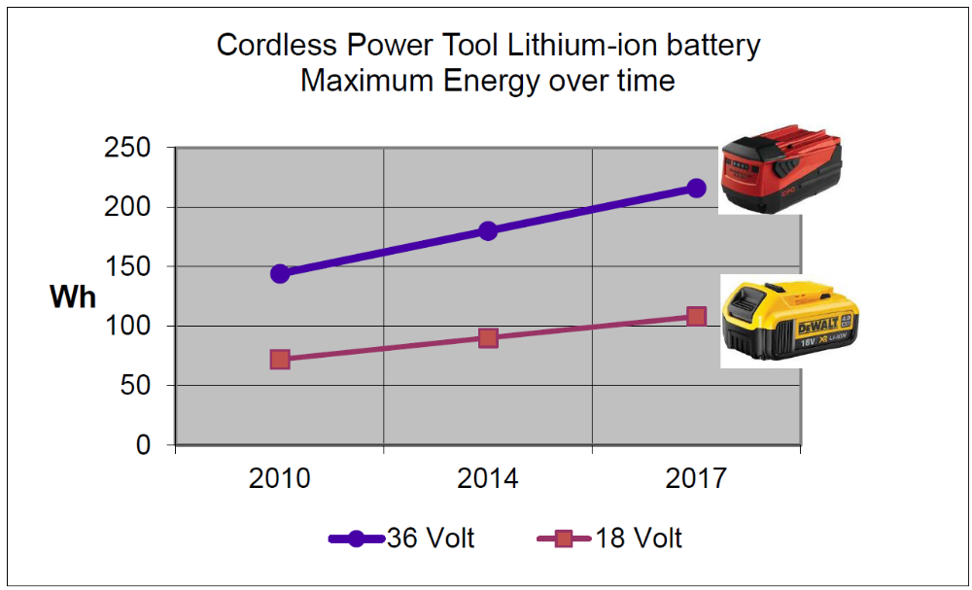
Annex 2
U.S. Hazardous Materials Regulations (January 2012) - 49 CFR § 173.185 Lithium batteries and cells.
189 Medium lithium cells and batteries. Effective October 1, 2008, when transported by motor vehicle or rail car, lithium cells or batteries, including cells or batteries packed with or contained in equipment, are not subject to any other requirements of this subchapter if they meet all of the following:
a. The lithium content anode of each cell, when fully charged, is not more than 5 grams.
b. The aggregate lithium content of the anode of each battery, when fully charged, is not more than 25 grams. (NB. This is equivalent to 320 Wh energy content).
c. The cells or batteries are of a type proven to meet the requirements of each test in the UN Manual of Tests and Criteria (IBR; see Sec. 171.7 of this subchapter). A cell or battery and equipment containing a cell or battery that was first transported prior to January 1, 2006 and is of a type proven to meet the criteria of Class 9 by testing in accordance with the tests in the UN Manual of Tests and Criteria, Third Revised Edition, 1999, need not be retested.
d. Cells or batteries are separated so as to prevent short circuits and are packed in a strong outer packaging or are contained in equipment.
e. The outside of each package must be marked ``LITHIUM BATTERIES--FORBIDDEN FOR TRANSPORT ABOARD AIRCRAFT AND VESSEL'' on a background of contrasting color, in letters:
(1) At least 12 mm (0.5 inch) in height on packages having a gross weight of more than 30 kg (66 pounds); or
(2) At least 6 mm (0.25 inch) on packages having a gross weight of 30 kg (66 pounds) or less, except that smaller font may be used as necessary to fit package dimensions.
f. Except when contained in equipment, each package containing more than 24 lithium cells or 12 lithium batteries must be:
(1) Marked to indicate that it contains lithium batteries, and that special procedures should be followed in the event that the package is damaged;
(2) Accompanied by a document indicating that the package contains lithium batteries and that special procedures should be followed in the event that the package is damaged;
(3) Capable of withstanding a 1.2 meter drop test in any orientation without damage to cells or batteries contained in the package, without shifting of the contents that would allow short circuiting and without release of package contents; and
(4) Gross weight of the package may not exceed 30 kg (66 pounds). This requirement does not apply to lithium cells or batteries packed with equipment.
Annex 3
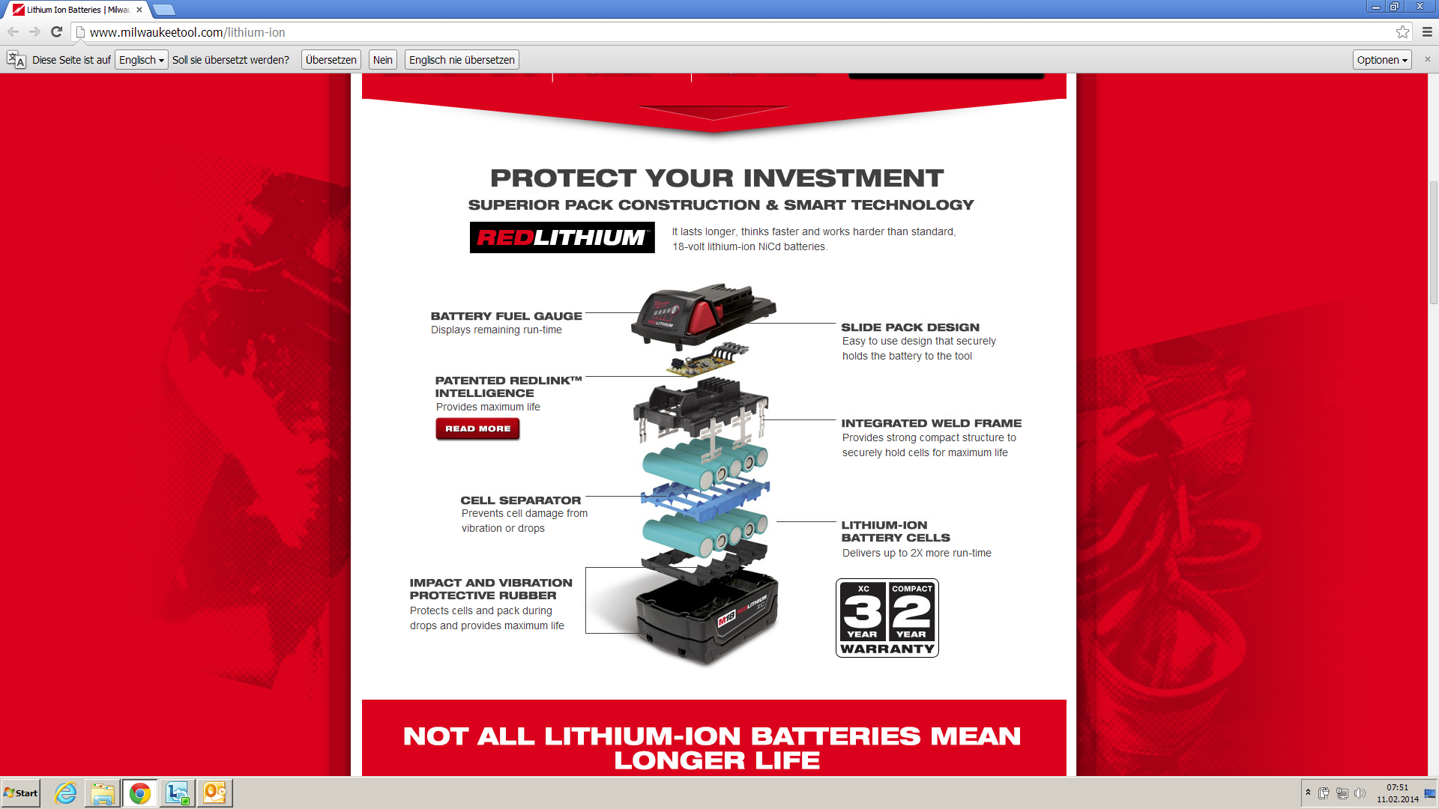

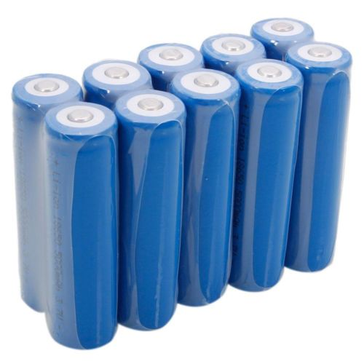

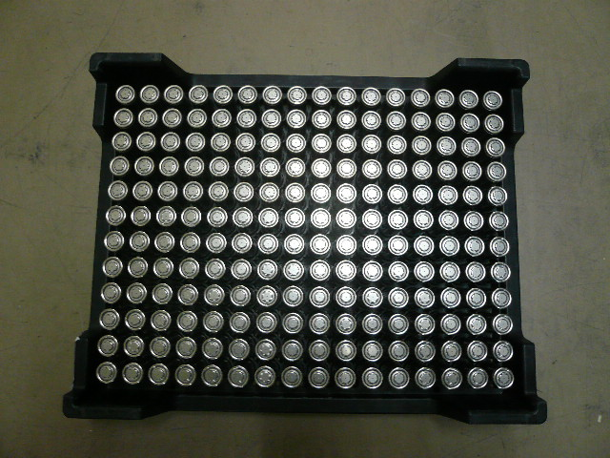

Illustration of a package with 192 individual 18650 Lithium-Ion cells (left) and of a Cordless Power Tool Battery (right) made of 18650 cells.
In a battery for cordless power tools, the cells are individually protected against short-circuit, they are assembled in order to prevent the movement in the power tool. A safety system is in place to protect them against inadvertent activation during transport.
The energy density of a power pack is smaller than the energy density of individual cells packed all together.
Annex 4
EPTA: The European Power Tools Association (EPTA) represents European power tool manufacturers using rechargeable batteries in their cordless products. Cordless power tools are the fastest growing segment of the power tool market with a 40% share of the power tool market. The companies represented by EPTA account for about 16,000 employees in Europe. EPTA represents around 86% of corded and cordless power tool sales in Europe (by value). The industry’s annual turnover in the EU is around €3.8bn. Power tools are used both by skilled tradesmen, in a professional capacity, mainly in the construction industry, as well as home users undertaking improvement projects.

? Prepared in cooperation with EPTA, the European Power Tools Association (see Annex 4 for references).

