UN/SCEGHS/29/INF.11
Committee of Experts on the Transport of Dangerous Goods
and on the Globally Harmonized System of Classification
and Labelling of Chemicals
Sub-Committee of Experts on the Globally Harmonized
System of Classification and Labelling of Chemicals 22 June 2015
Twenty–ninth session
Geneva, 29 June – 1 July 2015
Item 3 (a) of the provisional agenda
Hazard communication issues: labelling of small packagings
Labelling of small packagings
Transmitted by the European Chemical Industry Council (CEFIC) on behalf of the informal correspondence group
Introduction
1. After the first example illustrating some of the general principles applicable to the labelling of small packagings, adopted by the Sub-Committee during its 28th session for inclusion in Annex 7 of the GHS, the informal correspondence group proposed a second example for the 29th session (document ST/SG/AC.10/C.4/2015/7).
2. A third example addressing principally the requirements for sets or kits is currently being developed.
Development of an example for sets or kits
3. A third example is proposed, with a preliminary layout, to be examined by the informal correspondence group during the 29th session to acquaint the group with the issues surrounding sets or kits.
4. A set or kit is a combination package, which includes two or more individual packages or single compartments with different components.
5. Sets or kits are subject to the provisions of the GHS, if an individual package contains at least one hazardous substance, a hazardous mixture or a hazardous article.
6. A complete labelling of the single package can be omitted, if it can be assured that the single packages can´t be removed from the combined package
7. Single containers and single packages have to be named in such a way that an identification of the content is given clearly. The identification shall be reiterated on the outer package label, or a package leaflet which includes, at least, the labelling of the related component.
Example 1:
Standard analytical kit
Product and use:
Activator for professional use

Packaging description and size

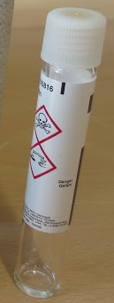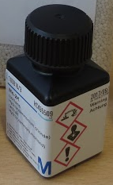

Glass container with 2.5 ml capacity Plastic container with 7ml capacity

Example 2:
Test reagent kit
Outer kit package holding approximately 130 inner packagings, each containing a different substance or mixture

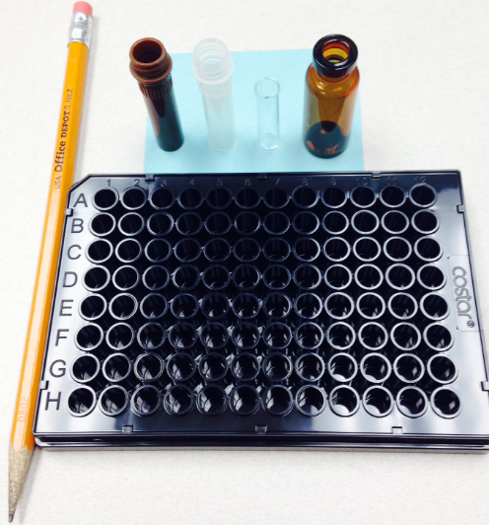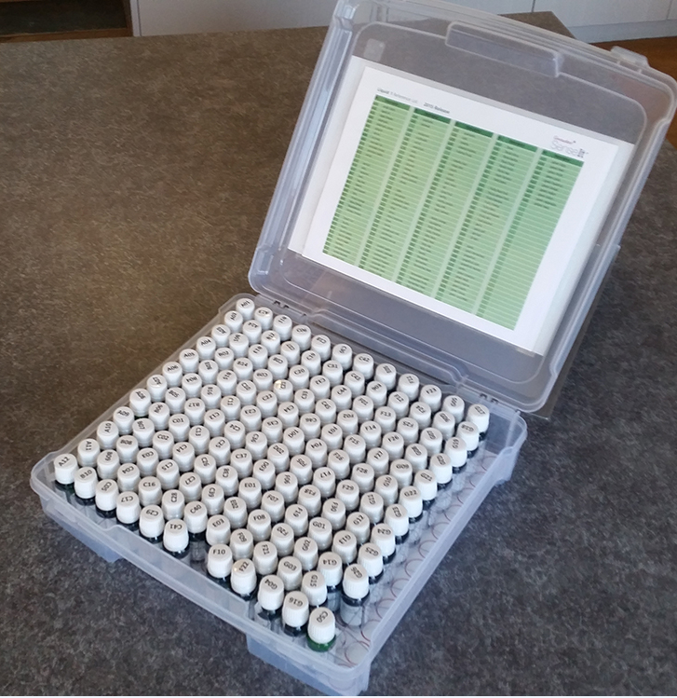

Labelling problems encountered
8. The products/kits contain lot of different single substances or mixtures which are required to carry a large number of different GHS label elements (multiple pictograms, hazard statements and numerous precautionary statements).
9. In both examples the inner packagings are too small to display full labelling information. In each case the outer package needs to display and clearly identify the labelling information for all of the individual inner packagings contained within it.

Proposed/suggested solution
Option 1 for kits with up to 5 inners
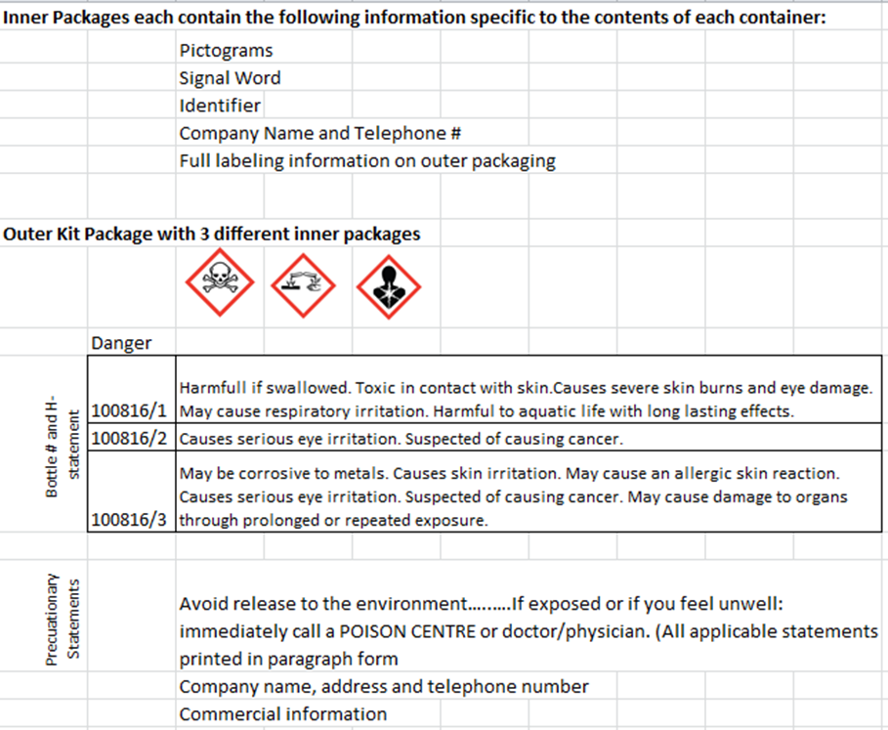
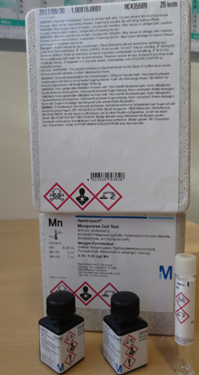

Option 2 for kits with more than 5 inners
