Economic Commission for Europe

Inland Transport Committee

Working Party on the Transport of Dangerous Goods
Joint Meeting of the RID Committee of Experts and the
Working Party on the Transport of Dangerous Goods
Geneva, 15–25 September 2015
Item 3 (b) of the provisional agenda
Proposals for amendments to RID/ADR/ADN:
new proposals

Exemption under 1.1.3.3

Transmitted by the Government of Switzerland,

Summary
Executive summary: The English version of 1.1.3.3 of RID/ADR establishes an exemption for liquid fuels (“combustibles” in French), whereas the French and German versions refer to liquid motor fuels (“carburants” in French).
Action to be taken: In the French and (for RID) German versions of 1.1.3.3, replace the term “carburant” (motor fuel) with “combustible” (fuel).
Related documents: ECE/TRANS/WP.15/AC.1/2014/38; ECE/TRANS/WP.15/AC.1/136, paras. 41 and 42; ST/SG/AC.10/42/Add.1

I. Introduction

1. The principle set out in ECE/TRANS/WP.15/AC.1/2014/38, submitted in September 2014, was supported by the Joint Meeting, which agreed with the Government of Switzerland that the exemptions under 1.1.3.3 should not be restricted, in the French, to “carburants” (motor fuels) (which by definition power internal combustion engines) and should cover other liquid fuels used to operate equipment other than internal combustion engines. The proposal to replace the term “carburant” with “combustible” in the French version of subsection 1.1.3.3 of RID/ADR was nonetheless not adopted, pending the decisions to be made by the United Nations Sub-Committee of Experts in December 2014 (ECE/TRANS/WP.15/AC.1/136, paras. 41 and 42).
2. The amendments adopted by the United Nations Sub-Committee of Experts (ST/SG/AC.10/42/Add.1) and also proposed by the Ad Hoc Working Group on the Harmonization of RID/ADR/ADN with the UN Recommendations on the Transport of Dangerous Goods in May 2015 (ECE/TRANS/WP.15/AC.1/2015/23/Add.1) have no impact on the exemption under 1.1.3.3. The entry for UN No. 3166 will still be eligible for the existing exemption in RID/ADR/ADN. Consequently, we wish to resubmit our proposal.
3. As a reminder, 1.1.3.3 (a) applies to the fuel (“carburant” in French) contained in the tanks of a vehicle performing a transport operation and destined for its propulsion or for the operation of any of its equipment used or intended for use during carriage.
4. However, the term “carburant” used in the French version of subsection 1.1.3.3 is restrictive, since it refers to internal combustion engines. For some equipment — heaters, for instance — the proper term in French is “combustible”, which is, incidentally, the term used in French in the current version of special provision 363 (“Cette rubrique s’applique également aux combustibles liquides autres que ceux exemptés en vertu du 1.1.3.3”).
5. To illustrate this issue, we present in the annex an example of a heating system intended to prevent snow and ice from accumulating on the roof of a vehicle.

II. Proposal

6. (This proposal does not apply to the English version.) In the French version of 1.1.3.3, replace “carburants” with “combustibles” in the title and “carburant” with “combustible” each time it appears in the text (five times in RID, nine times in ADR).

Annex
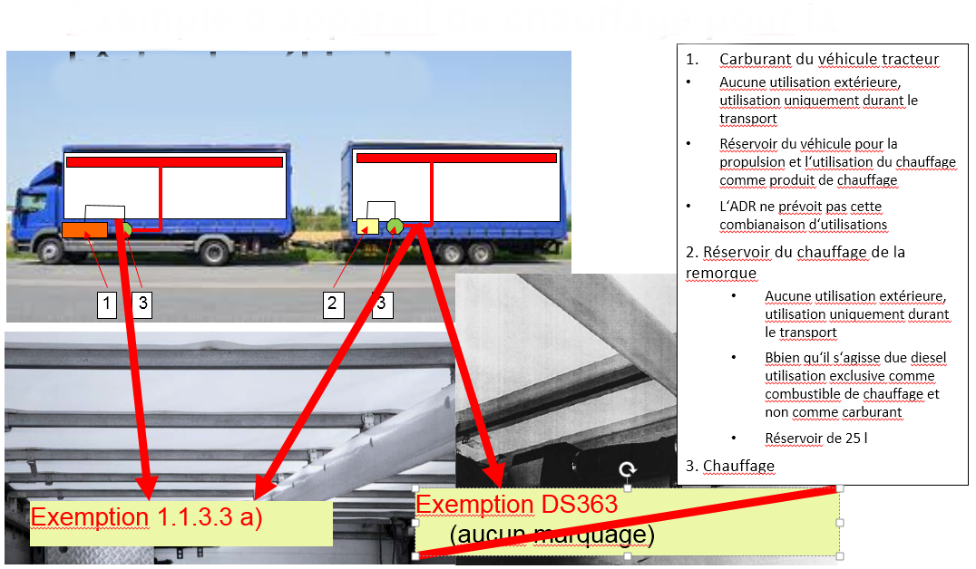
Example of a heating system for the
vehicle sheets
1. Fuel for towing vehicle
• No external use, use only during carriage
• Vehicle tank for propulsion and use of resultant heat for heating
• ADR does not provide for this combination of uses
2. Trailer heating tank
• No external use, use only during carriage
• Diesel, but used only as heating fuel, not as motor fuel
• 25-litre tank
3. Heater
Exemption under 1.1.3.3 (a)
Exemption under special provision
363 (no marking)

In accordance with the programme of work of the Inland Transport Committee for 2014–2015 (ECE/TRANS/240, para. 100; ECE/TRANS/2014/23, cluster 9, para. 9.2).
Circulated by the Intergovernmental Organisation for International Carriage by Rail (OTIF) under the symbol OTIF/RID/RC/2015/40.

