 | MEMORANDUM
To | Ministry of Infrastructure and the Environment, The Netherlands
Attn. | Johan Sliggers
From | Erik de Graaff and Christiaan Tollenaar
E-mail | erikdegraaff@mp.nl
Telephone | 073-6589050
Memo number | MIenM.14.02.1/eg
Date | August 24, 2015
Pages | 11
Subject | Statistics of tyre noise label values in Original Equipment Manufacturer (OEM) tyres.

Introduction
At the GRB meeting in September 2014 the Netherlands introduced two papers on tyre noise (GRB informal doc 60-8 and 60-12). Furthermore, the Netherlands introduced various papers on the potential benefits from high performance tyres with A-labels on each parameter of the EU tyre label (GRB informal doc 60-03, 60-13 and 60-14). Conclusions of these papers were:
- There is a significant shift in sound emission values between 2007 and 2013, which is suggested to be caused by the new noise limits and tyre label, both introduced in 2012;
- There is a significant financial benefit (both for society as well as for the vehicle owner) when a further improvement could be realized in tyre performance according to the criteria in the tyre label.
At the GRB meeting in January 2015 the Netherlands introduced amongst others a justification and working proposal for future tyre noise limits (GRB informal doc 61-03).
During the discussion of this paper the following remarks and suggestion where noted:
- Various contracting parties welcomed the discussion and would appreciate further information;
- It was suggested to investigate the difference between Original Equipment Manufacturer (OEM) tyres and replacement tyres, as OEM tyres could have better performance. Probably for the same reason the transitional provisions in EC/661/2009 take into account the earlier introduction of noise limits of OEM tyres mounted on new vehicle types.
Therefore, the Dutch Ministry of Infrastructure and the Environment has asked M+P to investigate the statistics of tyre noise label values in OEM tyres in more detail.

This memo contains the following chapters:
- Chapter 2 introduces the study objective and method of investigation;
- Chapter 3 gives some background information on the introduction dates and transitional provisions of the relevant EC and ECE tyre regulations ;
- Chapter 4 displays the results of our investigations into the kind of tyres that are used as Original Equipment in new vehicles;
- Chapter 5 deals with the difference in noise emission of these Original Equipment tyres compared to other tyres;
- Chapter 6 gives the discussion and conclusions.

Study objectives and method of investigation
The Ministry has defined the following research questions:
- What kind of tyres are used as Original Equipment Manufacturer (OEM) tyres in new vehicles?
- Is the noise emission of these OEM tyres different from Replacement tyres?
- Is there a base for separate noise limits for OEM and Replacement tyres?
These research questions are investigated in the following way:
- Starting points:
  - For this study we focus on passenger car (C1) tyres only. The accessibility and number of data of C1 tyres is far better than for C2 and C3 tyres. Furthermore, commercial vehicle owners often have separate contracts with tyre manufacturers, which means they order their vehicle without tyres or transport tyres only.
  - A part of this study zooms in further on the most popular C1 tyre size: 205/55R16. This has been done because the required data base should be representative, statistical relevant and manageable. This means it should have sufficient data, as the conclusions should be statistical significant.
  - In this investigation we use the term “Top6” tyre brands and “Other” tyre brands. The Top6 brands are the brands with the highest market share in our investigation. These brands are: Bridgestone, Continental, Dunlop, Goodyear, Michelin and Pirelli. The same six brands appear in various lists on the internet with the highest global turnover, the highest brand value or with the highest consumer appeal ([6], [7], [8], [9]). They are often called “premium” brands, but as this may be a qualification depending on regions, we use the term “Top6”.
  - We use the terms “New” and “Young” vehicles. For the purpose of this investigation we assume a new vehicle is a vehicle that is displayed in the showroom, which has not been sold to the end user yet. A Young vehicle is assumed to be a vehicle that has been sold to the end user, is driving on the public road and less than two years old since its first registration. Such young vehicles have been sold after the introduction of the tyre label in November 2012. We assume that most of them are still driving on the original tyres. Tyre label information should be available from most of the mounted tyres.
- First, we tried to answer the question what kind of tyres are mounted as Original Equipment tyres on new vehicles.
  - Therefore, we interviewed eighteen sales persons at vehicle retail organizations (i.e. showroom, import organization and vehicle exhibition) about their view on the characteristics of OEM tyres and their noise emission.
  - We also built a dBase with the tyre characteristics of over 500 new and young vehicles. This was done by visual inspection of the information on the side wall of the tyres (name, size etc). The new vehicles were investigated at the showroom of dealers and at the Amsterdam international motor show AutoRAI. The young vehicles were investigated at several parking places close to a hospital, a transferium, a shopping centre, an airport and an amusement park. Only the vehicles with a license plate younger than 2 years were incorporated in the dBase. Pictures were taken from the vehicle and the tyre side wall, as to check license plate and tyre characteristics at the office. All ambiguous data were extracted from the dBase. The final dBase contains data of 467 vehicle/tyre combinations.
- Next we tried to answer the question what the noise emission of these OEM tyres is relative to Replacement tyres.
  - Initially, we tried to collect the tyre label information of the 467 vehicle/tyre combination above. Based on the tyre side wall information we searched the affiliated tyre labels from the tyre manufacturer website. After gathering and inspection of the data we concluded that this information might not be very useful. First of all, the reliability of the collected tyre labels may be questionable. Secondly we could not collect a similar database with Replacement tyres to compare the OEM data with.
  - Therefore, we sought for a more reliable source of tyre label information. We investigated the statistics of the tyre label data on the base of the information on the internet site of Delticom. This is claimed to be the most popular internet tyre retailer in Europe (Reifendirect.de, 123pneus.fr, mytyres.co.uk, etc.). These label data were coupled to the findings of the OEM tyre above via the terms “Top6 tyre brands” and “Other tyre brands”. “Top6” tyre brands are found to be highly correlated to OEM tyre brands. The “Other tyre brands” are taken as tyres representing the Replacement tyres. The size and the content of the dBase should be such that the data and results are representative, statistical significant and manageable. Therefore, we focused on the data of the most popular tyre size 205/55R16. This led to a dBase with 865 different tyres.

Transitional provisions for R117.02
In an earlier paper [1] we found that the noise emission of tyres is changing rapidly over the last years, due to the introduction of new limits and the tyre label in 2012. In this chapter we briefly summarize the introduction dates and the transitional provisions of the relevant EC and ECE regulations. This may increase the understanding of the dynamics of the rapid changes, why certain noise levels are still available on the market and why OEM tyres may have different performance compared to other tyres.
The noise emission of tyres is regulated since 2001 by EU and ECE Regulations. In 2012 a tightening of limit values by about 2 to 5 dB was introduced by the EC Regulation 661/2009 and ECE Regulation R117.02. The regulations enter into force in multiple stages for transitional provisions, which differ slightly for EC and ECE. EC regulation 523/2012 links the relevant EC and ECE regulations together. The transitional provisions are given in table I.

- Introduction dates and transitional provisions for the new (stage 2) tyre noise limits in EC/661/2009 and ECE R117. The regulation applies as from the listed date for the indicated tyres and events
 | EC/661/2009 | EC/523/2012 Referring to ECE R117.02 | ECE R117
New tyre types | 1-11-2012 | 1-11-2012 | 1-11-2012
Tyres mounted on new vehicle types | 1-11-2013 | - | -
Vehicle Certificate of Conformity invalid if the tyres do not fulfill the indicated requirements | 1-11-2016 | - | -
Sale and entry into service of new tyres, produced after this date | 1-11-2016 | 1-11-2016 | 1-11-2016
Sale and entry into service of tyres produced before 1-11-2016 | 1-5-2019 | 1-5-2019 | -

Tyres mounted on new and young vehicles
We investigated what kind of tyres are used as Original Equipment Manufacturer tyres. First, we went to several vehicle showrooms to look at the vehicles/tyres and to talk to the sales people. We also went to the Amsterdam international motor show to do the same. Next, we gathered statistical data on the new vehicles and their tyres which were displayed in the showroom. We also did some field research into young vehicles (less than 2 years old) driving on the street. From the information on the tyre side wall we tried to collect the tyre label information via the website of the tyre manufacturer. All these pieces of information together give us information on the tyres that are mounted as OEM tyre.

Tyres mounted on new vehicles: interviews with sales persons
Based on the interviews with eighteen sales persons, we found the following highlights or trends for the mounting of OEM tyres: They unanimously claim to mount “premium” brands only, but the definition of premium is not so clear. New vehicles are always sold with summer tyres. Winter or all-season tyres are mounted as an option by the local dealer. New vehicles come with a standard tyre size or with an optional variant, which is “one step” wider.
In the vehicle showroom we could not find any information on the tyre labels of the OEM tyres mounted on new vehicles; not on the vehicle when it is displayed, nor on the website of the vehicle importer/manufacturer. For tyres that are sold as an option, such as wider tyres or winter tyres, the tyre label information is easily available.

Tyres mounted on new and young vehicles: field research
We collected the side wall information (brand, size etcetera’s) of the tyres of 500 new and young vehicles. It appears that tyres mounted on vehicles in the showroom differ significantly from tyres mounted on young vehicles in the street.
- Vehicles in the showroom have a different size compared to young vehicles in the street. Figure 1 shows the statistic distribution of the sizes of the tyres in new and young vehicles. New vehicles in the showroom and motor show are mounted with generally wider and flatter tyres compared to the sample of young vehicles in the street. For vehicles in the street, the most popular tyre size is 205/55R16. For new vehicles in the showroom the most popular size is 225/45R17. These tyres have the same outside diameter, but the latter tyre is one step wider/flatter. According to the sales people, this is for display reasons only. They do not think this is connected to a rapid change in common tyre sizes. Although, there is a slow trend towards wider and flatter tyres in the market.
- Both new and young vehicles are mainly equipped with “Top6” tyres, but the group of “Other” brands is different in new and young vehicles. Figure 2 shows the statistic distribution of the brands and season indication of the tyres in new and young vehicles. From the new vehicles, 74% is equipped with “Top6” tyres. From the young vehicles in the street, 84% is equipped with “Top6” tyres. For the young vehicles many of the “Other” tyres are winter tyres and all season tyres. Most of the new vehicles with “Other” brand tyres are non-European vehicles with non-European tyre brands. These products have a relatively low share in the group of young vehicles in the street, but a significantly higher share in the vehicle exhibition. From the young vehicles in the street, which are equipped with summer tyres, 91% of the tyres are from a “Top6” brand (see figure 4).

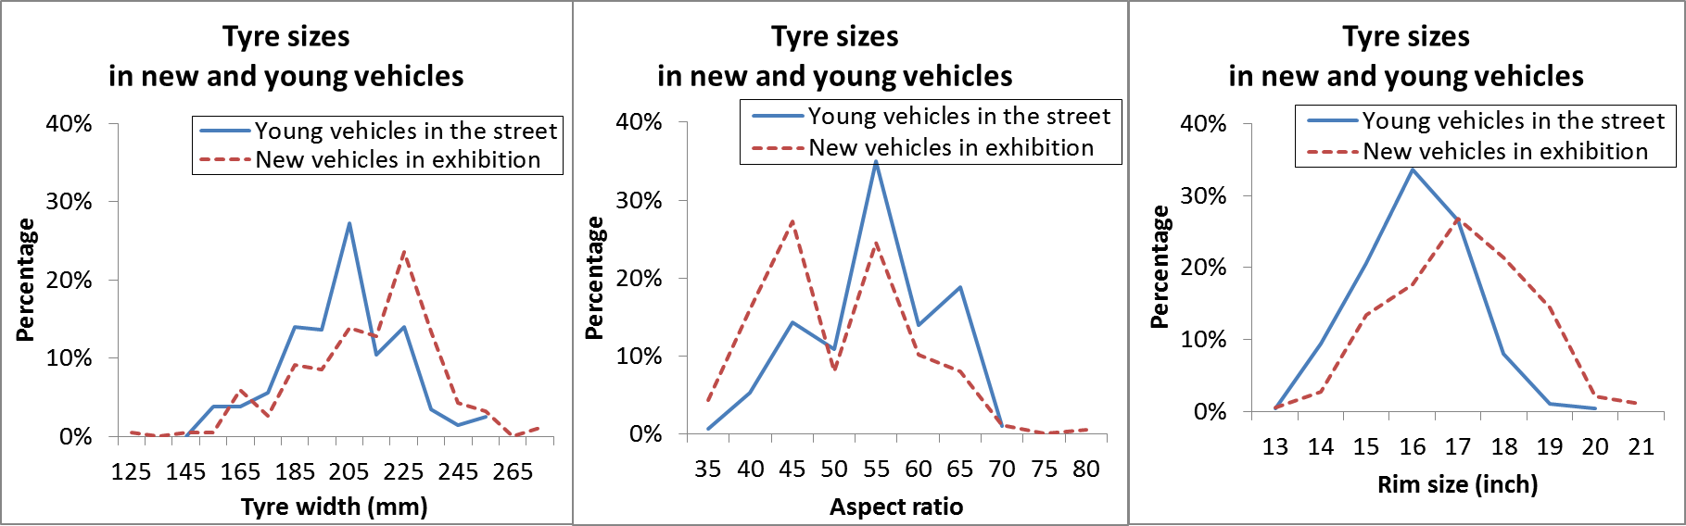
- Tyre sizes of tyres in new and young vehicles.

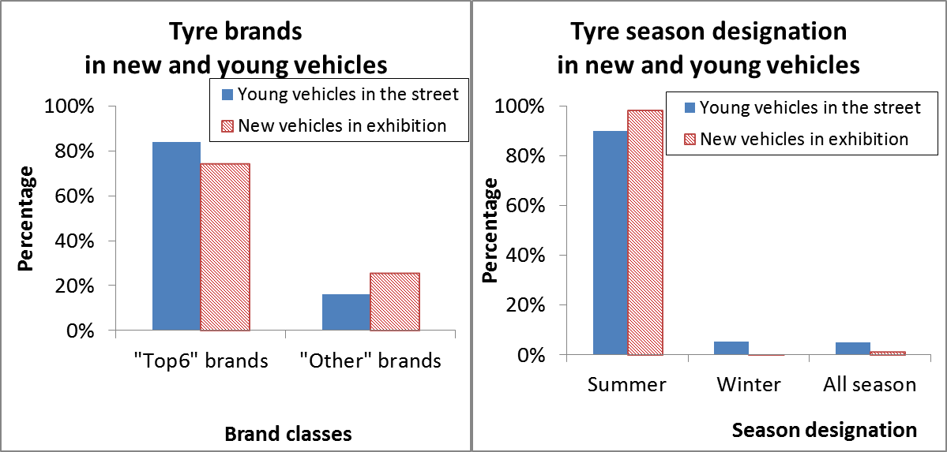
- Tyre characteristics of tyres in new and young vehicles. The data were gathered from late April to late May 2015, clearly after the advised change from winter to summer tyres. Note: the later investigations focused on summer tyres only

Tyres mounted on new and young vehicles: tyre label info
Based on the side wall information, we tried to find affiliated tyre labels for all tyres from the website of the tyre manufacturers. For 393 of the 467 vehicle/tyre combinations we could find tyre labels. Figure 3 shows the statistics of the collected tyre noise data.

However, we are not confident about the reliability of these data. The tyres in the new and young vehicles are produced in the period 2013 -2015, but we are not sure if they can be matched with the most recent tyre label information from June 2015.The 15% missing data were caused by tyre types that were meanwhile replaced by a successor. It also happens that more than one label exists for the same side wall information. This could be caused by the fact that some tyre types exist in multiple OEM variants. Sometimes this is visible on the side wall, with marks like “OM”, “OA” or “*” , but sometimes such signs cannot be recognized. Inside information also learned that tyre labels can be updated regularly, without changing the name on the side wall.

Another limiting factor for this part of the project, is that we do not have a similar dBase with Replacement tyres. This makes a comparison between OEM and replacement tyres impossible.

Finally, these data may be partly based on relatively older tyre models. The dBase may not incorporate the information about the latest tyre models. This altogether made us hesitant to draw conclusions on the dBase.
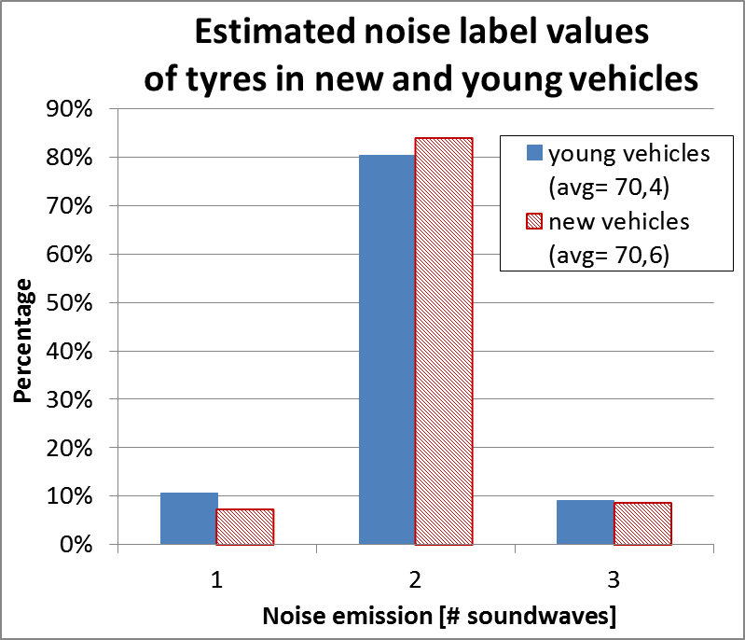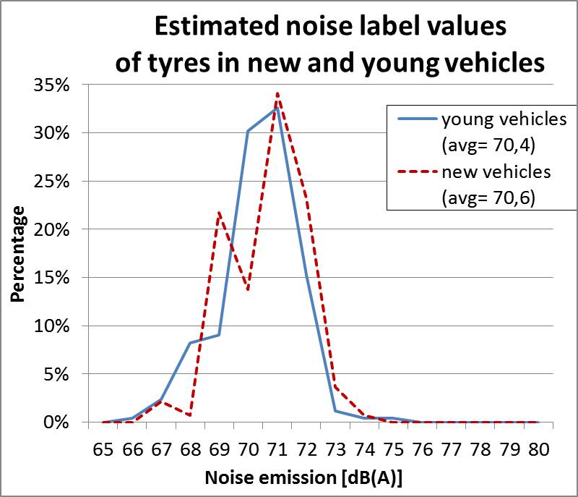
- Estimated tyre noise data of the tyres in new and young vehicles. Note: the reliability and representativity of these data may be questionable (see text)

Tyres mounted on new and young vehicles: the importance of the “Top6” tyres
The “Top6” tyre brands have a very important market position, especially in Original Equipment. Figure 4 shows the share of “Top6” tyre brands in various circumstances. They represent 4% of the brands in the market, but they have a market share of 91% in the group of young vehicles equipped with summer tyres. This means there is a strong correlation between the terms “OEM tyres” and “Top6 tyres”. For the term “Replacement tyre” we suggest that this could be interpreted as “any legal tyre available on the market from a different brand than a Top6 brand”

Difference between “Top6” brand tyres and “Other” tyres
We take on board these findings and assume that we can do further investigations on the groups “Top6” tyres and “Other” tyres as highly correlated, but easier to handle representatives for the groups with “OEM” tyres and “Replacement” tyres. In order to further investigate the difference in tyre label information, we need a data source that holds recent tyre labels, has sufficient data of both groups. Therefore, we used the data of the biggest internet retailer. To start with, we gathered all data of the most popular size 205/55R16 only. This gave the desired size and representativity of the data set. In total 865 tyres were found. In this group the “Top6” tyres have a market share of 38%.
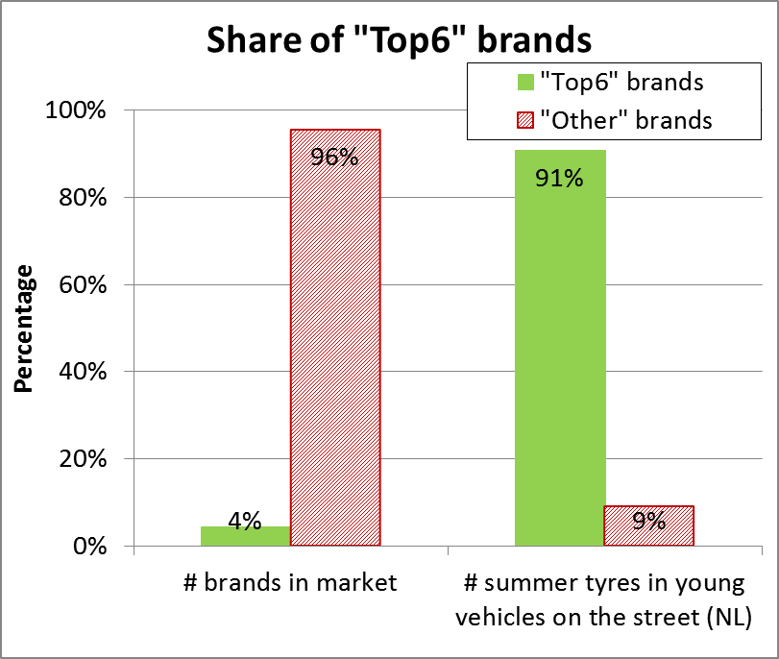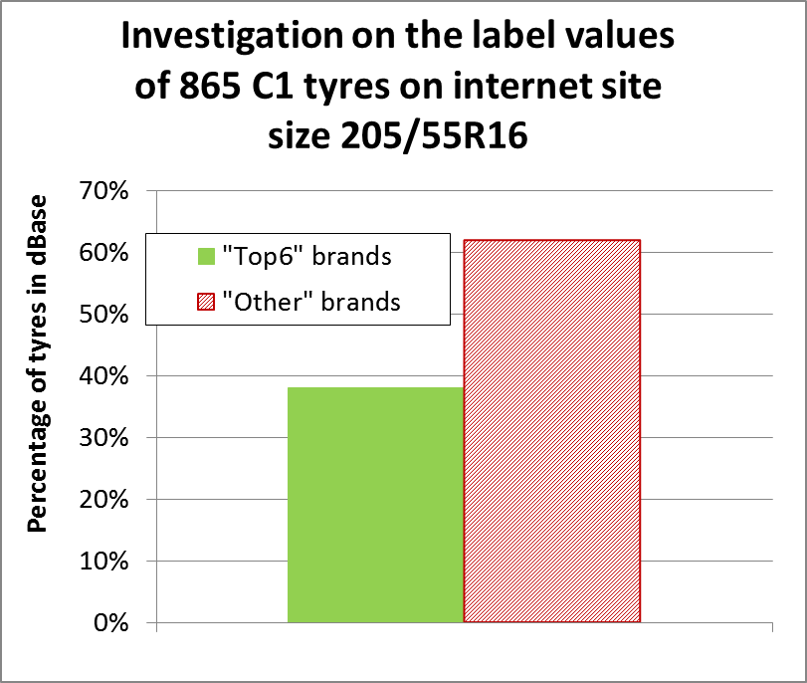
- Share of “Top6” brands in various circumstances

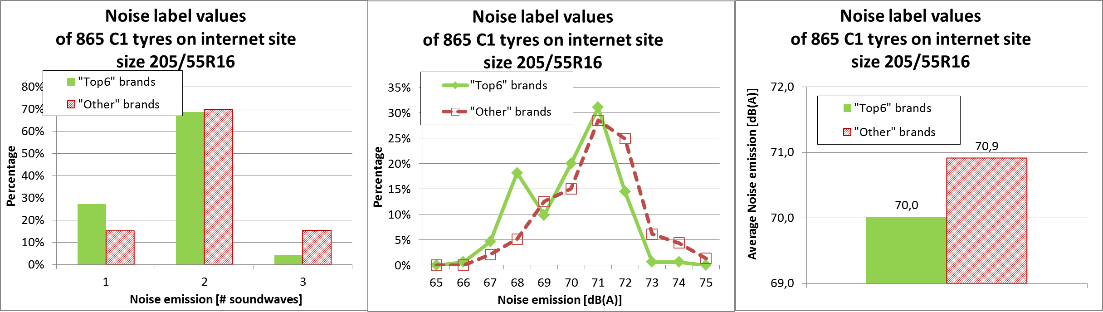
- Statistical distribution of tyre noise emission values of 865 C1 tyres in the size 205/55R16

From this data set we analyzed the tyre label information. The “Top6” tyre brands not only have a special market position, they also have a performance which is different from the “Other” brands. Figure 5 shows the statistical distribution of the noise values of these 865 tyres. The noise emission of “Top6” tyres is significantly lower compared to the group with “Other” tyres. This can be seen in the following data:
- The distribution of noise values is shifted. Especially the amount of low noise tyres (≤ 68 dB(A)) is much higher and the amount of high noise values (≥72 dB(A)) is much lower;
- The amount of tyres with a tyre label with one sound wave is significantly higher: 27% versus 15%;
- The amount of tyres with a tyre label with three sound waves is significantly lower: 4% versus 15%;
- The average noise emission is 0,9 dB(A) lower.

The “Top6” tyre brands do not only perform better with respect to noise emission, they also perform better with respect to the other performance criteria in the tyre label: Rolling Resistance and Wet Grip, as “Top6” tyres show more A and B labels compared to the “Other” tyres (see figure 6).

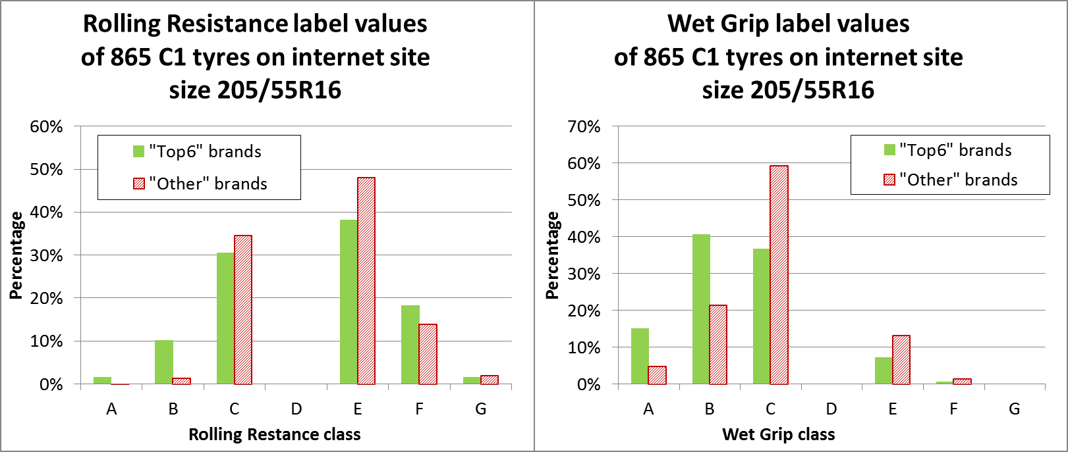
- Statistical distribution of rolling resistance and wet grip values of 865 C1 tyres in the size 205/55R16

Discussion and conclusions
This investigation is meant as pilot study, to see if some important trends can be found. As a pilot study it focusses on easily accessible data, without the ambition to be complete over all of the available data. For this investigation we focused on C1 tyres only, as the availability and reliability of data is much better than for C2 and C3 tyres. For one of the later questions we zoomed in into the most sold C1 tyre size: 205/55R16. We assume that one could find similar results for other tyre sizes.
As an answer to the questions from the Ministry we conclude with the following discussion:
- What kind of tyres are used as Original Equipment Manufacturer (OEM) tyres in new vehicles?
  - OEM tyres are mainly summer tyres from high quality or premium brands. Over 90% of the summer tyres we found in young vehicles are from only six brands. These are the six brands with the highest market share; both in our research as well as on the global market.
- Is the noise emission of these OEM tyres different from Replacement tyres?
  - The noise emission of OEM tyres is not directly available. Therefore, we have to find affiliated information to come to an answer. The best link is via the “Top6” tyres, as we found there is a strong correlation between OEM tyres and “Top6” tyres. For the term “Replacement tyre” we suggest that this could be interpreted as “any legal tyre available on the market from a different brand than a Top6 brand”.
  - We investigated the tyre labels of 865 tyres in the size 205/55R16. The conclusion is that the tyres from the “Top6” brands on average have a 0,9 dB(A) lower noise emission compared to the rest of the tyres. The percentage of “Top6” tyres with one sound wave is significantly higher (27% compared to 15%). This means that 27% of the “Top6” tyres currently has a noise emission which is 3 dB below the current limit.
- Is there a base for separate noise limits for OEM and Replacement tyres?
  - As from the conclusion above it is clear that there is a statistical significant difference in the noise emission of the two groups of tyres. One could opt for stricter limits for OEM tyres or differentiate the limits for both groups in their date of entry into force. Further deliberations for the discussion could be:
    - 1 dB is a relevant difference. The current regulations has differentiated limits for many tyre subgroups, such as winter tyres, extra load tyres, etc. For such tyres a similar 1 dB difference was found in the statistics prior to setting the limits.
    - Unlike ECE R117, EC/661/2009 does have a differentiated timing for the earlier introduction of new tyre noise limits in new vehicle types (see table I). The validity of this differentiation is corroborated by the underlying study.
    - While considering such demands for new vehicle types in UNECE, it might be good to reconcile the necessary administrative framework. (e.g. system of whole vehicle type approval, as currently under discussion in UNECE).

References
- Informal document GRB 60; -08; “Tyre noise limits of EC/661/2009 and ECE R117: Evaluation based on sold tyres in the Netherlands”; September 2014
- Informal document GRB 60-12; Shifts in tyre sound levels between 2007 and 2013; September 2014
- Informal document GRB-61-03; “Possible Future Tyre Noise limits”; January 2015
- Report of GRB 60; September 2014; ECE-TRANS-WP29-GRB-58e – par 14-16
- Report of GRB 61; January 2015; ECE-TRANS-WP29-GRB-59e - par 18;
- ETRMA statistics booklet 2014
- www.tyrereviews.co.uk
- www.rankingthebrands.com
- http://brandirectory.com

