SLR-05-04

Regulation No. 99

This document shows all content of Regulation No. 99 up to and

Including:

 |  | WP.29 | in force | notification / published
Revision 3 | ( Incl. Suppl. 9) | November 2013 | 10-06-2014 | 17-06-2014//26-06-2014
 | Corrigendum 1 |  |  | ./04-03-2015
 | draft Suppl. 10 | March 2015 | [8-10-2015] | ./ WP.29/2015/28
 | draft Suppl. 11 | [November 2015]

Including:

Paragraphs amended for the simplification of light source regulations.

Some issues are still open

Regulation No. 99
Uniform provisions concerning the approval of gas-discharge light sources for use in approved [gas-discharge] lamp units of power-driven vehicles
Page numbers incorrect
Contents
Page
Regulation
1. Scope 3
2. Administrative provisions 3
3. Technical requirements 5
4. Conformity of production 9
5. Penalties for non-conformity of production 11
6. Production definitively discontinued 11
7. Names and addresses of the Technical Services responsible for conducting approval tests,
and of Type Approval Authorities 11
Annexes
1 Sheets for gas-discharge light sources 12
2 Communication 13
3 Example of the arrangement of the approval mark 15
4 Method of measurement of electrical and photometric characteristics 16
5 Optical setup for the measurement of the position and form of the arc and of the position
of the electrodes 19
6 Minimum requirements for quality control procedures by the manufacturer 21
7 Sampling and compliance levels for manufacturer’s test records 23
8 Minimum requirements for sampling by an inspector 27

1. Scope
This Regulation applies to gas-discharge light sources shown in Annex 1 to this Regulation and intended for use in approved [gas-discharge] lamp units of power-driven vehicles.
2. Administrative provisions
2.1. Definitions
2.1.1. The term "category" is used in this Regulation to describe different basic design of standardized gas-discharge light sources. Each category has a specific designation, as for example: "D2S".
2.1.2. "Gas-discharge light sources of different types" are gas-discharge light sources within the same category which differ in such essential respects as:
2.1.2.1. Trade name or mark; that means:
(a) Gas-discharge light sources bearing the same trade name or mark but produced by different manufacturers are considered as being of different types.
(b) Gas-discharge light sources produced by the same manufacturer differing only by the trade name or mark may be considered to be of the same type;
2.1.2.2. Bulb and/or cap design, in so far as these differences affect the optical results.
2.2. Application for approval
2.2.1. Application for approval shall be submitted by the owner of the trade name or mark, or by his duly accredited representative.
2.2.2. Every application for approval shall be accompanied (see also paragraph 2.4.2. below) by:
2.2.2.1. Drawings in triplicate, sufficiently detailed to permit identification of the type;
2.2.2.2. A technical description including, if the ballast is not integrated with the light source, ballast identification;
2.2.2.3. Three samples of each colour which has been applied for;
2.2.2.4. One sample of the ballast in case the ballast is not integrated with the light source.
2.2.3. In the case of a type of gas-discharge light source differing only by the trade name or mark from a type that has already been approved it shall be sufficient to submit:
2.2.3.1. A declaration by the manufacturer that the type submitted is identical (except in the trade name or mark) to and has been produced by the same manufacturer as, the type already approved, the latter being identified by its approval code;
2.2.3.2. Two samples bearing the new trade name or mark.
2.2.4. The Type Approval Authority shall verify the existence of satisfactory arrangements for ensuring effective control of the conformity of production before type approval is granted.
2.3. Inscriptions
2.3.1. Gas-discharge light sources submitted for approval shall bear on the cap or bulb:
2.3.1.1. The trade name or mark of the applicant;
2.3.1.2. The international designation of the relevant category;
2.3.1.3. The rated wattage; this need not to be indicated separately if it is part of the international designation of the relevant category;
2.3.1.4. A space of sufficient size to accommodate the approval mark.
2.3.2. The space mentioned in paragraph 2.3.1.4. above shall be indicated in the drawings accompanying the application for approval.
2.3.3. Other inscriptions than those covered by paragraphs 2.3.1. above and 2.4.4. below may be affixed on the cap.
2.3.4. In case the ballast is not integrated with the light source, the ballast used for the type approval of the light source shall be marked with type and trade mark identification and with the rated voltage and wattage, as indicated on the relevant gas-discharge light source lamp data sheet.
2.4. Approval
2.4.1. If all samples of a type of gas-discharge light source which are submitted in accordance with paragraphs 2.2.2.3. or 2.2.3.2. above comply with the requirements of this Regulation, when tested with the ballast according to paragraph 2.2.2.4. in case the ballast is not integrated with the light source, approval shall be granted.
2.4.2. An approval code shall be assigned to each type approved. Its first character shall indicate the series of amendments incorporating the most recent major technical amendments made to the Regulation at the time of issue of the approval.
This will be followed by an identification code comprising not more than three characters. Only the Arabic numerals and capital letters listed in footnote shall be used.
The same Contracting Party may not assign the same code to another type of gas-discharge light source. If the applicant so desires the same approval code may be assigned to both gas-discharge light sources emitting white and selective yellow light (see paragraph 2.1.2. above).
2.4.3. Notice of approval or of extension or refusal or withdrawal of approval or production definitively discontinued of a type of gas-discharge light source pursuant to this Regulation shall be communicated to the Parties of the Agreement which apply this Regulation by means of a form conforming to the model in Annex 2 to this Regulation and of a drawing, supplied by the applicant for approval in a format not exceeding A4 (210 x 297 mm) and on a scale of at least 2 : 1.
2.4.4. To every gas-discharge light source conforming to a type approved under this Regulation there shall be affixed in the space referred to in paragraph 2.3.1.4. above, in addition to the inscriptions required under paragraph 2.3.1. above, an international approval mark consisting of:
2.4.4.1. A truncated circle surrounding the letter "E" followed by the distinguishing number of the country which has granted approval;
2.4.4.2. The approval code, placed close to the truncated circle.
2.4.5. If the applicant has obtained the same approval code for several trade names or marks, one or more of them will suffice to meet the requirements of paragraph 2.3.1.1 above.
2.4.6. The marks and inscriptions specified in paragraphs 2.3.1. and 2.4.3. above shall be clearly legible and be indelible.
2.4.7. Annex 3 to this Regulation gives an example of arrangement of the approval mark.
3. Technical requirements
3.1. Definitions
3.1.1. "Gas-discharge light source": means a light source where the element for visible radiation is a in which the light is produced by a stabilized discharge arc.
3.1.2. "Ballast": Specific electrical supply for the gas-discharge light source, optionally integrated with the light source.
3.1.3. "Rated voltage": Input voltage marked on the ballast or on the light source in the case that the ballast is integrated with the light source.
3.1.4. "Rated wattage": Wattage marked on the gas-discharge light source and ballast.
3.1.5. "Test voltage": Voltage, at the input terminals of the ballast or at the terminals of the light source in the case that the ballast is integrated with the light source, for which the electrical and photometric characteristics of the gas-discharge light source are intended and are to be tested.
3.1.6. "Objective value": Design value of an electrical or photometric characteristic. To be achieved, within the specified tolerances, when the gas-discharge light source is energized by the ballast, optionally integrated with the light source, and operated at test voltage.
3.1.7. "Standard (etalon) gas-discharge light source": Special gas-discharge light source used for the testing of headlamps. It has reduced dimensional, electrical and photometric characteristics as specified on the relevant data sheet.
3.1.8. "Reference axis": An axis defined with reference to the cap and to which certain dimensions of the gas-discharge light source are referred.
3.1.9. "Reference plane": a plane defined with reference to the cap and to which certain dimensions of the gas-discharge light source are referred.
3.1.10. Lamp unit: device, using a light source and designed to either illuminate the road, to illuminate the rear registration plate or to emit a light signal to other road users.
3.2. General specifications
3.2.1. Each sample submitted shall conform to the relevant specifications of this Regulation when tested, in the case the ballast is not integrated with the light source with the ballast according to paragraph 2.2.2.4 above.
3.2.2. Gas-discharge light sources shall be so designed as to be and to remain in good working order when in normal use. They shall moreover exhibit no fault in design or manufacture.
3.2.3. The discharge arc shall be the only element of the gas-discharge light source that generates and emits light when energised.
3.3. Manufacture
3.3.1. The bulb of the gas-discharge light source shall exhibit no scores or spots which might impair their efficiency and their optical performance.
3.3.2. In the case of a coloured (outer) bulb, after an operating period of 15 hours with the ballast or the light source with the ballast integrated at test voltage, the surface of the bulb shall be lightly wiped with a cotton cloth soaked in a mixture of 70 volume per cent of n-heptane and 30 volume per cent of toluol. After about five minutes, the surface shall be inspected visually. It shall not show any apparent changes.
Gas-discharge light sources shall be equipped with standard caps complying with the cap data sheets of IEC Publication 60061, third edition, as specified on the individual data sheets of Annex 1 to this Regulation.
3.3.4. The cap shall be strong and firmly secured to the bulb.
3.3.5. To ascertain whether gas-discharge light sources conform to the requirements of paragraphs 3.3.3. to 3.3.4. above, a visual inspection, a dimension check and, where appropriate, a trial fitting shall be carried out.
3.4. Tests
3.4.1. Gas-discharge light sources shall be aged as indicated in Annex 4 to this Regulation.
3.4.2. All samples shall be tested with the ballast, according to paragraph 2.2.2.4. above, in case the ballast is not integrated with the light source.
3.4.3. Electrical measurements shall be carried out with instruments of at least class 0.2. (0.2 per cent full scale accuracy).
3.5. Position and dimensions of electrodes, arc and stripes
3.5.1. The geometric position of the electrodes shall be as specified on the relevant data sheet. An example of a method of measuring arc and electrodes position is given in Annex 5 to this Regulation. Other methods may be used.
3.5.1.1. The position and dimensions of the light source electrodes shall be measured before the ageing period, the gas-discharge light source unlit and using optical methods through the glass envelope.
3.5.2. The shape and the displacement of the arc shall conform to the requirements as given on the relevant data sheet.
3.5.2.1. The measurement shall be made after ageing with the light source supplied by the ballast at test voltage or the light source with the ballast integrated at test voltage.
3.5.3. The position and dimension and transmission of the stripes shall comply with the requirements as given on the relevant data sheet.
3.5.3.1. The measurement shall be made after ageing with the light source supplied by the ballast at test voltage or the light source with the ballast integrated at test voltage.
3.6. Starting, run-up and hot-restrike characteristics
3.6.1. Starting
When tested according to the conditions specified in Annex 4 to this Regulation, the gas-discharge light source shall start directly and remain alight.
3.6.2. Run-up
3.6.2.1. For gas-discharge light sources having an objective luminous flux which exceeds 2000 lm:
When measured according to the conditions specified in Annex 4, the gas-discharge light source shall emit at least:
After 1 second: 25 per cent of its objective luminous flux;
After 4 seconds: 80 per cent of its objective luminous flux.
The objective luminous flux as indicated on the relevant data sheet.
3.6.2.2. For gas-discharge light sources having an objective luminous flux which does not exceed 2000 lm and does not contain black stripes:
When measured according to the conditions specified in Annex 4, the gas-discharge light sources shall emit at least 800 lm after 1 second and at least 1000 lm after 4 seconds.
The objective luminous flux as indicated on the relevant data sheet.
For gas-discharge light sources having an objective luminous flux which does not exceed 2000 lm but does contain black stripes:
When measured according to the conditions specified in Annex 4, the gas-discharge light sources shall emit at least 700 lm after 1 second and at least 900 lm after 4 seconds.
The objective luminous flux as indicated on the relevant data sheet.
3.6.3. Hot-restrike
When tested according to the conditions specified in Annex 4 to this Regulation, the gas-discharge light source shall restart directly after being switched-off for a period as indicated on the data sheet. After one second the light source shall emit at least 80 per cent of its objective luminous flux.
3.7. Electrical characteristics
When measured according to the conditions specified in Annex 4 to this Regulation, the voltage and wattage of the light source shall be within the limits given on the relevant data sheet.
3.8. Luminous flux
When measured according to the conditions specified in Annex 4 to this Regulation, the luminous flux shall be within the limits given on the relevant data sheet. In the case where white and selective yellow is specified for the same type, the objective value applies to light sources emitting white light, whereas the luminous flux of the light source emitting selective yellow light shall be at least 68 per cent of the specified value.
3.9. Colour
3.9.1. The colour of the light emitted shall be white or selective yellow. Moreover, the colorimetric characteristics, expressed in CIE chromaticity coordinates, shall lie within the boundaries given on the relevant data sheet.
3.9.2. The definitions of the colour of the light emitted, given in Regulation No. 48 [Part B] and its series of amendments in force at the time of application for type approval shall apply to this Regulation.
3.9.3. The colour shall be measured according to the conditions specified in Annex 4 to this Regulation, paragraph 10.
3.9.4. The minimum red content of a gas-discharge light source shall be such that:
780 nm
∫ Ee(λ).V(λ).dλ
λ=610 nm
kred = ____________________ ≥ 0.05
780 nm
∫ Ee(λ).V(λ).dλ
λ=380 nm
Where:
Ee (λ) [W/nm] is the spectral distribution of the radiant flux;
V (λ) [1] is the spectral luminous efficiency;
λ [nm] is the wave length.
This value shall be calculated using intervals of one nanometre.
3.10. UV radiation
The UV radiation of the gas-discharge light source shall be such that the gas discharge light source is of the low UV type complying with:
400 nm
∫ Ee(λ)∙S(λ)∙dλ
λ=250 nm
kuv = ____________________ ≤ 10-5 W/lm
780 nm
k_{m} ∙ ∫ Ee(λ)∙V(λ)∙dλ
λ=380 nm
Where:
S (λ) [1] is the spectral weighting function;
km = 683 [lm/W] is the photometric radiation equivalent;
(For definitions of other symbols see paragraph 3.9.5. above).
This value shall be calculated using intervals of one nanometre.
The UV-radiation shall be weighted according to the values as indicated in the following table.
λ | S(λ) | λ | S(λ) | λ | S(λ)
250 | 0.430 | 305 | 0.060 | 355 | 0.00016
255 | 0.520 | 310 | 0.015 | 360 | 0.00013
260 | 0.650 | 315 | 0.003 | 365 | 0.00011
265 | 0.810 | 320 | 0.001 | 370 | 0.000090
270 | 1.000 | 325 | 0.00050 | 375 | 0.000077
275 | 0.960 | 330 | 0.00041 | 380 | 0.000064
280 | 0.880 | 335 | 0.00034 | 385 | 0.000053
285 | 0.770 | 340 | 0.00028 | 390 | 0.000044
290 | 0.640 | 345 | 0.00024 | 395 | 0.000036
295 | 0.540 | 350 | 0.00020 | 400 | 0.000030
300 | 0.300
Wavelengths chosen are representative; other values should be interpolated.
Values according to "IRPA/INIRC Guidelines on limits of exposure to ultraviolet radiation".
3.11. Standard gas-discharge light sources
Standard (etalon) gas-discharge light sources shall comply with the requirements applicable to type approval light sources and to the specific requirements as stated in the relevant data sheet. In case of a type emitting white and selective yellow light, the standard light source shall emit white light.
4. Conformity of production
4.1. Gas-discharge light sources approved to this Regulation shall be so manufactured as to conform to the type approved by meeting the inscriptions and technical requirements set forth in paragraph 3. above and Annexes 1 and 3 to this Regulation.
4.2. In order to verify that the requirements of paragraph 4.1. are met, suitable controls of the production shall be carried out.
4.3. The holder of the approval shall in particular:
4.3.1. Ensure existence of procedures for the effective control of the quality of products,
4.3.2. Have access to the control equipment necessary for checking the conformity to each approved type,
4.3.3. Ensure that data of test results are recorded and that related documents shall remain available for a period to be determined in accordance with the administrative service,
4.3.4. Analyse the results of each type of test, applying criteria of Annex 7 to this Regulation, in order to verify and ensure the stability of the product characteristics making allowance for variation of an industrial production,
4.3.5. Ensure that for each type of gas-discharge light source, at least the tests prescribed in Annex 6 to this Regulation are carried out,
4.3.6. Ensure that any collecting of samples giving evidence of non-conformity with the type of test considered shall give rise to another sampling and another test. All the necessary steps shall be taken to re-establish the conformity of the corresponding production.
4.4. The Type Approval Authority which has granted type-approval may at any time verify the conformity control methods applicable to each production unit.
4.4.1. In every inspection, the test books and production survey records shall be presented to the visiting inspector.
4.4.2. The inspector may take samples at random which will be tested in the manufacturer's laboratory. The minimum number of samples may be determined according to the results of the manufacturer's own verification.
4.4.3. When the quality level appears unsatisfactory or when it seems necessary to verify the validity of the tests carried out in application of paragraph 4.4.2. above, the inspector shall select samples, to be sent to the Technical Service which has conducted the type approval tests.
4.4.4. The Type Approval Authority may carry out any tests prescribed in this Regulation. These tests will be on samples selected at random without causing distortion of the manufacturer’s delivery commitments and in accordance with criteria of Annex 8 to this Regulation.
4.4.5. The Type Approval Authority shall strive to obtain a frequency of inspection of once every two years. However, this is at the discretion of the Type Approval Authority and their confidence in the arrangements for ensuring effective control of conformity of production. In the case where negative results are recorded, the Type Approval Authority shall ensure that all necessary steps are taken to re-establish the conformity of production as rapidly as possible.
5. Penalties for non-conformity of production
5.1. The approval granted in respect of a gas-discharge light source pursuant to this Regulation may be withdrawn if the prescribed conformity of production requirements are not met.
5.2. If a Contracting Party to the Agreement applying this Regulation withdraws an approval it has previously granted, it shall forthwith so notify the other Contracting Parties applying this Regulation, by means of a communication form conforming to the model in Annex 2 to this Regulation.
6. Production definitively discontinued
If the holder of the approval completely ceases to manufacture a type of gas-discharge light source approved in accordance with this Regulation, he shall so inform the authority which had granted the approval. Upon receiving the relevant communication, that authority shall inform thereof the other Parties to the Agreement applying this Regulation by means of a communication form conforming to the model in Annex 2 to this Regulation.
7. Names and addresses of the Technical Services responsible for conducting approval tests, and of Type Approval Authorities
The Contracting Parties to the Agreement which apply this Regulation shall communicate to the United Nations Secretary-General the names and addresses of the Technical Services responsible for conducting approval tests and of the Type Approval Authorities which grant approval and to which forms certifying approval or extension or refusal or withdrawal of approval, or production definitively discontinued issued in other countries, are to be sent.

Annex 1
Sheets* for gas-discharge light sources

The sheets of the relevant gas-discharge light source category and the group in which this category is listed with restrictions on the use of this category shall apply as incorporated in the Resolution [No. y] or its subsequent revisions, applicable at the time of application for type approval of the gas-discharge light source.

* From [date] onwards, the sheets for gas-discharge light sources, the list and group of light source categories with restrictions on the use of this category and their sheet numbers are incorporated in the Resolution [No. y] with symbol ECE/TRANS/WP.29/11XX.

Annex 2
Communication
(Maximum format: A4 (210 x 297 mm))
issued by: Name of administration:
......................................
......................................
......................................
Concerning: Approval granted
Approval extended
Approval refused
Approval withdrawn
Production definitively discontinued
of a type of gas-discharge light source pursuant to Regulation No. 99
Approval No:............................................ Extension No:.........................................
1. Gas-discharge light source - category .....................................................
- rated wattage ..............................................
2. Trade name or mark
3. Manufacturer's name and address
4. If applicable, name and address of manufacturer's representative

5. Brand and type number of the ballast........................................
(In case the ballast is not integrated with the light source.)
6. Submitted for approval on
7. Technical Service responsible for conducting approval test
8. Date of report issued by that service
9. Number of report issued by that service
10. Approval granted/refused/extended/withdrawn²
11. Place
12. Date
13. Signature
14. The attached drawing No….. shows the entire light source.

Annex 3
Example of the arrangement of the approval mark
(see paragraph 2.4.4. of this Regulation)
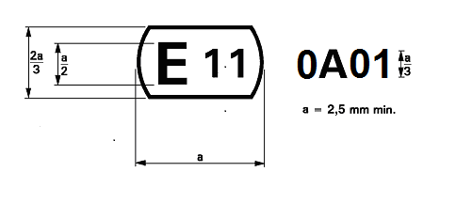
The above approval mark affixed to a gas-discharge light source indicates that the light source has been approved in the United Kingdom (E 11) under the approval code 0A01. The first character of the approval code indicates that the approval was granted in accordance with the requirements of Regulation No. 99 in its original form.

Annex 4
Method of measurement of electrical and photometric characteristics
1. General
For starting, run-up and hot-restrike tests and for the measurement of electrical and photometric characteristics, the gas-discharge light source shall be operated in free air with an ambient temperature of 25° ± 5° C.
2. Ballast
In the case the ballast is not integrated with the light source, all tests and measurements shall be carried out with the ballast as per paragraph 2.2.2.4. of this Regulation. The power supply used for the starting and run-up tests shall be qualified to secure the quick rise of the high current pulse.
3. Burning position
The burning position shall be horizontal within ±10° with the lead wire down. Ageing and testing positions shall be identical. If the lamp gas-discharge light source is accidentally operated in the wrong direction, it shall be re-aged before measurements begin. During ageing and measurements no electrically conducting objects shall be allowed within a cylinder having a diameter of 32 mm and a length of 60 mm concentric with the reference axis and symmetric to the arc. Moreover stray magnetic fields shall be avoided.
4. Ageing
All tests shall be carried out with light sources which have been aged for a minimum of 15 cycles having the following switching cycle:
45 minutes on, 15 seconds off, 5 minutes on, 10 minutes off.
5. Supply voltage
All tests shall be carried out at test voltage as indicated on the relevant data sheet.
6. Starting test
The starting test shall be applied to light sources which have not been aged and have not been used for a period of at least 24 hours prior to the test.
7. Run-up test
The run-up test shall be applied to light sources which have not been used for a period of at least 1 hour prior to the test.
8. Hot restrike test
The light source shall be started and be operated with the ballast (possibly integrated) at test voltage for a period of 15 minutes. Then the supply voltage to the ballast or the light source with the ballast integrated shall be switched off for a switch-off period as indicated on the relevant data sheet and be switched on again.
9. Electrical and photometric test
Before any measurement, the light source shall be stabilized for a period of 15 minutes.
10. Colour
The colour of the light source shall be measured in an integrating sphere using a measuring system which shows the CIE chromaticity co-ordinates of the received light with a resolution of ± 0.002.The following figure shows the colour tolerance area for colour white and the restricted tolerance area for the gas-discharge light sources D1R, D1S, D2R, D2S, D3R, D3S, D4R, D4S, D5S, D6S, D8R and D8S.

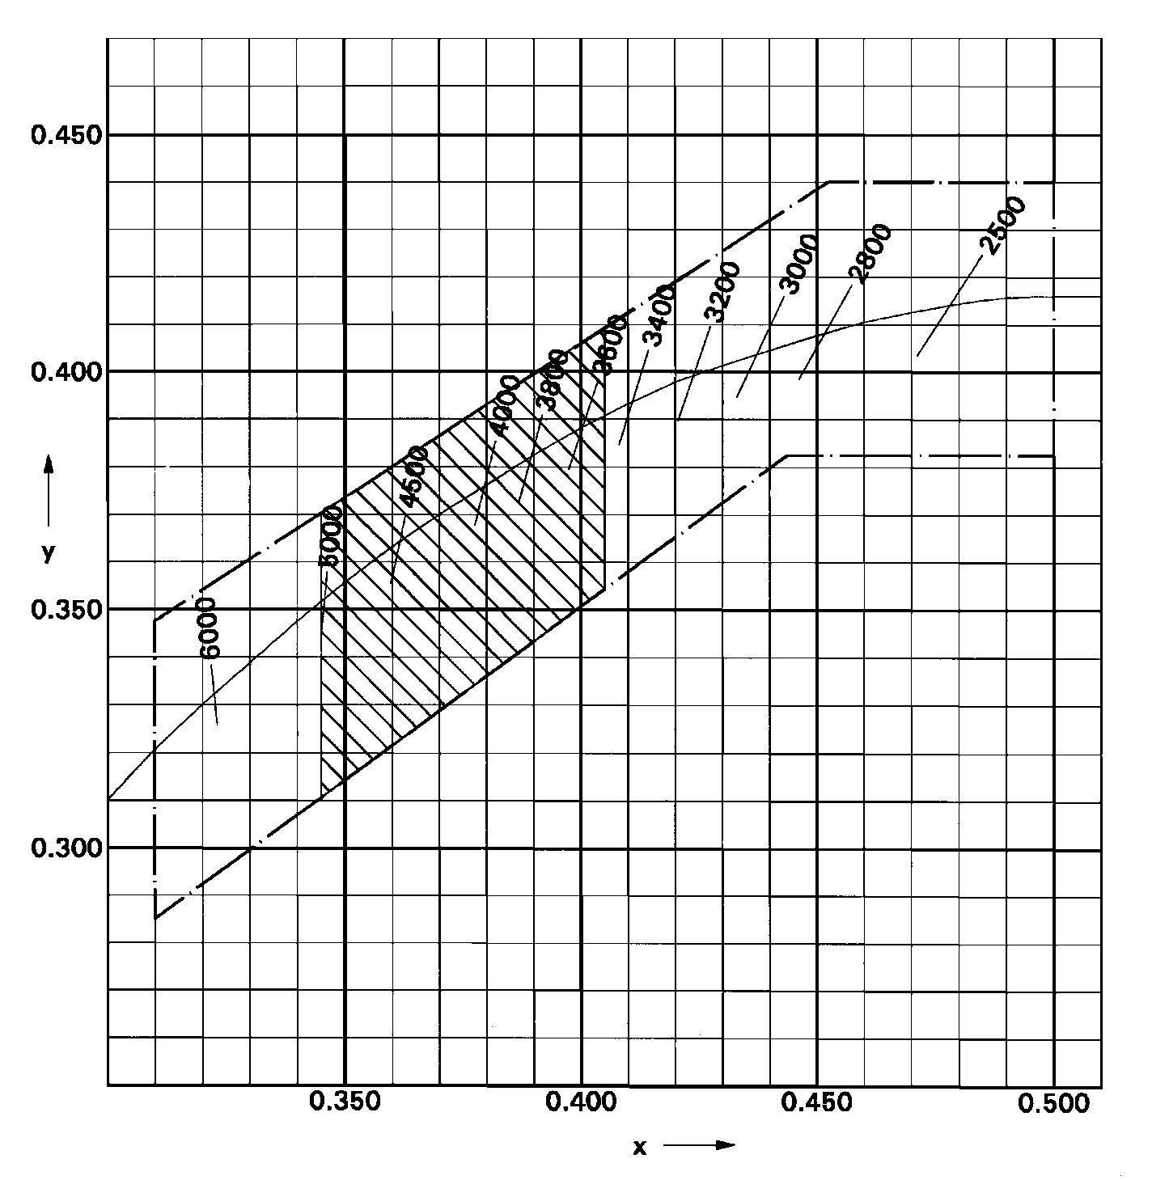

Annex 5
Optical setup for the measurement of the position and form
of the arc and of the position of the electrodes
The gas-discharge light source shall be positioned as shown: in the main drawing of the respective category.
in figure 1 or figure 2 on sheet DxR/1 or sheet DxS/1;
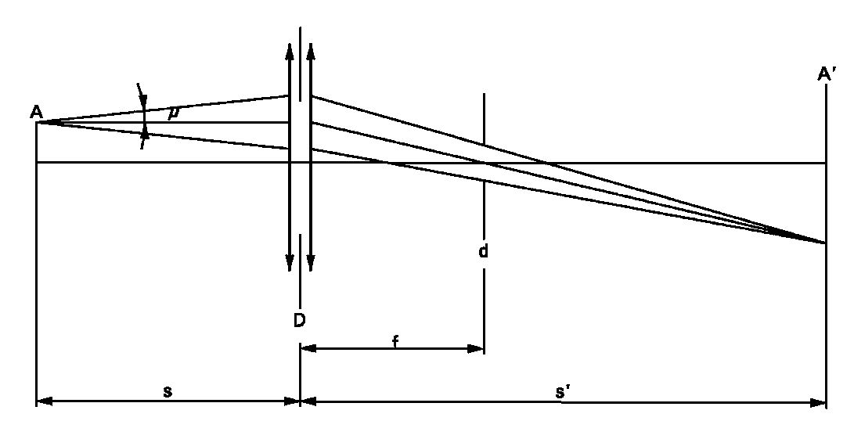
in figure 3 or figure 4 on sheet DxR/2 or sheet DxS/2.
An optical system shall project a real image A' of the arc A with a magnification of preferably M = s'/s = 20 on a screen. The optical system shall be aplanatic and achromatic. In the focus-length f of the optical system a diaphragm d shall cause a projection of the arc with nearly parallel observation directions. To get the angle of the half divergence not larger than μ = 0.5°, the diameter of the focus-diaphragm with respect to the focus-length of the optical system shall be not more than d = 2f tan(μ). The active diameter of the optical system shall be not more than:
D = (1 + 1/M)d + c + (b1 + b2)/2. (c, b1 and b2 are given in the sheets prescribing the position of the electrodes on sheet DxS/5, respectively sheet DxR/5).
A scale on the screen shall enable to measure the position of the electrodes. The calibration of the arrangement advantageously can be done by using a separate projector with a parallel beam in connection with a gauge whose shadow is projected to the screen. The gauge shall show the reference axis and the plane parallel to the reference plane and at distance "e" mm from it (e = 27.1 for D1R, D1S, D2R, D2S, D3R, D3S, D4R and D4S).
In the plane of the screen a receiver has to be mounted movable in a vertical direction on a line corresponding to the plane at "e" from the reference plane of the gas discharge light source.
The receiver shall have the relative spectral sensitivity of the human eye. The size of the receiver shall be not more than 0.2 M mm in the horizontal and not more than 0.025 M mm in the vertical direction (M = the magnification). The range of measurable movement shall be such that the required measures of the arc bending r and arc diffusion s can be measured. For the measurement of the stray light, the size of the receiver shall be circular with a diameter of 0.2M mm diameter.

Annex 6
Minimum requirements for quality control procedures by the manufacturer
1. General
The conformity requirements shall be considered satisfied from a photometric (including UV-radiation), geometrical, visual and electrical standpoint if the specified tolerances for production gas-discharge light sources in the relevant data sheet of Annex 1 to this Regulation and the relevant data sheet for the caps are met.
2. Minimum requirements for verification of conformity by the manufacturer
For each type of gas-discharge light source the manufacturer or the holder of the approval mark shall carry out tests, in accordance with the provisions of this Regulation, at appropriate intervals.
2.1. Nature of tests
Tests of conformity of these specifications shall cover their photometric, geometrical and optical characteristics.
2.2. Methods used in tests
2.2.1. Tests shall generally be carried out in accordance with the methods set out in this Regulation.
2.2.2. The application of paragraph 2.2.1. of this annex requires regular calibration of test apparatus and its correlation with measurements made by a Type Approval Authority.
2.3. Nature of sampling
Samples of gas-discharge light sources shall be selected at random from the production of a uniform batch. A uniform batch means a set of gas-discharge light sources of the same type, defined according to the production methods of the manufacturer.
2.4. Inspected and recorded characteristics
The gas-discharge light sources shall be inspected and test results recorded following the grouping of characteristics as listed in Annex 7 to this Regulation, table 1.
2.5. Criteria governing acceptability
The manufacturer or the holder of approval is responsible for carrying out a statistical study of the test results in order to meet the specification laid down for verification of conformity of products in paragraph 4.1. of this Regulation.
Compliance shall be assured if the level of acceptable non-compliance per grouping of characteristics given in table 1 of Annex 7 to this Regulation is not exceeded. This means that the number of gas-discharge light sources not complying with the requirement for any grouping of characteristics of any gas-discharge light source type does not exceed the qualifying limits in the relevant tables 2, 3 or 4 of Annex 7 to this Regulation.
Note: Each individual gas-discharge light source requirement shall be considered as a characteristic.

Annex 7
Sampling and compliance levels for manufacturer’s test records

Table 1
Characteristics
Grouping of characteristics | Grouping* of test records between gas-discharge light source types | Minimum 12 monthly sample per grouping* | Acceptable level of non-compliance per grouping of characteristics (%)
Marking, legibility and durability | All types with the same external dimensions | 315 | 1
Bulb quality | All types with the same bulb | 315 | 1
External dimensions (excluding cap) | All types of the same category | 315 | 1
Position and dimensions of arc and stripes | All types of the same category | 200 | 6.5
Starting, run-up and hot-restrike | All types of the same category | 200 | 1
Lamp Gas-discharge light source voltage and wattage | All types of the same category | 200 | 1
Luminous flux, colour and  UV radiation | All types of the same category | 200 | 1
* The assessment shall in general cover series production gas-discharge light sources from individual factories. A manufacturer may group together records concerning the same type from several factories, provided these operate under the same quality system and quality management.

Qualifying limits for acceptance based on different numbers of test results for each grouping of characteristics are listed in table 2 as maximum number of non-compliances. The limits are based on an acceptable level of 1 per cent of non-compliances, assuming an acceptance probability of at least 0.95.

Table 2
Number of test results of each characteristics | Qualifying limits for acceptance
- 200  201 - 260  261 - 315  316 - 370  371 - 435  436 - 500  501 - 570  571 - 645  646 - 720  721 - 800  801 - 860  861 - 920  921 - 990  991 - 1060  1061 - 1125  1126 - 1190  1191 - 1249 | 5  6  7  8  9  10  11  12  13  14  15  16  17  18  19  20  21
Qualifying limits for acceptance based on different numbers of test results for each grouping of characteristics are listed in table 3 given as maximum number of non-compliances. The limits are based on an acceptable level of 6.5 per cent of non-compliances, assuming an acceptance probability of at least 0.95.

Table 3
Number of lamps gas-discharge light sources in records | Qualifying limit | Number of lamps gas-discharge light sources in records | Qualifying limit | Number of lamps gas-discharge light sources in records | Qualifying limit
- 200  201 - 213  214 - 227  228 - 240  241 - 254  255 - 268  269 - 281  282 - 295  296 - 308  309 - 322  323 - 336  337 - 349  350 - 363  364 - 376  377 - 390  391 - 404  405 - 417  418 - 431  432 - 444  445 - 458  459 - 472  473 - 485  486 - 499  500 - 512  513 - 526  527 - 540 | 21  22  23  24  25  26  27  28  29  30  31  32  33  34  35  36  37  38  39  40  41  42  43  44  45  46 | 541 - 553  554 - 567  568 - 580  581 - 594  595 - 608  609 - 621  622 - 635  636 - 648  649 - 662  663 - 676  677 - 689  690 - 703  704 - 716  717 - 730  731 - 744  745 - 757  758 - 771  772 - 784  785 - 798  799 - 812  813 - 825  826 - 839  840 - 852  853 - 866  867 - 880  881 - 893 | 47  48  49  50  51  52  53  54  55  56  57  58  59  60  61  62  63  64  65  66  67  68  69  70  71  72 | 894 - 907  908 - 920  921 - 934  935 - 948  949 - 961  962 - 975  976 - 988  989 - 1002  1003 -1016  1017 - 1029  1030 - 1043  1044 - 1056  1057 - 1070  1071 - 1084  1085 - 1097  1098 - 1111  1112 - 1124  1125 - 1138  1139 - 1152  1153 - 1165  1166 - 1179  1180 - 1192  1193 - 1206  1207 - 1220  1221 - 1233  1234 - 1249 | 73  74  75  76  77  78  79  80  81  82  83  84  85  86  87  88  89  90  91  92  93  94  95  96  97  98
Qualifying limits for acceptance based on different numbers of test results for each grouping of characteristics are listed in table 4 given as a percentage of the results, assuming an acceptance probability of at least 0.95.

Table 4
Number of test results of each characteristic | Qualifying limits shown as a percentage of results.  Acceptable level of 1 per cent of non-compliances | Qualifying limits shown as a percentage of results.  Acceptable level of 6.5 per cent of non-compliances
1 250  2 000  4 000  6 000  8 000  10 000  20 000  40 000  80 000  100 000  1 000 000 | 1.68  1.52  1.37  1.30  1.26  1.23  1.16  1.12  1.09  1.08  1.02 | 7.91  7.61  7.29  7.15  7.06  7.00  6.85  6.75  6.68  6.65  6.55

Annex 8
Minimum requirements for sampling by an inspector
1. The conformity requirements shall be considered satisfied from a photometric, geometrical, visual and electrical standpoint if the specified tolerances for production gas-discharge light sources in the relevant data sheet of Annex 1 and the relevant data sheet for the caps are met.
2. The conformity of mass-produced gas-discharge light sources shall not be contested if the results are in agreement with paragraph 5 of this annex.
3. Conformity shall be contested and the manufacturer requested to make the production meet the requirements if the results are not in agreement with paragraph 5 of this annex.
4. If paragraph 3 of this annex is applied, a further sample of 250 gas-discharge light sources, selected at random from a recent production run, shall be taken within two months.
5. Compliance approved or disapproved shall be decided according to the values in table 1. For each grouping of characteristics gas-discharge light sources shall be either accepted or rejected according to the values in table 1*.

Table 1
Sample | 1 per cent** |  | 6.5 per cent**
 | Accept | Reject | Accept | Reject
First sample size: 125  If the number of non-conforming units is greater than 2 (11) and less than 5 (16) take a second sample size of 125 and assess the 250 | 2  6 | 5  7 | 11  26 | 16  27
* The proposed scheme is designed to assess the compliance of gas-discharge light sources to an acceptance level of non-compliance of 1 per cent and 6.5 per cent respectively and is based on the Double Sampling Plan for Normal Inspection in IEC Publication 60410: Sampling Plans and Procedures for Inspection by Attributes.
** The gas-discharge light sources shall be inspected and test results recorded following the grouping of characteristics as listed in Annex 7 to this Regulation, table 1.

A selective yellow bulb or an additional selective yellow outer bulb, solely intended to change the colour but not the other characteristics of a gas-discharge light source emitting white light, does not constitute a change of type of the gas-discharge light source.
0 1 2 3 4 5 6 7 8 9 A B C D E F G H J K L M N P R S T U V W X Y Z
The distinguishing numbers of the Contracting Parties to the 1958 Agreement are reproduced in Annex 3 to the Consolidated Resolution on the Construction of Vehicles (R.E.3), document ECE/TRANS/WP.29/78/Rev. 3, Annex 3 - www.unece.org/trans/main/wp29/wp29wgs/wp29gen/wp29resolutions.html
Distinguishing number of the country which has granted/extended/refused/ withdrawn approval (see approval provisions in the Regulation).
Strike out what does not apply.
This method is an example of a measurement method; any method with equivalent measurement accuracy may be used.

