Proposal for a Supplement to the 01 series of amendments to Regulation No. 112 (Headlamps emitting an asymmetrical passing-beam)
The text reproduced below was prepared by the expert from Poland to introduce new optional “Class B1” headlamp. Photometric requirements for Class B1 are based on average real performance of present Class B (halogen/LED) but has no additional design restriction just like luminous flux of light source. The modifications to the existing text of the Regulation are marked in bold for new characters.
- Proposal
Paragraph 1.4., amend to read:
“1.4. Headlamps of different "Classes" (A or B or B1) mean headlamps identified by particular photometric provisions.”
Paragraph 2.1.4., amend to read:
“2.1.4. Whether it concerns a Class A or B or B1 headlamp;”

Moreover identically in all other places (par. 4.2.2.3.; 4.2.2.4.; 4.2.2.5.; Annex 2) concerning headlamp Class (…) B amend to read:
“Class (…) B and B1”
respectively.

Paragraph 5.3.2.3. amend to read:
“5.3.2.3. For the class B headlamps the total objective luminous flux of all LED modules producing the principal passing-beam and measured as described in paragraph 5. of Annex 10 shall be equal or greater than 1,000 lumens”

Paragraph 6.2.4 renumber as 6.2.4.1.

Add a new paragraph 6.2.4.2., to read:
“6.2.4.2. The passing-beam of Class B1 shall meet the luminous intensities described as follows:
For right hand traffic luminous intensities shall be such that the vertical illumination defined for direction parallel to line connecting headlamp centre and given point at the road surface will be equal or more as described on the graph and in tables below.

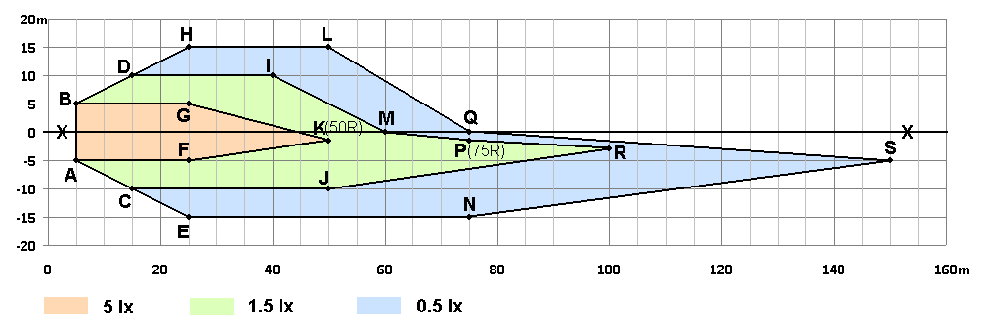
Vertical illumination at the road surface to be recalculated for luminous intensities for single headlamp. Side: + Left , -Right; 0,0 – headlamp position at 0.75 m above road surface.

Co-ordinates of points limiting requirements for areas.
Point | Side position (m) | Beyond headlamp (m) | Height  (m)
Headlamp centre | 0 | 0 | 0.75
A | -5 | 5 | 0
B | 5 | 5 | 0
C | -10 | 15 | 0
D | 10 | 15 | 0
E | -15 | 25 | 0
F | -5 | 25 | 0
G | 5 | 25 | 0
H | 15 | 25 | 0
I | 10 | 40 | 0
J | -10 | 50 | 0
K(50R) | -1.5 | 50 | 0
L | 15 | 50 | 0
M | 0 | 60 | 0
N | -15 | 75 | 0
P(75R) | -1.5 | 75 | 0
Q | 0 | 75 | 0
R | -3 | 100 | 0
S | -5 | 150 | 0

Required vertical illumination at the road surface
Area restricted by points | Minimum required value  (lux)
A, F, K, G, B, A | 5.0
A, C, J, R, P, M, I, D, B, G, K, F, A | 1.5
C, E, N, S, Q, L, H, D, I, M, P, R, J, C | 0.5

In any point and area the value of 100lx shall not be exceeded.
For left hand traffic all points and values should be mirrored with respect to X-X line.
Measurements shall be done by standard photogoniometric equipment in spherical coordinate measuring system as described in Annex 3.
For measurement purpose the recalculation of the vertical illumination at the road surface to luminous intensities in angular system according Fig. A in Annex 3 should be done. The position of optical centre of headlamp should be taken as 0.75 m above point 0,0 of the road surface (see graph above).
Before measurements cut-off shall be aimed according p. 6.2.2. with exclusion of p. 6.2.2.3.
Luminous intensities mapping the illumination at all the points in the tables above (points A to S) shall be measured.
For measurements of the other points and the areas described above (luminous intensities mapping the illumination at the road surface) the random procedure may be used for reduction the quantity of measurements. Such random procedure should provide reliable results and cannot be influenced by anybody including technical service and applicant. The angular resolution of goniophotometer measurements should reflect uniform density of measuring points on whole equivalent road surface as presented in graph above. At least one random measurement should be done for area representing each rectangle 1 m in width and 5 m in length of prescribed road surface area. Any visible inhomogeneity on the vertical screen illuminated by headlamp should be additionally verified by measurements of darkest and brightest visible points and areas as well as for any other doubts.
Any equivalent measuring method may be used under condition to guarantee result as described above and below.
Moreover the passing-beam shall meet the luminous intensities at the test points referred to in the tables below and in Annex 3 Figure B (or mirrored about the VV line for left-hand traffic):

Headlamps for RH Traffic* |  | LED Headlamp
Test point designation | Test point  angular coordinates - Degrees | Required luminous intensity  cd
 |  | Max
B 50 L | 0.57U, 3.43L | 350
BR | 1.0 U, 2.5R | 1,750
Any point in zone III  (bounded by the following coordinates in degrees)  8 L 8 L 8 R 8 R 6 R 1.5 R V-V 4 L  1 U 4 U 4 U 2 U 1.5 U 1.5 U H-H H-H |  | 625
Note: In the table:
Letter L means that the point is located on the left of VV line.
Letter R means that the point is located on the right of VV line.
Letter U means the point is located above HH line
* For left-hand traffic, the letter R shall be replaced by letter L and vice versa.

Headlamps for RH Traffic*
Test point | Angular coordinates  Degrees | Required luminous intensity- cd  Min
1 | 4U, 8L | Points 1+2+3  190
2 | 4U, 0
3 | 4U, 8R
4 | 2U, 4L | Points 4+5+6  375
5 | 2U, 0
6 | 2U, 4R
7 | 0, 8L | 65
8 | 0, 4L | 125
„
II. Justification
1000 lm luminous flux required for LED modules is substitute to flux required for halogen light sources (Reg. 37) used in passing beam headlamps. Such requirement does not guarantee automatically good road illumination because it depend on optical design of headlamp and light distribution. For LED headlamps optical design can significantly differ from incandescent lamp. Additionally there are more general relations between light source luminous flux, light source geometrical size, diameter (size) of optical unit, focal distance, flux efficiency and finally precision of the light beam focusing (quality of far field road illumination). All this design factors cannot be effectively controlled by present prescriptions of Regulation 112. For the early paraboloidal design above relations were more or less fixed and because of it there were defined very simplified screen requirements (as for the current Class A and B). For modern optical design and light sources (LED, laser) these simplifications are not valid. But generally higher flux efficiency (lower light source flux) is in contradiction to road illumination quality. There is interest to remove the requirement of luminous flux of light source for modern and effective headlamps (LED, laser etc.). The key point is that present minimum photometric requirements of Reg. No 112 are very minimalistic in fare distances and it is important for safety. However average real 1000lm (and more) halogen headlights allow for much better road illumination than this minimum. Unfortunately simplify the requirements by removing the requirement for light source flux for LED will lead to a real safety impairment .
The intention of proposal is to introduce optional performance based requirements which are equivalent to present Class B headlamps (average halogen quality) but without artificial restriction for new (e.g. LED or laser) technology like the luminous flux of the light source. Remove of the flux requirement cannot be done without another criterion. The reasonable performance criterion is minimum road illumination. It is used from many years to objective assessment of quality of road illumination eg. CIE TC4-45 method. This criterion is very easy to recalculate (map) for photogoniometric system whilst measurements will be done identically as till now.

