Submitted by VPSD IWG | Informal document GRPE-71-13-Rev.1  71st GRPE, 8-12 June 2015,  agenda item 11

Amendments to ECE/TRANS/WP.29/GRPE/2015/13
(Proposal for a new Mutual Resolution (M.R.2) containing
Vehicle Powertrain Definitions)
A. Explanatory report
1. Some existing UN Regulations and UN global technical regulations or those currently under development contain terms, definitions and classifications on:
(a) Vehicle powertrain system type (e.g. electric vehicle, fuel cell vehicle);
(b) Energy storage system (e.g. fuel tank, gas cylinder, battery);
(c) Energy converter (e.g. internal combustion engine, fuel cell, electric machine).
2. In some cases these classifications and definitions are different in the various regulations, and the current activities to develop regulations for innovative powertrains and alternative fuels may lead to an even more inconsistent situation, if not coordinated. A frame-system of a classification with the main terms and definitions introduced as a new Mutual Resolution No. 2 (M.R.2) under both Agreements (1958 and 1998) would be helpful. It should build a framework that ensures consistency for all definitions used in UN Regulations or UN global technical regulations by providing a general and basic system, which enables the addition of future technologies at later stages. The level of descriptive classification should serve the purpose of the regulatory process under the aegis of the World Forum for Harmonization of Vehicle Regulations (WP.29), without going into unnecessary details of components which are beyond the scope of WP.29 UN Regulations. As an example, a fuel cell or a battery should not be defined as electrochemical process or its sub-components but rather as a black box where the important parameters for its functionality in the vehicle for regulatory purposes are the input and the output to this box.
3. It was discussed whether fuel definitions (gasoline, diesel, liquefied petroleum gas, compressed natural gas, liquefied natural gas, E10, E85, H₂ ...) should be included in this system of VPSD. It is proposed to consider this issue in a second phase.
4. At the March 2012 session, WP.29 mandated an informal working group on VPSD under the GRPE to develop a proposal for a framework of terms, definitions and classifications regarding vehicle powertrain systems for introduction into the Consolidated Resolution on the Construction of Vehicles (R.E.3) and the Special Resolution No. 1 (S.R.1). Since mutual resolutions are introduced under both agreements, a new M.R.2 is proposed (part B of this document).
5. Principles:
(a) Use of existing definitions:
Do not create new definitions to the possible extent.
(b) Develop only necessary definitions:
Needed for the clear understanding of requirements in UN Regulations or UN global technical regulations.
(c) Only a framework in a new M.R.2 should be developed:
(i) More detailed definitions in UN Regulations or UN global technical regulations;
(ii) Framework must enable consistency;
(iii) Framework should be as simple as possible;
(iv) Definitions should be preferably understandable and also be comprehensible to people who are not familiar with vehicle regulations;
(v) Technology neutral to the possible extent.
(d) Such a framework should enable the later addition of new definitions on novel technologies, easily fitting into the given structure of definitions.
(e) The hierarchical system of the definitions (the structure) should contain a minimum number of levels to the extent possible.
6. The VPSD informal working group discussed a proposal to mark a term in a definition that is being defined elsewhere in the text. In part B such terms are underlined. If such a system is considered helpful, it might be introduced later also in regulations.
7. Powertrain related definitions are primarily included in regulations under control of GRPE:
(a) 1958 agreement: UN Regulations Nos. 40, 47, 49, 83, 85, 96, 101, 115, 120 and 132;
(b) 1998 agreement: UN global technical regulations Nos. 2, 4, 5, 10, 11 and 15.
8. But also other regulations under the control of other Working Parties can contain powertrain related definitions, e.g.:
(a) 1958 agreement: UN Regulations Nos. 41, 51, 67, 100 and 110;
(b) 1998 agreement: UN global technical regulations No. 13 and on Quiet Road Transport Vehicles (QRTV).
1. Powertrain
9. In national/international regulations and standards, different definitions of propulsion system and powertrain can be found. Understanding the propulsion system as the combination of the energy storage system, the energy supply system and the powertrain mainly follows the approach of International Organization for Standardization (ISO) standards and national Chinese standards.
10. It was herewith decided to define the powertrain as the part of the vehicle containing the propulsion energy storage system, the propulsion energy converter and the drivetrain, which provides directly or indirectly the mechanical energy at the wheels for the purpose of vehicle propulsion. The main reason for introducing this powertrain concept was to simplify the definitions, to avoid unnecessary hierarchical levels and to clarify what is actually meant with this expression, as it is regularly used in various existing UN Regulations and UN global technical regulations but, at the same time, perceived differently by various stakeholders and authorities. For non-road mobile machinery, the powertrain and any of its constitutive parts referred to in the definitions may have other purposes than propulsion.
11. Key elements of such powertrain concept are:
(a) A vehicle shall have only one powertrain;
(b) The propulsion energy storage systems and the propulsion energy converters are those non-peripheral main parts of the powertrain providing different forms of energy directly or indirectly for the purpose of propulsion, finally as mechanical energy at the wheels. The different powertrain vehicle definitions (Chapter 3) are classified regarding the different structures of energy storage systems and energy converters in a powertrain;
(c) Inclusion of peripheral devices (e.g. electrical capacitor, 12 V battery, starter motor, intake system, fuel delivery system, electric power conditioning device, sensors, actuators, electronic control unit, exhaust after-treatment systems);
(d) Exclusion of auxiliariy devices (e.g. auxiliary battery, mobile air conditioning, electric window lift, hydraulic crane, heating system, etc.).
12. Below are schemes of powertrains as represented in the Figure 1 (basic principle) and some examples (Figures 2 to 7):

Figure 1
Powertrain – Basic principle

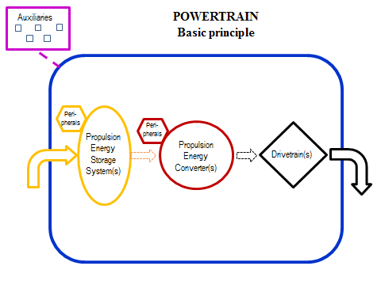Figure 2

Internal Combustion Engine-Vehicle (conventional) - ICEV
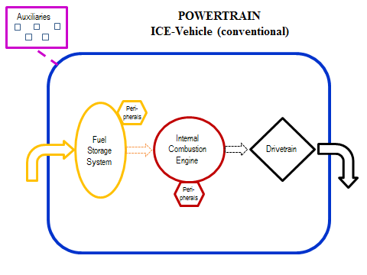

Figure 3

Pure Electric Vehicle - PEV
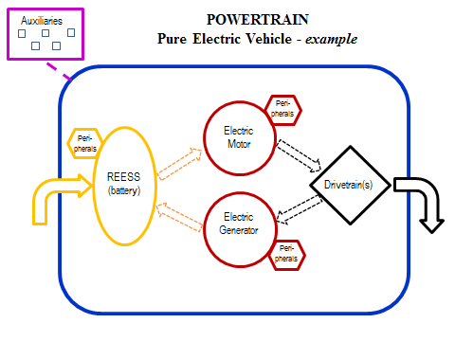

Figure 4

Hybrid Electric Vehicle-Not Off Vehicle Charging (parallel) - HEV-NOVC
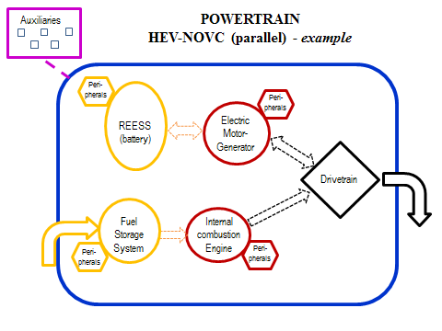

Figure 5

Hybrid Electric Vehicle-Off Vehicle Charging (serial, range extender) - HEV-OVC
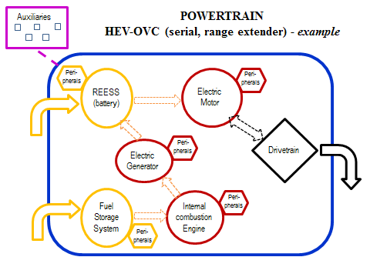

Figure 6

Hybrid Electric Vehicle-Off Vehicle Charging (combined) - HEV-OVC
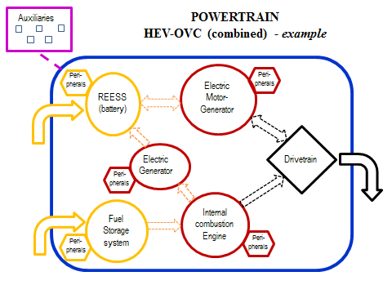

Figure 7

Fuel Cell Hybrid Vehicle - Not Off Vehicle Charging - FCHV-NOVC
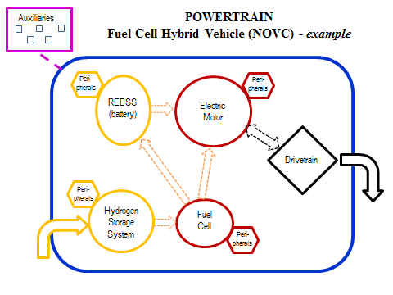
13. Moreover, it was considered defining "fuel/energy delivery system" as one part of the powertrain but, after thorough discussion, it was decided to assume it as part of the peripherals of the energy storage system or of the energy converter (e.g. fuel pump, linings, electric power conditioning device, evaporative emission control system).
1.1. Propulsion energy storage system
14. After discussion in VPSD informal working group it was decided to distinguish between energy storage systems whose output energy is used directly or indirectly for the purpose of vehicle propulsion (e.g. an Internal Combustion Engine (ICE) in a range extender Hybrid Electric Vehicle (HEV)), and other energy storage systems as parts of the powertrain (peripheral devices) or as parts of the remaining part of the vehicle (auxiliary devices). Without such a differentiation the definitions of Hybrid Vehicle (HV) and HEV are not explicit enough, and a conventional ICE vehicle could be understood as an HEV.
15. One example for another energy storage system, which is not considered as a propulsion energy storage system, is the 12 V battery, which provides the basic power to the electric and electronic systems on-board of the vehicle. In the context of powertrain definitions, the 12 V battery should be regarded as a peripheral device and clearly be separated from e.g. the Rechargeable Electrical Energy Storage System (REESS) of a hybrid vehicle, although it should not be excluded that the REESS and its peripheral (battery providing basic electric power) are combined into a single system.
1.1.1. Fuel storage system
16. Fuel storage system means a propulsion energy storage system that stores and delivers chemical energy on board of the vehicle and which is refillable. It can store liquid, cryogenic or compressed gaseous fuels.
1.1.2. Rechargeable Energy Storage System (RESS)

17. RESS means a propulsion energy storage system that stores electrical or mechanical energy and which is rechargeable.
1.1.2.1. Rechargeable Electric Energy Storage System (REESS)
18. The problem of the definitions RESS and REESS has been discussed for a long time in WP.29 and in UN global technical regulations. RESS is used in UN Regulation No. 92, meaning "replacement exhaust silencer system". Therefore the Electrical Safety (ELSA) informal working group decided that REESS in UN Regulation No. 100 means "rechargeable energy storage system". Unfortunately this definition in UN Regulation No. 100 does not differentiate between electric and non-electric REESS. It is herewith proposed to specify the acronym REESS, i.e. rechargeable electric energy storage system.
19. The input and output of a REESS is electrical energy. Additional internal processes (e.g. electrochemical processes of a battery) are not taken into account. A REESS can be a battery (accumulator) or a capacitor for example. A REESS can be externally charged (ovc) or exclusively internally charged (novc).
1.1.2.2. Rechargeable mechanical energy storage system (RMESS)
20. Input and output of a RMESS is mechanical energy, including hydraulic and pneumatic energy. Examples for RMESS are flywheels and containers for compressed air.
1.1.3. Category of propulsion energy storage system
21. The definition of hybrid vehicles requires a differentiation of propulsion energy storage system, which can be any combination of (i) a fuel storage system, or (ii) a rechargeable electric energy storage system, or (iii) a rechargeable mechanical energy storage system.
1.2. Propulsion energy converter
22. The same approach as described in section 1.1. is needed for energy converters. Examples for "other energy converters" are a fuel pump (peripheral device) or a mobile air conditioning system (auxiliary device), which are not considered as propulsion energy converters.
1.2.1. Internal combustion engine (ICE)
23. The terminology "Internal Combustion Engine (ICE)" is already used in several regulations, but was never defined because its meaning is inherently clear. However, while ICE is one of the essential elements of defining a powertrain category, it might be helpful to define ICE as one category of energy converter.
24. It was discussed whether to describe the internal combustion process in details in the definition ("... means an energy converter in which [intermittent or continuous oxidation of combustible material takes place in a confined space] / [in which combustion of the fuel takes place in a confined space], producing expanding gases that are used directly to provide mechanical power]"), or to take the more general and simple language ("means an energy converter transforming chemical energy [(input)] into mechanical energy [(output)] with an internal combustion process").
25. It was discussed, in order to open up the possibility of regulating external combustion engines and getting them approved, to introduce the overarching term of "Combustion Engine (CE)", sub-dividing it into an internal and an external one. It was agreed to start with the definition of ICE and to introduce the external CE concept at a later stage if needed.
26. In some regulations (e.g. UN Regulation No. 49) the term "engine" is used as an alternative to ICE as a propulsion energy converter. To use such a term in a regulation might be useful for practical reasons, but with the introduction of additional powertrain configurations (e.g. Pure Electric Vehicle (PEV), HEV, Fuel Cell Hybrid Vehicle (FCHV)) it is necessary to avoid possible misinterpretations of the text of the regulations. Therefore it is necessary to clarify in future the meaning of terms like "engine", or to introduce a definition.
1.2.2. Electric machine
27. It was carefully evaluated whether to define an electric machine and an electric motor as two different entities. On many of the current electrified vehicles, there is only one energy converter (electric machine), which can operate as an electric motor (input electric energy, output mechanical energy) or as an electric generator (vice versa). By the classic academic definition, electric machines encompass electric motors, electric generators and electric motor-generators, all of which are electromechanical energy converters: converting electric to mechanical power (i.e. electric motor) or mechanical to electric power (i.e. electric generator).
1.2.2.1. Electric motor
28. It means an electric machine transforming electrical energy (input) into mechanical energy (output).
1.2.2.2. Electric generator
29. It means an electric machine transforming mechanical energy (input) into electrical energy (output).
1.2.2.3. Electric motor-generator
30. It means an electric machine transforming electric energy into mechanical energy and vice versa.
1.2.3. Fuel cell (FC)
31. A Fuel Cell (FC) is an energy converter transforming chemical energy from a fuel into electrical energy, through a chemical reaction with oxygen or another oxidizing agent. As a fuel, the most commonly one used nowadays is hydrogen, but hydrocarbons (such as natural gas) and alcohols (such as methanol) may also be used. Since in the future there may be different ways of using fuel cells –i.e. not limited to the above-mentioned fuels directly converted by the fuel cell– the scope of the definition was kept as wide as possible to prevent legal barriers to technical progress.
32. Fuel cells are different from batteries in that they require a constant source of fuel and oxygen to run, but they can produce electricity continuously for as long as these inputs are supplied. It was discussed whether a FC can be understood as an energy converter (hydrogen input, electric energy output) or as an energy storage system (electrochemical cell). VPSD informal working group agreed finally to classify a FC as an energy converter, because the forms of energy input and output are different.
33. In case a reformer is used upstream of the fuel cell in order to generate hydrogen from a liquid or gaseous fuel, this reformer is not understood as an energy converter (form of energy is unchanged by the reformer). In order to measure and limit possible emissions of such a reformer (CO₂, CO, HC), new requirements need to be introduced in regulations.
1.2.4. Category of propulsion energy converter
34. Corresponding to the approach in section 1.1., the definition of hybrid vehicles requires a differentiation of propulsion energy converter, which can be (i) an internal combustion engine, or (ii) an electric machine, or (iii) a fuel cell.
1.3. Drivetrain
35. It was discussed whether it is more appropriate to use the terminology "drivetrain" or "power transmission system", including the part (or parts) / connected elements of the powertrain, which transmit(s) the mechanical energy between energy converters (e.g. in case of a combined hybrid electric vehicle) and/or between energy converter(s) and the contact point between the vehicle and the road. A conventional ICE vehicle contains only one drivetrain downstream of the ICE. A HEV vehicle (combined) can contain more than one drivetrain. Clutch, gearbox, differential gear, drive shaft, wheels, etc. can be parts of the drivetrain.
36. As the term "drivetrain" is already used in several regulations (e.g. UN Regulations Nos. 85 and 101), but without having a definition, the wording of these regulations needs to be amended accordingly after the adoption of the proposed part B of this document.
1.4. Peripheral devices
37. Peripheral devices are part of the powertrain. They can be energy storing, convering, supplying or consuming devices or other parts, systems and control units, which are essential to the operation of the powertrain. They are not understood as propulsion energy storage systems or propulsion energy converters of the powertrain. These devices are not providing different forms of energy directly or indirectly for the purpose of propulsion. Examples of peripheral devices are electrical capacitor, 12 V battery , starter motor, intake system, fuel delivery system, electric power conditioning device, sensor, actuator, capacitor, electronic control unit, turbo charger, exhaust after-treatment system.
38. This concept is important to clearly distinguish peripheral devices from propulsion energy storage systems or propulsion energy converters of the powertrain, because otherwise conventional ICE vehicles can be understood as HEV.
2. Energy storage system
39. The main energy storage systems of a powertrain where the output energy is used directly or indirectly for the purpose of vehicle propulsion, are defined as "propulsion energy storage systems" (see section 1.1.). But there are also other energy storage systems in a vehicle, as peripheral devices of the powertrain or auxiliary devices.
40. A specific kind of energy storage system stores only one form of energy (chemical, electrical, mechanical). The fundamental characteristic of an energy storage system is that the form of energy input to the storage system is the same as the form of energy output from the storage system. Independent from other processes which may occur inside an energy storage system, it is understood as a black box which stores and releases the same form of energy. The proposal structures energy storage systems into:
(a) Fuel storage systems, which are refillable with liquid or gaseous fuel);
(b) Rechargeable Electrical Energy Storage Systems (REESS); or
(c) Rechargeable Mechanical Energy Storage Systems (RMESS).
41. In a vehicle two or more different fuel storage systems can be installed, for example in a bi-fuel or dual-fuel vehicle.
42. Rechargeable mechanical energy storage systems also cover systems which store hydraulic and pneumatic energy. Rechargeable energy storage systems can be recharged, either both externally from a separate source (plug in, off vehicle charging), or merely from an on board source (not off vehicle charging).
43. Peripheral devices for the purpose of refilling/recharging (e.g. fuel nozzle, connector) and the purpose of energy delivery (e.g. fuel pump, fuel lines, wires) are understood as parts of the energy storage system. Some regulations require distinguishing between the whole storage system and the core storage device (e.g. fuel tank, container, cylinder). In such cases the regulation should include more specific definitions.
44. Exchangeable energy storage systems (e.g. battery swapping, fuel cartridge) are a subcategory of rechargeable ones. But for the time being there is no regulatory need to differentiate them from those systems, which are fixed installed in the vehicle. Electric trolley vehicles are not covered in vehicle regulations at this stage.
3. Energy converter
45. The main energy converters of a powertrain, whose output energy is used directly or indirectly for the purpose of vehicle propulsion, are defined as "propulsion energy converter" (see section 1.2.). This means for example that an ICE of a range extender HEV is understood as a propulsion energy converter of the powertrain. This clarification is important for the classification of range extender vehicles as hybrid vehicles for regulatory purposes. But there are also other energy converters in a vehicle, as peripheral devices of the powertrain or auxiliary devices.
46. "Energy converter" is a device transforming one form of energy (e.g. chemical, electrical, mechanical) into a different one, in some cases also vice versa. The form of energy output is different from the form of energy input.
47. Internal combustion engine, electric machine and fuel cell are already defined and regulated in existing regulations, and thus, included in the present framework. Other types of energy converters like external combustion engine, turbine or compressed air engine could be added later, once they are regulated. It was also considered whether to define Positive Ignition (PI), Compression-Ignition (CI), 2-stroke, 4-stroke, since this terminology is already used in regulations. It was, however, concluded that these definitions are not needed for further clarification in regulations, because their meaning is clear and the use of such terminology is adequate.
48. Sections 1.2.1. to 1.2.3. define three different categories of energy converters, which are currently used as propulsion energy converters in powertrains of vehicles in 2015.
4. Auxiliary devices
49. Auxiliary devices are not part of the powertrain. They are energy consuming, converting, storing or supplying devices of the vehicle outside the powertrain, used for other purposes. Examples of auxiliary devices are auxiliary battery, mobile air conditioning, hydraulic crane, electric window lift or heating system. The historical approach is to measure and limit the emissions and the efficiency of a vehicle regarding its powertrain. Emissions and efficiency of auxiliary devices are to be treated separately.
5. Vehicle definitions - related to the powertrain configuration
50. After consideration it was decided to classify and introduce definitions of vehicles (regarding their powertrain) rather than powertrain or engine related definitions. If any regulation required such definitions (e.g. powertrain or engine definitions in regulations like UN Regulation No. 49), a similar wording could be used.
51. Figure 8 gives an overview of the structure of the classification and definitions of vehicles related to their powertrain configuration.
Figure 8

Structure overview of the classification and definitions of
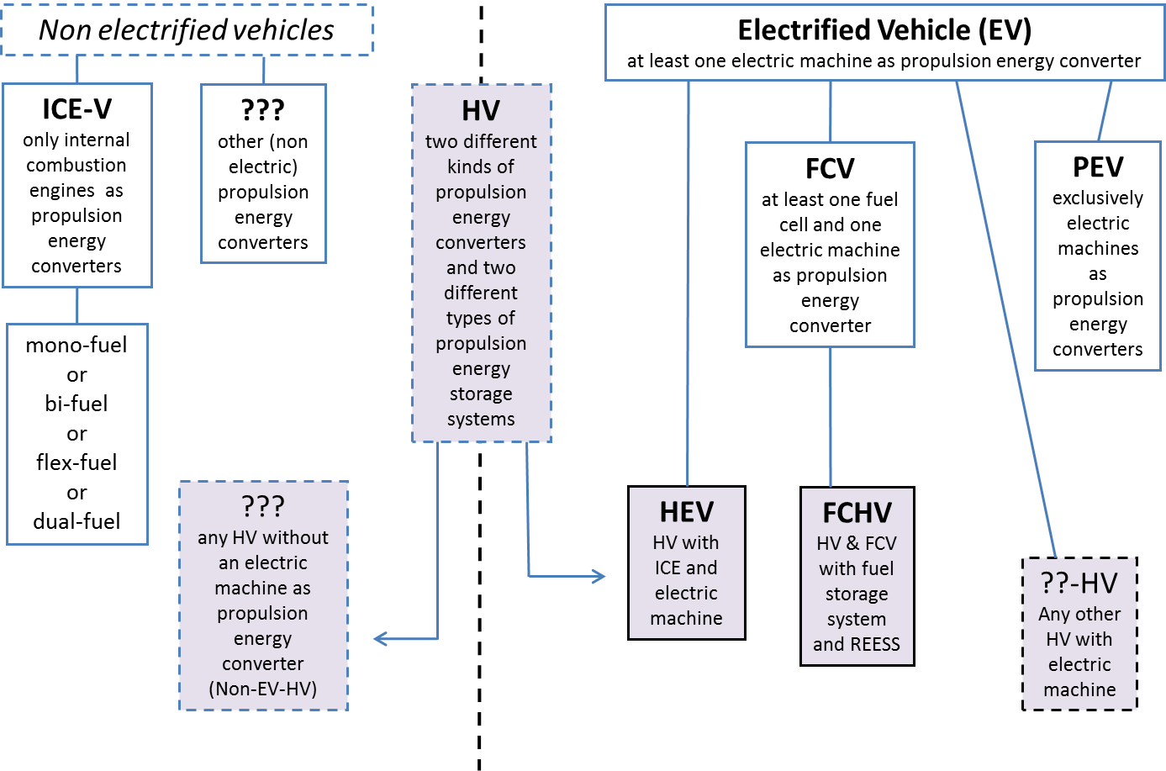
5.1. Internal Combustion Engine vehicle (ICEV)
52. This is a conventional vehicle with exclusively ICE(s) as propulsion energy converter, usually one ICE per vehicle.
5.2. Hybrid vehicle (HV)
53. The principle definition of hybrid vehicles is available in several regulations. After thorough consideration of the need and the way to add new definitions of novel technologies, the following conclusions were drawn:
(a) A subcategorization into parallel, serial and mixed/combined hybrid vehicles was not deemed necessary for the time being, because this differentiation was not reflected in the requirements. The important criteria were switch yes/no and OVC/NOVC (which are defined in section 4.). However, with the Heavy-Duty vehicle Hybrid (HDH) proposal to amend global technical regulation No. 4 (ECE/TRANS/WP.29/2014/84) definitions for parallel and serial hybrids have been introduced. They have to be reconsidered at a later stage.
(b) It is not appropriate to define micro-, mild-, and strong HV for the time being, because these definitions are not required in current regulations.
(c) The same argument applies for the definition of range extenders. However, the powertrain definition is important to ensure that range extender vehicles are clearly defined as HV (HEV or FCHV). For this purpose a hybrid electric vehicle equipped with a range extender shall be understood as a serial hybrid vehicle.
(d) It has to be highlighted again that, in general, the VPSD framework should enable the addition of new definitions at a later stage, without changing the principle system.
5.3. Electrified Vehicle (EV)
54. The definition of an Electrified Vehicle (EV) may not be needed for regulatory purposes; it was considered helpful to group all vehicles with a powertrain containing at least one electric motor or electric motor-generator as propulsion energy converter under this generic term.
55. It was discussed whether ICE vehicles with a stop/start system (sometimes called "micro hybrid") can be considered as EVs. If the stop/start system is designed so that the starter electric motor is only connected to the ICE for the purpose of initiating the start of the combustion process (like for conventional vehicles), and there is no direct or indirect connection of the starter electric motor for the transmission of mechanical energy to the drivetrain, such a vehicle should not be considered as an EV, because the stop/start system is a peripheral device, and not a propulsion energy converter. Otherwise already a conventional ICE vehicle must be considered as an EV/HEV, because the 12 V battery and the starter electric motor might have been considered as second energy storage system and energy converter. In case the starter electric motor contributes partly or continuously, directly or indirectly mechanical energy to the drivetrain, it should be considered as EV/HEV (e.g. boost function/mild hybrid).
5.3.1. Pure Electric Vehicle (PEV)
56. It was agreed to use PEV, even if the acronym BEV (battery electric vehicle) has also been used in the past to indicate the same concept.
5.3.2. Hybrid Electric Vehicle (HEV)
57. It was discussed whether HEV should cover all HV with an electric machine as propulsion energy converter, or if it should be limited to HV with at least one ICE and at least one electric motor/motor-generator. The first option would also cover hybrid FCV. The second option would limit the definition to those HV, which are currently coming onto the market. VPSD agreed on the second option.
5.3.3. Fuel Cell Vehicle (FCV)
58. Vehicles with a fuel cell and an electric machine as propulsion energy converters are defined as FCV. This can be also non-hybrid FCV.
5.3.3.1. Fuel Cell Hybrid Vehicle (FCHV)
59. A FCHV is a hybrid FCV with at least one fuel storage system (mainly hydrogen) and at least on REESS (mainly a battery) as propulsion energy storage systems. For regulatory purposes it might be required to distinguish between hybrid and non-hybrid FCV.

6. List of acronyms/abbreviations
60. At the November 2014 meeting of WP.29 it was considered useful to have a list of acronyms in addition to the definitions in regulations. This will foster the efficient work with the regulation and will help to avoid inconsistencies between the existing regulations under the 1958 and 1998 agreements.
61. Definitions, acronyms and abbreviations are closely related and a limited number were already published on the United Nations Economic Commission for Europe (UNECE) website. There should be continuous interaction between groups working on supplementing harmonized acronyms and definitions as both are linked and should not diverge.
62. In any case the determination and use of acronyms should be limited to the extent possible. Only in cases where an acronym helps to read and understand a regulation efficiently, it should be introduced.
6.1 List of acronyms/abbreviations
EV Electrified Vehicle
HEV Hybrid Electric Vehicle
HV Hybrid Vehicle
ICE Internal Combustion Engine
ICEV Internal Combustion Engine Vehicle
FC Fuel Cell
FCV Fuel Cell Vehicle
FCHV Fuel Cell Hybrid Vehicle
NOVC Not off vehicle charging
OVC Off vehicle charging
PEV Pure Electric Vehicle
REESS Rechargeable Electrical Energy Storage System
RESS Rechargeable Energy Storage System
RMESS Rechargeable Mechanical Energy Storage System
B. Vehicle powertrain definitions
Definitions of vehicle powertrains for vehicles propelled by mechanical energy at the wheels of the vehicle:
1. "Powertrain" means the total combination in a vehicle, of propulsion energy storage system(s), propulsion energy converter(s), the drivetrain(s),, providing the mechanical energy at the wheels for the purpose of vehicle propulsion, plus peripheral devices.
1.1. "Propulsion energy storage system" means an energy storage system of the powertrain, whose output energy is used directly or indirectly for the purpose of vehicle propulsion.
1.1.1. "Fuel storage system" means a propulsion energy storage system that stores chemical energy as liquid or gaseous fuel.
1.1.2. "Rechargeable energy storage system" means a propulsion energy storage system that stores electrical or mechanical energy and which may be re-energised .
1.1.2.1. "Rechargeable electrical energy storage system" means a propulsion energy storage system that stores electrical energy and which is rechargeable.
1.1.2.2. "Rechargeable mechanical energy storage system" means a propulsion energy storage system that stores mechanical energy and which is rechargeable.
1.1.3. "Category of propulsion energy storage system" means (i) a fuel storage system, or (ii) a rechargeable electric energy storage system, or (iii) a rechargeable mechanical energy storage system.
1.2. "Propulsion energy converter" means an energy converter of the powertrain, whose output energy is used directly or indirectly for the purpose of vehicle propulsion."
1.2.1. "Internal combustion engine" means a propulsion energy converter designed to transform chemical energy (input) into mechanical energy (output) with an internal combustion process;
1.2.2. "Electric machine" means a propulsion energy converter transforming between electrical and mechanical energy.
1.2.2.1. "Electric motor" means an electric machine transforming electrical energy (input) into mechanical energy (output).
1.2.2.2. "Electric generator" means an electric machine transforming mechanical energy (input) into electrical energy (output).
1.2.2.3. "Electric motor-generator" means an electric machine transforming electric energy into mechanical energy and vice versa.
1.2.3. "Fuel cell" means a propulsion energy converter transforming chemical energy (input) into electrical energy (output) or vice versa.
1.2.4. "Category of propulsion energy converter" means (i) an internal combustion engine, or (ii) an electric machine, or (iii) a fuel cell.
1.3. "Drivetrain" means the connected elements of the powertrain for transmission of the mechanical energy between the propulsion energy converter(s) and the wheels.
1.4. "Peripheral devices" means energy consuming, converting, storing or supplying devices, where the energy is not primarily used for the purpose of vehicle propulsion, or other parts, systems and control units, which are essential to the operation of the powertrain.
2. "Energy storage system" means a system which stores energy and releases it in the same form as was put in.
3. "Energy converter" means a system where the form of energy output is different from the form of energy input.
4. "Auxiliariy devices" means energy consuming, converting, storing or supplying devices or systems which are installed in the vehicle for purposes other than the propulsion of the vehicle and are therefore not considered to be part of the powertrain.
5. Vehicle definitions - powertrain related
5.1. "Internal combustion engine vehicle" means a vehicle equipped with a powertrain containing exclusively ICE(s) as propulsion energy converter(s).
5.2. "Hybrid vehicle" means a vehicle equipped with a powertrain containing at least two different categories of propulsion energy converters and at least two different categories of propulsion energy storage systems.
5.3. "Electrified vehicle" means a vehicle equipped with a powertrain containing at least one electric motor or electric motor-generator as propulsion energy converter.
5.3.1. "Pure electric vehicle" means a vehicle equipped with a powertrain containing exclusively electric machines as propulsion energy converters and exclusively rechargeable electric energy storage systems as propulsion energy storage systems.
5.3.2. "Hybrid electric vehicle" means a hybrid vehicle equipped with a powertrain containing at least one electric motor or electric motor-generator and at least one internal combustion engine as propulsion energy converter.
5.3.3. "Fuel cell vehicle" means a vehicle equipped with a powertrain containing exclusively fuel cell(s) and electric machine(s) as propulsion energy converter(s).
5.3.4. "Fuel cell hybrid vehicle" means a fuel cell vehicle equipped with a powertrain containing at least one fuel storage system and at least one rechargeable electric energy storage system as propulsion energy storage systems.

www.unece.org/trans/main/wp29/wp29wgs/wp29gen/acronyms_definitions.html
For non-road mobile machinery, the powertrain and any of its constitutive parts referred to in the definitions above may have other purposes than propulsion.

