Submitted by the chair of the IWG on GFV Informal document GRPE-72-12
72nd GRPE, 11-15 January 2016,
agenda item 8

Draft proposal for a new regulation for the approval of Heavy Duty Dual-Fuel Retrofit Systems (HDDF-RS) to be installed on heavy duty diesel engines and vehicles

Informal document GRPE-72-12

Submitted by the chair of the IWG on Gaseous Fuelled Vehicles (GFV)

This document is a draft proposal of a new regulation prepared by the GFV informal working group to enable type approval of dual-fuel retrofit systems to be installed on already approved and in service heavy duty diesel engines and vehicles.
A dual-fuel system is a design to simultaneously operate with diesel fuel and a gaseous fuel, which is already included into the series 05 and 06 of amendments to Regulation No. 49 and for which (OEM) type approvals can be applied. The dual-fuel amendment for the 05 series of Regulation No. 49 (Euro-V) was specially developed to enable the additional procedures for retrofit systems. This draft proposal is the result of developments in the GFV informal group and the work done in the heavy duty dual-fuel task force (HDDF-TF).
This document is primarily submitted to inform the Contracting Parties and stakeholders regarding the provisions and requirements of this new proposed regulation. Some (mainly administrative) provisions still need to be finalized. Those parts are marked with a grey font color.
GFV intends to submit a working document for the 73rd session of GRPE.

Regulation No. xx
Regulation on uniform provisions concerning the approval of dual fuel retrofit systems to be installed on heavy duty diesel engines and vehicles.
Contents

I – Preamble and guidance to the approval of vehicles equipped with a dual-fuel engine retrofit system 4
1. Engine dual-fuel retrofit systems 4
2. Dual-fuel engine retrofit system families and application ranges 5
3. Conformity of production requirements 7
II – Requirements and specifications 8
1. Scope 8
2. Definitions 8
4. Application for approval 10
5. Approval 11
6. Actual applications 12
7. Technical requirements and tests 12
8. Engine retrofit system family and application range 13
9. Conformity of production 14
10. Penalties for non-conformity of production 15
11. Modification and extension of approvals 15
12. Production definitely discontinued 16
13. Names and addresses of Technical Services responsible for conducting approval tests and of Type Approval Authorities 16
Annex 1 – Information and Communication documents 17
Annex 1 Appendix 1 - Information document on dual-fuel engine retrofit system intended to be fitted in road vehicles 21
Annex 1 Appendix 2 - Information document regarding the modification of the retrofitted vehicle / engine 22
Annex 1 Appendix 3 - Information document regarding the application range 23
Annex 1 Appendix 4 - Information documents regarding the actual applications 24
a) Compliance statement 24
b) List of the actual applications 24
Annex 1 Appendix 5 - Information document regarding the demonstration engine 25
Annex 1 Appendix 6 - Arrangement of the dual-fuel engine retrofit system type approval mark 26
Annex 1 Appendix 7 - Communication documents 28
a) concerning the approval of a dual-fuel engine retrofit system pursuant to Regulation No. XX 28
b) concerning the extension of approval of a dual-fuel engine retrofit system pursuant to Regulation No. XX 28
c) concerning the application range of a dual-fuel engine retrofit system pursuant to Regulation No. XX 28
d) concerning the actual applications of a dual-fuel engine retrofit system pursuant to Regulation No. XX 28
Annex 2 - Dual-fuel engine retrofit systems intended to be fitted on road vehicles – requirements and tests 29

I – Preamble and guidance to the approval of vehicles equipped with a dual-fuel engine retrofit system
This Regulation provides a harmonized method for the approval of a dual-fuel engine retrofit system to comply with the level of emissions within the scope of this regulation and as defined by the dual-fuel engine requirements in Regulation 49 (R49). The engine retrofit system includes the devices and components necessary to operate a vehicle in dual-fuel mode, but for the safety provisions reference is made to the safety regulations R67 (LPG) and R110 (CNG/LNG). This Regulation provides uniform provisions to assist national vehicle approval and registration authorities to approve heavy duty vehicles (trucks and busses) with diesel engines that are retrofitted to operate as a dual-fuel vehicle.
Dual-fuel is a mode of operation, which enables the retrofitted diesel engine to operate with diesel fuel and a gaseous fuel simultaneously, both fuels being metered separately, where the consumed amount of one of the fuels relative to the other one may vary depending on the operation (see the dual-fuel engine definition in R49).
A complete dual-fuel retrofit system consists of:
- retrofit elements that enable the operation of the engine either in diesel mode or in dual-fuel mode and constitute the engine retrofit system, and
- devices and components that complete the engine retrofit system (for example gas cylinders , valves, pressure regulators etc.) and that are necessary to permit the operation of the vehicle either in dual-fuel or in diesel mode.
This Regulation is dedicated to the type-approval of dual-fuel engine retrofit systems and not to the type-approval complete retrofit systems.

1. Engine dual-fuel retrofit systems
1.1 The engine retrofit system shall only be type-approved if it complies as a whole with the provisions of this Regulation.
1.2. The essence of this Regulation is to complete the elements helping the Approval Authority to approve the Registration of diesel vehicles retrofitted into dual-fuel vehicles:
- by providing a world-wide recognised type-approval scheme of the engine retrofit system
- by requiring the manufacturer of the engine retrofit system to issue instructions regarding the devices and components that will complete the engine retrofit system, and specifications on how to verify the compliance to these instructions.
- by requiring the manufacturer of the engine retrofit system to issue instructions regarding the installation and use/operation of that system on the engines/vehicles intended to be retrofitted.
- by providing guidance for conformity of production requirements regarding the retrofit operations (manufacture of the retrofit systems as well as installation of these systems on the engines/vehicles intended to be retrofitted.

2. Dual-fuel engine retrofit system families and application ranges
2.1. The approval of an engine retrofit system according to the provisions of this regulation takes into account the characteristics of the components of the engine retrofit system, the interface with the additional required components and the identification of the engines that can be retrofitted with the engine retrofit system.
2.2. For the initial type approval the engine retrofit system (the “parent engine retrofit system”) is installed on a demonstration engine.
2.3. In general the tests for the initial type approval consist of engine performance tests (for example emission tests and the verification of dual-fuel specific requirements).
2.3. When the initial approval is granted, the demonstration engine can be retrofitted with the parent engine retrofit system. The approval is considered also valid for similar engines which do not differ from the tested engine by relevant aspects as specified in this regulation. This set of engines is called “application range”.
2.4. In order to be mounted on all engines belonging to the application range, the engine retrofit system may require some adaptations (for example layout, dimension, etc.) and its components may vary for aspects not relevant as specified in this regulation. This set of engine retrofit systems represents the “engine retrofit system family”.
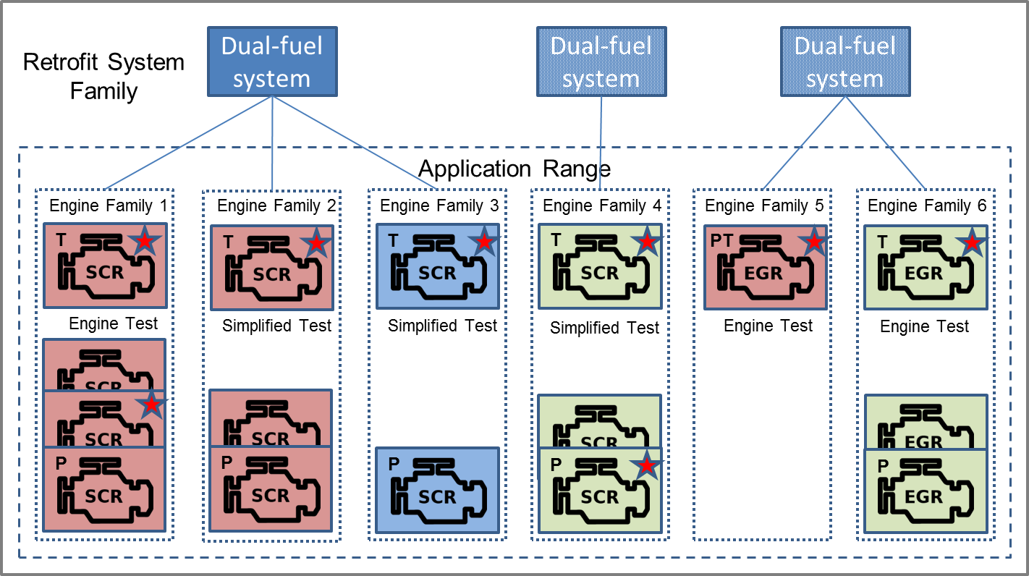
Figure 1: System Family, Application Range and Actual Applications
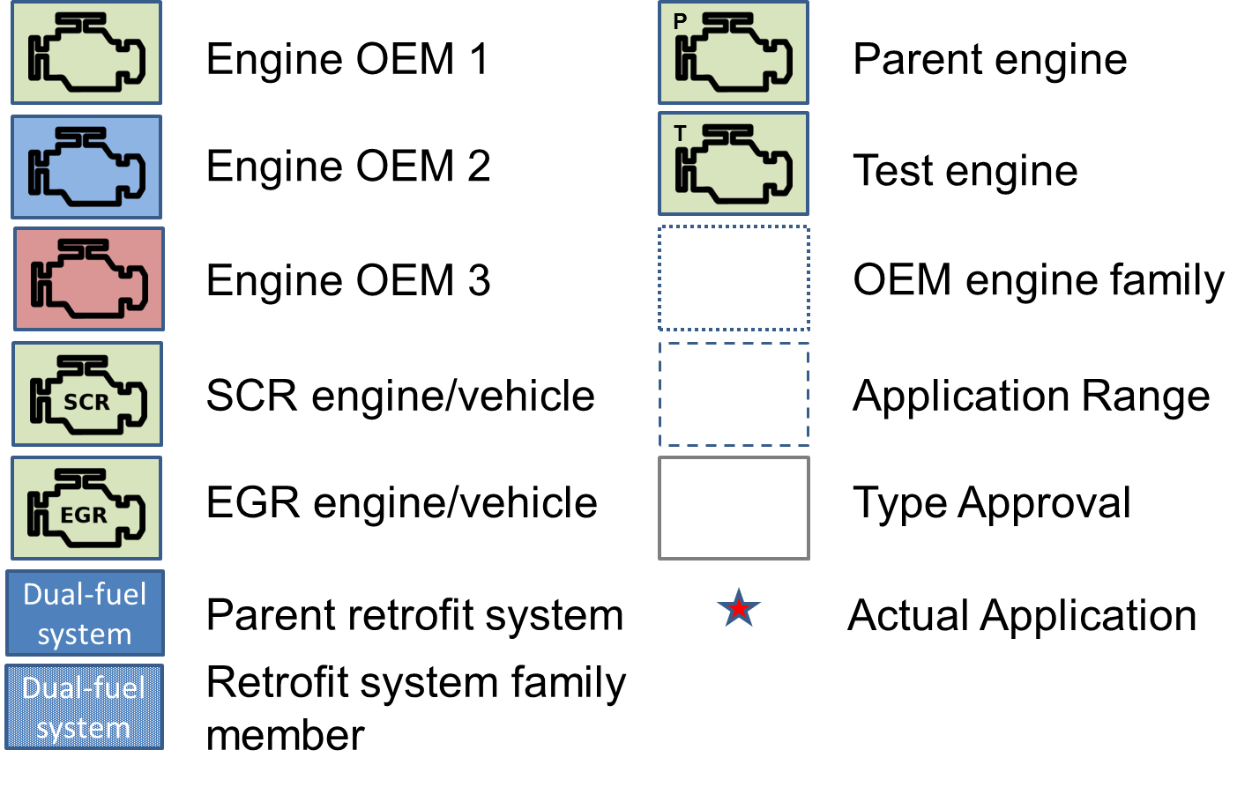
Figure 2: Legend
2.5. The application range may be extended to include other engines by extending the initial type approval.
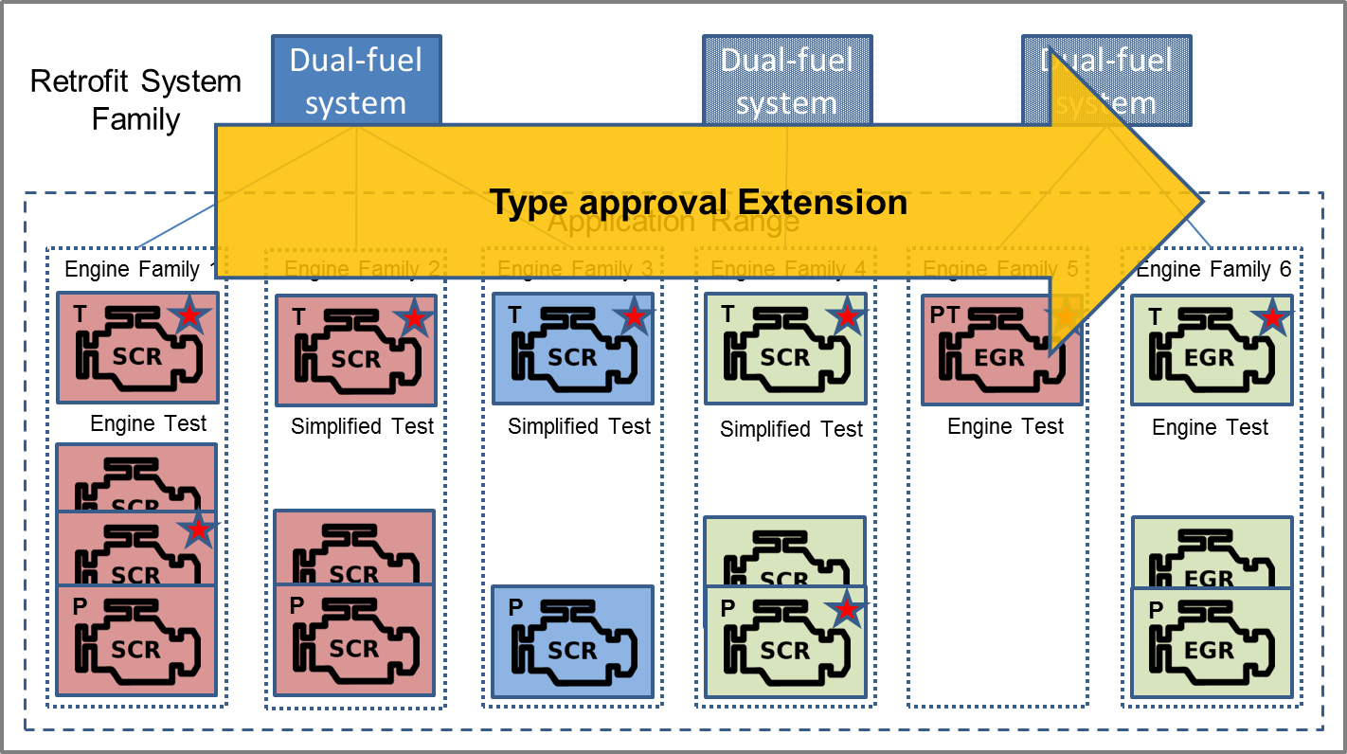
Figure 3: Type Approval Extension
2.5.1. When applying for such an extension, the manufacturer shall submit an engine representative of the additional engines for performing additional tests. The nature of these tests depends on the desired extension.
2.5.2. A test procedure is introduced to evaluate the emission performance of the retrofitted engine by comparing the emissions in dual-fuel mode with those in diesel mode.
2.5.3. Tests may be performed using conventional or portable emission measurement systems on an engine test bench, on a chassis or powertrain test bench or on the road.
2.6. The manufacturer shall notify the Approval Authority for which engines in the application range an engine retrofit system will be developed and produced. This set of engine retrofit systems represents the “Actual Applications”.

3. Conformity of production requirements

3.1. The implementation of and a schedule for conformity of production tests shall be necessary to ensure the quality of the retrofit systems and their application.
3.2. Conformity of production tests shall only be performed on actual applications.
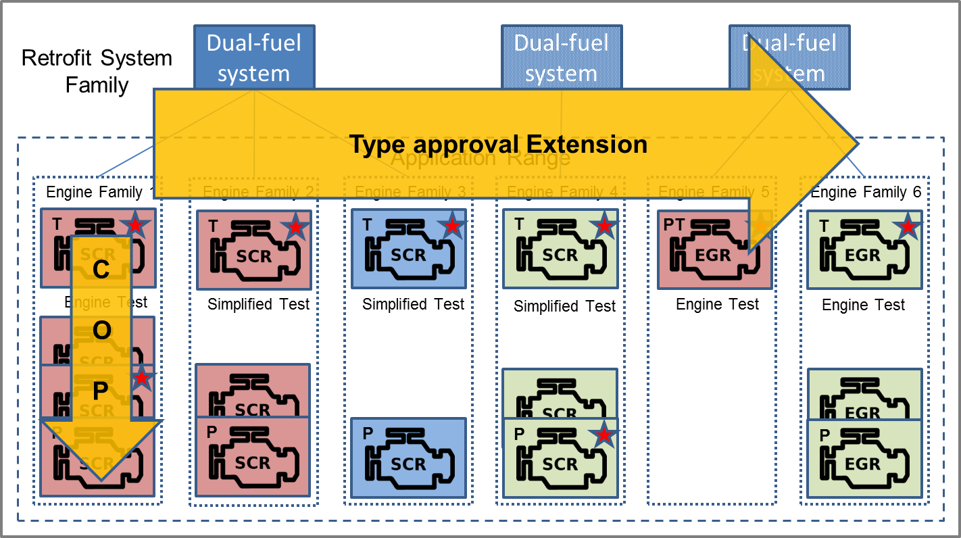
Figure 4: Respective roles of Type Approval Extension and conformity of production.

II – Requirements and specifications

1. Scope
1.1. This Regulation applies to dual-fuel retrofit systems intended to be fitted on vehicles of categories M and N, equipped with engines approved to the requirements of rows B2 or C of tables 1 and 2 of paragraph 5.2.1. of Regulation No. 49 as amended by the 05 series of amendments or to regulations considered as equivalent by the contracting party at the time of type approval.

2. Definitions
2.1. For the purpose of this Regulation, without any further precision,
“Regulation 49” means Regulation No. 49 as amended by the 05 series of amendments.
2.2. For the purposes of this Regulation the definitions listed in Regulation 49 shall apply, unless otherwise stated by paragraph 2.3.
2.3. For the purposes of this Regulation the following definitions shall apply:
2.3.1. “Retrofit system or dual-fuel retrofit system” means a retrofit system for a heavy duty diesel vehicle to enable the operation of their engine either in diesel mode or in dual-fuel mode.
2.3.2. “Engine retrofit system” means a retrofit system for a heavy duty diesel engine to enable its operation either in diesel mode or in dual-fuel mode.
2.3.3. “Engine retrofit system manufacturer” means the person or body who is responsible to the approval authority for all aspects of the type-approval of the engine retrofit system and for ensuring the conformity of production of that system.
2.3.4. “Retrofit system installer or installer” means the person or body responsible for the installation of a type-approved engine retrofit system.
2.3. 5. “Engine retrofit system installation manual” means the manual provided by the manufacturer of the engine retrofit system that includes the information, the specifications, and the tests that are necessary for installing and using the engine retrofit system in a retrofitted dual-fuel vehicle
2.3.6. “End-user manual” means the manual provided by the retrofit system manufacturer to the end-user that includes the information, that is necessary in addition to the original end-user manual of the vehicle for using and maintaining the retrofitted dual-fuel vehicle
2.3.7. “Euro IV engine” means an engine approved to the requirements of row B1 of tables 1 and 2 of paragraph 5.2.1. of Regulation 49 or to regulations considered as equivalent by the contracting party at the time of type approval.
2.3.8. “Euro V engine” means an engine approved to the requirements of row B2 of tables 1 and 2 of paragraph 5.2.1. of Regulation 49 or to regulations considered as equivalent by the contracting party at the time of type approval.
2.3.9. “EEV engine” means an engine approved to the requirements of row C of tables 1 and 2 of paragraph 5.2.1. of Regulation 49 or to regulations considered as equivalent by the contracting party at the time of type approval.
2.3.10. “Original engine system or original engine” means the diesel engine system prior to the installation of the engine retrofit system.
2.3.11. “Original engine family” means the family of the original engine system as type-approved according to Regulation no 49
2.3.12. “R49 original emission limits” means the emission limits as defined in Regulation 49 to which the original engine system was approved.
2.3.13. “Engine retrofit system family” means a retrofit system manufacturer’s grouping of engine retrofit systems which through their design, as defined in this Regulation, have similar retrofitting characteristics.
2.3.14. “Parent engine retrofit system” means an engine retrofit system used for demonstrating compliance at type-approval with the requirements of this Regulation
2.3.15. “Demonstration engine” means the retrofitted dual-fuel engine used at type-approval for demonstrating compliance with the requirements of this Regulation
2.3.16. “Application range” means a grouping of engine systems from which engines may be selected by the engine retrofit system manufacturer to become an actual application.
2.3.17. “Actual application” means an engine system within the application range for which the engine retrofit system manufacturer supplies engine retrofit systems.
2.3.18. “Active CAN communication” means communication via a CAN bus by actively requesting or sending CAN messages (error frames included).
2.3.19. “Passive CAN communication” means communication via a CAN bus without actively requesting or sending CAN messages (“listen-only”).

3. Abbreviations
AR Application Range
CAN Controller Area Network
COP Conformity of production
EEV Enhanced Environmentally Friendly Vehicle
EMC Electro Magnetic Compatibility
EGR Exhaust Gas Recirculation
ELR European load response test
ESC European steady state cycle
ETC European transient cycle
LPG Liquefied petroleum gas
LNG Liquefied Natural Gas
MI Malfunction Indicator
NG Natural gas
OEM Original Equipment Manufacturer
PEMS Portable Emission Measurement System
R49 Regulation 49
TA Type Approval
TAA Type Approval Authority

4. Application for approval
4.1. Application for approval of a dual-fuel engine retrofit system family.
4.1.1. The application for approval of a dual-fuel engine retrofit system family shall be submitted by the engine retrofit system manufacturer or by his duly accredited representative.
4.2. Documentation package
4.2.1 The application for approval shall be accompanied by an information package describing the demonstration retrofit system and engine, the retrofit system family and the application range:
4.2.1.1. Demonstration retrofit system and engine
- Description of the demonstration engine retrofit system (including the list of the components);
- Description of the demonstration engine;
- Installation manual of the demonstration engine retrofit system on the demonstration engine;
- End-user manual.
4.2.1.2. Retrofit system family and application range
- Description of the engine retrofit system family (including the list of the components);
- Description of the application range;
- Description of the actual applications;
- Description of any modification of the engine system (hardware or software) required for the installation of the engine retrofit system (point d needs to be included in each installation manual see point e);
- The installation manuals of the engine retrofit systems for all the actual applications;
- The table 1 of Appendix XX to Annex 1 properly filled in;
- The elements demonstrating compliance with and required by this Regulation (note: tests reports at the “Type Approval application” stage and compliance statements);
4.2.2 The content of the information package shall comply with the requirements specified in Annex 1
4.3. Engine retrofit system sample
4.3.1. A sample of the engine retrofit system and a demonstration engine with the installed engine retrofit system shall be made available at type-approval to the type-approval authority.

5. Approval
5.1. Approval of a dual-fuel engine retrofit system family.
5.1.1. Type approval shall be granted if the dual-fuel engine retrofit system family meets the requirements of this Regulation.
5.1.2. An approval number shall be assigned to each approved engine retrofit system family.
5.1.2.1 Its first two digits (at present 00 according to the Regulation in its original form) shall indicate the series of amendments incorporating the most recent major technical amendments made to the Regulation at the time of issue of the approval.
5.1.2.2. The same Contracting Party shall not assign the same type approval number to another engine retrofit system family.
5.1.3. Notice of approval or of refusal or of extension of approval of an engine retrofit system family pursuant to this Regulation shall be communicated to the Parties to the Agreement applying this Regulation, by means of a form conforming to the model in Appendix 5 to Annex 1 to this Regulation.
5.1.4. In addition to the Notice specified in paragraph 5.1.3., when applicable, the application range of the approved dual-fuel engine retrofit system family shall be communicated to the Parties to the Agreement applying this Regulation by means of a form conforming to the model in Appendix 3 to Annex 1 to this Regulation.
5.2. Markings of an approved dual-fuel engine retrofit system
5.2.1. The sample(s) of a specific dual-fuel engine retrofit system submitted to type approval shall be accompanied by a plate or its drawing with following information;
- the approval number;
- the trade name or mark of the engine retrofit system manufacturer;
- the type;
- the date of approval, extension or notification, whichever is the latest;
- a list of the components types comprising the system;
as shown in Appendix 6 to Annex 1.
5.2.2. All dual-fuel engine retrofit systems shall be identified by the plate described in 5.2.1. which shall be permanently fixed on the body of the vehicle.

6. Actual applications
6.1. An approved engine retrofit system shall only be installed on an engine system belonging to its actual applications.
6.2. An engine system belongs to the actual applications when the engine retrofit system manufacturer has notified the type approval authority that this engine system is added to the actual applications or when it was already included as an actual application at type approval.
6.3. The engine retrofit system manufacturer shall at that time provide the installation manual of the system, compliant with paragraph 13 of Annex 2 and specific for each actual application, the compliance statement, as well as a form containing an updated table x of Appendix 4 to Annex 1.
6.3.1. In addition to the Notices specified in paragraphs 5.1.3. and 5.1.4., when notified, the actual applications of the approved dual-fuel engine retrofit system family shall be communicated to the Parties to the Agreement applying this Regulation by means of a form conforming to the model in Appendix 7 to Annex 1 to this Regulation
6.4. The engine retrofit system manufacturer shall ensure that actual applications will be compliant with the requirements of this Regulation.
6.5 The engine retrofit system manufacturer shall only supply engine retrofit systems for engine systems which belong to the actual applications.

7. Technical requirements and tests
7.1. The engine retrofit system shall fulfill the requirements specified in sections 7.2. to 7.5
7.2. Requirements for dual-fuel engine retrofit systems intended to be fitted in road vehicles
7.2.1. Engine retrofit systems shall fulfill the requirements specified in Annex 2 of this Regulation.
7.2.2. The engine retrofit system shall pass the tests specified in Annex 2 whenever the manufacturer applies for an initial approval or for an extension.
7.3. Additional requirements for NG dual-fuel retrofit systems
7.3.1. The specific components of the engine retrofit system shall comply with Regulation no. 110/XX part I, as applicable.
7.3.2. The installation of an engine retrofit system on an engine shall comply with Regulation no. 110/XX part II, as applicable, and with the specifications of the engine retrofit system installation manual.
7.4. Additional requirements for LPG dual-fuel retrofit systems
7.4.1. The specific components of the engine retrofit system shall comply with Regulation no. 67/01 part I, as applicable.
7.4.2. The installation of an engine retrofit system on an engine shall comply with Regulation no. 67/01 part II, as applicable, and with the specifications of the engine retrofit system installation manual.
7.5. Other additional general requirements
7.5.1. Communication within the vehicle.
7.5.1.1. An engine retrofit system may make use of passive CAN communication.
7.5.1.2. Any CAN communication between the engine retrofit system and the original engine and/or vehicle shall be performed in accordance with the applicable ISO/SAE-Standards.
7.5.1.3. In case the engine retrofit system performs active CAN communication, it shall not increase the CAN bus load by more than 10 per cent (e.g. from 30% to 40%), while the total CAN bus load shall remain less than 80 per cent.
7.5.1.4.. The CAN bus load shall be tested at rated engine power and speed and at full load at 50% and 75% of rated engine speed.
7.5.2. Functional Safety
7.5.2.1. If CAN messages are modified in dual-fuel mode then the original safety functions of the engine or the vehicle shall not be inhibited.
7.5.2.2. The specifications of any modified CAN message shall be part of the documentation submitted at type approval.
7.5.3. Electrical Safety
7.5.3.1. The electrical connections between the engine retrofit system and the engine/vehicle shall be designed according to the applicable ISO/SAE-Standards.
7.5.4. EMC
7.5.4.1. The engine retrofit system shall be compliant with Regulation 10.

8. Engine retrofit system family and application range
8.1. Engine retrofit system family
8.1.1. The parent engine retrofit system of an engine retrofit system family is the engine retrofit system that is used for performing the demonstration tests specified in Annex 2 during the type-approval of the engine retrofit system for its initial application range.
8.1.2. Each member of the engine retrofit system family shall have the characteristics specified in paragraph 3 of Annex 2 in common with the parent engine retrofit system.
8.1.3. The engine retrofit system manufacturer shall provide the list of the engine retrofit systems belonging to the engine retrofit system family in accordance with Appendix xx of Annex 1.
8.2. Application range of an engine retrofit system
8.2.1 Initial application range
8.2.1.1 The initial application range of an engine retrofit system shall be the original engine family to which the demonstration engine belongs.

9. Conformity of production
9.1. The conformity of production (COP) procedures shall comply with those set out in the 1958 Agreement, appendix 2 (E/ECE/324 - E/ECE/TRANS/505/Rev.2).
9.2. The measures taken to guarantee conformity of production shall fulfil the requirements of paragraph 2. of Appendix 2 to the 1958 Agreement.
9.3. Special requirements:
(a) The checks as meant in paragraph 2.2. of Appendix 2 to the 1958 agreement include the checks on conformity with the criteria of paragraphs 7 of this Regulation.
(b) For the application of paragraph 2.4.4. of Appendix 2 to the 1958 Agreement one of the test procedures described in the paragraphs 10.1.1 to 10.1.3. of Annex 2 of this Regulation shall be carried out.
(c) Actual applications as notified by the engine retrofit system manufacturer in accordance with paragraphs 6.2. and 6.3. shall be selected by the approval authority for conformity of production testing.
9.4. Before type approvals can be granted the manufacturers shall submit the following data on conformity of production for the purpose of the initial assessment:
(a) A completed and signed application form, in accordance with a model to be provided by the Type Approval Authority;
(b) A description of the requested information, in accordance with the application form;
(c) A copy of the ISO 9001:2000 certificate, or any equivalent quality system, with a relevant scope.
9.5. Based on this information manufacturers who have a certified quality system may be admitted to the type approval procedure, receiving an Initial Assessment Statement based on the appraisal of documents.
9.6. In case the manufacturer does not have a certified quality system, an assessment of the company shall be carried out based on ISO 9001:2000, including conformity of production aspects.
9.7. At least the following aspects of ISO 9001:2000 are to be described and verified:
(a) Quality management system;
(b) Responsibilities of the board.

10. Penalties for non-conformity of production
10.1. The approvals granted pursuant to this Regulation may be withdrawn if the requirements laid down in Annex 2 are not complied with.
10.2. If a Party to the Agreement applying this Regulation withdraws an approval it has previously granted, it shall forthwith so notify the other Contracting Parties applying this Regulation, by means of the Communication specified in Appendix 5 to this Regulation.

11. Modification and extension of approvals
11.1. Modification and extension of the approval of a dual-fuel engine retrofit system
11.1.1. The authority that granted the type approval shall be notified of any modification to the engine retrofit system. The authority will then assess whether or not the engine retrofit system still complies with the requirements for inclusion in the appropriate family.
The authority may require a further test report from the technical service responsible for conducting the tests in order to assist in its assessment.
11.1.2 Any modification or extension of the application range, as defined in paragraph 11.2, is dealt with as a modification or extension of the type approval of the dual-fuel engine retrofit system. The provisions of paragraph 10 of Annex 2 shall be met.
11.1.3. When the type-approval authority approves the modification, a reference to the formal notification of that approval shall be included in the installation manual.
11.1.4. Confirmation or refusal of approval, specifying the alteration, shall be communicated by the procedure specified in paragraph 6 above to the Parties to the 1958 Agreement applying this Regulation.
11.1.5. The competent authority issuing the extension of approval shall assign a series number for such an extension and inform thereof the other Parties to the 1958 Agreement applying to this Regulation of that number by means of the Communication specified in Appendix 5 of Annex 1 to this Regulation.
11.2 Extension of the application range
11.2.1 Any extension of the application range shall be subject to an extension of the type-approval.
11.2.2. The technical requirements and the tests relative to the extension of the application range of an engine retrofit system as specified in paragraph 10 of Annex 2 shall be fulfilled.
11.2.3. If the demonstration engine meets the requirements of paragraph 10 of Annex 2, the application range is extended with the original engine family of the demonstration engine.

12. Production definitely discontinued
12.1. If the holder of the approval completely ceases to manufacture a type of engine retrofit system approved in accordance with this Regulation, he shall so inform the authority that granted the approval. Upon receiving the relevant communication, that authority shall inform thereof the other Parties to the 1958 Agreement applying this Regulation by means of the Communication specified in Appendix 5 to this Regulation.

13. Names and addresses of Technical Services responsible for conducting approval tests and of Type Approval Authorities
13.1. The Parties to the Agreement applying this Regulation shall communicate to the United Nations Secretariat the names and addresses of the technical services responsible for conducting approval tests and of the administrative departments that grant approval and to which forms certifying approval, extensions, refusals or withdrawal of approval, issued in other countries, are to be sent.

Annex 1 – Information and Communication documents
1. Information document
1.1. General
This information document is related to the approval of dual-fuel engine retrofit systems in accordance with Regulation No. xx. It is referring to measures to be taken against the emission of gaseous and particulate pollutants from compression-ignition engines for use in vehicles and retrofitted to dual-fuel operation with said engine retrofit system.
“Parent engine retrofit system/retrofit system
0. General
0.1. Make (name of undertaking):
0.2. Type and commercial description (mention any variants):
0.3. Means and location of identification of type, if marked on the vehicle:
0.4. Category of vehicle (if applicable):
0.5. Category of engine: diesel and NG/LNG₂₀/LPG fuelled¹
0.6. Name and address of manufacturer:
0.7. Location of statutory plates and inscriptions and method of affixing:
0.8. In the case of components and separate technical units, location and
method of affixing of the ECE approval mark:
0.9. Address(es) of assembly plant(s):
Appendices:
1. Essential characteristics of the (parent) engine retrofit system and information concerning
the conduct of test (see Appendix x).
2. Essential characteristics of the engine retrofit system family (see Appendix xx).
3. Characteristics of the engine-related vehicle parts, if applicable (see Appendix xx).
4. OBD-related information, if applicable
5. Photographs and/or drawings of the demonstration engine and, if applicable, of the engine compartment.
6. […….]
7. List further attachments, if any.

Date and place: “

1.2. Information regarding the engine retrofit system
See R49 Annex 1 – 2nd section
1.3. Information regarding the modifications to be performed on the diesel engine and on the diesel vehicle
1.3.1. Changes affecting characteristics declared in R49
Modifications of the characteristics in the tables in parts 1 and 2 of Annex 1 of R49
Appendix 2 – part I

1.3.2. Other changes subject to type-approval
For example changes in strategies new strategy descriptions
Appendix 2 – part II

1.4. Information regarding the initial application range
Engine family of the demonstration engine (as applicable)
Vehicles equipped with an engine of that family and concerned by the engine retrofit system (as applicable)
Appendix 3 – part I

1.5. Information regarding the demonstration engine
See appendix to information document in Annex 1 of R49
Appendix 4 – parts I and/or II as appropriate

2. Information document for an extension of the application range
2.1. General
Reference to previous type-approvals either for the initial application range or for previous extensions.
2.2. Information regarding the modifications to be performed on the diesel engines / vehicles of the extended application range
Concerns only the modifications not yet declared at type-approval either for the initial application range or for previous extensions.
2.2.1 Changes affecting characteristics declared in R49
Modifications of the characteristics in the tables in parts 1 and 2 of Annex 1 of R49.
Appendix 2 – part I

2.2.2 Other changes subject to type-approval
For example changes in strategies new strategy descriptions
Appendix 2 – part II

2.3. Information regarding the extension of the application range
Concerned engine families (as applicable)
Vehicles equipped with an engine of these families and concerned by the engine retrofit system (as applicable)
Appendix 3 – part II

2.4. Information regarding the demonstration engine
See appendix to information document in Annex 1 of R49
Appendix 4 – parts III

Annex 1 Appendix 1 - Information document on dual-fuel engine retrofit system intended to be fitted in road vehicles

Annex 1 Appendix 2 - Information document regarding the modification of the retrofitted vehicle / engine

Annex 1 Appendix 3 - Information document regarding the application range

Annex 1 Appendix 4 - Information documents regarding the actual applications

Compliance statement
1. The following is a model of the compliance statement:
"[Name of manufacturer] attests that the actual application [Identification of the actual application] complies with all requirements of Regulation XX. [Name of manufacturer] makes this statement in good faith, after having performed an appropriate engineering evaluation of the emissions performance of the actual application over the applicable range of operating and ambient conditions.
Date: [Date]
Place: [Place]
[Stamp and signature of the manufacturer’s representative]"

List of the actual applications

Annex 1 Appendix 5 - Information document regarding the demonstration engine

Annex 1 Appendix 6 - Arrangement of the dual-fuel engine retrofit system type approval mark
1. The approval mark shall consist of:
1.1. A circle surrounding the letter “E” followed by the distinguishing number of the country which has granted the approval;
1.2. A symbol indicating the fuel type, where the symbol “➢” indicates an CNG retrofit system, a “#” means LPG, a “%” means LNG.
1.3. The number of this Regulation, followed by the letter “R”, a dash and the approval number to the right of the circle defined below. The approval number consists of the retrofit system type approval number, which appears in the communication form for this type approval (see paragraph 11.2. and Appendix 5 of Annex 1) preceded by two figures indicating the latest series of amendments to this Regulation.

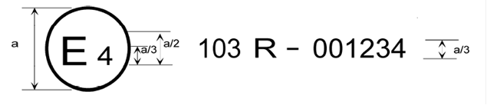
*XXX

a = min. 8mm

The above approval mark affixed to the plate of dual-fuel retrofit system, shows an approval from the Netherlands (E4), pursuant to Regulation No. XXX under approval number 001234. The symbol "➢" indicates a CNG retrofit system. The first two digits of the approval number indicate that approval was granted in accordance to the requirement of Regulation No. XXX in its original form.

Revise diagram below

Annex 1 Appendix 7 - Communication documents

concerning the approval of a dual-fuel engine retrofit system pursuant to Regulation No. XX

concerning the extension of approval of a dual-fuel engine retrofit system pursuant to Regulation No. XX

concerning the application range of a dual-fuel engine retrofit system pursuant to Regulation No. XX

concerning the actual applications of a dual-fuel engine retrofit system pursuant to Regulation No. XX

Annex 2 - Dual-fuel engine retrofit systems intended to be fitted on road vehicles – requirements and tests

1. Definitions
For the purpose of this Annex, the following definitions shall apply in addition to the definitions of paragraph 2 of this Regulation and to the definitions of Regulation 49:
1.1. Reserved
2. Determination of the diesel fuel replacement by a dual-fuel engine retrofit system
2.1 The following process is applicable for determining the diesel fuel replacement by a dual-fuel engine retrofit system.
2.1.1. The demonstration engine is submitted in dual-fuel mode to an ETC test and to an ESC test as specified in Annex 4A of Regulation 49.
2.1.2. The Gas Energy Ratio (GER), as defined in paragraph 2.1 of Annex 11 of Regulation 49, is calculated over the ETC test cycle.
2.1.3. The GER of the demonstration engine over the ETC test cycle shall be higher than 10 per cent.
2.1.4. The ETC and ESC tests referred to in 2.1.1 shall be performed consecutively, in either order.
2.1.5. The fuels used in both tests shall be the same as well as all other test conditions, including the test bench.
2.1.6. The average gas ratio over this ESC test-cycle (GER_{ESC}) is calculated using the weighted average of the consumption of both fuels over this cycle.
2.1.7. The absolute difference between the average gas ratio calculated over this ETC test-cycle (GER_{ETC}) and the average gas ratio calculated over this ESC test-cycle (GER_{ESC}) shall not exceed 20 per cent of the GER_{ETC}.
3. Characteristics and criteria defining an engine retrofit system family
3.1. An engine retrofit system family is defined by design characteristics. These shall be common to all engine retrofit systems within the engine retrofit system family.
3.1.1. An engine retrofit system can only be a member of the same engine retrofit system family as the parent engine retrofit system when it shares with that engine retrofit system the characteristics defined in paragraph 3.2.
3.2. Characteristics defining an engine retrofit system family
3.2.1 Operational characteristics defining an engine retrofit system family:
- Engine retrofit system manufacturer;
- Fuel type (LPG, NG H, NG L, NG HL, LNG₂₀…);
- Adaptation capability for different gaseous fuel compositions;
- Pressure regulator/vaporizer outlet pressure between 0,8 and 1,2 times that of the parent system;
- With or without a fuel pump;
- Fuel supply type (i.e. induction mixer, injector device, vapour or liquid, single or multi-point injection system);
- Fuelling control strategy;
- The difference between the highest and the lowest GER_{ETC} (i.e. the highest GER_{ETC} minus the lowest GER_{ETC}) within a dual-fuel engine retrofit system family shall not exceed 30 per cent.

4 Operating modes
Dual-fuel engine retrofit systems shall be capable of operating in both diesel mode and dual-fuel mode.
A diesel engine retrofitted with a dual-fuel engine retrofit system shall operate in diesel mode or in dual-fuel mode.
4.1. Conditions for a dual-fuel engine to idle using diesel fuel exclusively
4.1.2. Retrofitted dual-fuel engines may idle using diesel fuel exclusively.
4.2. Conditions for a dual-fuel engine to warm-up or start using diesel fuel exclusively in dual fuel mode.
4.2.1. A retrofitted dual-fuel engine may warm-up or start using diesel fuel solely. However, in that case, it shall operate in diesel mode.
4.3. Switch back to diesel mode
A dual-fuel engine retrofit system when operating in dual-fuel mode shall switch-back to diesel mode in all cases listed in this paragraph. The switch- back shall occur as soon as possible.
4.3.1. Unavailability of gaseous fuel
The unavailability of gaseous fuel when operating in dual-fuel mode can be caused by the following cases:
4.3.1.1 Empty gaseous fuel tank
When the gas quantity in the tank exceeds the level that caused the activation of the switch-back, the dual-fuel mode shall be reactivated as soon as possible.
4.3.1.2. Malfunctioning gas supply
The gas injection system electronics, fuel quantity and timing actuator(s) shall be monitored for circuit continuity (i.e. open circuit or short circuit) and functional failure when the engine operates in dual-fuel mode.
As soon as the gas diagnostic system concludes that the malfunction is no longer present or when the OBD information is erased by a scan tool, the dual-fuel mode may be reactivated.
4.3.2. Malfunction(s) detected by the OBD system of the original engine or the dual-fuel retrofit OBD system.
The dual-fuel mode may only be reactivated when the cause of the malfunction is removed and the OBD information is erased by a scan tool.
4.4. Dual-fuel indicators
4.4.1. Dual-fuel operating mode indicator
A dual-fuel engine retrofit system shall have a visual indicator indicating to the driver the mode under which the engine operates (dual-fuel mode or diesel mode).
The characteristics and the location of this indicator are left to the discretion of the retrofit system manufacturer and may be part of an already existing visual indication system.
This indicator may be completed by a message display. The system used for displaying the messages referred to in this point may be the same as the ones used for OBD, correct operation of NO control measures, or other maintenance purposes.
The visual element of the dual-fuel operating mode indicator shall not be the same as the one used for the purposes of OBD (that is, the MI – malfunction indicator), for the purpose of ensuring the correct operation of NO_{x} control measures, or for other engine maintenance purposes.
Safety alerts always have display priority over the operating mode indication.
4.4.1.1. The dual-fuel system shall warn the driver by means of the dual-fuel mode indicator or an audio signal (or both) when the engine operation is forced to diesel mode as required by paragraph 4.3.
4.4.1.2. The dual-fuel mode indicator shall be active for at least one minute on dual-fuel mode or diesel mode as soon as the engine operating mode is changed from diesel to dual-fuel mode or vice-versa. This indication is also required for at least one minute at key-on, or at the request of the retrofit system manufacturer at engine cranking. The indication shall also be given upon the driver's request.

5. Exhaust emissions requirements
5.1. General
5.1.1. The dual-fuel engine retrofit system shall be designed and manufactured as to enable the retrofitted engine or vehicle, in normal use, using that engine retrofit system and complying with the instructions of the engine retrofit system installation manual, to comply with the requirements defined in this Regulation.
5.1.1.1. The emission tests at type-approval shall be performed according to the requirements specified in section 5.2 of this Annex.
5.1.1.2. The emission limits shall be those specified in section 5.3 of this Annex.
5.1.2 The engine retrofit system shall comply with the general requirements regarding emission control strategies specified in Regulation 49 Annex 10, whether operating in diesel or in dual-fuel mode.
5.1.2.1. Defeat strategies or defeat devices, as defined and considered by Regulation 49 Annex 10 are forbidden.
5.2. Test requirements at type-approval.
5.2.1. Measurement methods
The emission performance of the demonstration engine shall be measured using the test procedures as specified in this Annex and in R49 Annex 11.
5.2.2. Type approval tests
5.2.2.1. The components of the engine retrofit system installed on the demonstration engine shall be aged in accordance with paragraph 9.2.
5.2.2.2. The demonstration engine shall be tested in the following configurations and operational modes:
(a) diesel mode without the dual-fuel engine retrofit system installed (original engine)
(b) diesel mode with the dual-fuel engine retrofit system installed
(c) dual fuel mode
5.2.3. Laboratory tests
The demonstration engine shall be tested in diesel mode and in dual-fuel mode. The ETC and ESC test cycles shall be used. The emissions to be measured are shown in Table 1.
The average gas ratios over the ESC test-cycle (GER_{ESC}) and over the ETC test-cycle (GER_{ETC}) shall be determined in accordance with paragraph 2.

Table 1 - Laboratory tests to be performed by the demonstration engine
 | Diesel Mode | Dual-fuel Mode
ETC | NMHC; CO; NO_{X}; PM | NMHC; CH₄ª; CO; NO_{X}; PM
ESC | HC; CO; NO_{X}; PM | GER determination only
ª For NG engines only.
5.3. Emission limits for dual-fuel engines retrofitted with an engine retrofit system
5.3.1. Diesel mode after retrofit
The exhaust emissions of the engine operating in diesel mode shall not exceed the R49 original emission limits unless paragraph 5.3.3. applies.
5.3.2. Dual-fuel mode after retrofit
The exhaust emissions of the demonstration engine operating in dual-fuel mode shall not exceed the emission limits specified in this paragraph. No deterioration factors shall be applied as the engine and components are already aged.
5.3.2.1. CO, NO_{x}, PM emissions
The CO, NO_{x} and PM emission limits applicable for Type 2B dual-fuel engines as specified in R49.
5.3.2.2. THC, NMHC, CH₄ emissions
5.3.2.2.1. For LPG engines the THC emission limit applicable for Type 2B LPG dual-fuel engines as specified in R49.
5.3.2.2.2. For NG engines and at the request of the manufacturer in agreement with the Type Approval Authority, the hydrocarbon emissions shall comply with either paragraph 5.3.2.2.3. or paragraph 5.3.2.2.4.
5.3.2.2.3. The hydrocarbon emission limit applicable for Type 2B NG dual-fuel engines as specified in R49.
5.3.2.2.4. The NMHC emission limit applicable for Type 2B NG dual-fuel engines as specified in R49 and the following GER dependent CH₄ limit:
${CH}_{4}≤6.84*GER/100$ AND ${CH}_{4}≤6$ [g/kWh]
5.3.3. Demonstration engine not meeting the engine baseline emission stage
If the test results relating to configuration (a) of paragraph 5.2.2.2. exceed the applicable emission limits for one or more pollutants, the engine may still be used for the type approval tests, provided that:
- the test results for such pollutants relating to configuration (b) of paragraph 5.2.2.2. shall not exceed the exhaust emissions of the engine before the retrofit, and;
- the test results for such pollutants relating to configuration (c) of paragraph 5.2.2.2. shall not exceed the applicable emission limits.

This provision is applicable only at the request of the engine retrofit system manufacturer if both the following conditions are met:
5.3.3.1. it can be demonstrated that no other equivalent engine can be submitted as demonstration engine for the type approval of the dual-fuel engine retrofit system, and
5.3.3.2. no confirmed and active DTC is present in the OBD system of the original engine.

6. Power requirements
6.1 Demonstration engine configuration and operational modes
The demonstration engine in the configuration of paragraph 5.2.2.2., subparagraph (b) and (c), shall be submitted to the test procedures of paragraph 5.2.2.2.
The measured power in configuration (c) shall be within 5 per cent of the power measured in configuration (a).
6.1.1. The maximum power at the crankshaft is measured on an engine test bench in accordance with Regulation No. 85 (engine dynamometer method).
6.2. CAN transmitted torque Test
The comparisons mentioned below are between the CAN messages present on the CAN bus.
6.2.1. The engine output torque message in dual-fuel mode shall be compared with the engine output torque message in diesel mode on an engine test bench.
6.2.2. The difference between the engine output torque message in diesel mode and the engine output torque message in dual-fuel mode shall be less than 5 per cent.
6.2.3. The comparison shall be performed in all modes of the ESC test, except mode 1.

7. Requirements and tests for dual-fuel engine retrofit system OBD
7.1. The dual-fuel engine retrofit system shall implement an OBD system that complies with the requirements for type 2B engines specified in paragraph 7 of R49 Annex 11 and with the following restrictions:
(a) During diesel operation the diesel OBD system shall remain the only on board diagnostic system of the vehicle. The MI shall activate in case of a detected malfunction;
(b) During dual-fuel operation the diesel OBD system shall continue to monitor the original emission related components in use. The MI shall activate in case of a detected malfunction;
(c) During dual-fuel operation the dual-fuel ECU shall only monitor the dual-fuel emission related components as well as their electrical connections. If the dual-fuel ECU detects a malfunction, the switch to diesel mode shall be performed as soon as possible. Operation in dual-fuel mode shall not be possible until the cause of the malfunction is removed and a clear visual or acoustic signal shall inform the driver about this situation.
7.2. The dual-fuel engine retrofit system OBD shall be submitted to the following tests carried out on the demonstration engine:
(a) In diesel mode the original malfunction indicator (MI) shall activate due to the electrical disconnection of any original emission-related component;
(b) In dual-fuel mode the original MI shall activate due to the electrical disconnection of any original emission-related component that is in use during dual-fuel operation. The engine retrofit system shall switch back to diesel operation as soon as the original MI is activated.
(c) In dual-fuel mode the automatic switch to diesel mode shall occur due to replacement of any dual-fuel emission-related component with a deteriorated and defective one or electronic simulation of such a failure.
7.3. Fault codes referring to malfunctions of the gas emission-related components and their electrical connections shall be stored in the dual-fuel ECU. The fault codes shall be available through the OBD bus or through a dedicated communication line.
7.4. The engine retrofit system manufacturer shall provide specific instructions and tools to read out the fault codes referred to in paragraph 7.3. of this annex in the case of a dedicated communication line.

8. Requirements to ensure the correct operation of NO_{X} control measures
8.1. If the MI is activated the system shall automatically switch to diesel mode and stay in that mode until the issue causing inducement is fixed.
8.2. This way the dual-fuel engine retrofit system enables the retrofitted engine to remain compliant with the requirements to ensure the correct operation of NO_{X} control measures specified in paragraph 5.5. of R49.

9. Durability requirements
9.1. The applicant shall declare that the dual-fuel engine retrofit system when used and maintained according to the manufacturer’s instructions will comply with the applicable provisions during normal operation over a useful life of 4000 operating hours or a service life of 6 years, whichever occurs first.
9.2. The dual-fuel engine retrofit system submitted to the durability tests as specified in R67 or R110, as applicable, shall be used to demonstrate the exhaust emission requirements as specified in paragraph 5. of this Annex.

10. Requirements and tests for the extension of the application range
10.1. Tests and requirements
An engine representative of the desired extension of the application range shall be tested in accordance with the provisions set out in paragraph 10.1.1. or 10.1.2. or 10.1.3. at the choice of the dual-fuel engine retrofit system manufacturer. Engine tests are always required for the extension of an application range with an engine family equipped with EGR.
The tests shall be carried out on a representative engine equipped with a member of the dual-fuel engine retrofit system family.
The same tests shall be performed in diesel mode and in dual-fuel mode in such a way that the operating points and conditions are as similar as possible.
The NO_{X}, non-methane hydrocarbon (NMHC), CO and PM emission test results in dual-fuel mode shall be lower than or equal to the results in diesel mode.
10.1.1. Engine testing
10.1.1.1. Emission tests
10.1.1.1.1. The representative engine and the engine retrofit system shall be tested on an engine test bed using ESC test procedures.
The test procedures and results shall comply with the applicable provisions of paragraph 5.
10.1.1.2. OBD requirements and tests
The representative engine equipped with the dual-fuel retrofit system shall comply with the provisions set out in paragraph 7. of this Annex.
10.1.1.3. Power measurement
The representative engine equipped with the dual-fuel retrofit system shall comply with provisions set out in paragraph 6. of this Annex. A separate test in accordance with R85 is not required.
10.1.2. Vehicle testing on a chassis dynamometer
10.1.2.1. Emission tests
10.1.2.1.1. A vehicle equipped with a representative engine and the engine retrofit system shall be tested on a chassis dynamometer at operating points similar to those of the ESC test procedure. All tests shall be performed in the highest gear possible to minimise tyre slip.
The test procedures shall comply with the applicable provisions of paragraph 5.
The NO_{X}, non-methane hydrocarbon (NMHC), CO and PM emission test results in dual-fuel mode shall be lower than or equal to the results in diesel mode.
In case the CO emissions in dual-fuel mode are higher than those in diesel mode, they may be expressed as brake specific emissions using the power at the rollers and shall then be lower than the respective original emission limit. The approval authority may consider other methods to derive brake specific CO emissions.
10.1.2.2. OBD requirements and tests
The representative engine equipped with the dual-fuel retrofit system installed in the vehicle shall comply with the provisions set out in paragraph 7. of this Annex.
10.1.2.3. Power measurement
The representative engine equipped with the dual-fuel retrofit system installed in the vehicle shall comply with provisions set out in paragraph 6. of this Annex. A separate test in accordance with R85 is not required.
10.1.3. On-road vehicle testing using PEMS
10.1.3.1. Emission tests
10.1.3.1.1. A vehicle equipped with a representative engine and the engine retrofit system shall be tested on the road performing the same test trip(s) in diesel mode and in dual-fuel mode with as little time as possible between the trips.
The tests shall be performed with a warmed-up engine.
Care shall be taken that velocities and loads of each respective diesel and dual-fuel mode trip shall be as similar as possible.
The trip shall consist of 45 minutes of city driving followed by 30 minutes of rural driving and 30 minutes of highway driving. The emissions of city driving, rural driving and highway driving shall be evaluated separately. Alternatively separate city, rural and highway trips may be driven and evaluated separately. The durations are approximate which means durations +/- 5 minutes.
City driving is characterized by speeds between 0 and 50 km/h and an average velocity between 15 and 30 km/h. [Some time [app. 12%] with velocity equal to zero and idling. The engine may be stopped during idling in case the engine is stopped during idling automatically by the engine control system.]
Rural driving is characterized by speeds between 50 and 75 km/h and an average velocity between 45 and 70 km/h.
Highway driving is characterized by speeds above 75 km/h.
The average mass emissions expressed in [g/s] from each separate trip (city, rural, highway) will be compared between dual-fuel mode and diesel mode.
The NO_{X}, non-methane hydrocarbon (NMHC), CO and PM emissions in dual-fuel mode shall be lower than or equal to those in diesel mode.
In case the CO emissions in dual-fuel mode are higher than those in diesel mode the approval authority may consider other methods to relate them to the original emission limits.
The test procedures shall comply with the applicable provisions of paragraph 5 and the PEMS testing procedures defined in Annex 8 and Appendix 5 of Annex 15 of the 06 series of amendments to Regulation 49 (R49r06) unless specified otherwise in this paragraph. The work and/or CO₂ based windowing approach and the use of conformity factors are not applicable.
PM or equivalent (e.g. PN) testing will only be required when the necessary procedures will be implemented in R49r06.
10.1.3.2. OBD requirements and tests
The representative engine equipped with the dual-fuel retrofit system installed in the vehicle shall comply with the provisions set out in paragraph 7. of this Annex.
10.1.3.3. Power measurement
Upon agreement with the Approval Authority the power may be determined by performing a full load acceleration according to R49r06, Annex 8, Appendix 4 or by any other suitable method.

11. (Reserved)

12. Installation manual.
12.1. Scope
This section specifies the minimum requirements that shall be contained in the manual.
12.2. General requirements
12.2.1. The purpose of the manual is to guide the installer through the correct procedures to install and assemble the components of a dual-fuel engine retrofit system on the engine.
12.2.2. The manual shall be provided by the dual-fuel engine retrofit system manufacturer.
12.2.3. The manual is considered as part of the engine retrofit system and shall be available to the installer for each conversion kit.
12.2.4. The manual shall be written in English and translated into the language of the country in which the conversion retrofit will be delivered, to the best extent possible.
12.3. Engine retrofit system
12.3.1. Dual-fuel engine retrofit system description
12.3.2. Operational principles of the dual-fuel engine retrofit system
12.3.3. Dual-fuel engine retrofit system approval number
12.3.5. List of the components
12.3.6. Operational principles of each component of the dual-fuel engine retrofit system
12.3.7. The following information for each component:
(a) Identification number;
(b) Manufacturer's code;
(c) Type approval, if it exists;
(d) For the containers: capacity/manufacturer/type/date of expiry or replacement date, if it exists.
12.4. Engine
12.4.1. Engine type and displacement
12.4.2. Engine….
12.5. Installation instructions
12.5.1. Installation instructions of each component together with diagrams or photographs showing clearly the layout of the individual components
12.5.2. Diagram or photograph showing the exact position where the installer shall place the engine retrofit system type approval plate (contained in the conversion kit).
12.5.3. Clear wiring diagram of the electrical system containing the mechanical components to which the wires shall be connected.
12.5.4. Description (including drawings, if applicable) of the fitting devices of the container installation on the vehicle.
12.5.5. Description of any modification of the engine system (hardware and/or software) required for the installation of the engine retrofit system.
12.6 Interfaces
12.6.1. The instructions for completing the system shall include, at a minimum, the following elements:
12.6.1.1. Approvals and markings of the components and devices that are used to complete the engine retrofit system.
12.6.1.2. The technical specifications to be met by the components and devices that are used to complete the engine retrofit system:
- to correctly function,
- to comply with the provisions of this regulation,
- to ensure the desired level of performance and reliability.
The technical specifications shall include the interface specifications (e.g. connection characteristics, gas pressure, communication parameters, fuel gauge or level indicator etc.)

12.7. Proper assembly check
12.7.1. The installation manual shall contain the detailed procedures and actions to be taken by the installer to ensure that the system has been properly assembled in order to perform safely and in accordance with the installation instructions.
12.8. Start-up procedures
12.8.1. The installation manual shall contain the start-up operations to be performed by the installer to ensure that the correct software and calibration are present.
12.9. Service instructions
12.9.1. The installation manual shall contain the maintenance schedule for single components as well as the system throughout their working life (time in km covered by the vehicle) will be specified.
12.9.2. The installation manual shall specify the expertise necessary for the installation/service of the engine retrofit system.
12.10. Engine retrofit system malfunctions
12.10.1. The installation manual shall contain the actions which shall be taken in case the engine retrofit system malfunctions.
12.11. Diagnostics
12.11.1. The installation manual shall contain a detailed description of the diagnostic system and the corrective actions that can be taken in case of malfunctions.
12.12. Scrapping of the product
The manual shall give proper instructions to the installer about precautions to be taken when the system has to be removed from the vehicle.
13. End-User manual
13.1. Scope
To specify the minimum requirements of the end-user manual for dual-fuel retrofit systems operation and maintenance.
13.2. General requirements
13.2.1. The user manual informs the end-user about the characteristics and safety features of the installed dual-fuel retrofit systems.
13.2.2. The user manual shall be provided by the dual-fuel retrofit system manufacturer.
13.2.3. The manufacturer of the system shall include all the necessary information that is needed for correct and safe operation of the dual-fuel retrofit systems.
13.2.4. The user manual shall be considered as an integral part of the system and, therefore, must be included with the delivery of the dual-fuel retrofit system hardware.
13.2.5. The user manual shall be written in the language of the country to which the system is delivered.
13.2.6. The user manual shall reference the product types, versions and production years for which it is applicable.
13.2.7. Information shall be given for relevant extreme ambient conditions.
13.3. Contents of the end-user manual
13.3.1. Technical specifications
The user manual shall contain at least the following information:
(a) Operating characteristics
(b) Performance under normal operating conditions and in extreme ambient conditions.
(
13.3.2. Safety instructions
The user manual shall give warning for dangers to health and safety categorised in the following way:
(a) SUGGESTIONS for optimal use of the system
(b) ATTENTION for possible problems due to misuse
(c) WARNING for damage to persons or goods when procedures are not followed.
If and when safety symbols are used, they shall be in accordance with the international system, SI and their purpose shall be clearly specified in the user manual.
The user manual shall indicate proper actions to be taken in case the vehicle is repainted and put in a hot drying cabin.
13.3.3. Dual-fuel retrofit systems description
The purpose and function of all the components of the dual-fuel retrofit systems shall be clearly described.
13.3.4. First use and adjustment of the dual-fuel retrofit systems
The user manual shall contain all the necessary information for the end user about initial running-in and or adjustment of the system when needed.
13.3.5. Operating the dual-fuel retrofit systems
13.3.5.1. Filling fuel tanks of the dual-fuel retrofit systems
The user manual shall indicate the sequence of operations needed to fill up the gas containers. In the case of LPG, particular attention shall be paid to the maximum filling level of the 80 per cent.
13.3.5.2. Switch-over procedure
The user manual shall clearly describe the method of switching back and forth between the diesel and gas mode by giving the sequence of operations.
13.3.5.3. Opening/closing of manual valves
The user manual shall indicate the proper procedure to operate the manual valves.
13.3.5.4. Fuel level indicator
The user manual shall state the location of the fuel level indicator, for example at the dashboard or at the container. Its read-out has to be clearly explained to the user, giving particular attention to the 80 per cent filling level in case of LPG.
13.3.5.5. Maintenance
If maintenance is required by the end user, the manual shall state the frequency and type of maintenance to be carried out.
13.3.5.6. Defects and repairs
The end user manual shall indicate what actions must be taken in the case of a defect of the system. When the system is equipped with a diagnostic system the user manual shall describe this system and indicate proper actions to be taken.
13.3.5.7. Scrapping of the product
The user manual shall give proper indication that the dual-fuel retrofit system shall be removed from the vehicle by an installer.

As defined in Annex 7 to the Consolidated Resolution on the Construction of Vehicles (R.E.3), (document TRANS/WP.29/78/Rev.1/Amend.2, as last amended by Amend.4).
Delete as appropriate.

