Proposal for amendments to Regulation No. 60
(two-wheeled motor cycles and mopeds - identification of controls, tell-tales and indicators)

The text reproduced below was prepared by the expert from IMMA to amend the requirements for identification of controls, tell-tales and indicators on two-wheeled motor cycles and mopeds. The modifications to the current text of UN Regulation No. 60 are marked in bold for new or strikethrough for deleted characters.
I. Proposal

Insert new paragraph 5.3.1.1., to read:

"5.3.1.1. It shall be ensured that no substantial deviations in the shape and orientation of the provided symbols are permitted. Small irregularities concerning line thickness, and marking application shall be accepted."

Paragraph 5.5.4., amend to read:

"5.5.4. Each symbol used for the identification of a tell-tale, control or indicator shall be in a colour that stands out clearly against the background."

II. Justification
Reproduction of the Regulation can lead to small deviations in appearance of the symbol on actual vehicles. Such irregularities do however not endanger the correct understanding of the symbol and should therefore not lead to interpretation differences at the time of type approval.

Some examples of minor deviations that are found on actual vehicles:
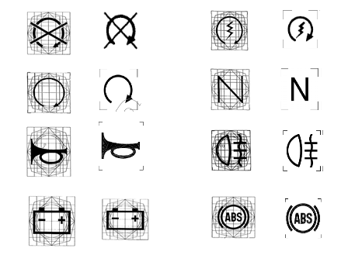

Other types of identification such as embossed or engraved symbols can also stand out clearly against a background. The obligation to use colour is not necessary and is also not present in Regulation No. 121.

_____________________

