INF.4/Add.1
Economic Commission for Europe
Inland Transport Committee
Working Party on the Transport of Dangerous Goods
Joint Meeting of the RID Committee of Experts and the
Working Party on the Transport of Dangerous Goods 04 January 2016
Bern, 14–18 March 2016
Item 6 of the provisional agenda
Reports of informal working groups
RID ADR JOINT MEETING Telematics Working Group
Draft Impact Assessment Implementation of ITS architecture for the transport of dangerous goods
This document is a preliminary impact assessment related to the implementation of an ITS architecture allowing document dematerialization for the dangerous goods inland transport as well as other application such as improving emergency response. It partially follows the EC “Impact Assessment Guidelines” and is presented to the Working Group as a “Work In Progress” document. In particular, it aims at gathering elements to answer a need expressed by the European Commission and assesses impact in general and inside the European Union in the setting up of the architecture developed by the Working Group and presented to the Joint Meeting.
It is proposed to review this draft document and gather Working Group’s recommendation, in particular to assess whether a complete Impact Assessment should be prepared.
Additional data and idea are welcome
Nature and extent of the problem
Dangerous Goods Inland Transport
Dangerous goods transport by road, rail and inland waterway is regulated. All documents providing required information on the goods carried are currently in paper form in the transport unit, barge, or the driver of a train. These documents are used by participants in the transport chain and requested in case of enforcement checks and in the event of an accident, police and emergency services must be able to retrieve them, either directly for instance from the driver or, if the driver is incapacitated, by finding them in the transport unit.
Current regulations allow the use of telematics to meet regulatory requirements but under some conditions (see text reproduced at the end of the document). However there is no global approach for a technical and functional architecture of a multi-modal system for the dangerous goods transport in real time to define how these conditions have to be met in an international context. It would be better to be able to define a system that would meet the needs of all public and private players over Europe in a harmonised way.
Yet many transport companies already possess a system holding all the necessary information in electronic form and it is possible to fit transport units with an incident/accident alert system (such as e call).
Legislation on dangerous goods transport (ADR/ADN/RID) could easily, evolve with the introduction of simple interfaces allowing paperless transport documents and other improvements
Benefits of Telematics
The advantages of using telematics services for the transport of dangerous goods would be numerous:
- Faster access to transport documents by emergency services before they even travel to the accident site, and thus allowing to prepare themselves to cope with any hazard.
- Possibility of accessing documents if the transport unit is partly destroyed in an accident.
- Improved legibility of documents, facilitating their comprehension and interpretation (differing formats, different languages).
- Accrued safety during transport phases thanks to transmission of alerts to the right players of the supply chain, before an incident occurs, thus avoiding accidents.
- Possibility to transfer data along the chain from initiator to final receiver, avoiding the need for multiple inputs in different systems.
- Easier updates of the various documents, logs and maps, allowing each user to store and consolidate data for his own needs or to meet regulatory requirements.
- Same service available to all companies, whatever their scale.
- Better visibility of thoroughness in daily work, demonstrating the professionalism of dangerous goods transport players.
- Possibility to allow one-off exemptions to facilitate travel on certain routes which would otherwise be restricted or prohibited.
- Guarantee that any party could access easily and in real time all up to date information he needs to know, and strictly only the information for which it has a need to know.
- Faster access to transport documents by emergency services before they even travel to the accident site, and thus allowing to prepare themselves to cope with any hazard.
- Possibility of accessing documents if the transport unit is partly destroyed in an accident.
WP15 Group of the UN-ECE
The “Joint Meeting” is the body which establishes rules applying to the land transport of dangerous goods (ADR/ADN/RID). At the request of the European Commission, this group set up a working group on the use of telematics for DG transport (called the Telematics Working Group).
The Telematics Group examined numerous projects carried out in different European countries on the transition from paper transport documents to electronic ones and decided that it was not necessary to store this information in equipment fitted on transport units. Instead, the Telematics Group discussed the setting up of an interoperable interface to allow access to the data via internet. Dangerous goods transport documents will go paperless on the basis of an exchange format to be standardized.
In order to ensure that all players needing to access information can do so securely, it became necessary to create a central management role for the service. The Telematics Group envisages a central management system concerning just two groups of players: public services and transport companies.
Preliminary Architecture (TP1/TP2)
An operational system would eventually be set up to allow emergency services and public authorities to access dematerialized real-time information on dangerous goods transport, in compliance with developments of the ADR, ADN and RID standards. This concerns the 48 countries of the UN-ECE and requires the setting up of secured internet sites to act as trusted third parties, for transporters on the one hand, and authorities and emergency services on the other.
The basic preliminary architecture is presented in the following diagram. The following elements are especially important:
“Trusted Party 1” - TP1: trusted third party server for public players;
“Trusted Party 2” - TP2: trusted third party server for private players.
It should be noted that no direct exchanges occur between a public player and a TP2. Modules can be added to this architecture to provide additional features.
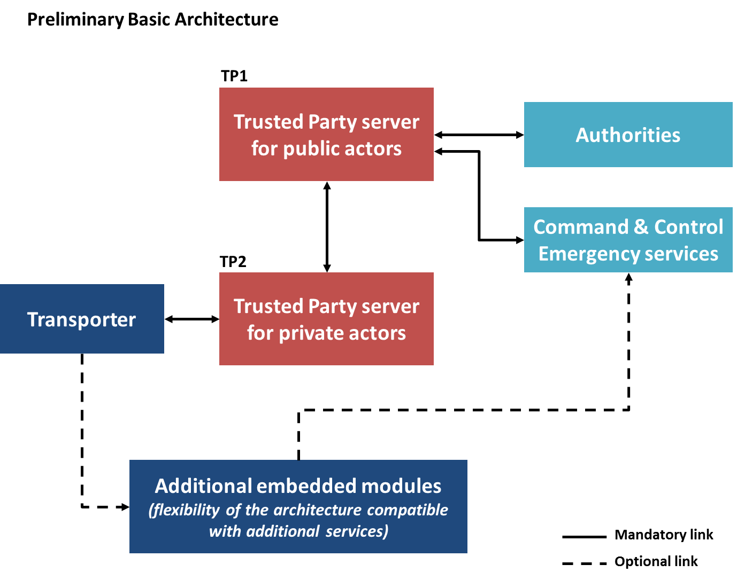

Preliminary Basic TP1 Service
The basic service of the TP1 would involve:
1. Registering the identification of each transport unit and of the TP2 which holds the electronic transport documents from the moment the start of the transport is declared to that when it is declared finished.
2. Processing requests for access to electronic documents from emergency services or public authorities.
3. Possibilities to retrieve information during 3 in order to comply with 5.4.4.1. of ADR/RID/ADN.
4. Retrieving electronic documents from the appropriate TP2 and sending them back to the service requesting them allowing to comply with ADR/RID/ADN rule 5.4.4.1 and to retrieve the information during months.
5. Registering and handling the public services authorised to use the service.
6. Registering and handling the different TP2s
Minimum Scenario
The most usual scenario (hereafter called “minimum scenario”) is as follows:
- Before departure of a load of dangerous goods, a transport company registers a transport document on a TP2 server.
- The TP2 then holds the following information:
- a transport unit ID
- a transport document ID
- a status (Active when a load remains, Inactive after complete unloading)
- The TP2 sends the transport unit ID and its status to the TP1, as well as any updates to the status.
- An external player (Authority, emergency services) wishing to obtain information on the transport document connects to a TP1.
- If the external player is authorised, the request is processed by the TP1 server, which relays the information held by the TP2 (hence the term “Proxy” chosen for the architecture).
NB: The architecture can play its role only if the TP1 and TP2 servers are operational and if the network links enable actual exchanges between them.
Cost benefits elements
There is not enough data to establish neither a precise assessment of the total cost of the required ITS infrastructure nor the corresponding overall possible economical and societal benefits. However several examples of costs and benefits can be provided.
Costs elements
The proposed architecture is mainly about putting in place relevant interfaces. The cost of setting up the architecture is therefore mainly related to building TP1 / TP2 interfaces costs and maintenance costs. Besides, because it is based on an Internet backbone the operational cost does not increase with the number of transactions. However the estimated number of transactions has an impact on the cost for building the infrastructure (Capital expenditure more than Operational expenditure).
Example of costs
It is possible to identify partial elements such as the cost for developing a TP1 in France only for road and rail transport:
- Specification and Development 100 to 150 days
- Deployment - server centre: 20 to 30 days including “performance bench marking, scalability and security test”
- Cost related to server and building are depending on the assumption whether the organisation already has the required equipment or not
For a TP2 offering the minimum services, the following development cost can be expected:
- Specification and development 30 to 50 days if an HMI already exists (depending the MMI and the added services the figures can grow up rapidly)
- Deployment in server centre 10 to 20 days including “performance bench marking, scalability and security test”
Operational costs have to be further evaluated.
Example of benefits
Most of the benefits of the proposed architecture are to be expected for both dematerialization of the transport document and increased efficiency of emergency responses and other societal benefits.
Although the TP1/TP2 back office infrastructure allows to remove the need of a printing or reading terminal in the transport unit as public authorities would get access to it remotely – which guarantees the access even when the on board equipment is not working.
As an exhaustive evaluation of the benefits is not feasible, it is proposed to mention some examples of societal and economic benefits.
Related to paperless procedures
Benefits of avoiding paper: example of cost associated to printing paper documents for a company dealing with transport of package goods is to be developed.
A complementary benefit associated to this architecture is that it does not require any electronic device or other terminal on board the transport unit for the need of public authorities. That means that the operators are free to define their own process for on board terminal related to documentation.
Moreover, the basic solution that is developed in the GEOTRANS MD pilot project does not take care if the transport document is correct or not but it allows developing applications that are not in the core back office allowing to check consistency of the transport document –hence additional potential benefits for transport companies in avoiding mistakes and related costs.
Related to emergency services
For emergency response, exhaustive data concerning accidents and the potential costs related to their consequences are not available. Therefore mainly assessments made on example may be done. Recent examples have shown again that proper and timely information would have an important reduction of the consequence of accident.
A first example is the Marsas accident which happened on April 4th 2015 in France. This accident happened on a secondary road involving a tank vehicle. More than 5 hectares burnt and the traffic was stopped for more than 12 hours. If relevant information had been sent to emergency services quicker, it is possible that firemen could have arrived with the proper equipment and limits the damages.
Another example is the Mathilde bridge accident that occurred on October 29th 2012 in France. A tanker lied on the central slide of the Mathilde Bridge (nearby Rouen, France). The tank was ripped open. Very quickly, a significant quantity of oil spills on the floor and catches fire. The oils streams under the bridge and spreads the fire to vehicles parked at that lower level. The bridge faced high thermal flows with impacts on the bridge superstructure. Besides, many vehicles and caravans were destroyed. Emergency services reacted very quickly but if a tracking service were in place the emergency services could have located more precisely the location of the accident and intervene more efficiently as it was initially not fully clear whether the tanker was on the bridge or under the bridge.
This list may be completed by other examples proposed by the groups. Inputs from other competent authorities or organizations are welcome.
Related to statistics services
Use of data accessible through this infrastructure could provide exact value of traffic quantity in an anonymized way through provision of additional software. To achieve the same results only at the level of France the benefits is estimated between 1 and 2 M€ per year (50 local survey + national survey).
This is of particular interest in relation to the work initiated by EC in the workshops on risk evaluation held at ERA.
Assessment of different options
Concerning the implementation of TP1s, different possible scenarios can be considered:
- A TP1 per country or per region (depending on the role of administrative organisations specific to each country).
- A single TP1 for a group of countries (for instance at European Union level) and another TP1 for each other country or group of countries having signed the ADR/ADN/RID.
- A hybrid approach for a group of countries to enable States to introduce optional services if they wish, in particular when it comes to one-off national adaptations and the management of security measures.
As this preliminary impact study has been required by EC, it is oriented towards an application centralised inside the EU and therefore analyses the possible role to be played by the European Union in the setting up of this architecture.
Three options can be envisaged:
- Option 1: Decentralised approach, with no implementation at EC level (cf. basic scenario).
- Option 2: Centralised approach, with a central service piloted by the EC
- Option 3: Hybrid approach, with flexibility of roles according to the wishes of each Member State.
Option 1: Decentralised Approach
In this case each Member State deploys its own TP1(s) and ensures interconnection with all other TP1s. The European Union does not intervene in the implementation or interconnection.
This option generates the highest number of transactions per interface. It therefore does not allow reducing the size of each single interface.
Option 2: Centralised Approach
The European Union sets up a common TP1 to carry out minimum scenario functions. This TP1 is operated by the European Union (or by a representative on its behalf). Each TP2 and each public entity authorized to query the TP1 must be listed at European level.
With this option it is possible to achieve a uniform system at European level facilitating its setting up and use for all Member States, large and small. It also guarantees a uniform level of service for all players throughout Europe.
Nevertheless, it creates the necessity for connections with all TP2s on the market and all public services (forces of law and emergency response services) all over Europe. This option requires links with TP1s of third parties countries. The number of transactions is considerably reduced compared to the decentralised approach offering economies of scale. The infrastructure required for the centralised TP1 would be a little bit heavier but not 28 times bigger than a TP1 of the decentralised approach. It requires a registration procedure of the TP2 to be managed at EU level.
Option 3: Hybrid Approach
The European Union sets up a TP1 holding all information from the 28 EU Member States, to be used directly by those Member States requiring only a minimum service. This option allows reducing the number of transaction between regional TP1 as they would only need to interface with the central TP1 and reduce the registration burden for the central TP1.
EU rights to act
The transport of dangerous goods is regulated through an EU directive which contains in its annex the text of the three international regulations developed at UN level. There is no regulation at national level.
The international agreement is binding for both operators and transport authorities. Consequently if no action is taken at international level there is no way for an ITS technical solution to be used for the carriage of dangerous goods in an harmonized way. This would also create problems for the recognition of electronic documents as an alternative to the existing requirements in every contracting party or member state.
In addition, this regulation annexed to the Directive 2008/68 already contains some references to the use of ITS for electronic documentation, in particular:
ADR 5.4.0:
Any carriage of goods governed by ADR shall be accompanied by the documentation prescribed in this Chapter, as appropriate, unless exempted under 1.1.3.1 to 1.1.3.5.
NOTE 1: For the list of documentation to be carried on board transport units, see 8.1.2.
NOTE 2: The use of electronic data processing (EDP) or electronic data interchange (EDI) techniques as an aid to or instead of paper documentation is permitted, provided that the procedures used for the capture, storage and processing of electronics data meet the legal requirements as regards the evidential value and availability of data during transport in a manner at least equivalent to that of paper documentation.
ADR 1.4.2.2.1 b
Ascertain that all information prescribed in ADR related to the dangerous goods to be carried has been provided by the consignor before carriage, that the prescribed documentation is on board the transport unit or if electronic data processing (EDP) or if electronic data interchange (EDI) techniques are used instead of paper documentation, that data is available during transport in a manner at least equivalent to that of paper documentation;
ADR1.10.3.3
NOTE: When appropriate and already fitted, the use of transport telemetry or other tracking methods or devices should be used to monitor the movement of high consequence dangerous goods (see Table 1.10.3.1.2) or high consequence radioactive material (see 1.10.3.1.3).
In conclusion not only is the EU legitimate to act but no development of ITS or EDI will be possible without an evolution of the regulation annexed to 2008/68. This evolution will need to describe the mandatory use of the TP1/TP2 architecture if telematics solutions are used.
Another important aspect that legitimates EU acting is related to standardization:
- TP1 / TP2 data exchanges as per the UML model defined by the WG
- Consistency with other EU initiatives:
- Ecall to transmit only VIN and TDG active/Inactive
- Projects on Cooperative-ITS

