Economic Commission for Europe

Inland Transport Committee

Working Party on the Transport of Dangerous Goods

Joint Meeting of the RID Committee of Experts and the

Working Party on the Transport of Dangerous Goods

Bern, 14-18 March 2016
Item 5 (a) of the provisional agenda
Proposals for amendments to RID/ADR/ADN:
Pending issues

Adopted texts for 2017 — 1.1.3.2 and 1.1.3.3 and special provisions 363 and 666

Transmitted by the Government of Switzerland,

Summary
Executive summary: Clarification is needed of the relationship between the various exemptions under 1.1.3 and special provisions 363 and 666 that apply to vehicle equipment.
Decision to be taken:: Amend special provisions 363 and 666. Add a new special provision to apply to UN Nos. 3166 and 3171.
Related documents: ECE/TRANS/WP.15/AC.1/140/Add.1, ECE/TRANS/WP.15/230, informal documents INF.16 and INF.18 from the 99th session of WP.15 and INF.35 from the September 2015 session of the Joint Meeting.

Introduction

1. At the September 2015 session of the Joint Meeting, informal document INF.35 highlighted some problems with the interpretation and application of the new provisions proposed in informal document INF.12 at the same session. Of the issues raised, the following points were subsequently noted by the Working Party on the Transport of Dangerous Goods (WP.15) at its meeting in November (ECE/TRANS/WP.15/230, paras. 21 to 24):
- The possible contradictions between the exemptions that remained applicable in 1.1.3.2 and 1.1.3.7 and the new special provisions;
- The problems with implementation of the exemption criteria in paragraph (g) (iv) of special provision 363.
Since these issues also concern the other forms of transport, the Joint Meeting is invited to take a decision on them.

Scope of special provisions 363 and 666 and exemptions from 1.1.3.3, 1.1.3.2 and 1.1.3.7

2. To draw a clear distinction between the scope of special provision 363 and that of the exemption for vehicle equipment “intended for use during carriage”, the Joint Meeting decided to introduce an explanatory NOTE after the first paragraph of special provision 363:
“NOTE: This entry does not apply to equipment referred to in 1.1.3.3.”
3. In the texts for 2017, special provision 363 is no longer assigned specifically to the liquid fuels in UN Nos. 1202, 1203, 1223, 1268, 1863 and 3475, but rather to more general UN numbers (3528, 3529 and 3530), which concern ENGINE, INTERNAL COMBUSTION or MACHINERY, INTERNAL COMBUSTION containing different types of fuel (flammable liquids, gas and environmentally hazardous substances); the NOTE should therefore also specify the relationship between special provision 363 and the exemption for vehicle equipment operating on gas found in 1.1.3.2 (a), (d) and (e) (remark: in the texts adopted for 2017, 1.1.3.2 (b) is transferred to special provision 666 (b)).
4. Paragraph (f) of the 2017 version of special provision 363 requires that lithium batteries meet the requirements of 2.2.9.1.7. It should also be specified that this requirement is not applicable to equipment intended for use during carriage, that is, equipment exempted under 1.1.3.7. A reference to 1.1.3.7 should therefore be included in the NOTE referred to above.

Proposal 1

In the NOTE after the first paragraph of special provision 363, replace “1.1.3.3” by “1.1.3.2 (a), (d) and (e), 1.1.3.3 and 1.1.3.7”.
5. The introductory text of special provision 666 for 2017 reads as follows:
“666 Vehicles assigned to UN Nos. 3166 or 3171 and battery powered equipment assigned to UN No. 3171 in conformity with special provisions 240, 312 and 385, as well as any dangerous goods they contain that are necessary for their operation or the operation of their equipment, when carried as a load, are not subject to any other provisions of ADR, provided the following conditions are met:”
We consider that a clearer distinction should be introduced into the new provisions between the equipment of a vehicle “intended for use during carriage”, to which special provision 666 is applicable, and equipment that is not intended for use during carriage, to which special provision 363 applies.
6. The annex to the present document offers five examples of trailers for which it is difficult to establish whether special provision 363 or special provision 666 will apply from 2017. According to the texts in force until 31 December 2016, examples 1 to 3 cannot be exempted under 1.1.3.3 because the equipment was never intended for use during carriage and can therefore only be exempted under special provision 363. Examples 4 and 5, on the other hand, can only be exempted under 1.1.3.3 because they are intended for use during carriage. With the text adopted for introduction in 2017, this distinction can be ascertained partly through the NOTE, but not sufficiently clearly to distinguish between the equipment referred to in special provision 666 and that in special provision 363. Examples 1 to 3 could thus be interpreted as falling under special provision 666 as well, not just special provision 363. Conversely, examples 4 and 5 could erroneously be considered to be subject to special provision 363 if they were not operating during a specific journey, such as during salvage or transhipment onto a rail shuttle for passage through tunnels.
7. Furthermore, a solution should also be found to the problem noted during the September 2015 session of the Joint Meeting of exempting trailers under special provision 666, which results from the wording of the Model Regulations and led to the adoption of an amendment to 1.1.3.3 (a), as follows:
“1.1.3.3 In (a), at the end of the first sentence of the third paragraph, insert: ‘, irrespective of whether the trailer is towed or carried on another trailer’” (version from the November session of WP.15).
Without this addition, these trailers could no longer be exempted from the provisions of RID/ADR/ADN because, according to the definition of a vehicle given in the new special provision 385, vehicles in UN No. 3166 affected by special provision 666 are “self-propelled apparatus”. This is clearly not true for trailers.
8. The same problems occur in the case of trailers that use electric motors and special provisions 240 and 666.
9. To avoid this type of confusion and to overcome the problem of scope for trailers in special provision 666, we propose referring to use during carriage in the first sentence of special provision 666:

Proposal 2

Amend the first paragraph of special provision 666 as follows (new text in bold and underlined):
“666 Vehicles assigned to UN Nos. 3166 or 3171 and battery powered equipment assigned to UN No. 3171 in conformity with special provisions 240, 312 and 385, as well as any dangerous goods they contain that are necessary for their operation or the operation of their equipment, intended for use during carriage under 1.1.3.3, 1.1.3.2 (a), (d) and (e), and 1.1.3.7, when carried as a load, are not subject to any other provisions of ADR, provided the following conditions are met:”

Justification

10. It is thus clear that special provision 666 covers equipment intended for use during carriage (see annex, examples 4. Heating appliance for vehicle sheet, and 5. Refrigerated trailer), while special provision 363 is aimed at equipment not intended for use during carriage, which cannot come under special provision 666 (examples 1. to 3.). Furthermore, the reference to 1.1.3.3 makes it possible to include in the scope of special provision 666 trailers which, as noted above, have been included in the scope of 1.1.3.3, like the vehicles defined as self-propelled apparatus in special provision 385, which are mentioned at the beginning of the text.

Possibility of using vehicle equipment when carried as a load

11. The texts of 1.1.3.2 (b) and of 1.1.3.3 (b) and (c) have been transferred to special provision 666 (b) and special provision 666 (a), respectively. The possibility of the use of liquid fuels during carriage as a load, which had hitherto been included in 1.1.3.3 (b), is now included in special provision 666 (a). However, the same possibility for gases, which is still retained in 1.1.3.2 (e), has not been included in special provision 666 (b). Given that, according to the first sentence of special provision 666, this special provision also applies to the dangerous goods required for the functioning of vehicle equipment when carried as a load, there are two possibilities for exempting equipment that uses gaseous fuels: one in 1.1.3.2 (e) and the other in special provision 666 (b). The texts are incompatible, since the former (1.1.3.2 (e)) allows the equipment to be used during carriage, whereas the latter (special provision 666 (b)) does not.
12. There are three possibilities for continuing to allow vehicle equipment to be carried as described in 1.1.3.2 (b):
(a) Either delete the text in special provision 666 (b) and retain 1.1.3.2 (b); or
(b) By analogy with the decision taken on 1.1.3.3 (b) and (c), delete 1.1.3.2 (e) and introduce at the end of the sentence in special provision 666 (b) the same phrase as in special provision 666 (a): “, unless it is essential for the equipment to remain operational”; or
(c) Retain the current structure and refer to the texts of 1.1.3 in special provision 666.
13. We consider that this confusion and the incompatibility between identical texts in different parts of the regulations could be avoided if, rather than moving them, the current structure were to be retained and reference made in special provision 666 to the relevant texts of 1.1.3. The result could be presented as follows (new text in bold and underlined, deleted text in strikethrough):

Proposal 3

“666 Vehicles assigned to UN Nos. 3166 or 3171 and battery powered equipment assigned to UN No. 3171 in conformity with special provisions 240, 312 and 385, as well as any dangerous goods they contain that are necessary for their operation or the operation of their equipment, intended for use during carriage under 1.1.3.3, 1.1.3.2 (a), (d) and (e) and 1.1.3.7, when carried as a load, are not subject to any other provisions of ADR, provided the following conditions are met:
(a) For liquid fuels,* the provisions of 1.1.3.3 (b) are applicable; any fuel cocks between the engine or equipment and the fuel tank shall be closed during carriage unless it is essential for the equipment to remain operational. Where appropriate, the vehicles shall be loaded upright and secured against falling;
(b) For gaseous fuels, the provisions of 1.1.3.3 (b), (d) and (e) are applicable the fuel cock between the gas tank and engine shall be closed and the electric contact open;
(c) Metal hydride storage systems shall be approved by the competent authority of the country of manufacture. If the country of manufacture is not a contracting party to ADR, the approval shall be recognized by the competent authority of a contracting party to ADR;
(d) The provisions of (a) and (b) do not apply to vehicles which are empty of liquid or gaseous fuels.
NOTE 1: A vehicle is considered to be empty of liquid fuel when the liquid fuel tank has been drained and the vehicle cannot be operated due to a lack of fuel. Vehicle components such as fuel lines, fuel filters and injectors do not need to be cleaned, drained or purged to be considered empty of liquid fuels. In addition, the liquid fuel tank does not need to be cleaned or purged.
NOTE 2: A vehicle is considered to be empty of gaseous fuels when the gaseous fuel tanks are empty of liquid (for liquefied gases), the pressure in the tanks does not exceed 2 bar and the fuel shut-off or isolation valve is closed and secured.”
The text of the footnote * reads: “Footnote * does not apply to the English text.”
14. That way, the current 1.1.3.2 (b) and 1.1.3.3 (b) would be retained, while 1.1.3.3 (c) which is not of any use, would be deleted.

Justification

15. The direct reference in special provision 666 to the relevant parts of the text of 1.1.3 identifies the applicable provisions without there being any possible contradiction between the various exemptions in 1.1.3 and those that appear in parallel in special provision 666. It is clear that special provision 666 does not refer to the complete exemption from RID/ADR/ADN that is provided under 1.1.3.2 or 1.1.3.3, but rather exemption from the conditions described in the different paragraphs of 1.1.3.
The advantage of this approach is that it retains in 1.1.3 an overview of the exemptions applicable to vehicles and equipment when they are used during carriage, while continuing towards harmonization with the structure of the Model Regulations.

Problems with implementation of the exemption criteria in paragraph (g) (vi) of special provision 363

Internal combustion engines for liquids (and gases) now included not in UN No. 3166, but in UN Nos. 3528, 3529 and 3530

16. They are subject to special provision 363. If empty, they are exempted according to NOTE 1 of special provision 363 (b). If full, they may be exempted under special provision 363 (g). In the latter case, engines containing more than 60 l, and with a capacity of more than 450 l, shall bear labels affixed on both sides, and those above 3,000 l shall bear placards affixed on opposite sides. For gas-fuelled engines, the relevant capacities are 450 l and 1,000 l, without any lower fuel limit.
A transport document is also required for quantities above 1,000 l of liquid fuel. Hence there is a change from the current “capacity” of 1,500 l to a “content” of 1,000 l and, moreover, it is not clear how the quantity may be verified in actual fact.
For gases, a transport document is required for a capacity of over 1,000 l, which has the advantage of being easily verifiable.
17. In conclusion, garages that transport engines alone should avoid sending them with the fuel tank; otherwise they should apply special provision 363, as indicated above. Furthermore, if the tank is not empty and has a capacity of more than 1,000 l, they will have to check the exact content to establish which type of label to affix and whether they need to complete a transport document in accordance with 5.4.1.
18. We do not consider that these provisions are relevant for land transport. The Joint Meeting should decide whether it is appropriate to include internal combustion engines in the entries for UN Nos. 3528, 3529 and 3530 or whether it would perhaps be better to exempt them, as has been the case until now, from the provisions of RID/ADR/ADN. This could be the subject of an ad hoc special provision.

Scope of special provision 363 and 1.1.3.1 (b)

19. This question was not put to the United Nations Sub-Committee of Experts on the Transport of Dangerous Goods because it relates specifically to land transport and the exemption under 1.1.3.1 (b).
20. At the moment, special provision 363 contains exactly the same terms as 1.1.3.1 (b), “machinery or equipment”, so that special provision 363 for liquid fuels replaces exemption 1.1.3.1 (b) for machinery and equipment. With the new provisions, this relationship with 1.1.3.1 (b) will be lost, because special provision 363 and UN Nos. 3528, 3529 and 3530 refer only to machinery and not to equipment. This becomes an issue if someone defines an object as equipment rather than machinery. In that case, would he or she have the right, by virtue of the exemption under 1.1.3.1 (b), to exempt the equipment, as was the case before the introduction of special provision 363?
21. We consider that the 2017 version of special provision 363 should use the terms “machinery or equipment” in order to cover the same objects as in the past.

Proposal 4

In special provision 363, except in the names of the entries for UN Nos. 3528, 3529 and 3530, replace the term “machinery” by “machinery or equipment”.

Relationship between 1.1.3.7 and special provisions 312, 240, 385, 666 and 667

22. Special provisions 312, 240, 385, 666 and 667 for vehicles carried all refer to the requirements for lithium batteries under 2.2.9.1.7. However, the exemption under 1.1.3.7 for the same vehicles and their equipment has not been modified, so that any vehicle and its equipment can continue to be used as transport without needing to check whether it meets the requirements of 2.2.9.1.7. However, if it is carried as a load, its lithium batteries must be checked for conformity with 2.2.9.1.7. It is unclear how the owner can provide proof of conformity if he or she wants, for instance, to use rail shuttles, when the vehicle has to be towed to a garage or when new or used vehicles are moved.
23. We think that special provisions 312, 240, 385, 666 and 667 should not be applicable to vehicles used for land transport when they are carried as a load during land journeys.

Proposal 5

Add the following new special provision to Table A in Chapter 3.2 for UN Nos. 3166 and 3171:
“SPXXX Special provisions 312, 240, 385, 666 and 667 are not applicable to vehicles used for land transport when they are carried as a load during journeys subject to RID/ADR/ADN. In that case, the provisions of 1.1.3.2, 1.1.3.3 and 1.1.3.7 remain applicable.”

Annex

1 | 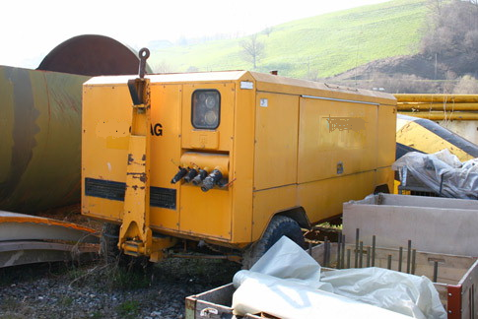 | Compressor  Vehicle, trailer  Liquid fuel, UN No. 1202/1203  Quantity: 2 000 l
2 | 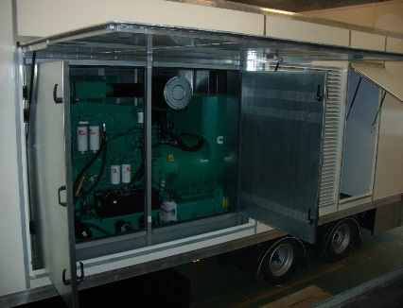 | Mobile generator set  Vehicle, tri-axle trailer  Liquid fuel, UN No. 1202  Quantity: 1 900 l
3 | 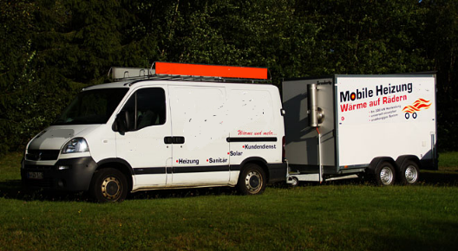 | Heating equipment  Vehicle, trailer  Liquid fuel  Heating oil, UN No. 1202  Quantity: 100 - 300 l
4 | 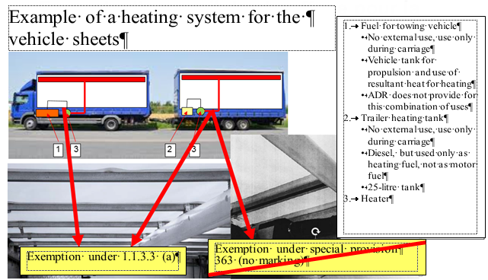 | Heating appliance for the vehicle sheets  Trailer tank 25 l
5 | 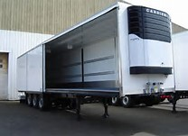 | Refrigerated trailer

In accordance with the draft programme of work of the Inland Transport Committee for 2016-2017, (ECE/TRANS/WP.15/2015/19 (9.2)).
Circulated by the Intergovernmental Organisation for International Carriage by Rail (OTIF) under the symbol OTIF/RID/RC/2016/16.

