|  |  |  |  |
| --- | --- | --- | --- |
|  | United Nations | ECE/TRANS/2016/33 | |
| Description: _unlogo | **Economic and Social Council** | | Distr.: General  17 December 2015  Original: English |

**Economic Commission for Europe**

Inland Transport Committee

**Seventy-eighth session**

Geneva, 23–26 February 2016  
Item 18 of the provisional agenda  
**Transport developments in the European Union**

Transport developments in the European Union

Submitted by the European Commission and the secretariat[[1]](#footnote-2)\*

|  |
| --- |
| *Summary* |
| This note provides the Inland Transport Committee with: |
| (i) A brief review of some of the main activities, policy developments and decisions by the European Union (EU) in the course of 2015, relevant for the countries in the United Nations Economic Commission for Europe (UNECE) region and particularly for the Inland Transport Committee to consider in light of its regional and global activities; and |
| (ii) Information about cooperation between EU and UNECE. |
| It is intended to supplement the oral information provided by the representative of the European Commission at the seventy-eighth session of the Inland Transport Committee. Related ITC activities are highlighted to facilitate the discussion. |
|  |

I. Introduction

1. EU transport policies aim at fostering clean, safe and efficient mobility throughout Europe, underpinning the internal market of goods and the right of citizens to travel freely throughout the EU. The main actions — new legislations, consultations, publications, initiatives — carried out by EU during 2015 in the field of inland transport, and also relevant for non-EU countries, are illustrated below.

II. Transport infrastructure

A. Launch of the new infrastructure policy of the European Union

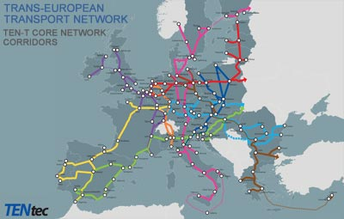2. On 15 January 2015 the European Commission published nine studies on the state of play and the development needs of the Trans-European Transport Networks (TEN-T) core network corridors. The studies have identified infrastructure development needs, which represent approximately €700 billion of financial investment until 2030. They highlight the importance of optimising the use of infrastructure along the corridors, notably through intelligent transport systems, efficient management and the promotion of future-oriented clean transport solutions. This is the first time that tens of thousands kilometres of rail, road, inland waterway connections, ports, airports and other transport terminals have been studied in such a comprehensive way and with a common methodology.

3. Violeta Bulc, EU Commissioner for Transport said, "We have to step up our efforts to make sure the core network will be fully operational by 2030, to ensure smooth transport flows for passengers and goods throughout the EU. Now is the time to invest in TEN-T projects and to maximise the benefits of the Connecting Europe facility and the Commission's €315 billion Investment Plan. After all, the Trans-European Transport Network is crucial for a Union striving for more growth, jobs and competitiveness. As Europe is slowly stepping out of the economic crisis, we need a connected Union, without barriers, in order for our single market to thrive."

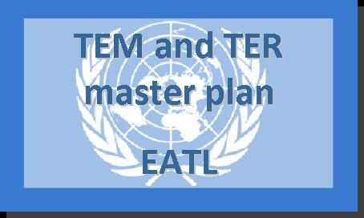4. For each Trans-European Transport corridor, which is led by a European Coordinator, a team of external experts has undertaken a comprehensive study. They analysed the current infrastructure status, located problems hampering traffic flows for passengers and freight, and identified action to be undertaken from now to 2030.

*Next steps*

5. The results of these studies will be taken into account when deciding on the allocation of EU funds for the period 2014–2020, under the Connecting Europe Facility. In particular, the "project pipeline" resulting from these corridor studies constitutes an important source for the € 315 billion European Investment Plan, which was published by the Commission in November 2014. In this context, the Commission also mandated the former Vice-President of the European Commission, Henning Christophersen, as well as the European Coordinators Kurt Bodewig and Carlo Secchi to identify concrete TEN-T projects which are suitable for contributing to the new investment plan.

*Background*

6. The core network will connect:

* 1.94 main European ports with rail and road links;
* 2.38 key airports with rail connections into major cities;
* 3.15,000 km of railway line upgraded to high speed;
* 4.35 cross-border projects to reduce bottlenecks.

7. This will be the economic lifeblood of the single market, allowing a real free flow of goods and people around the EU.

B. Transport in Alpine region

8. On March 2015 Commissioner Bulc and seven Transport Ministers from the Alpine states promoted sustainable transport in Austria. A congress took place in Innsbruck (Austria) with seven Transport Ministers from the Alpine States (Austria, France, Germany, Italy, Liechtenstein, Slovenia and Switzerland) where the development of transport across the Alpine region was discussed.

9. In the presence of some 500 participants, the Commissioner, Ministers and promoters of key Alpine crossing projects discussed the challenges of preparing, implementing and financing large-scale projects that cross borders of several member States. Once completed, these projects would significantly change the flow of goods and passengers' mobility across the Alps, and improve economic relations. The Commissioner and the Ministers signed a joint declaration renewing their commitment to further promote sustainable transport in the region.

C. European Commission puts forward record €13.1 billion investment in transport infrastructure to boost jobs and growth

10. On June 2015 the Commission further delivered on its top priority of creating jobs and boosting growth in Europe, by unveiling a record €13.1 billion investment plan in 276 transport projects, selected under the Connecting Europe Facility (CEF). This investment would unlock additional public and private co-financing for a combined amount of €28.8 billion. Along with the future European Fund for Strategic Investments (EFSI), the CEF would play a major role in bridging the investment gap in Europe, which is one of the Commission's top priorities. Beyond transport, it will benefit the European economy as a whole by creating more favourable conditions for growth and jobs.

11. Selected projects are primarily located in the core trans-European transport network. Among the beneficiaries are flagship initiatives such as Rail Baltica, the Brenner Base Tunnel, the Seine-Escaut waterway, the Caland Bridge and the Fehmarn Belt Fixed Link. Smaller-scale initiatives include cross-border projects between Groningen and Bremen, the Iron Rhine rail line, LNG (Liquefied Natural Gas) deployment plans or projects enhancing the navigability of the Danube River.

12. Launched in September 2014, the CEF calls for proposals generated an unprecedented interest. The Commission received 700 applications totalling €36 billion of requested funding, three times more than the available envelope. This allowed the Commission to select the projects with the highest European added value, while guaranteeing a balanced distribution geographically and between the transport modes. In particular, nearly €4.8 billion have been earmarked for member States eligible for Cohesion Funds. Contribution to other Commission priority actions, such as the Energy Union or the Digital Single Market, was also evaluated during the selection process.

13. The financial contribution of EU is made in the form of grants, the co-financing rate of which is between 20 per cent and 85 per cent of a given project, depending on its type.

III. Road Transport and Road Safety

A. How safe are your roads? Commission road safety statistics show small improvement for 2014

14. Following two years of solid decreases in the number of people killed on EU roads, the first reports on road deaths in 2014 were disappointing. According to the updated statistics in November 2015, the number of road fatalities remained the same from 2013 to 2014. This follows on the 8 per cent decrease in 2012 and 2013. The figures reveal a total of 25, 900 road deaths in 2014 across all 28 member States of the EU. While this is fewer than in 2010, it falls short of the intended target decrease.

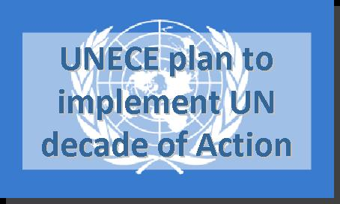15. In 2014, the country specific statistics showed that the number of road deaths still vary greatly across the EU. The average EU fatality rate for 2014 was 51 road deaths per million inhabitants. Malta, the Netherlands, Sweden and the United Kingdom continue to report the lowest road fatality rates, with less than 30 deaths per million inhabitants. Four countries still report fatality rates above 90 dead per million inhabitants: Bulgaria, Latvia, Lithuania and Romania.

16. The total number of EU road deaths has decreased by 18 per cent since 2010. Some European countries report a better than average road safety improvement over the years. This is the case of notably for Greece, Portugal and Spain. Equally, Croatia, Cyprus, the Czech Republic, Denmark, Italy, Malta, Romania, and Slovenia report a reduction of road deaths above the EU average for 2010–2014.

*Road safety targets and actions*

17. In order to reach the EU strategic target of halving the number of road deaths from 2010 to 2020, additional efforts are now needed. Most every-day road safety actions were done at local or national level, for example through the enforcement of road traffic rules, education campaigns and infrastructure development and maintenance. EU contributes with legislation and recommendations on issues of common concern, for example on the minimum requirements for technical vehicle inspections and the harmonization of technical standards.

18. In May 2015, the Commission finalised an interim evaluation of the EU road safety policy framework. The evaluation concluded that the framework remains relevant and that the strategic fatality target has contributed to progress, but that additional efforts especially on Member State level will be required to continue the downwards trend on fatalities.

19. During summer and autumn, the Commission also organized five expert round tables jointly with Bulgaria, Latvia, Lithuania, Poland and Romania to discuss possibilities for road safety progress in these countries, all suffering high road fatality rates. Key topics for discussion included seat belt use, speed management, drink-driving prevention and infrastructure safety measures.

20. What will the Commission do next:

* Continued work on the new analysis of serious road traffic injuries. member States are in the process of collecting data on serious road injuries using a new, common EU definition of serious injury. A study on factors contributing to such injuries was launched in October 2015;
* A review of rules on training and qualifications of professional drivers is ongoing;
* A review of the EU framework for infrastructure safety management is ongoing;
* Follow-up works of the Roadworthiness Package (Directives 2014/45/EU, 2014/46/EU and 2014/47/EU).

B. Road Safety: New European Union driving licence code on alcohol interlocks

21. To improve road safety the European Commission has introduced a harmonized EU code on alcohol interlock devices for driving licences (Commission Directive (EU) 2015/653 of 24 April 2015 amending Directive 2006/126/EC of the European Parliament and of the Council on driving licences).

22. This new code "69" will replace different national codes in use, for programmes where the driver is restricted to drive vehicles that are only equipped with alcohol interlock devices. Such programmes are planned or in use in several member States, notably to prevent drink-driving offences from re-occurring.

23. A harmonized EU code will facilitate EU-wide understanding of the restriction as well as enable member States to enforce it. However it is still for the Member States to decide both whether or not to introduce such programmes and how to enforce the restriction.

24. In addition to this new code, the Commission has adapted the existing harmonized EU driving licence codes to technical and scientific progress, especially in the field of vehicle adaptations and technical support for drivers with disabilities.

*Background information*

25. An alcohol interlock device is a system installed in the vehicle to prevent a driver impaired by alcohol from operating the vehicle. Introduction of a code on such devices has been requested by member States and recommended in a study.

26. Several member States already have such restricted licences, but currently the codes vary between member States and cannot be understood nor enforced in other member States. The main purpose of this new code is to facilitate EU-wide understanding and to make it enforceable EU-wide.

27. It is important to note that this code is only to be used by the member States who issue licences with this restriction. There are many member States who do not have alcohol interlocks and thus do not issue licences with such restrictions. They can continue to do so.

C. European Commission engages in United Nations global efforts for safer roads

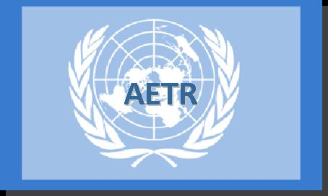28. The European Commission welcomed the United Nations global commitment to achieve safer roads all over the world at an extraordinary interministerial conference held in Brazil, 18–19 November. The Brasilia Declaration adopted at the Second Global High-level Conference on Road Safety emphasises the need to make road safety a global priority.

29. Transport Commissioner Violeta Bulc said: "The European Commission is committed to improving road safety. We fully support all initiatives from the United Nations towards this major development goal. Today, at half-time of the decade of action for Road Safety, the United Nations will assess the progress made so far and renew their commitments. The EU is ready to support and strengthen this work in any way we can. EU has substantial experience and best practices to share with other regions. I hope our lessons learned can help save lives also beyond the EU borders. The Commission is proud of being part of this overarching global commitment to road safety."

30. EU roads are indeed much safer today than ever before and the EU is the safest region worldwide. In 2014, the EU fatality rate was 51 deaths per million inhabitants, compared to 93 deaths per million for the entire European region (53 countries, including the Russian Federation) and 159 deaths per million in the American region. The total number of road traffic deaths globally is about 1.2 million per year, of which only around 25,900 in the EU.

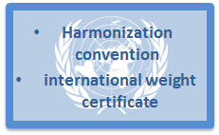31. The EU success story is the result of many contributing factors. EU has made road safety a political priority and started broad cooperation across borders for a EU-wide road safety area. Major achievements in legislative work include the mandatory use of seat belts and proper child seats, binding principles for infrastructure safety management as well as common rules on type approval and technical inspections of vehicles. Information on road traffic crashes gathered in the European Road Safety Observatory and the CARE database create a solid knowledge base for decision-making, and for developing the most efficient road safety measures.

32. The Second United Nations High-level Conference on Road Safety brought together ministers and heads of delegations from all over the world with representatives of international and regional organizations as well as actors from the civil, academic and private sectors. The conference reaffirmed the commitment of the international community around policies, legislation, measures and actions that can halt the factors causing 1.2 million deaths worldwide and physical trauma to another 30 to 50 million people every year, primarily affecting children and young people with an estimated global annual cost of about 500 billion United States dollars.

IV. Rail Transport

A. The European Railway Traffic Management System (ERTMS)

33. In January the European Commission adopted an improved set of specifications for ERTMS, the results of two years of cooperation among railway experts. These new technical requirements (Technical Specifications for Interoperability – TSI) have taken effect upon notification to member States and are applicable as of July 2015 across the whole European railway network.

34. This Decision contained an improved set of detailed system specifications, recommended by the European Railway Agency, the "ERTMS system authority", which are the results of work that stakeholders committed themselves to do with the European Railway Agency in the Memorandum of Understanding signed between them and the Commission in Copenhagen in 2012 to complete what has been adopted in Decision 2012/696/EU. This Decision also clarifies technical requirements and extends them to the whole railway system in the EU, as this has been the case for the other TSIs (cf. rail news of 18 November 2014).

35. The Technical Specifications for Interoperability (TSI) are adopted in accordance with the Interoperability rules (Directive 2008/57/EC), and they define the technical and operational standards which must be met in order to ensure that trains can run throughout Europe without technical problems and meet the essential requirements (safety, reliability and availability, health, environmental protection, technical compatibility and accessibility). TSIs cover all aspects of the rail systems, such as infrastructure, energy, rolling stock, signalling, train control, traffic operation and telematics applications for passengers and freight services.

B. Rail passenger rights

36. In March a report was issued by the Commission on rail passenger rights.

37. The report provides a factual overview over the situation of national exemptions for rail passengers' rights in the EU in the past five years, since the entry into force of the Regulation on 3 December 2009. The projection on the future application of the rules, i.e. the renewal of the exemptions, is based on information provided by member States and is subject to future changes.

38. In the past five years, only four member States have fully applied the Regulation on rail passenger rights, while 22 have granted exemptions to varying degrees. The report also stresses that the extensive exemptions have led to legal insecurity for both passengers and the rail industry. Looking at the future, the report findings show that only one more Member State will fully apply the rules in the near future. A level playing field for railway undertakings and a high level of protection for passengers in the EU is therefore still far from a reality.

39. Rules on rail passengers' rights apply, in principle, to all rail passenger services in the EU. However, the Regulation gives the possibility to member States to grant exemptions to certain domestic services[[2]](#footnote-3), either to ease the phasing in of the Regulation or to take into account the specificities of certain services, notably the urban, suburban and regional ones. The rail services that can be exempted are:

(a) Domestic services for a maximum period of five years, renewable twice;

(b) Urban, suburban and regional services;

(c) Services or journeys of which a significant part is operated outside the EU for a maximum period of five years. This exemption may be renewed.

40. On 3 July 2015, the Commission adopted interpretative guidelines on Regulation 1371/2007 (JO C 220 04 July 2015, p. 1) to clarify and strengthen the application and enforcement of rail passenger rights in the European Union. The guidelines are based on a detailed assessment of the Regulation and relevant case law. They are aimed at facilitating rail travel for passengers including disabled persons and persons with reduced mobility and thus assist railway companies and station managers to improve the application of the Regulation. They also aim at improving enforcement activities of national authorities.

41. The guidelines clarify provisions under the Regulation such as:

1. Scope of application of the Regulation and exemptions granted by member States

42. In order to ensure a uniform protection of rail passengers in all EU countries, the Commission recommends that exemptions should only be used as long as needed to phase in full application of the Regulation and for certain specific services.

2. Issues on the transport contract, information and tickets

43. The guidelines emphasise the importance for all actors to make information on travel, tariffs and ticketing available to passengers, including in alternative formats for persons with disabilities. A broad offer of tickets via different sales channels shall ensure that all categories of passengers can benefit from low fare tickets.

3. Delays, cancellations and missed connections

44. The guidelines clarify the rights of passengers in case of travel disruption. For journeys with a connection, the Commission reminds rail companies to offer through tickets wherever possible and that through tickets can also consist of separate tickets. Thus passengers holding separate tickets under a single contract have equal rights to information, assistance, re-routing, reimbursement or compensation as passengers with a single ticket, when they suffer a delay of more than 60 minutes at their final destination.

4. Rights of persons with disabilities or reduced mobility

45. The guidelines clarify that rail companies cannot ask for medical certificates as a precondition to selling a ticket or allowing persons with disabilities or reduced mobility to use rail services or to justify the request for assistance. The Commission also insists on adequate disability awareness training of service staff.

5. Complaint handling, enforcement and cooperation between national authorities

46. Companies have to set up adequate complaint handling mechanisms and reply to passengers within strict timeframes. National authorities have to be adequately equipped and staffed to receive and handle complaints from citizens and to cooperate in case of cross border complaints. They also have to have adequate means in place to enforce the Regulation and, where necessary, sanction infringements.

47. In addition another study was issued during 2015 by the Commission on the cost and contribution of the rail sector.

48. The rail sector makes a substantial contribution to the EU economy, directly employing 577,000 people across passenger and freight operations, and the provision of track and station infrastructure. Some estimates suggest that, once the entire supply chain for rail services is taken into account (e.g. including train manufacturing, catering services etc.), the economic footprint of the rail sector in Europe extends to 2.3 million employees and €143 billion of Gross Value Added (some 1.1 per cent of the total). It is also critical to the EU strategy for improving economic and social cohesion and connectivity within and between member States.

49. The key findings of the study are as follows:

* 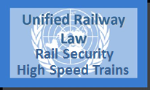Despite an unfavourable economic climate across much of the EU between 2007 and 2012, rail passenger km have grown, although tonne km transported by rail have fallen significantly;
* The overall cost of the rail industry in the EU is €110 billion, 60 per cent of which is covered by passenger and freight revenue, 30 per cent by public subsidy and the remainder by other sources of income;
* Railways in different member States vary considerably in terms of their national characteristics, and any analysis of their comparative efficiency levels must take account of the impact of geographical, demographic and other external factors;
* Levels of efficiency in the rail sector are also influenced by scale effects – some member States that appear to be performing less efficiently are actually performing relatively well once the limited size of their networks is taken into account;
* Some member States, notably Bulgaria, the Czech Republic, Hungary and Romania, nevertheless have substantial scope for improving the total capital productivity of their railways;
* If all member States were to achieve levels of efficiency equivalent to the highest performing peers in their cluster, the NPV of the resulting increase in direct Gross Value Added (GVA) between 2015 and 2030 could be €32 billion; when including indirect GVA generated by upstream sectors, the benefits would rise to €64 billion;
* The increase in rail activity resulting from reinvesting the operating surpluses can generate 1,600 direct jobs and a broadly equivalent number of indirect jobs over the period 2015–2030;
* Various deficiencies in the data limit the potential for analysis, and hence the information required to inform policy both at national and EU level.

C. Completing the European Rail Network for Competitive Freight: Three more EU Rail Freight Corridors up and running

50. In November 2015 three EU Rail Freight Corridors (RFCs) — the Scandinavian-Mediterranean RFC, the Baltic-Adriatic RFC and the North Sea-Baltic RFC — became operational, marking the completion of the European Rail Network for Competitive Freight totalling nine corridors. Six other RFCs have become operational already in November 2013.

51. The RFCs form the rail freight backbone of the multimodal Core Network Corridor of the EU. They are a key initiative of the Commission to achieve a truly Single European Rail Area for rail freight; the Commission is providing co-funding for their activities through CEF). The RFCs foster cooperation across borders both at the level of member States and rail infrastructure managers and strengthen the involvement of users in the development of the European rail freight system, most importantly through Advisory Groups for Railway Undertakings and Terminals. The RFC concept aims at providing capacity of good quality for international freight trains by coordinating capacity planning, traffic and infrastructure management and setting up Corridor One-Stop-Shops as single contact points for the customers.

V. Inland Waterways

A. European Committee for drawing up standards in the field of inland navigation (CESNI)

52. The CCNR adopted at its Spring Plenary session on 3 June 2015 Resolution CCNR 2015-I-3 concerning the creation and functioning of a European Committee for drawing up standards in the field of inland navigation (CESNI). Its mission includes the adoption of technical standards in various fields, in particular as regards vessels, information technology and crew, the uniform interpretation of these standards and of the corresponding procedures as well as deliberations on safety of navigation, protection of environment or other areas of navigation.

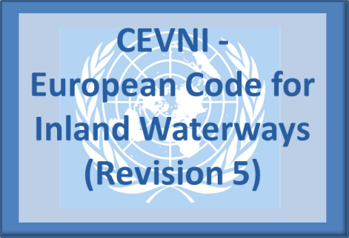53. CESNI is composed of experts representing member States of CCNR and of EU. The parties to the CCNR (Belgium, France, Germany, the Netherlands, and Switzerland) and the remaining member States of the EU have voting rights on the basis of one vote per State. EU is not a party to the CCNR or to CESNI. However, it may participate in the work of CESNI, along with international organizations whose mission covers the areas concerned by CESNI, without voting rights.

54. The CESNI Committee adopts standards by unanimity of the votes of the CCNR and EU member States present. In the absence of a consensus regarding the decision to put the adoption of standards on the agenda, CESNI decides by two-thirds majority of the votes of those Members present at the meeting. In a second step, the CESNI adopts standards by unanimity of the votes of the CCNR and EU member States present. Once decided, standards are given a unique reference number and are published.

55. The CCNR has built up significant experience in establishing technical requirements for inland waterway vessels. Established in the framework of CCNR and with the participation of all EU member States, CESNI therefore possesses the necessary expertise and geographical representativeness to draw up standards common to the entire network of inland waterways in the European Union.

56. The preparatory work on a uniform technical standard for inland waterway vessels to be applied both within the EU and the CCNR has started in the framework of the existing Joint Working Group which supports the implementation of the Directive of the European Parliament and of the Council 2006/87/EC laying down technical requirements for inland waterway vessels and repealing Council Directive 82/714/EEC.

57. The Joint Working Group has compared the existing technical requirements applicable under the EU legislation and in the framework of CCNR and developed uniform solutions in the areas where there are differences. CESNI has continued the work of the Joint Working Group and intends to adopt a standard for technical requirements for inland waterway vessels.

B. Inland Waterways in the Trans European Transport Networks (TEN-T)

****58. In July 2015, under the first call for applications of CEF, the EU approved grants for a total value of EUR 1.33 billion for inland waterway infrastructures. The approved projects will improve connections of industrial regions and urban areas and link them to ports. Priority was given to projects enhancing multi-modal points of interconnection between the waterways and other modes of transport. The call also supported a new generation of River Information Services projects and also studies, like the FAIRway project (seven actions in Austria, Bulgaria, Croatia, Hungary, Romania and Slovakia), aimed to accelerate the removal of bottlenecks and the achievement of stable navigation conditions in the Danube (part of the Danube Master Plan).

59. Furthermore, under the CEF, in November and December 2015, the EU approved two programme support actions (PSA) in favour of the CCNR and of the Danube River Commissions. The PSAs are intended to strengthen both river commissions in matters related to technical standards and recommendations (cf CESNI), market observations, expert groups and stakeholders' consultations, etc. The PSAs should also contribute to ensure that the long standing experience and technical know-how of both CCNR and DC is appropriately taken into account in the implementation of the TEN-T corridors, of the Naiades II Action Plan, achievement of good navigation status in all TEN-T IWW corridors by 2030, deployment of RIS, etc.

60. Finally, during the year 2015, EU worked closely with IWW ports and operators for discussing the implementation of EU related measures, such as the deployment of clean combustibles in the main IWW corridors (e.g. LNG masterplan), the support of the European Fund for Strategic Investments (EFSI) to the financing of IWW infrastructures, the survey on financial needs of IWW operators or the deployment of innovation and intelligent transport systems in the sector.

61. In the legislative side, the European Parliament and the Council achieved steady progress in the finalisation of the revision of Directive 2006/87 on technical requirements for inland navigation vessels. The Commission also carried out a full impact assessment regarding possible options for enhancing the mutual recognition of IWW boat-masters and crew certificates. A new legislative proposal is planned to be presented to Parliament and Council in 2016.

VI. Continuity of passenger mobility following disruption of the transport system

A. Bremen and Östersund announced sustainable urban mobility winners in Europe

62. On 23 March at a ceremony in Brussels, the European Commissioner for Transport Violeta Bulc presented Bremen (Germany) with the Sustainable Urban Mobility Plan (SUMP) Award. Östersund (Sweden) was presented with the European Mobility Week Award by Karl Falkenberg of the European Commission's Directorate-General for the Environment.

63. "These cities found creative and innovative ways of improving the urban environment using cleaner transport solutions. I would like to congratulate all our finalist cities for tackling their own individual challenges with such dedication and determination. Bremen stands out as an excellent example of using feedback from residents to develop the city's urban mobility plans by learning from past experiences and coordinating with peer cities and partnerships. Östersund is being recognised for its ambitious campaign programme featuring a broad variety of sustainable travel options during European Mobility Week 2014," said Commissioner Bulc.

64. Karl Falkenberg, Director-General of DG Environment commented: "Breathing clean air doesn't seem too much to ask – but air pollution is still needlessly shortening the lives of too many Europeans all over our continent. A large part of that pollution comes from private transport, so it's extremely encouraging to see these clean, green solutions to urban mobility. Better mobility doesn't just bring better air quality it also means reduced emissions, less noise and a healthier urban environment for all."

65. The jury particularly acknowledged Thessaloniki (Greece) for demonstrating considerable commitment and effort in the field of SUMPs. The Greek city, which adopted its first SUMP in February 2014, made tremendous efforts in a difficult working environment, towards establishing brand-new procedures for the implementation, monitoring and evaluation of its mobility plan.

66. Bremen wins the EUR 10,000 prize because of its imaginative and systematic approach to monitoring and evaluation. An interactive web platform was used to obtain feedback from residents. Using this and other data, a SWOT (Strength, Weakness, Opportunity and Threat) analysis was conducted. Five different scenarios were then examined showing the effect of different measures, e.g. major investment in public transport, or only smaller measures promoting walking and cycling. The scenarios illustrated that promoting active mobility was the most efficient strategy for Bremen. Finally, a cost-benefit analysis was conducted under the guidance of external experts.

67. Since effective monitoring and evaluation strategies were what the judges based their assessments on, they were especially impressed by Bremen. In particular, the judges appreciated Bremen's ability to keep learning and to communicate these lessons effectively to stakeholders. Town hall meetings and public information booths are used to raise awareness amongst residents.

68. The other finalists were Dresden (Germany) and Ghent (Belgium). Östersund has participated in European Mobility Week for 12 years in a row and this year's achievement — winning a promotional three-minute video — follows on from its selection as a finalist in 2012. As a city with well over 7 000 students, Östersund works closely with Mid Sweden University to encourage students to travel in a sustainable way. Last year, the city focused on cooperation and inclusion, for example by organizing a three-day course teaching young migrants how to cycle. Östersund is also a lead partner in the Green Highway project, which aims to establish a 440 kilometre fossil fuel-free route across Sweden and Norway.

69. The city also introduced a range of permanent measures, including improved infrastructure for cycling and walking, new bus shelters, a real time information app for public transport users and charging infrastructure for electric vehicles.

70. Murcia (Spain) and Vienna (Austria) were the other two finalists.

Background

71. The SUMP Award is presented to local authorities that demonstrate excellence in the given theme. This year the focus was on monitoring and evaluation of both the planning processes and the implementation measures of sustainable urban mobility plans. This year, the SUMP award attracted 17 applications from 10 countries.

72. The SUMP Award jury consisted of specialists in the fields of transport and urban planning: Patrizia Malgieri, TRT (Transporti e Territorio), Aljaž Plevnik, UIRS (Urbanistični inštitut Republike Slovenije), and Susanne Boehler-Baedeker, Rupprecht Consult.

73. A total of 38 cities from 18 countries applied for the European Mobility Week (EMW) Award. These cities were selected on the basis of a strong link with the 2014 EMW theme of ‘Our streets, our choice’.

74. The EMW Award jury was composed of four independent transport experts — William Todts T&E — Transport & Environment, Robert Pressl, FGM-AMOR (Austrian Mobility Research), Vincent Meerschaert, Traject, Benedicte Swennen, ECF (European Cyclists’ Federation), a representative from DG ENV and a representative from DG MOVE.

VII. Reduce Oil Dependence and Fight Against Climate Change

Setting-up an expert group on alternative transport fuels –   
The Sustainable Transport Forum

75. Following the adoption of Directive 2014/94/EU on the deployment of alternative fuels infrastructure the European Commission announced on 23 April 2015 the creation of the Sustainable Transport Forum (STF).

76. The STF should help the Commission to advance the application of the Clean Power for Transport strategy and facilitate the implementation of Directive 2014/94/EU. It shall assist the Commission in implementing the Union’s activities and programmes aimed at fostering the deployment of alternative fuels infrastructure to contribute to EU energy and climate goals.

77. The STF is bringing together member States and alternative fuels industry stakeholders. It will enable a structured dialogue, exchange of best practices and coordination, thus providing the opportunity to discuss practical issues that could be encountered during the implementation process of Directive 2014/94/EU.

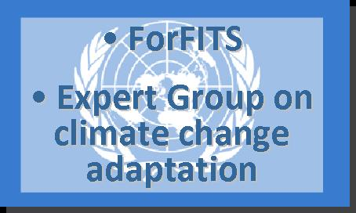78. The STF kick off meeting was held on June 29th 2015. The STF is operating with the following structure: a plenary, a secretariat, and non-permanent technical subgroups to further develop the actions outlined in the Commission Decision. The STF envisages in particular to:

* provide advice and technical expertise to the Commission on the development and implementation of legislation, policies, projects and programmes in the field of alternative transport fuels and contribute towards an energy-efficient, decarbonised transport sector;
* facilitate exchanges of information on initiatives, projects and partnerships dealing with alternative transport fuels;
* deliver opinions, submit reports, or develop and propose innovative solutions to the Commission, either at the latter's request or on its own initiative, on any matter of relevance to the promotion of alternative transport fuels in the Union.

VIII. Intelligent Transport Systems

A. ITS Conference 2015 "A Digital Strategy for Mobility: from capacity to connectivity"

79. The European Commission organized its fifth Conference on Intelligent Transport Systems in Brussels on 24 April 2015. The objective of this high-level event was to provide an overview of the state-of-play with regard to a number of key actions and major initiatives in the context of the ITS Action Plan and the ITS Directive 2010/40/EU.

80. During the ITS Conference 2015 topics such as Data for digitising transport, Mobility as a Service and Connectivity and automation were discussed. The ITS Conference 2015 brought together high-level representatives from the European institutions and representatives of public and private stakeholders from the ITS community.

B. Provision of EU-wide multimodal travel information services under the ITS Directive 2010/40/EU

81. A public consultation was organized to collect the opinions of stakeholders and interested parties including EU citizens and private and public organizations and gain (quantitative) evidence on the issues related to the provision of EU-wide multimodal travel information services. The replies submitted to this public consultation will be taken into consideration for the development of the relevant specifications within the frame of the ITS Directive.

82. ITS can significantly contribute to a more sustainable, safer and efficient transport system and the ITS Directive was adopted to accelerate the deployment of these innovative transport technologies across Europe. The ITS Directive provides for the adoption of functional, technical and organizational specifications in the form of a delegated act to ensure the compatibility, interoperability and continuity for the deployment and operational use of EU-wide multimodal travel information services (Priority Action "A" of the ITS Directive). This delegated act will be a binding policy measure laying down provisions containing requirements or any other relevant rules to be followed in the case of deployment.

83. These specifications will be aimed at ensuring interoperable travel data and services, where possible based on existing standards and technology. At present, multimodal information services across Europe lack interoperability and are fragmented in terms of what they offer including modal and geographical coverage, real-time information and quality levels. This initiative is expected to contribute to EU-wide continuity and harmonized delivery of multimodal travel information services. This in turn is expected to encourage a positive modal shift to sustainable modes of transport and therefore improve the efficiency of Europe's transport network management.

84. The scope of these specifications does not include integrated multimodal ticketing; however this remains a long-term vision of the European Commission.

85. Multimodal travel information and planning services (MMTIPs) allow travellers to plan their journey from A to B comparing different travel options combing different variations of transport modes. MMTIPs may include a combination of two or more of the following transport modes which might be used by a traveller: air, rail, waterborne, coach, public transport, demand responsive transport, walking and cycling. Such services can allow the traveller to receive personalised routing results according to their specific travel preferences or needs including the fastest route, the cheapest route, the fewest connections, the most environmentally friendly, the most accessible for persons with reduced mobility etc. or simply a routing result based on the transport mode(s) they wish to use (i.e. cycling or public transport).

86. The users of multimodal travel information are primarily citizens travelling on journeys which can be new, infrequent or regular/daily. Travellers may require information to help select the most cost effective, quickest or time appropriate mode of transport for a given journey. Moreover, travellers may want to be aware of any changes to a journey which they are undertaking, whether it be disruptions, routing changes, or expected travel time. Users may require information for short local journeys or longer trips including those journeys which require cross-border travel.

87. However, the users of multimodal travel information services are not just limited to the travellers themselves, but increasingly transport operators and transport authorities also use MMTIPs to maximise the efficiency of their management of the transport network by using real-time information about travel disturbances and incidents to smoothly re-direct traffic flow across their network. Moreover, logistic firms and freight companies also use this real-time information to support their daily activities by making well informed decisions regarding choosing the best route to efficiently conduct their operations avoiding travel disturbances and incidents.

88. Multimodal travel information services can be delivered to users through a variety of channels. While there remains a portion of users who prefer to access information through staffed-services such as telephone advice lines or walk-in travel centres, the majority of these services are now provided online via browsers and also mobile phone applications. Information is provided by a range of organization types including transport operators, transport authorities, public sector initiatives and private sector technology companies.

IX. Vehicles Regulations

89. Poor-quality or old tyres with reduced tread depth may cause your car to skid in wet weather or when braking. New, quality tyres hold your car on the road, save fuel and reduce 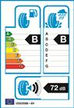noise and emissions.

90. Labels displaying tyre ratings for fuel efficiency, wet grip and noise

91. The EU has introduced a labelling scheme (from 1 November 2012) to help consumers choose the best tyres in terms of fuel efficiency, wet grip and noise. Tyres for cars and light commercial vehicles must have a sticker on them with product information. For heavy-duty-vehicle tyres, the label will appear in technical documents and on websites.

92. Fuel-efficient tyres - if widely used - could save an estimated 6.6 Mtoe (million tonnes of oil equivalent) of fuel per year by 2020. They could also cut CO2 emissions by 4 million tonnes a year, the equivalent of removing 1.3 million passenger cars from EU roads annually.

93. The labels will grade a tyre's ability to brake on a wet road. High-performing tyres can reduce braking distance by several metres.

94. Labels will also provide information on which are the quietest tyres.

95. EU is a Contracting Party to the 1958 and 1998 Agreements on vehicle construction managed by the World Forum for Harmonization of Vehicle Regulations (WP.29). As from 1 November 2014, a large number UN Regulations became binding EU law through the implementation of the relevant provisions of Regulation (EC) No 661/2009 on the General Safety of motor vehicles (General Safety Regulation), which repealed more than 50 EU Directives and replaced the majority of them with 70 UN Regulations covering the same subject.

96. The key focus of the EU Commission was on the successful finalisation of the reform of the 1958 Agreement through the swift adoption of its Revision 3, which is promising to bring substantial benefits in terms of trade facilitation and enhancing of the competitive position of the EU automotive industry on a global market whose centre of gravity is steadily shifting to emerging countries. There are already strong signals of increasing interest in joining the 1958 Agreement shown by important EU partners such as China, India and Brazil, as well as from other countries in the Asian region.

97. A considerable amount of energy was also devoted to the possible adoption of the new UN Regulation on International Whole Vehicle Type Approval (IWVTA), as part of the reform of the 1958 Agreement, in order to allow at least partial application of the scheme by the Contracting Parties in 2016. Having in mind that IWVTA will only be established between the Contracting Parties to the 1958 Agreement, thus excluding important EU partners, the need of fostering the accession of more countries to this Agreement becomes more tangible.

98. The European Commission’s efforts were streamed towards the strengthening of the implementation of internationally agreed standards under the UNECE framework and to complementing them through bilateral regulatory cooperation with key EU partners. In this regard, of paramount importance are the negotiations with the United States of America in the framework of the Translatlantic Trade and Investment Partnership.

99. At the European level, the Commission has been working intensely to develop robust procedures for the testing of emissions of vehicles. Currently nitrous oxide (NOx) emissions of diesel vehicles when measured on the road are higher than when measured on the regulatory test cycle (NEDC). To address this gap, the Commission has been working to develop Real Driving Emission (RDE) test procedures.

100. The RDE procedure will complement the current laboratory based procedure (NEDC) to check that the emission levels of nitrogen oxides (NOx), and at a later stage also particle numbers (PN), measured during the laboratory test are confirmed in real driving conditions. The pollutant emissions will be measured by portable emission measuring systems (PEMS) that will be attached to the car. RDE testing will significantly reduce the currently observed differences between emissions measured in the laboratory, and those measured on road under real-world conditions, and to a great extent limit the risk of cheating with a defeat device.

101. Subject to the endorsement of the European Parliament, the not-to-exceed emission limits agreed upon by member States in October 2015 will be introduced from September 2017.

X. Publications

A. EU Transport in figures 2015

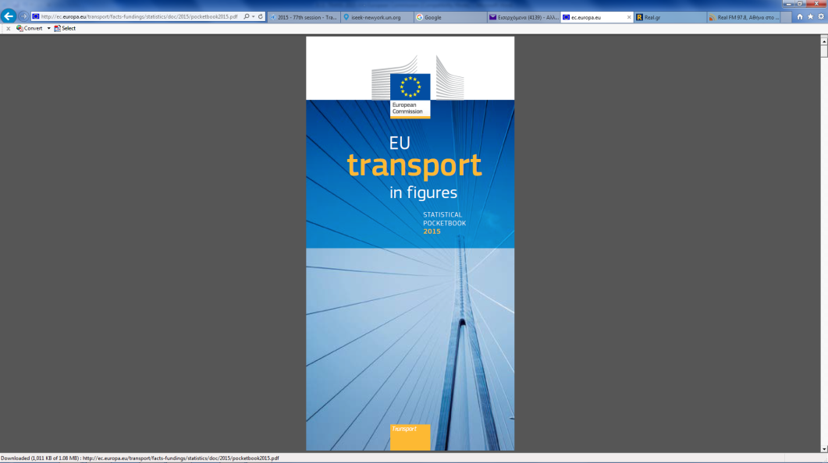 1. Gross Value Added

102. With around € 562 billion in Gross Value Added (GVA) at basic prices, the transport and storage services sector (including postal and courier activities) accounted for about 4.9 per cent of total GVA in the EU-28 in 2012. However, this figure only includes the GVA of companies whose main activity is the provision of transport (and transport-related) services and own account transport operations are not included.

2. Employment

103. In 2013, the transport and storage services sector (including postal and courier activities) in the EU-28 employed around 11 million persons, some 5.1 per cent of the total workforce. Around 53 per cent of them worked in land transport (road, rail and pipelines), 3 per cent in water transport (sea and inland waterways), 4 per cent in air transport and 25 per cent in warehousing and supporting and transport activities (such as cargo handling, storage and warehousing) and the remaining 16 per cent in postal and courier activities.

3. Household expenditure

104. In 2013, it is estimated that private households in the EU-28 spent € 961 billion or roughly 12.8 per cent of their total consumption on transport-related items. Close to 26 per cent of this sum (around € 248 billion) was used to purchase vehicles, more than half (€ 520 billion) was spent on the operation of personal transport equipment (e.g. to buy fuel for the car) and the rest (€ 193 billion) was spent for transport services (e.g. bus, train, plane tickets).

4. Goods transport

105. In 2013 total goods transport activities in the EU-28 are estimated to amount to 3481 billion tkm. This figure includes intra-EU air and sea transport but not transport activities between the EU and the rest of the world. Road transport accounted for 49.4 per cent of this total, rail for 11.7 per cent, inland waterways for 4.4 per cent and oil pipelines for 3.2 per cent. Intra-EU maritime transport was the second most important mode with a share of 31.3 per cent while intra-EU air transport only accounted for 0.1 per cent of the total.

5. Passenger transport

106. In 2013, total passenger transport activities in the EU-28 by any motorized means of transport are estimated to amount to 6 465 billion pkm or on average about 12 700 km per person. This figure includes intra-EU air and sea transport but not transport activities between the EU and the rest of the world. Passenger cars accounted for 72.3 per cent of this total, powered two wheelers for 1.9 per cent, buses and coaches for 8.1 per cent, railways for 6.6 per cent and tram and metro for 1.5 per cent. Intra-EU air and intra-EU maritime transport contributed for 9 per cent and 0.6 per cent respectively.

6. Safety

107. Road: 25 938 persons were killed in road accidents (fatalities within 30 days) in 2013, 7.8 per cent fewer than in 2012 (when 28 143 people lost their lives). In comparison with 2001, the number of road fatalities was lower by more than half (-52.8 per cent). Rail: 97 passengers lost their lives in 2013; this figure does not include casualties among railway employees or other people run over by trains. Air: 120 lives were lost in 2013

XI. UNECE – European Union cooperation

108. The EU and its member States have actively participated in all the transport intergovernmental forums of the United Nations serviced by the UNECE secretariat, i.e. in the Economic and Social Council (ECOSOC) Committee of Experts on the Transport of Dangerous Goods and on the Globally Harmonized System of Classification and Labelling of Chemicals, as well as in the Inland Transport Committee and its subsidiary bodies.

1. \* This document was submitted late due to delayed inputs from other sources. [↑](#footnote-ref-2)
2. No exemptions can be granted for the application of Articles 9,11,12, 19, 20(1) and 26. [↑](#footnote-ref-3)