|  |  |  |  |
| --- | --- | --- | --- |
|  | United Nations | ECE/TRANS/WP.29/2016/95 | |
| Description: _unlogo | **Economic and Social Council** | | Distr.: General  1 September 2016  Original: English |

**Economic Commission for Europe**

Inland Transport Committee

**World Forum for Harmonization of Vehicle Regulations**

**170th session**

Geneva, 15-18 November 2016

Item 4.7.7 of the provisional agenda

**1958 Agreement :   
Consideration of draft amendments**

**to existing Regulations submitted by GRSG**

Proposal for Supplement 5 to the 01 series of amendments to Regulation No. 110 (CNG and LNG vehicles)

**Submitted by the Working Party on General Safety Provisions[[1]](#footnote-2)\***

The text reproduced below was adopted by the Working Party on General Safety Provisions (GRSG) at its 110thsession (ECE/TRANS/WP.29/GRSG/89, paras. 32, 36 and 37). It is mainly based on the text of ECE/TRANS/WP.29/GRSG/2015/36, ECE/TRANS/WP.29/GRSG/2016/8 and ECE/TRANS/WP.29/GRSG/2016/9 as amended by paragraphs 32 and 36 of the report. It is submitted to the World Forum for Harmonization of Vehicle Regulations (WP.29) and to the Administrative Committee AC.1 for consideration at their November 2016 sessions.

Supplement 5 to the 01 series of amendments to Regulation No. 110 (CNG and LNG vehicles)

*Paragraph 7.1.,* correct "paragraphs 8.12. to 8.21." to read "paragraphs 8.12. to 8.22.".

*Paragraph 18.5.1.3.,* amend to read:

"18.5.1.3. Notwithstanding the provisions of paragraph 18.5.1.2.

(a) The automatic cylinder valve may stay in an open position during commanded stop phases, and

(b) In the case where a fire alarm system is installed in the compartment where a CNG combustion heater is located, the automatic cylinder valve(s) may be opened by an electronic control unit for the purpose of permitting its operation to warm the engine coolant."

*Annex 4A, paragraph 4.2.4.,* correct "of Class 1 and Class 2" to read "of Class 2".

*Annex 4B, paragraph 1.6.2.2.,* amend to read:

"1.6.2.2. The interface type for the hose coupling shall be:

(a) Sealing cone of swivel-nut type of the type with a half vertical angle of 45°, or

(b) Other couplings complying with the tests described in paragraph 1.7., as well as the tests mentioned in Annexes 5A and 5B.

In the case of an interface type using a soft seal body (e.g. O-ring), the type of material chosen shall be tested in accordance with Annexes 5D, 5F and 5G.

Couplings shall have complementary counterparts."

*Annex 4H, paragraph 2.2.,* correct "than 5 seconds" to read "than 2 seconds".

*Annex 4J*

*Paragraph 2.2.,* shall be deleted.

*Paragraph 3.1.6.,* correct "shall be not be" to read "shall not be".

*Insert new paragraphs 4. and 4.1.,* to read:

"4. LNG filling receptacle dimensions

4.1. Figure 1 shows the dimensions of the LNG filling receptacle.

Figure 1

**Dimensions of the receptacle**

"

all dimensions in millimeters

The 50 mm dimension is the minimum distance to the mounting flange

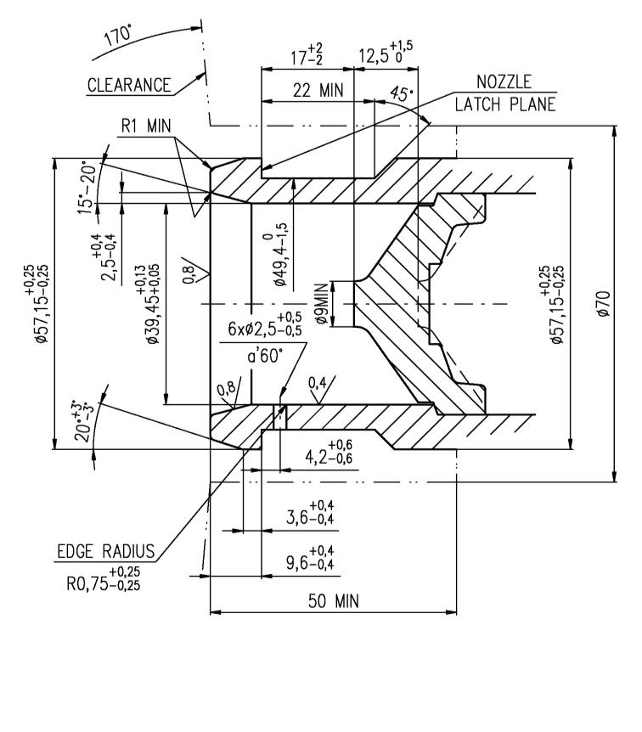

1. \* In accordance with the programme of work of the Inland Transport Committee for 2016–2017 (ECE/TRANS/254, para. 159 and ECE/TRANS/2016/28/Add.1, cluster 3.1), the World Forum will develop, harmonize and update Regulations in order to enhance the performance of vehicles. The present document is submitted in conformity with that mandate. [↑](#footnote-ref-2)