**Modifications to Annex 3 of the draft Resolution on the common specification of light source categories (ECE/TRANS/WP.29/GRE/2015/28)**

Annex 3

Sheets for led light sources

List of sheets for LED light sources and their sequence in this annex:

| *Sheet number(s)* |  |
| --- | --- |
| LR1/1 to 5 |  |
| LW2/1 to 5 |  |
| L3/1 to 6 |  |
| LR4/1 to 5 |  |
| L5/1 to 6 |  |
|  |  |

**Category LR1 Sheet LR1/1**

The drawings are intended only to illustrate the essential dimensions (in mm) of the LED light source

Figure 1

**Main drawing**

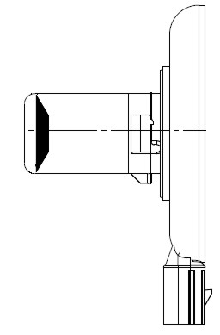

**e**

**35 max**

**Ø 22 max**

**14**

**Ø 67 max**

**min. free air space  
for convection**

**Reference plane 1/**

**Reference axis 2/**

**3/**

**28**

**5**

**Connector**

Figure 2

**Connector detail**



Not connected 4/

Major Function

Ground

Minor Function

___________________

1/ The reference plane is the plane defined by the contact points of the cap-holder fit.

2/ The reference axis is perpendicular to the reference plane and passing through the centre of the bayonet core.

3/ Light emitting area: to be checked by means of the box system in Figure 3.

4/ Optional pin.

**Category LR1 Sheet LR1/2**

Table 1

**Essential dimensional, electrical and photometric characteristics**

|  |  |  |  |  |  |
| --- | --- | --- | --- | --- | --- |
| *Dimensions in mm* | | *Tolerance* | | | |
| *LED light sources of normal production* | | *Standard LED light source* | |
| e 3/ 7/ | 24.0 | 0.2 | | 0.1 | |
| Cap PGJ21t-1 in accordance with IEC Publication 60061 (sheet 7004-165-1) | | | | | |
| Electrical and photometric characteristics 5/ | | | | | |
| Rated values |  | *Minor function* | *Major function* | *Minor function* | *Major function* |
| Volts | 12 | | 12 | |
| Objective  Values 6/ | Watts  (at 13.5 V DC) | 0.75 max. | 3.5 max. 1.4 min. | 0.75 max. | 3.5 max. 1.4 min. |
| Luminous flux  (in lm at 13.5V DC) |  |  | 3.5 ± 10% | 47 ± 10% |
| Luminous flux  (in lm at 10-16 V DC) | 3.5 ± 20% | 47 ± 20% |  |  |

5/ The emitted light shall be red.

6/ Continuous on for 30 minutes at 23 ± 2.5° C.

7/ Light centre length.

Failure condition behaviour

In case of LED light source failure (no light emitted) the maximum current draw – when operated within the input voltage range in major function mode – operation shall be less than 20 mA (open circuit condition).

Screen projection requirements

The following test is intended to define the requirements for the light emitting area of the LED light source and to determine whether the light emitting area is correctly positioned relative to the reference axis and reference plane in order to check compliance with the requirements.

The position of the light emitting area is checked by the box system defined in Figure 3, which shows the projections when viewing along direction γ=90º in the planes C90 and C180 (C, γ as defined in Figure 4). At least 95 per cent of the luminous flux emitted into the viewing direction has to come from the trapezoidal area defined by d1, d2 and c. Less than 70 per cent of the luminous flux shall be emitted from the rectangular area defined by d3 and c.

**Category LR1 Sheet LR1/3**

Figure 3

**Box definition of the light emitting area**

Reference plane

d2

d1

c

e

d3

Reference axis

Table 2

**Dimensions of the box system in Figure 3**

|  |  |  |  |  |  |
| --- | --- | --- | --- | --- | --- |
| *Dimensions in mm* | *e* | *c* | *d1* | *d2* | *d3* |
| LED light sources of normal production | 24.0 + 0.2 | 3.6 | 21.0 | 15.0 | 7.0 |
| Standard (etalon) LED light sources | 24.0 + 0.1 | 3.4 | 21.0 | 15.0 | 7.0 |

Normalized luminous intensity distribution

The following test is intended to determine the normalized luminous intensity distribution of the LEDlight source in an arbitrary plane containing the reference axis. The intersection of the reference axis and the upper edge of the box is used as the coordinate system origin.

The LED light source is mounted on a flat plate with the corresponding mounting lug features. The plate is mounted to the goniometer table by a bracket, so that the reference axis of the LEDlight source lines up with one of the rotating axis of the goniometer. The corresponding measurement set-up is described in Figure 4.

**Category LR1 Sheet LR1/4**

The drawings are intended only to illustrate the essential set-up for measurement of the LED light source

Figure 4

**Set-up to measure the luminous intensity distribution**

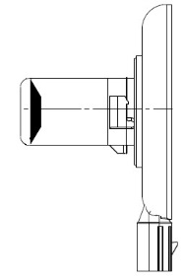

**γ**

**e**

**Photo-Detector of Goniometer**

**Reference Plane**

**Reference Axis**

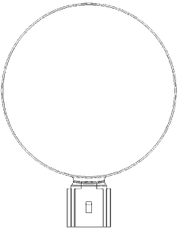

**C**

**Any C-plane between C30 and C330**

Luminous intensity data is recorded for the major function with a standard photo-goniometer. The measurement distance should be chosen appropriately, to make sure that the detector is located in the far field of the light distribution.

The measurements shall be performed in 3 C-planes, which contain the reference axis of the LEDlight source. The 3 C-planes shall be within C30 and C330 to avoid the connector shadows and they have to be at least 30º apart from each other. The test points for each plane for multiple polar angles γ are specified in Table 3.

The measured luminous intensity values, normalised to the measured luminous flux of the individual LED light source under test, shall be converted to normalised luminous intensity values of a 1000 lm LED light source.The data shall comply with the tolerance band as defined in Table 3.

C-planes: see CIE publication 70-1987, "The measurement of absolute intensity distributions".

**Category LR1 Sheet LR1/5**

Table 3

**Test point values of normalized intensity for the major function of normal production and standard LED light sources, respectively.**

|  |  |  |  |  |
| --- | --- | --- | --- | --- |
|  | *LED light source of normal production* | | *Standard LED light source* | |
| *γ* | *Minimum intensity  in cd /1000 lm* | *Maximum intensity  in cd/1000 lm* | *Minimum intensity  in cd /1000 lm* | *Maximum intensity in cd/1000 lm* |
| 0° | 0 | 30 | 0 | 20 |
| 15° | 0 | 30 | 0 | 20 |
| 30° | 0 | 70 | 0 | 40 |
| 45° | 20 | 100 | 20 | 60 |
| 60° | 35 | 120 | 35 | 80 |
| 75° | 50 | 140 | 50 | 100 |
| 90° | 70 | 160 | 70 | 120 |
| 105° | 90 | 180 | 90 | 140 |
| 120° | 110 | 200 | 110 | 160 |
| 135° | 110 | 200 | 110 | 160 |
| 150° | 90 | 180 | 90 | 140 |

The luminous intensity distribution as described in Table 3 shall be substantially uniform, i.e. in between two adjacent grid points the relative luminous intensity requirement is calculated by linear interpolation using the two adjacent grid points. **Category LW2 Sheet LW2/1**

The drawings are intended only to illustrate the essential dimensions (in mm) of the LED light source

Figure 1

Light emitting area 3/

Reference axis 2/

Reference plane 1/

**Main Drawing – front and side view**



Figure 2 – Connector Detail

Major function

Ground

Not connected 4/

Minor function



Table 1

**Essential dimensional, electrical and photometric characteristics**

|  |  |  |  |  |  |  |  |
| --- | --- | --- | --- | --- | --- | --- | --- |
| *Dimensions in mm* | | *Tolerances* | | | | | |
| *LED light sources of normal production* | | *Standard LED light sources* | | | |
| e 8/ | 26.4 | 0.2 | | 0.1 | | | |
| Cap PGJY50 in accordance with IEC Publication 60061 (sheet 7004-182-1) | | | | | | | |
| Electrical and photometric characteristics 5/ | | | | | | | |
| Rated values |  | *Minor function* | *Major function* | | *Minor function* | *Major function* | |
| Volts | 12 | | | 12 | | |
| Objective  Values 6/ 7/ | Watts  (at 13.5 V DC) | 1 max. | 12 max. 4 min. | | 1 max. | | 12 max. 4 min. |
| Luminous flux  (in lm at 13.5V DC) |  |  | | 50 ± 10% | | 725 ± 10% |
| Luminous flux  (in lm at 10-16 V DC) | 50 ± 15% | 725 ± 15% | |  | |  |
| Corresponding base temperature Tb in °C | | 30 ± 2 | 55 ± 2 | | 30 ± 0.5 | | 55 ± 0.5 |

1/ The reference plane is given by the thermal transfer area on the backside of the LEDlight source.

2/ The reference axis is perpendicular to the reference plane and passing through the centre of the LEDlight source as defined by three notches on the outer perimeter.

3/ Light emitting area: to be checked by means of the box system in Figure 3.

4/ Optional pin.

5/ The emitted light shall be white.

6/ Continuous operation for 30 minutes with base temperature Tb stabilized as specified above.

7/ Luminous flux from the light emitting area shall be determined within a solid angle of ­ 40° < α < + 40° and ­ 40° < β < +40° using either integral methods or the procedure described on sheets LW2/3 and LW2/4.

8/ Light centre length.

**Category LW2 Sheet LW2/2**

Screen projection requirements

This test is intended to determine whether the light emitting area of the LED light source is correctly positioned relative to the reference axis and reference plane.

Compliance of position and dimension as defined in Table 2 is checked by the box system shown in Figure 3. The left drawing displays the projection when viewing along the reference axis with an aperture acceptance angle of ±40° while the right drawing defines the position of the reference plane and axis.

Size determination shall be done with suitable means.

Figure 3

**Box definition of light emitting area**

Light emitting area 3/

Reference plane 1/

Reference axis 2/

Light Emission



Table 2

**Dimensions of the light emitting area in Figure 3**

|  |  |  |  |  |
| --- | --- | --- | --- | --- |
| *Dimensions in mm* | *e* | *a* | *b* | *c* |
| LED light sources of normal production | 26.4 ± 0.2 | 14.5 +0/ -2.5 | 10.1 +0/ -1.5 | Ø 50.00 + 0.10/ -0 |
| Standard (Etalon) LED light sources | 26.4 ± 0.1 | 14.5 +0/ -2.5 | 10.1 +0/ -1.5 | Ø 50.05 + 0.05/ -0 |

**Category LW2 Sheet LW2/3**

Cumulative luminous flux distribution

Measurement set-up

This test is intended to determine the cumulative luminous flux within defined solid angles of the luminous intensity distribution.

Goniophotometers of type I or II according to CIE publication No. 70 -1987 with the capability of turning the LEDlight source around two axes perpendicular to the axis of light emission can be used. The intersection of the reference axis and the parallel plane to the reference plane in distance e is used as the coordinate system origin.

Figure 4

**Set-up to measure the luminous intensity distribution using a type I photogoniometer**



Photometer  
of Goniometer

Photometer

Reference Axis

Reference Plane

The LEDlight source is mounted on a flat plate with the corresponding mounting lug features. The plate is mounted to the goniometer table by a bracket in such way, that the reference axis of the LEDlight source lines up with the measurement axis of the goniometer. The corresponding measurement set-up is described in Figure 4.

**Category LW2 Sheet LW2/4**

Cumulative luminous flux distribution

Measurement and calculation procedure

Data shall be recorded for the specified base temperature Tb from Table 1 at the location shown in Fig. 5.

Luminous intensity distribution data shall be recorded within a solid angle of -40° < α < +40° and -40° < β < +40°. The measurement distance shall be chosen in such manner that the detector is located in the far field of the light distribution. An angular step size of 1° or less is required.

After the measurement, the cumulative luminous flux distribution shall be calculated from the recorded data for various solid angles as specified in Table 3 according to CIE publication 84-1989, section 4.3. Subsequently, the distribution shall be normalized to the total luminous flux determined for -40° < α < +40° and -40° < β < +40. The data shall comply with the tolerance band defined in Table 3.

In order to secure a symmetrical distribution within each solid angle in Table 3 the luminous flux determination shall be done independently for all 4 quadrants and flux values shall not differ by more than 15%.

Table 3

**Test point values of normalized cumulative luminous flux for both normal production and standard LED light sources**

|  |  |  |
| --- | --- | --- |
| *Angle α, β* | *Min. normalized flux in %* | *Max. normalized flux in %* |
| -5° < α, β < +5° | 8 | 14 |
| -10° < α, β < +10° | 31 | 37 |
| -15° < α, β < +15° | 54 | 59 |
| -20° < α, β < +20° | 75 | 81 |
| -25° < α, β < +25° | 91 | 95 |
| -30° < α, β < +30° | 97 | 100 |
| -35° < α, β < +35° | 98 | 100 |
| -40° < α, β < +40° | 100 (by definition) | |

The cumulative luminous flux distribution of the minor function may be verified by measuring the ratio of major and minor function under a fixed angle and multiplication of this factor with the luminous flux of the major function.

In case of doubt that cumulative luminous flux distributions of major and minor function differ, the procedure as described above for the major function shall be repeated for the minor function.

Thermal interface geometry

The LW2 thermal interface is located within the reference plane (shaded area in Figure 5) and described in detail in IEC Publication 60061 as indicated in Table 1 on sheet LW2/1. It shall be attached to an appropriate heat sink or thermal management system.

The luminous flux given in Table 1 shall be achieved once the base temperature Tb measured at the location shown in Figure 5 is stabilized.

**Category LW2 Sheet LW2/5**

Figure 5

**Rear-view: thermal contact area and location of Tb-point on the vertical   
symmetry axis, at a distance f from the center**



|  |  |
| --- | --- |
| *Dimensions in mm* | |
| c | 50.0 |
| d | 34.5 |
| f | 13.0 |
| g | 10.0 |

Failure condition behaviour

In case of LED light source failure (no light emitted) the maximum current draw – when operated within the input voltage range in major function mode – shall be less than 20 mA (open circuit condition).















**CATEGORIES LR3A, LR3B, LW3A, LW3B, LY3A and LY3B Sheet L3/1**

The drawings are intended only to illustrate the essential dimensions of the LED light source.

Figure 1*

**Main Drawing**

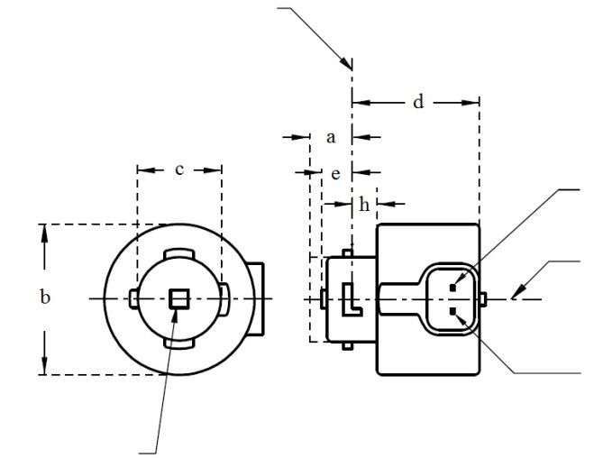

Reference plane 1

V+

Light emitting area 3

Reference axis 2

Ground

4

**LR3A, LW3A, LY3A**

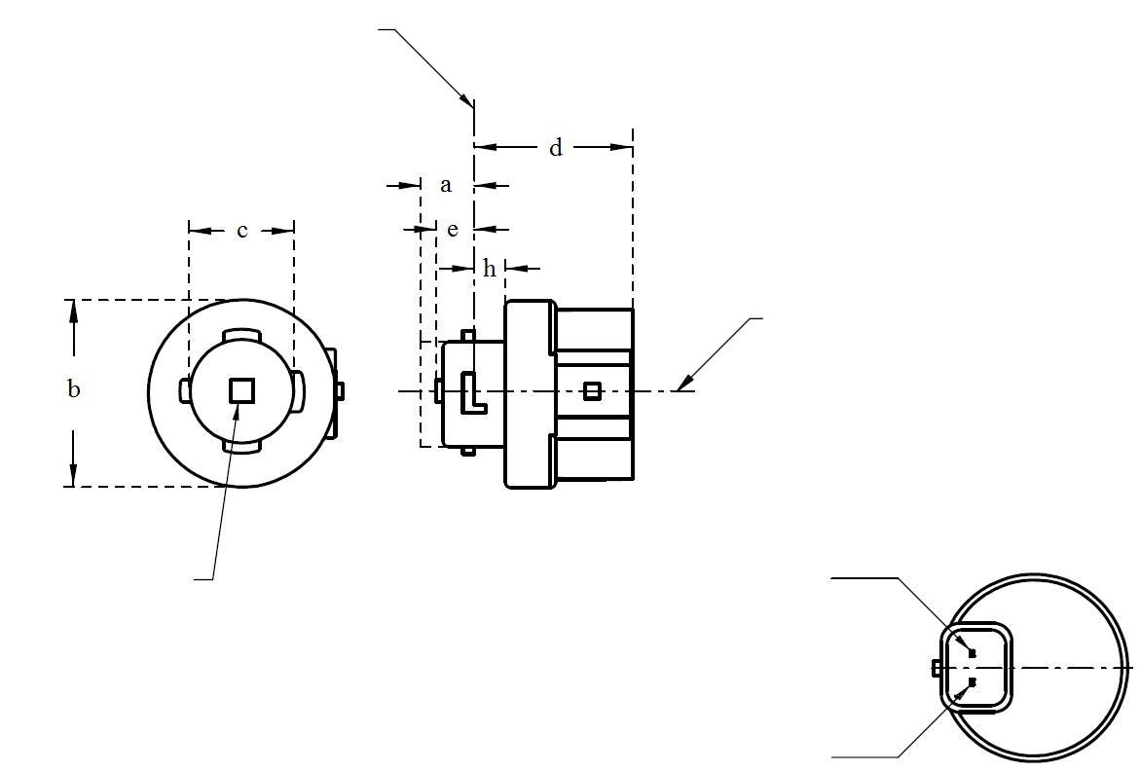

V+

Light emitting area 3

Reference axis 2

Ground

Reference plane 1

4

**LR3B, LW3B, LY3B**

For the notes see sheet L3/2.

* Projection method:

**CATEGORIES LR3A, LR3B, LW3A, LW3B, LY3A and LY3B Sheet L3/2**

Table 1

**Essential dimensional, electrical and photometric characteristics of the LED light source**

|  |  |  |  |  |  |  |  |
| --- | --- | --- | --- | --- | --- | --- | --- |
| *Dimensions* | | | | | | *Production LED light sources* | *Standard LED light sources* |
| a | | | | | mm | 6.0 max. | |
| b | | | | | mm | c + 10.0 min.  38.0 max. | |
| c | | | | | mm | 18.5 ± 0.1 | |
| d | | | | | mm | 28.0 max. | |
| e 13/ | | | | | mm | 3.0 ± 0.30 | 3.0 ± 0.15 |
| h | | | | | mm | 5.5 + 0.0/ – 0.1 | |
| Cap | LR3A, LR3B  LW3A, LW3B  LY3A, LY3B | | PGJ18**.**5d-1  PGJ18.5d-24 PGJ18.5d-15 | | in accordance with IEC Publication 60061 (sheet 7004-185-1) | | |
| *Electrical and photometric characteristics* | | | | | | | |
| Rated values | | Volts | |  | | 12 | |
| Watts | |  | LR3A, LR3B | 3 | |
|  | LW3A, LW3B  LY3A, LY3B | 4 | |
| Objective Values8 | | Watts  (at 13.5 V DC) | |  | LR3A, LR3B | 3.5 max. | |
|  | LW3A, LW3B | 5 max. | |
| 12 | LY3A, LY3B |
| Luminous flux  (in lm at 13.5 V DC) | | 5 | LR3A, LR3B | 80 ± 20%9 | 80 ± 10%10 |
| 6 | LW3A, LW3B | 250 ± 20% | 250 ± 10%11 |
| 7, 12 | LY3A, LY3B | 150 ± 20%9 | 150 ± 10%10 |
| Luminous flux  (in lm at 9 V DC) | | 5 | LR3A, LR3B | 19 min |  |
| 6 | LW3A, LW3B | 50 min. |  |
| 7, 12 | LY3A, LY3B | 30 min |  |

1/ The reference plane is the plane defined by the contact points of the cap-holder fit.

2/ The reference axis is perpendicular to the reference plane and passing through the centre of the bayonet core.

3/ Light emitting area: to be checked by means of the box system in Figure 2.

4/ A minimum free air space of 5mm around the light source shall be respected for convection.

5/ The emitted light shall be red.

6/ The emitted light shall be white.

7/ The emitted light shall be amber.

8/ After continuous operation for 30 minutes at 23 ± 2.5° C.

9/ The measured value shall be in between 100 per cent and 70 per cent of the value measured after 1 minute.

10/ The measured value shall be in between 85 per cent and 75 per cent of the value measured after 1 minute.

11/ The measured value shall be in between 100 per cent and 90 per cent of the value measured after 1 minute.

12/ Operated in flashing mode for 30 minutes (frequency = 1.5 Hz, duty cycle 50 per cent ON, 50 per cent OFF). Measured in the ON-state of flashing mode after 30 minutes of operation.

13/ Light centre length

Electrical characteristics

In case of LED light source failure (no light emitted) the max. electrical current draw, when operated between 12 V and 14 V, shall be less than 20 mA (open circuit condition).

**CATEGORIES LR3A, LR3B, LW3A, LW3B, LY3A and LY3B Sheet L3/3**

Screen projection requirements

The following test is intended to define the requirements for the light emitting area of the LED light source and to determine whether the light emitting area is correctly positioned relative to the reference axis and reference plane in order to check compliance with the requirements.

The position of the light emitting area is checked by the box system defined in Figure 2, which is aligned to the planes C90 and C180 and shows the projection when viewing along direction γ=0º (C, γ as defined in Figure 3).

The proportion of the total luminous flux emitted into the viewing direction shall be as described in table 3.

Figure 2

**Box definition of the light emitting area with dimensions as specified in table 2**

f/3

Reference axis

perpendicular in the

centre of the light-

emitting area

f/3

f/3

f/3

f/3

f/3

A

B

B

B

B

C

C

C

C

f/2

f/2

Table 2

**Dimensions of the box system in Figure 2**

|  |  |  |
| --- | --- | --- |
| *Dimensions in mm* | *f* | |
| LR3A, LR3B | LW3A, LW3B LY3A, LY3B |
| LED light sources of normal production | 3.0 | 4.5 |
| Standard LED light sources | 3.0 | 4.5 |

**CATEGORIES LR3A, LR3B, LW3A, LW3B, LY3A and LY3B Sheet L3/4**

Table 3

**Proportion of the total luminous flux emitted into the viewing direction from the areas specified in figure 2**

|  |  |  |  |
| --- | --- | --- | --- |
| *Category* | *Area(s)* | *LED light sources of normal production* | *Standard LED light sources* |
| LR3A  LR3B | A | ≤ 25% | ≤ 10% |
| Each B individually | ≥ 15% | ≥ 20% |
| Each C individually | - | ≤ 10% |
| A, all B and all C together | ≥ 90% | ≥ 90% |
| LW3A  LW3B  LY3A  LY3B | Each A,B individually | ≥ 6% | ≥ 8% |
| Each A, B individually | < 40% | < 30% |
| All A, B together | ≥ 55% | ≥ 60% |
| Each C individually | < 15% | < 10% |
| All A, B and C together | ≥ 90% | ≥ 90% |

**CATEGORIES LR3A, LR3B, LW3A, LW3B, LY3A and LY3B Sheet L3/5**

Normalized luminous intensity distribution

The following test is intended to determine the normalized luminous intensity distribution of the light source in an arbitrary plane containing the reference axis. The intersection of the reference axis and the parallel plane to the reference plane in distance e is used as the coordinate system origin.

The light source is mounted on a flat plate with the corresponding mounting lug features. The plate is mounted to the goniometer table by a bracket, so that the reference axis of the light source lines up with one of the rotating axis of the goniometer. The corresponding measurement set-up is described in Figure 3.

Luminous intensity data is recorded with a standard photo-goniometer. The measurement distance should be chosen appropriately, to make sure that the detector is located in the far field of the light distribution.

The measurements shall be performed in C-planes C0 (C180) and C90 (C270), which contain the reference axis of the light source. The test points for each plane for multiple polar angles γ are specified in Table**s** 4a and 4b.

The measured luminous intensity values, normalised to the measured luminous flux of the individual light source under test, shall be converted to normalised luminous intensity values of a 1,000 lm light source.The data shall comply with the tolerance band as defined in Tables 4a and 4b.

The drawings are intended only to illustrate the essential set-up for measurement of the LED light source.

Figure 3

**Set-up to measure the luminous intensity distribution**

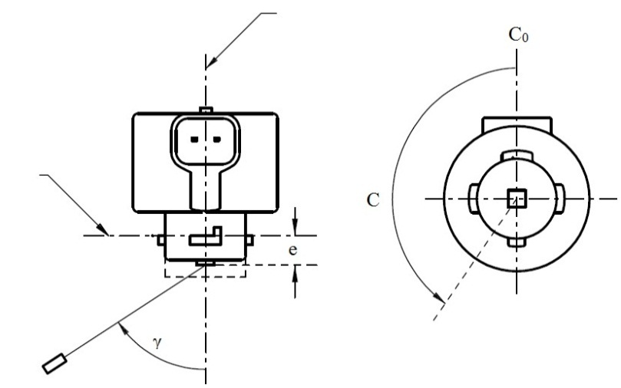

Reference axis

Reference plane

C-plane definition

Viewing direction along reference axis

Photo-Detector of Goniometer

**LR3A, LW3A, LY3A**

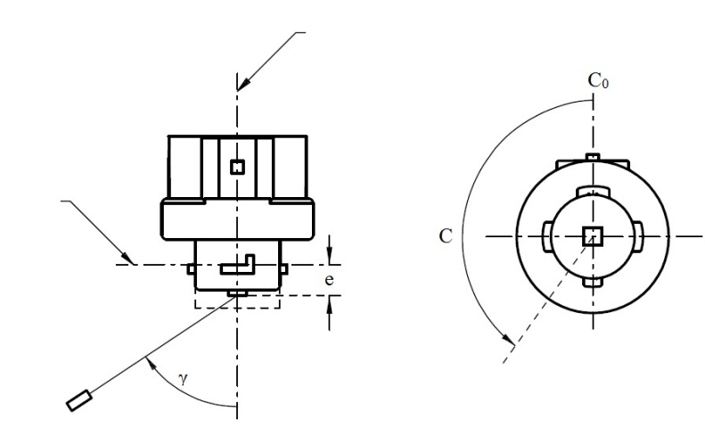

Reference axis

Reference plane

Photo-Detector of Goniometer

C-plane definition

Viewing direction along reference axis

**LR3B, LW3B, LY3B**

**CATEGORIES LR3A, LR3B, LW3A, LW3B, LY3A and LY3B Sheet L3/6**

The light pattern as described in Tables 4a and 4b shall be substantially uniform, i.e. in between two adjacent grid points the relative luminous intensity requirement is calculated by linear interpolation using the two adjacent grid points. In case of doubt this may be checked in addition to verification of the grid points given in Tables 4a and 4b.

Table 4a

**Test point values of normalized intensities for categories LR3A and LR3B**

|  |  |  |  |  |
| --- | --- | --- | --- | --- |
|  | *LED light sources of normal production* | | *Standard LED light sources* | |
| *Angle γ* | *Minimum Intensity  in cd /1000 lm* | *Maximum Intensity  in cd/1000 lm* | *Minimum Intensity  in cd /1000 lm* | *Maximum Intensity in cd /1000 lm* |
| -90° | 0 | 38 | 0 | 25 |
| -75° | 0 | 160 | 0 | 140 |
| -60° | 98 | 246 | 127 | 220 |
| -45° | 142 | 305 | 181 | 275 |
| -30° | 169 | 352 | 213 | 315 |
| -15° | 192 | 389 | 239 | 340 |
| 0° | 200 | 401 | 248 | 352 |
| 15° | 192 | 389 | 239 | 340 |
| 30° | 169 | 352 | 213 | 315 |
| 45° | 142 | 305 | 181 | 275 |
| 60° | 98 | 246 | 127 | 220 |
| 75° | 0 | 160 | 0 | 140 |
| 90° | 0 | 38 | 0 | 25 |

Table 4b

**Test point values of normalized intensities for categories LW3A, LW3B, LY3A and LY3B**

|  |  |  |  |  |
| --- | --- | --- | --- | --- |
|  | *LED light sources of normal production* | | *Standard LED light sources* | |
| *Angle γ* | *Minimum Intensity  in cd /1000 lm* | *Maximum Intensity  in cd/1000 lm* | *Minimum Intensity  in cd /1000 lm* | *Maximum Intensity in cd /1000 lm* |
| -90° | 0 | 70 | 0 | 65 |
| -75° | 0 | 160 | 0 | 150 |
| -60° | 85 | 245 | 105 | 220 |
| -45° | 145 | 310 | 180 | 275 |
| -30° | 170 | 380 | 220 | 335 |
| -15° | 190 | 415 | 240 | 370 |
| 0° | 200 | 425 | 250 | 390 |
| 15° | 190 | 415 | 240 | 370 |
| 30° | 170 | 380 | 220 | 335 |
| 45° | 145 | 310 | 180 | 275 |
| 60° | 85 | 245 | 105 | 220 |
| 75° | 0 | 160 | 0 | 150 |
| 90° | 0 | 70 | 0 | 65 |

**CATEGORIES LR4A and LR4B Sheet LR4/1**

The drawings are intended only to illustrate the essential dimensions of the LED light source.

Figure 1*

**Main Drawing**

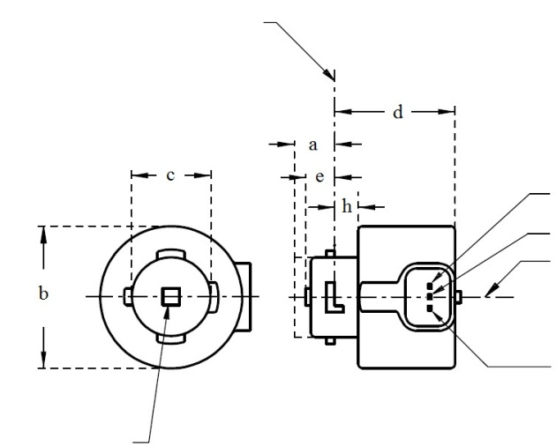

Reference plane 1

Major Function

Light emitting area 3

Reference axis 2

Ground

Minor Function

**LR4A**

4

* Projection method:

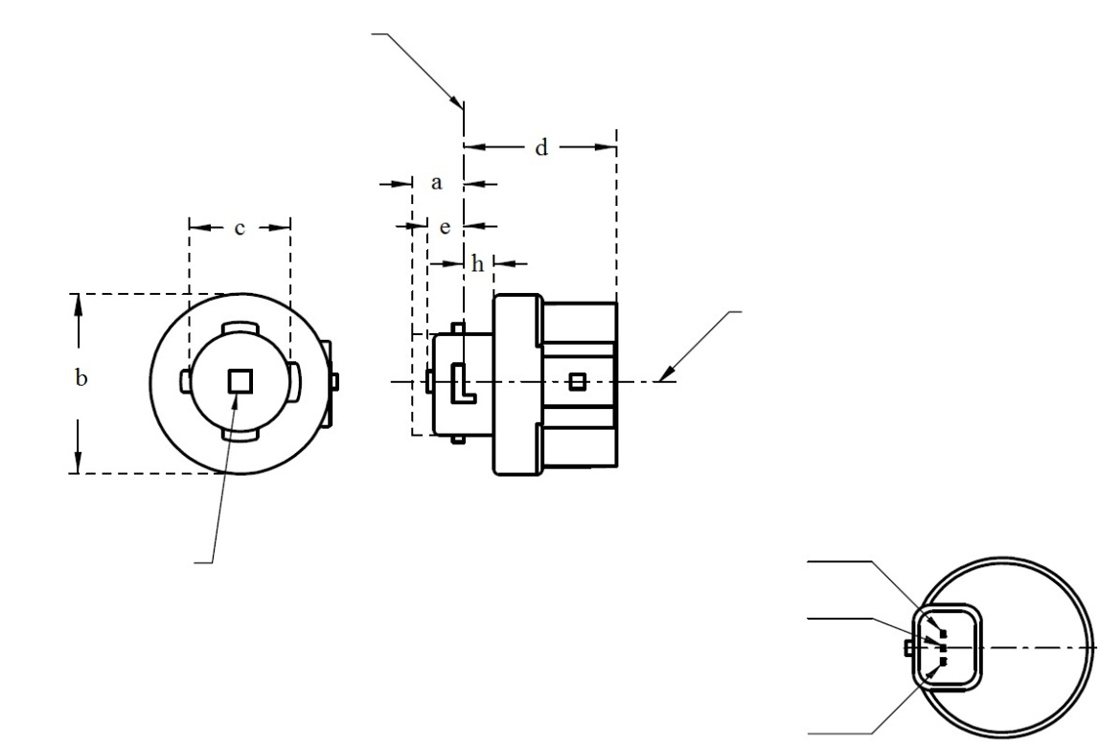

**LR4B**

Major Function

Light emitting area 3

Reference axis 2

Ground

Minor Function

Reference plane 1

4

For the notes see sheet LR4/2.

4

**CATEGORIES LR4A and LR4B Sheet LR4/2**

Table 1

**Essential dimensional, electrical and photometric characteristics of the LED light source**

|  |  |  |  |  |  |  |
| --- | --- | --- | --- | --- | --- | --- |
| *Dimensions* | |  | *Production LED light sources* | | *Standard LED light sources* | |
| a | | mm | 6.0 max. | | | |
| b | | mm | c + 10.0 min.  38.0 max. | | | |
| c | | mm | 18.5 ± 0.1 | | | |
| d | | mm | 28.0 max. | | | |
| e 9/ | | mm | 3.0 ± 0.30 | | 3.0 ± 0.15 | |
| h | | mm | 5.5 + 0.0/ – 0.1 | | | |
| Cap PGJ18.5t-5 in accordance with IEC Publication 60061 (sheet 7004-185-1) | | | | | | |
| Electrical and photometric characteristics 5 | | | | | | |
| Rated values |  | | *Minor function* | *Major function* | *Minor function* | *Major function* |
| Volts | | 12 | | 12 | |
| Watts | | 0.75 | 3 | 0.75 | 3 |
| Objective  Values 6 | Watts  (at 13.5 V DC) | | 1.0 max. | 3.5 max. | 1.0 max. | 3.5 max. |
| Luminous flux  (in lm at 13.5 V DC) | | 6 ± 20% | 80 ± 20% 7 | 6 ± 10% | 80 ± 10% 8 |
| Luminous flux  (in lm at 9 V DC) | | 1.5 min. | 19 min. |  |  |

1/ The reference plane is the plane defined by the contact points of the cap-holder fit.

2/ The reference axis is perpendicular to the reference plane and passing through the centre of the Bayonet core.

3/ Light emitting area: to be checked by means of the box system in Figure 2

4/ A minimum free air space of 5mm around the LEDlight source shall be respected for convection.

5/ The emitted light shall be red.

6/ After continuous operation for 30 minutes at 23 ± 2.5° C.

7/ The measured value shall be in between 100 per cent and 70 per cent of the value measured after 1 minute.

8/ The measured value shall be in between 85 per cent and 75 per cent of the value measured after 1 minute.

9/ Light centre length

Electrical characteristics

In case of LED light source failure (no light emitted) the max. electrical current draw, when operated between 12 V and 14 V, shall be less than 20 mA (open circuit condition).

The major and the minor function shall be operated by separate electrical circuits.

**CATEGORIES LR4A and LR4B Sheet LR4/3**

Screen projection requirements

The following test is intended to define the requirements for the light emitting area of the LED light source and to determine whether the light emitting area is correctly positioned relative to the reference axis and reference plane in order to check compliance with the requirements.

The position of the light emitting area is checked by the box system defined in Figure 2, which is aligned to the planes C90 and C180 and shows the projection when viewing along direction γ=0º (C, γ as defined in Figure 3).

The proportion of the total luminous flux emitted into the viewing direction shall be as described in table 3.

f/3

Reference axis

perpendicular in the

centre of the light-

emitting area

f/3

f/3

f/3

f/3

f/3

A

B

B

B

B

C

C

C

C

f/2

f/2

Figure 2

**Box definition of the light emitting area with dimensions as specified in table 2**

Table 2

**Dimensions of the box system in Figure 2**

|  |  |
| --- | --- |
| Dimensions in mm | f |
| LED light sources of normal production | 4.5 |
| Standard LED light sources | 4.5 |

Table 3

**Proportion of the total luminous flux emitted into the viewing direction from the areas specified in figure 2**

|  |  |  |  |
| --- | --- | --- | --- |
| *Function* | *Area(s)* | *LED light sources of normal production* | *Standard LED light sources* |
| *Minor* | A | ≥ 75% | ≥ 80% |
| *Major* | A | ≤ 25% | ≤ 10% |
| Each B individually | ≥ 15% | ≥ 20% |
| Each C individually | - | ≤ 10% |
| A, all B and all C together | ≥ 90% | ≥ 90% |

**CATEGORIES LR4A and LR4B Sheet LR4/4**

Normalized luminous intensity distribution

The following test is intended to determine the normalized luminous intensity distribution of the light source in an arbitrary plane containing the reference axis. The intersection of the reference axis and the parallel plane to the reference plane in distance e is used as the coordinate system origin.

The light source is mounted on a flat plate with the corresponding mounting lug features. The plate is mounted to the goniometer table by a bracket, so that the reference axis of the light source lines up with one of the rotating axis of the goniometer. The corresponding measurement set-up is described in Figure 3.

Luminous intensity data is recorded with a standard photo-goniometer. The measurement distance should be chosen appropriately, to make sure that the detector is located in the far field of the light distribution.

The measurements shall be performed in C-planes C0 (C180) and C90 (C270), which contain the reference axis of the light source. The test points for each plane for multiple polar angles γ are specified in Table 4.

After measurement the data shall be normalized to 1,000 lm according to paragraph 3.1.11 using the luminous flux of the individual light source under test. The data shall comply with the tolerance band as defined in Table 4.

The drawings are intended only to illustrate the essential set-up for measurement of the LED light source.

Figure 3*

**Set-up to measure the luminous intensity distribution**

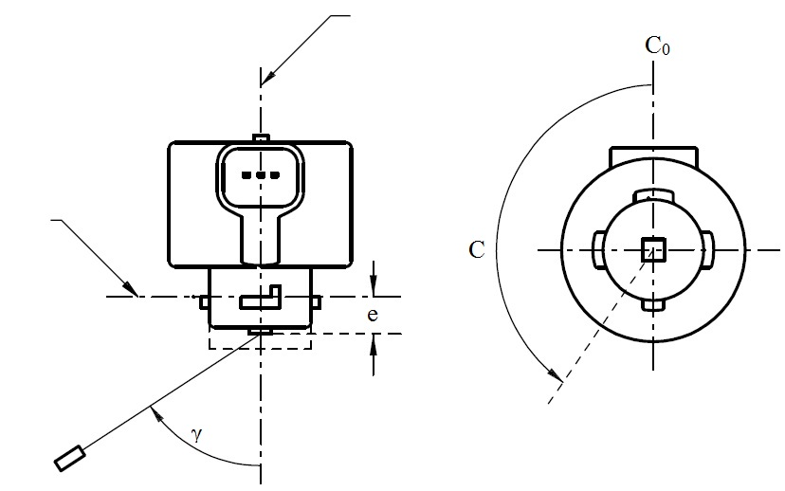

Reference axis

Reference plane

Photo-Detector of Goniometer

C-plane definition

Viewing direction along reference axis

**LR4A**

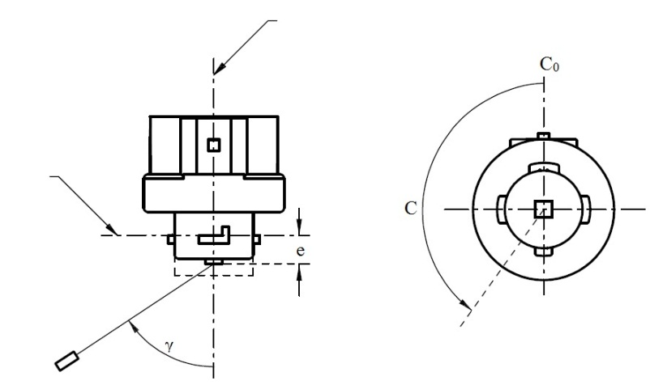

Reference axis

Reference plane

Photo-Detector of Goniometer

C-plane definition

Viewing direction along reference axis

**LR4B**

**CATEGORIES LR4A and LR4B Sheet LR4/5**

The light pattern as described in Table 4 shall be substantially uniform, i.e. in between two adjacent grid points the relative luminous intensity requirement is calculated by linear interpolation using the two adjacent grid points. In case of doubt this may be checked in addition to verification of the grid points given in Table 4.

Table 4

**Test point values of normalized intensities of normal production and standard LED light sources, respectively. Requirements apply to both, major and minor function.**

|  |  |  |  |  |
| --- | --- | --- | --- | --- |
|  | *LED light sources of normal production* | | *Standard LED light sources* | |
| *Angle γ* | *Minimum Intensity  in cd /1000lm* | *Maximum Intensity  in cd/1000lm* | *Minimum Intensity  in cd /1000lm* | *Maximum Intensity in cd/1000lm* |
| -90° | 0 | 38 | 0 | 25 |
| -75° | 0 | 160 | 0 | 140 |
| -60° | 98 | 246 | 127 | 220 |
| -45° | 142 | 305 | 181 | 275 |
| -30° | 169 | 352 | 213 | 315 |
| -15° | 192 | 389 | 239 | 340 |
| 0° | 200 | 401 | 248 | 352 |
| 15° | 192 | 389 | 239 | 340 |
| 30° | 169 | 352 | 213 | 315 |
| 45° | 142 | 305 | 181 | 275 |
| 60° | 98 | 246 | 127 | 220 |
| 75° | 0 | 160 | 0 | 140 |
| 90° | 0 | 38 | 0 | 25 |

**CATEGORIES LR5A, LR5B, LW5A, LW5B, LY5A, LY5B Sheet L5/1**

The drawings are intended only to illustrate the essential dimensions of the LED light source.

Figure 1*

**Main Drawing**

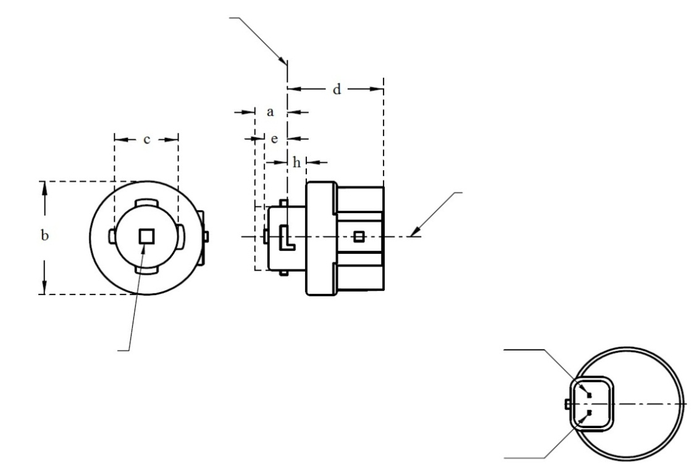

Ground

Reference plane 1

Light emitting area 3

Reference axis 2

4

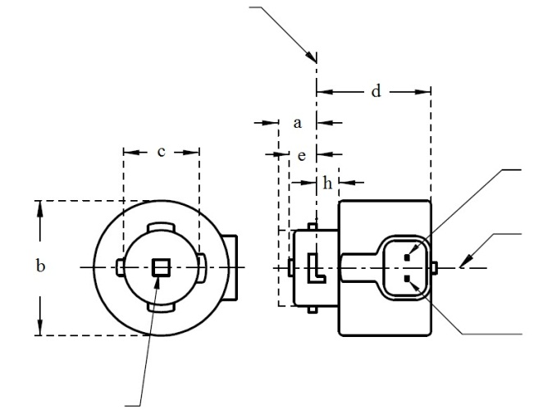

Reference plane 1

V+

Ground

4

Light emitting area 3

Reference axis 2

**LR5A, LW5A, LY5A**

**LR5B, LW5B, LY5B**

* Projection method:

For the notes see sheet L5/2

**CATEGORIES LR5A, LR5B, LW5A, LW5B, LY5A, LY5B Sheet L5/2**

Table 1

**Essential dimensional, electrical and photometric characteristics of the LED light source**

|  |  |  |  |  |  |  |  |
| --- | --- | --- | --- | --- | --- | --- | --- |
| *Dimensions* | | | | | | *Production LED light sources* | *Standard LED light sources* |
| a | | | | | mm | 6.0 max. | |
| b | | | | | mm | c + 10.0 min.  38.0 max. | |
| c | | | | | mm | 18.5 ± 0.1 | |
| d | | | | | mm | 28.0 max. | |
| e 11/ | | | | | mm | 3.0 ± 0.30 | 3.0 ± 0.15 |
| h | | | | | mm | 5.5 + 0.0/ – 0.1 | |
| Cap | LR5A, LR5B  LW5A, LW5B  LY5A, LY5B | | PGJ18.5d-10  PGJ18.5d-28  PGJ18.5d-19 | | in accordance with IEC Publication 60061 (sheet 7004-185-1) | | |
| *Electrical and photometric characteristics* | | | | | | | |
| Rated values | | Volts | |  | | 12 | |
| Watts | |  | LR5A, LR5B | 3 | |
|  | LW5A, LW5B  LY5A, LY5B | 6 | |
| Objective Values8 | | Watts  (at 13.5 V DC) | |  | LR5A, LR5B | 3.5 max. | |
|  | LW5A, LW5B | 8 max. | |
| 10 | LY5A, LY5B |
| Luminous flux  (in lm at 13.5 V DC) | | 5 | LR5A, LR5B | 120 ± 15% | 120 ± 5% 9 |
| 6 | LW5A, LW5B | 350 ± 20% | 350 ± 10% 9 |
| 7, 10 | LY5A, LY5B | 280 ± 20% | 280 ± 10% 9 |
| Luminous flux  (in lm at 9 V DC) | | 5 | LR5A, LR5B | 28 min. |  |
| 6 | LW5A, LW5B | 65 min. |  |
| 7, 10 | LY5A, LY5B | 55 min. |  |

1/ The reference plane is the plane defined by the contact points of the cap-holder fit.

2/ The reference axis is perpendicular to the reference plane and passing through the centre of the bayonet core.

3/ Light emitting area: to be checked by means of the box system in Figure 2

4/ A minimum free air space of 5mm around the light source shall be respected for convection.

5/ The emitted light shall be red.

6/ The emitted light shall be white.

7/ The emitted light shall be amber.

8/ After continuous operation for 30 minutes at 23 ± 2.5° C.

9/ The measured value shall be in between 100 per cent and 90 per cent of the value measured after 1 minute.

10/ Operated in flashing mode for 30 minutes (frequency = 1.5 Hz, duty cycle 50 per cent ON, 50 per cent OFF). Measured in the ON-state of flashing mode after 30 minutes of operation.

11/ Light centre length

Electrical characteristics

In case of LED light source failure (no light emitted) the max. electrical current draw, when operated between 12 V and 14 V, shall be less than 20 mA (open circuit condition).

**CATEGORIES LR5A, LR5B, LW5A, LW5B, LY5A, LY5B Sheet L5/3**

Screen projection requirements

The following test is intended to define the requirements for the light emitting area of the LED light source and to determine whether the light emitting area is correctly positioned relative to the reference axis and reference plane in order to check compliance with the requirements.

The position of the light emitting area is checked by the box system defined in Figure 2, which is aligned to the planes C90 and C180 and shows the projection when viewing along direction γ=0º (C, γ as defined in Figure 3).

The proportion of the total luminous flux emitted into the viewing direction shall be as described in table 3.

Figure 2

**Box definition of the light emitting area with dimensions as specified in table 2**

f/3

Reference axis

perpendicular in the

centre of the light-

emitting area

f/3

f/3

f/3

f/3

f/3

A

B

B

B

B

C

C

C

C

f/2

f/2

Table 2

**Dimensions of the box system in Figure 2**

|  |  |
| --- | --- |
| *Dimensions in mm* | *f* |
| LED light sources of normal production | 4.5 |
| Standard LED light sources | 4.5 |

**CATEGORIES LR5A, LR5B, LW5A, LW5B, LY5A, LY5B Sheet L5/4**

Table 3

**Proportion of the total luminous flux emitted into the viewing direction from the areas specified in figure 2**

|  |  |  |  |
| --- | --- | --- | --- |
| *Category* | *Area(s)* | *LED light sources of normal production* | *Standard LED light sources* |
| LR5A  LR5B | Each B individually | ≥ 10% | ≥ 15% |
| Each A, B individually | < 40% | < 30% |
| All B together | ≥ 60% | ≥ 65% |
| Each C individually | - | < 10% |
| All A, B and C together | ≥ 90% | ≥ 90% |
| LW5A  LW5B  LY5A  LY5B | Each A,B individually | ≥ 6% | ≥ 8% |
| Each A, B individually | < 40% | < 30% |
| All A, B together | ≥ 55% | ≥ 60% |
| Each C individually | < 15% | < 10% |
| All A, B and C together | ≥ 90% | ≥ 90% |

**CATEGORIES LR5A, LR5B, LW5A, LW5B, LY5A, LY5B Sheet L5/5**

Normalized luminous intensity distribution

The following test is intended to determine the normalized luminous intensity distribution of the light source in an arbitrary plane containing the reference axis. The intersection of the reference axis and the parallel plane to the reference plane in distance e is used as the coordinate system origin.

The light source is mounted on a flat plate with the corresponding mounting lug features. The plate is mounted to the goniometer table by a bracket, so that the reference axis of the light source lines up with one of the rotating axis of the goniometer. The corresponding measurement set-up is described in Figure 3.

Luminous intensity data is recorded with a standard photo-goniometer. The measurement distance should be chosen appropriately, to make sure that the detector is located in the far field of the light distribution.

The measurements shall be performed in C-planes C0 (C180) and C90 (C270), which contain the reference axis of the light source. The test points for each plane for multiple polar angles γ are specified in Table 4.

The measured luminous intensity values, normalised to the measured luminous flux of the individual light source under test, shall be converted to normalised luminous intensity values of a 1,000 lm light source. The data shall comply with the tolerance band as defined in Table 4.

The drawings are intended only to illustrate the essential set-up for measurement of the LED light source.

Figure 3

**Set-up to measure the luminous intensity distribution**



Reference axis

Reference plane

Photo-Detector of Goniometer

C-plane definition

Viewing direction along reference axis

**LR5A, LW5A, LY5A**



Reference axis

Photo-Detector of Goniometer

Reference plane

C-plane definition

Viewing direction along reference axis

**LR5B, LW5B, LY5B**

**CATEGORIES LR5A, LR5B, LW5A, LW5B, LY5A, LY5B Sheet L5/6**

The light pattern as described in Table 4 shall be substantially uniform, i.e. in between two adjacent grid points the relative luminous intensity requirement is calculated by linear interpolation using the two adjacent grid points. In case of doubt this may be checked in addition to verification of the grid points given in Table 4.

Table 4

**Test point values of normalized intensities for categories LR5A, LR5B, LW5A, LW5B, LY5A and LY5B**

|  |  |  |  |  |
| --- | --- | --- | --- | --- |
|  | *LED light sources of normal production* | | *Standard LED light sources* | |
| *Angle γ* | *Minimum Intensity  in cd /1000 lm* | *Maximum Intensity  in cd/1000 lm* | *Minimum Intensity  in cd /1000 lm* | *Maximum Intensity in cd /1000 lm* |
| -90° | 0 | 70 | 0 | 65 |
| -75° | 0 | 160 | 0 | 150 |
| -60° | 85 | 245 | 105 | 220 |
| -45° | 145 | 310 | 180 | 275 |
| -30° | 170 | 380 | 220 | 335 |
| -15° | 190 | 415 | 240 | 370 |
| 0° | 200 | 425 | 250 | 390 |
| 15° | 190 | 415 | 240 | 370 |
| 30° | 170 | 380 | 220 | 335 |
| 45° | 145 | 310 | 180 | 275 |
| 60° | 85 | 245 | 105 | 220 |
| 75° | 0 | 160 | 0 | 150 |
| 90° | 0 | 70 | 0 | 65 |