Proposal for amendments to ECE/TRANS/WP.29/2016/114 Proposal for the 04 series of amendments to Regulation No. 78 (Braking (category L vehicles))

The text reproduced below was prepared by the expert from IMMA to propose two minor editorial corrections. The changes are highlighted in yellow.

- Proposal
Insert a new paragraph 5.1.16., to read:
"5.1.16. A means to deactivate the antilock brake system is not permitted.
By derogation, vehicles which are suitable for off road driving and fitted with a riding mode selector allowing an "off-road" or "all terrain" mode may be fitted with a single means (e.g. switch, lever, button, menu option) to disable the antilock brake system function, which is only permitted under the following conditions:
(a) The vehicle is stationary; and
(b) The disablement of the antilock brake system function shall be the result of a deliberate action by the rider according to one of the following methods:
(i) Simultaneous actuation of the antilock brake system on/off switch and the front, rear or combined brake system actuator (brake lever or pedal); or
(ii) The actuation of the antilock brake system on/off switch for a minimum of two seconds; or
(iii) The progression through at least two successive steps or levels of actuation of a rotating knob, a touch panel switch or a menu option selector;
(c) Disabling of the antilock brake system function shall only be allowed when the riding mode selector is in the "off-road" or "all terrain" mode; and
(d) The antilock brake system function shall be automatically activated after each start-up of the vehicle, except for restarts after unintentional stalling of the engine; and
(e) The disablement of the antilock brake system function shall be indicated by the activation of symbol B.18 as specified in ISO 2575:2010/Amd1:2011 (ISO 7000-2623) or any other equivalent unequivocal indication of the disabled antilock brake system state. Alternatively the warning lamp referred to in paragraph 53.1.13. shall be continuously activated (i.e. lit or flashing); and
(f) Prohibition of any software and/or hardware defeat device compromising or allowing to circumnavigate one or more of the requirements set out in points (a) to (fe); and
(g) Instantaneous re-enablement of a functional stage which complies with anti-lock brake system approval requirements of the antilock brake system under all operation modes shall be warranted and shall be demonstrated to the satisfaction of the certification authority (e.g. simple press of a button)."

Paragraph 9., amend to read:
"9. Transitional provisions
9.1. As from the official date of entry into force of the 04 series of amendments to this UN Regulation, no Contracting Party applying this UN Regulation shall refuse to grant or refuse to accept UN type approvals under this UN Regulation as amended by the 04 series of amendments.
9.2. As from 1 September 2018, Contracting Parties applying this UN Regulation shall grant approvals only if the type of vehicle corresponds to the requirements of the UN Regulation as amended by the 04 series of amendments.
9.3. As from 1 September 2021, Contracting Parties applying this Regulation shall not be obliged to accept, for the purpose of national or regional type approval, a vehicle type approved to the preceding series of amendments to this UN Regulation.
9.4. Notwithstanding the transitional provisions above, Contracting Parties whose application of this UN Regulation comes into force after the date of entry into force of the most recent series of amendments are not obliged to accept UN type approvals which were granted in accordance with any of the preceding series of amendments to this UN Regulation."

- Justification
- The amendment 1 does not delete any kind of symbol present in ISO 2575-2010. It introduces only new symbols or variations. So symbol B.18 in ISO 2575-2010 is still valid.
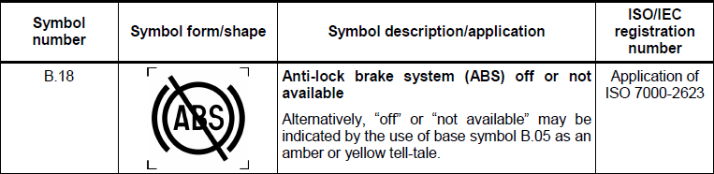
2. Under (e), the correct reference to the paragraph should read 5.1.13.
3. The correct reference under f) to the previous points should be (a) to (e) instead of (a) to (f).

