|  |  |  |  |
| --- | --- | --- | --- |
|  | United Nations | ECE/TRANS/WP.29/GRSG/2016/18 | |
| _unlogo | **Economic and Social Council** | | Distr.: General  22 July 2016  Original: English |

**Economic Commission for Europe**

Inland Transport Committee

**World Forum for Harmonization of Vehicle Regulations**

**Working Party on General Safety Provisions**

**111th session**

Geneva, 11–14 October 2016

Item 8 of the provisional agenda

**Regulation No. 73 (Lateral protection devices)**

Proposal for amendments to Regulation No. 73 (Lateral protection devices)

Submitted by the expert from the International Association of the Body and Trailer Building Industry[[1]](#footnote-2)\*

The text reproduced below was prepared by the expert from the International Association of the Body and Trailer Building Industry (CLCCR) to ensure that lateral protection devices are fitted on as many vehicles as possible. It is based on ECE/TRANS/WP.29/GRSG/2016/2 and informal document GRSG-110-20-Rev.1, both distributed during the 110th session of the Working Party on General Safety Provisions (GRSG) (see report ECE/TRANS/WP.29/GRSG/89, paras. 27 and 28). The modifications to the current text of the Regulation are marked in bold for new characters and in strikethrough for deleted characters.

1. Proposal

*Paragraph 1.2.,* amend to read (deleting paragraph 1.2.2.):

"1.2. This Regulation does not apply to:

1.2.1. Tractors for semi-trailers.

~~1.2.2.~~ ~~Vehicles designed and constructed for special purposes where it is not possible, for practical reasons, to fit lateral protection devices.~~"

*Insert a new paragraph 13.3*., to read:

"**13.3. Vehicles where any LPD (e.g. fixed, removable, foldable, adjustable, etc.) is incompatible with their on-road use may be partly or fully exempted from this Regulation, subject to the decision of the Type Approval Authority**."

*Insert a new paragraph 16.2*., to read:

"**16.2. Vehicles where any LPD (e.g. fixed, removable, foldable, adjustable, etc.) is incompatible with their on-road use may be partly or fully exempted from this Regulation, subject to the decision of the Type Approval Authority**."

II. Justification

1. CLCCR supports the principle of ECE/TRANS/WP.29/GRSG/2016/2 from the United Kingdom of Great Britain and Northern Ireland.
2. Deleting paragraph 1.2.2. without introducing new paragraphs 13.3. and 16.2. would cause difficulties for Type Approval Authorities (TAA) in the certification and homologation process of niche products.
3. It is impossible for the industry concerned to provide an exhaustive list of derogations as mentioned in paragraph 13. of UN Regulation No. 73. An important part of CLCCR members is specialized in niche products and must offer solutions for national and international clients. The industry is prepared to fulfil as much as possible the requirements according to UN Regulation No. 73, but this is not always possible. For that reason, TAA should be given the possibility to certify niche products in the case that requirements cannot be fully met.
4. CLCCR proposes to introduce paragraphs 13.3. and 16.2. with text similar to paragraph 1.3. of ECE/TRANS/WP.29/GRSG/2015/17, amending UN Regulation No. 58 (RUPD), as adopted during the 108th session of GRSG.
5. Some examples of a non-exhausted list of niche products are shown below:

Figure 1

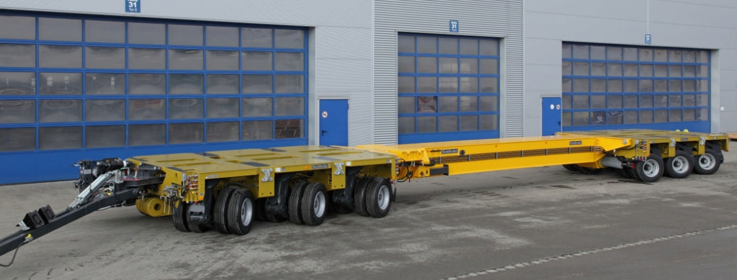

Figure 2

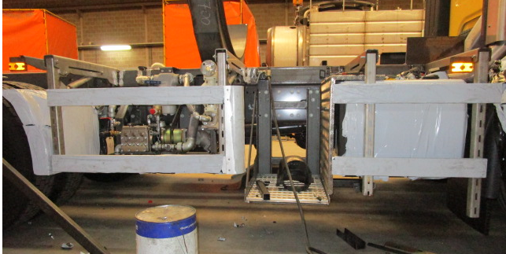

Figure 3

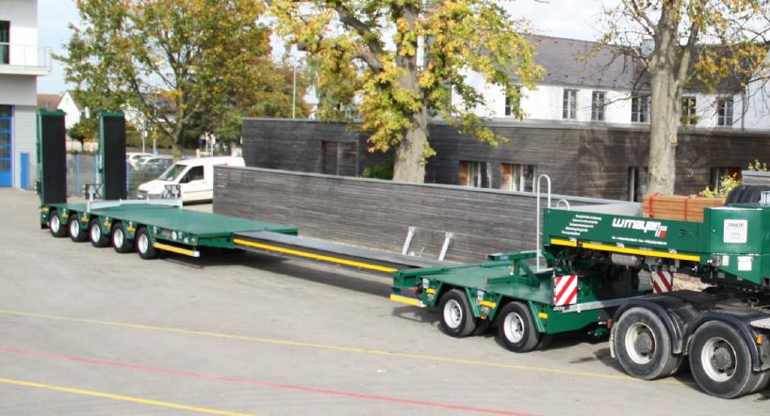

Figure 4

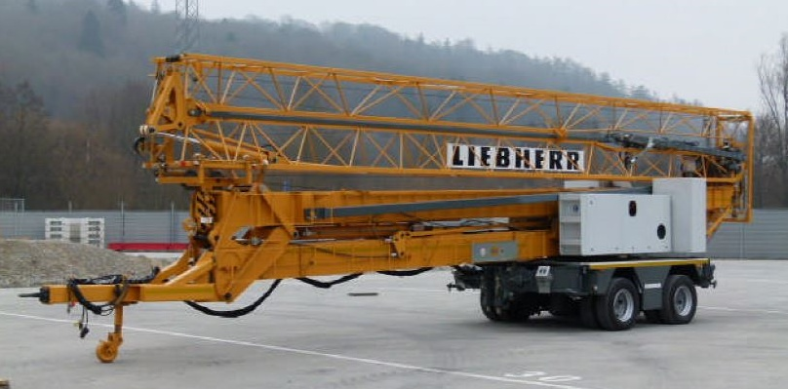

1. \* In accordance with the programme of work of the Inland Transport Committee for 2016–2017 (ECE/TRANS/254, para. 159 and ECE/TRANS/2016/28/Add.1, cluster 3.1), the World Forum will develop, harmonize and update Regulations in order to enhance the performance of vehicles. The present document is submitted in conformity with that mandate. [↑](#footnote-ref-2)