**Proposal for amendments to UN Regulation No. 107 (Buses and coaches)**

The text reproduced below represents a common Romanian – CLCCR – OICA counter proposal to working document ECE/TRANS/WP.29/GRSG/2015/21. The modifications to the current text of Regulation are marked in **bold** for new or strikethrough for deleted characters.

I. Proposal

*Annex 3, paragraphs 7.7.8.4. to 7.7.8.4.2.,* amend to read:

"7.7.8.4. Seat spacing (see Annex 4, Figures 12**A and 12B**)

7.7.8.4.1. In the case of seats facing in the same direction, the distance between the front of a seat squab and the back of the squab of the seat preceding it (dimension H), shall, when measured horizontally**, parallel to the longitudinal plane of the vehicle** and at all heights above the floor between the level of the top surface of the seat cushion and a point 620 mm above the floor, not be less than:

| *H* | |
| --- | --- |
| Classes I, A and B | 650 mm |
| Classes II and III | 680 mm |

* + - * 1. All measurements shall be taken, with the seat cushion and squab uncompressed, in a vertical plane passing through the centreline of the individual seating place **using the testing gauge shown in Annex 4, Figure 12B**."

*Annex 4, Figure 12,* amend to read:

"Figure 12**A**

Seat spacing ……

…………

**Figure 12B**

**Testing gauge for H dimension (see Annex 3, paragraph 7.7.8.4.2.)**

**Thickness of the gauge: 5 mm maximum**

"

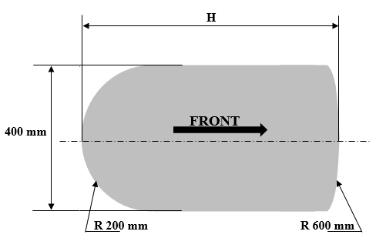

II. Justification

1. The current text of paragraph 7.7.8.4.2. specifies that the measurements shall be taken in a vertical plane passing through the centreline of the individual seating place.

2. In its document ECE/TRANS/WP.29/GRSG/2015/21, Romania indicated that the Technical Service practice has shown that there are dedicated seats for vehicles M2 or M3 for which the backrest configuration lead to fulfilment of the minimum H dimension only in middle seat line or near them, but the real passenger comfort is not assured:

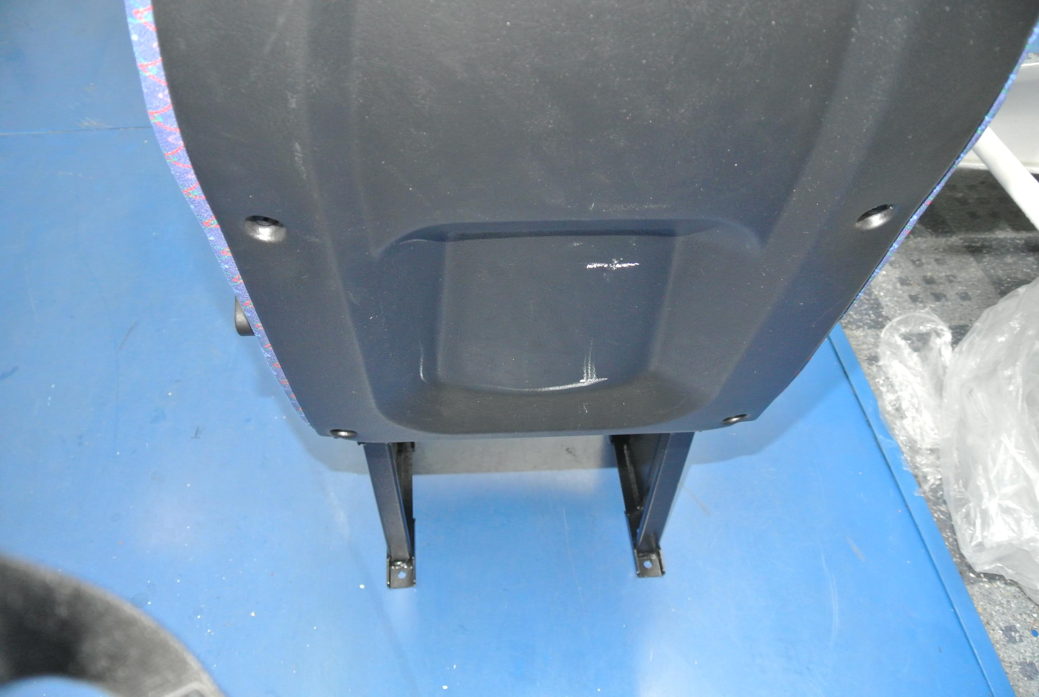

3. The Type Approval Authorities of the Member States of the European Union (TAAM) discussed during meetings in 2014 the proper interpretation of the text of the Regulation in the case of seats produced with a central recess (sunken area), to comply with dimension H measurement requirement.

4. ECE/TRANS/WP.29/GRSG/2015/21 points out that the Type Approval Authorities decided that the text of the Regulation shall be modified to provide an adequate method to measure the H dimension.

5. The text proposed above by OICA, CLCCR and Romania is correlated with the free space over seating positions defined in paragraph 7.7.8.6.2. and, hence, aims at providing a solution to the problem raised by ECE/TRANS/WP.29/GRSG /2015/21, so that current good practices only are approvable:

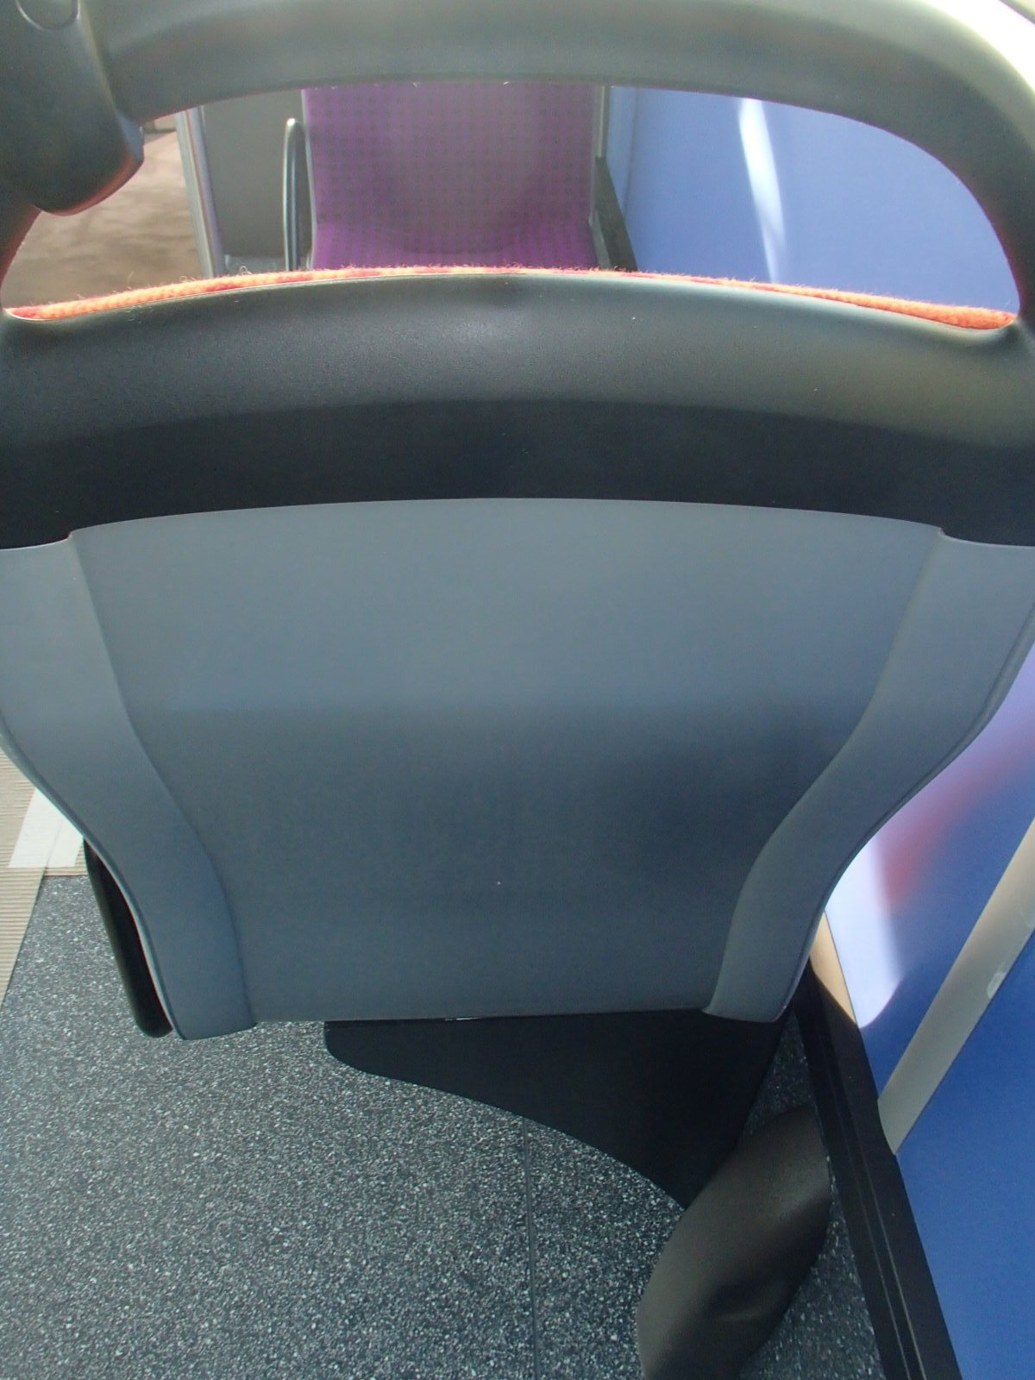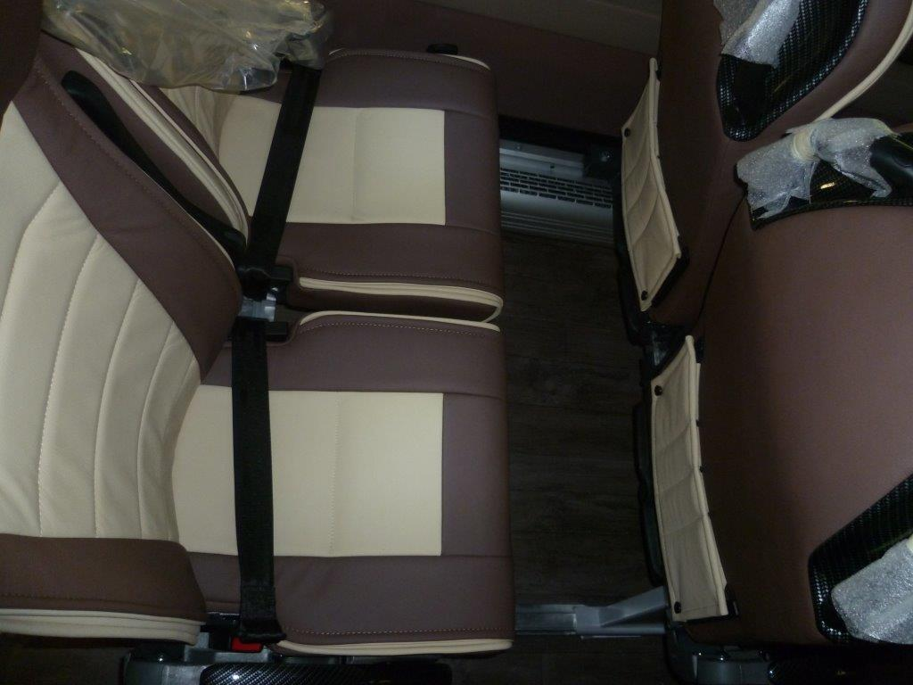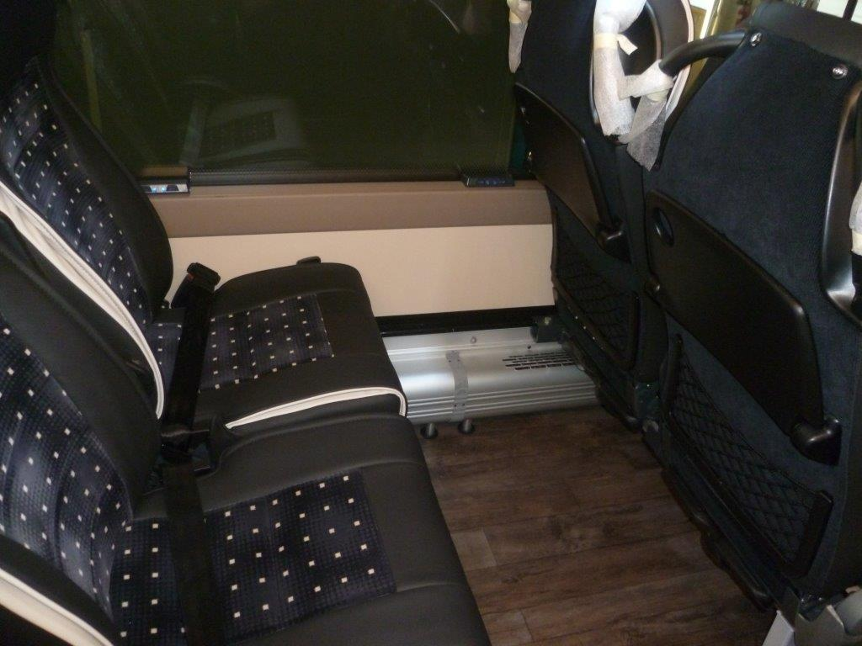

6. Generally the bottom of the squab of passenger seats is curved (especially for Class B and III vehicles) to provide best comfort to the occupants. The rear part of the new proposed gauge aims at reflecting the shape of the human back, and the radius of the front aims at simulating the rotation of the knees around the hips.

_________