|  |  |  |  |
| --- | --- | --- | --- |
|  | United Nations | ECE/TRANS/WP.29/GRSP/2016/14 | |
| _unlogo | **Economic and Social Council** | | Distr.: General  26 February 2016  Original: English |

**Economic Commission for Europe**

Inland Transport Committee

**World Forum for Harmonization of Vehicle Regulations**

**Working Party on Passive Safety**

**Fifty-ninth session**

Geneva, 9-13 May 2016

Item 14 of the provisional agenda

**Regulation No. 44 (Child restraints systems)**

Proposal for a Supplement to Regulation No. 44 (Child Restraint Systems)

Submitted by the expert from the Netherlands[[1]](#footnote-2)\*

The text reproduced below was prepared by the expert from the Netherlands, aimed at excluding dangerous interpretations on the installation of child restraint systems in UN Regulation No. 44. The modifications to the current text of UN Regulation No. 44 are marked in bold for new characters.

I. Proposal

*Paragraph 6.2.2*., amend to read:

"6.2.2. For groups I, II and III, all restraint devices utilizing a "lap strap" shall positively **and symmetrically** guide the "lap strap" to ensure that the loads transmitted by the "lap strap" are transmitted through the pelvis. **The "lap strap" shall contact the left and right thigh of the dummy when seated and strapped in the CRS.  The angle between the tangent line in which the belt touches the thighs and the horizontal shall be greater than [10 °].** The assembly shall not subject weak parts of the child's body (abdomen, crotch, etc.) to excessive stresses.

# **Figures of Strapped child**

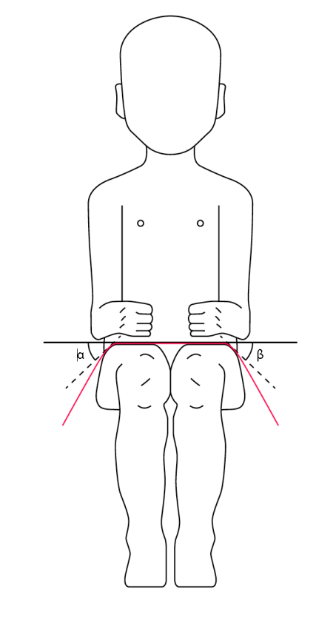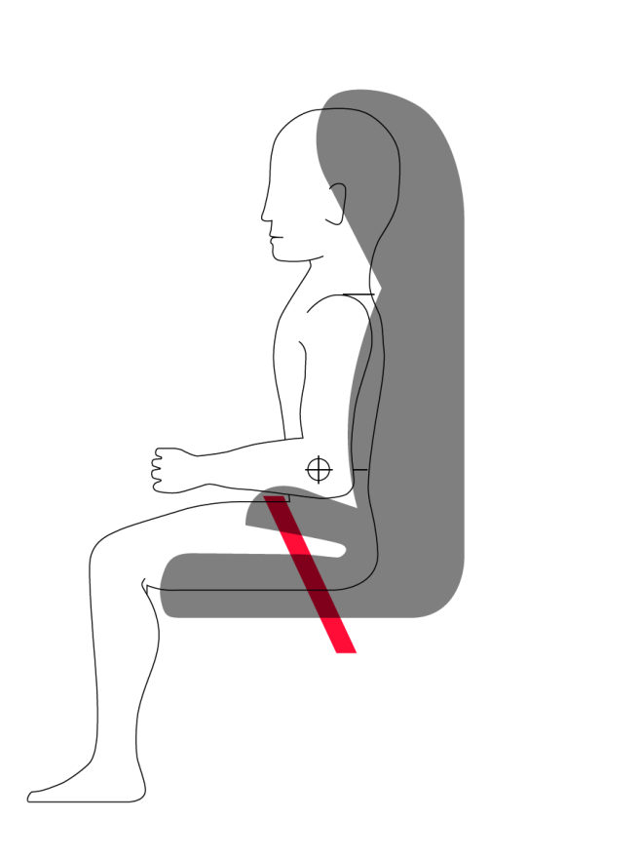"

II. Justification

1. It is supposed that child restraints have been approved that ensured only positive guidance.

2. To exclude this dangerous interpretation the text has been modified.

1. \* In accordance with the programme of work of the Inland Transport Committee for 2014–2018 (ECE/TRANS/240, para. 105 and ECE/TRANS/2014/26, programme activity 02.4), the World Forum will develop, harmonize and update Regulations in order to enhance the performance of vehicles. The present document is submitted in conformity with that mandate. [↑](#footnote-ref-2)