|  |  |  |  |
| --- | --- | --- | --- |
|  | United Nations | ECE/TRANS/WP.5/2016/3 | |
| _unlogo | **Economic and Social Council** | | Distr.: General  27 June 2016  Original: English |

**Economic Commission for Europe**

Inland Transport Committee

**Working Party on Transport Trends and Economics**

**Twenty-ninth session**

Geneva, 5–7 September 2016

Item 7 (b) of the provisional agenda

**Euro-Asian Transport Links:  
Road and Rail transport corridors along Europe and Asia**

Road and Rail transport corridors along Europe and Asia

Note by the secretariat

I. Mandate

1. During the twenty eight session (Geneva, 7–9 September 2015) of the Working Party on Transport Trends and Economics (WP.5) a Workshop took place on “Road and Rail transport corridors along Europe and Asia”. The Working Party requested the secretariat to elaborate a formal document based on inputs received by the experts and discussions made during the workshop for consideration by the Working Party at its next session. Proposals for possible further actions to be taken by the Working Party on this issue should be included (ECE/TRANS/WP.5/58, para. 11).

II. Initiatives on Road and Rail transport corridors along Europe and Asia

3. The Participants during the Workshop on “Road and Rail transport corridors along Europe and Asia” took stock of the initiatives that exist and operate between Europe and Asia on the development of transport corridors.

(a) The European Commission (EC) TEN-T network where nine core network corridors are identified. A work plan was drawn up for each corridor (approved in June 2015) that set out the current status of its infrastructure, a schedule for removing physical, technical, operational and administrative bottlenecks, and an overview of the financial resources (EC, international, national, regional and local, public and private);

|  |
| --- |
| **TEN-T network** |
|  |
| *Source:* EU |

(b) The Economic Cooperation organization (ECO) road and rail network in Central Asia which includes eight road transport corridors and six rail transport corridors; A project started in 2009 in cooperation with the Islamic Development Bank (IsDB) in order to ensure implementation of ECO Transit Transport Framework Agreement (TTFA);

|  |
| --- |
| **ECO road and rail network** |
|  |
| *Source:* ECO Secretariat |

(c) The Organization for Cooperation between Railways (OSJD) has identified thirteen rail transport corridors along Europe and Asia; A memorandum on cooperation in the field of technical, operational and commercial development of each railway corridor was developed to be signed among the different stakeholders;

|  |
| --- |
| **OSJD rail corridors** |
|  |
| *Source:* OSJD Secretariat |

(d) The South-East Europe Transport Observatory (SEETO) has developed its comprehensive network which is part of the TEN-T network and includes eight road transport corridors and seven rail corridors; A transport facilitation working group was created to follow the implementation of the soft measures and specific actions are taking place for each corridor;

|  |  |
| --- | --- |
| **SEETO network** | |
| **Road** | **Rail** |
|  |  |
| *Source:* SEETO Secretariat | |

(e) The Central Asia Regional Economic Cooperation (CAREC) which has identified six main transport corridors; The CAREC Transport and Trade Facilitation Strategy 2020 – Priority Projects and tasks has been prepared where 108 transport infrastructure financing projects and 49 technical assistance ones have been identified;

|  |
| --- |
| **CAREC corridors** |
|  |
| *Source:* CAREC Secretariat |

(f) The Black Sea Economic Cooperation (BSEC) sets as one of its goals the establishment of an efficient transport network among its member States and promotes the development of the Black Sea Ring Highway project which envisages a four lane ring highway system, approximately 7500 km long, which will connect the BSEC member States with each other;

(g) The Transport Corridor Europe-Caucasus-Asia (TRACECA) where two main corridors have been identified; The TRACECA International investment forum has been established which is a standing mechanism providing direct and consistent interaction between TRACECA and investors;

|  |
| --- |
| **TRACECA corridors** |
|  |
| *Source:* TRACECA Secretariat |

(h) The International Road Transport Union (IRU) New Eurasian Land Transport Initiative (NELTI) where three main corridors - routes are identified; Four caravans have been accomplished in these corridors with concrete results and recommendations;

|  |
| --- |
| **IRU Eurasian Land Transport Initiative** |
|  |
| *Source:* IRU Secretariat |

(i) The Centre for Transportation Studies for the Western Mediterranean (CETMO) where seven transport corridors where identified; Six out of them are part of the TEN-T corridors; Especially for the transmaghrébin multimodal transport corridor an action plan with horizontal actions was developed;

|  |
| --- |
| **CETMO transport corridors** |
|  |
| *Source:* CETMO Secretariat |

4. The map that follows includes all corridors initiatives along Europe and Asia.

**Transport Corridors along Europe and Asia**

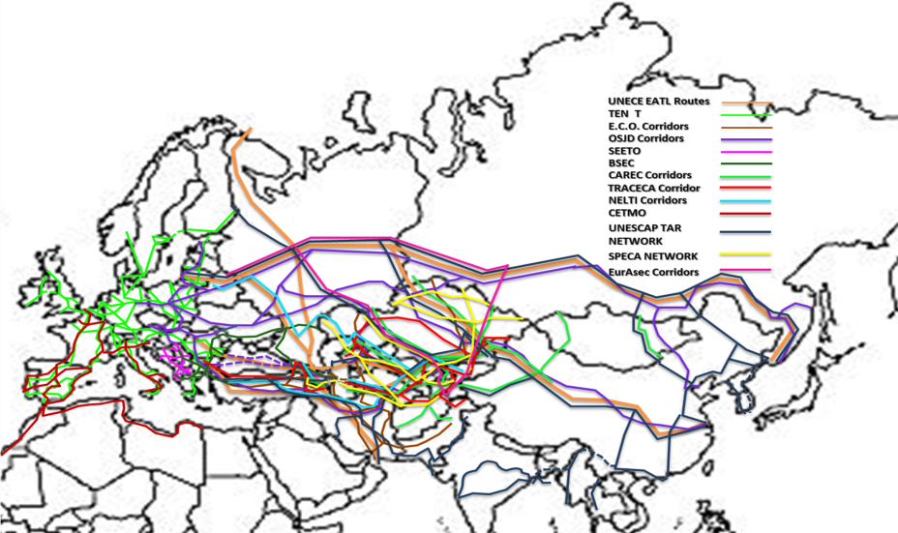

*Source:* UNECE, Transport Division

III. Conclusions and Recommendations from the Workshop

5. The participants to the Workshop:

(a) Agreed that despite the fact that numerous initiatives exist and operate for transport corridors development along Europe and Asia, cooperation among these initiatives is very low or even non-existent;

(b) Noted that China (but not exclusively) is now challenging Europe with the launching of its OBOR (One Belt One Road Policy);

(c) Noted that Asia-Europe trade is the trade route that has one of the highest growth rates for the decades to come;

(d) Observed that it is essential to consider long-term, long distance Asia-Europe transport development plans, in order to set up an efficient, integrated transport system covering all transport modes;

(e) Agreed that it is essential also to consider new technologies in order to make transport operations between our two continents more cost-effective, greener and safer;

(f) Noted that in International rail transport there are a number of obstacles that make railways non-competitive such as: poor infrastructure, non-competitive tariffs, two at least existing legal regimes, delays in border crossings;

(g) Noted that based on data presented by IRU 57% of road transport time is lost at border crossings and 38% of transport costs is due to unofficial levies!;

(h) Agreed that the development of transport corridors will facilitate the cross border movement of Goods, Services, People, Capital, Information/Knowledge through:

* Regional Connectivity including infrastructural connectivity;
* Facilitation and liberalization of trade and investment through simplification, harmonization and unification of policies, regulatory frameworks, and procedures;
* Mobilization of technical and financial resources for implementation of RCI projects.

(i) Observed and agreed that corridors may impact the distribution of economic activity and development across regions and promote poverty reduction and inclusive growth. This is so because:

* Corridors facilitate more efficient trade, which generates economic growth and expands market access.
* Corridors may expand factor mobility and access to education, health care and other services.
* Ultimately corridors may expand a poor household’s consumption possibility frontier.

(j) Noted that climate change impacts to transport networks should be taken into account while identifying transport corridors while adaptation measures to these climate change impacts should be implemented during construction phases;

(k) Agreed that main challenges for transport corridors development are:

The large financing needs;

* Asymmetry in costs and benefits among neighbouring countries investing in common infrastructure;
* Landlocked countries are economically disadvantaged by lack of access to ports;
* Diverging standards (e.g. on axle load of trucks) or weak transit regimes can lead to forced cargo transfer at borders, costly guarantee schemes, empty backhaul.

6. The workshop showed the complexity of the substantive issues involved in the development of transport corridors along Europe and Asia and the need for further analysis. The importance of modern and efficient transport infrastructure as well as the implementation of soft measures and in particular the United Nations Conventions in order to facilitate border crossings was highlighted. Furthermore, the lack of cooperation among the different stakeholders and initiatives for transport corridors development between Europe and Asia was mentioned as one of the key challenges that should be addressed in the future.

IV. Proposal for a Transport Infrastructure Observatory along Europe and Asia

7. Since the main conclusion from the workshop was the lack of cooperation among the different stakeholders / initiatives involved in the development of transport corridors, the development of an Observatory that would bring all stakeholders together and that would promote communication, cooperation and development of synergies is being suggested.

8. This Observatory will be an electronic space, an internet based platform which would permit to all users:

(a) communicate and exchange of basic information (next meetings of their groups, agendas, reports, workshops programs, etc.);

(b) disseminate ad hoc knowledge and best / good practices including information about vendors, consultants, etc.;

(c) exchange information about projects and other initiatives / proposals;

(d) seek for cooperation on specific transport infrastructure projects / tasks / studies and researches decided during their Secretariat sessions;

(e) at a later stage and depending on extra budgetary resources all international transport corridors will be hosted in this observatory in a GIS environment in order to create a more interactive and user friendly environment that would further promote and enhance cooperation on development of transport infrastructure.

9. Stakeholders and therefore users of this Observatory will be representatives of different initiatives mentioned above as well as representatives of Governments. The access of these stakeholders to the platform will be personalised therefore all stakeholders should nominate focal points. Access to the web platform will be secured and restricted with usernames and passwords.

10. Each focal point should be responsible for updating and revising information uploaded on the observatory. The secretariat will perform only administration tasks regarding the operations of this Observatory such as hosting, development of usernames and passwords, creation of new pages, etc.

V. Guidance by WP.5

11. WP.5 may wish to consider the above proposal and may wish to provide guidance to the secretariat on further action in this field.