INF.18
Economic Commission for Europe
Inland Transport Committee
Working Party on the Transport of Dangerous Goods
103rd session 30 October 2017
Geneva, 6-10 November 2017
Item 5 (b) of the provisional agenda
Proposals for amendments to Annexes A and B of ADR:
miscellaneous proposals
Provision for the carriage of waste gas cartridges (UN No. 2037)
Transmitted by the Government of Ireland
Summary
Executive summary: Ireland wold like to ask WP15 to discuss the potential for including provisions in the ADR for waste gas cartridges (UN No. 2037) similar to those that are in place for waste aerosols (UN No. 1950).
Action to be taken: Discussion
Introduction
Currently the ADR contains provisions for carriage of waste UN1950 AEROSOLS, but there are no equivalent provisions for waste UN2037 RECEPTACLES, SMALL, CONTAINING GAS (GAS CARTRIDGES) without a release device, non-refillable.
Both aerosols and gas cartridges are assigned to Class 2, Classification Code 5 in ADR 2.2.2.3 list of collective entries. Both aerosols and gas cartridges, under special provision 344, are subject to the provisions of ADR 6.2.6, general requirements for aerosol dispensers, small receptacles containing gas (gas cartridges) and fuel cell cartridges containing liquid flammable gas.
The carriage of waste aerosols is provided for in special provision 327 which allows aerosols to be carried under the entry for the purposes of reprocessing or disposal. Under this special provision waste aerosols which are not leaking or severely deformed can be packed in accordance with packing instruction P207 and special packing provision PP87, or packing instruction LP200 and special packing provision L2, and need not be protected against movement and inadvertent discharge provided that measures are taken to prevent dangerous build-up of pressure and dangerous atmospheres. Special packing provision PP87 stipulates that packagings carried under special provision 327 must have a means of retaining any free liquid that might escape during carriage and that the packagings must be adequately ventilated to prevent the creation of flammable atmosphere and the build-up of pressure.
There are no equivalent provisions for gas cartridges.
As illustrated in Figure 1 many gas cartridges have an appearance quite similar to aerosols and the general public will not be aware of the difference so both will end up in collection bins at public amenity sites.
Proposal
It is proposed that the working party holds a discussion regarding the following proposal:
- To propose a new special provision in the ADR for waste gas cartridges collected at public amenity sites, with wording similar to special provision 327 currently in place for waste aerosols, and to include the requirements for ventilation and a means of retaining any free liquid as provided in PP87 for UN 1950 waste aerosols under packing provision P207.
Is it the case that the amendments will only be required in the ADR for carriage by road from public amenity sites to the intermediate processing facility (similar to special provision 636(b) for lithium cells and batteries), or would it need to be extended to other modes of transport?
Note: This proposal has the potential to be expanded in the future to include a proposal for a new special packing provision in the Model Regulations under P003 specifically for UN 2037 waste gas cartridges, which is equivalent to PP87 under P207, and to include UN No. 2037 in LP200 and its associated L2.
If the proposal is deemed to be capable of consideration, a formal proposal will be submitted at a subsequent meeting.
Figure 1

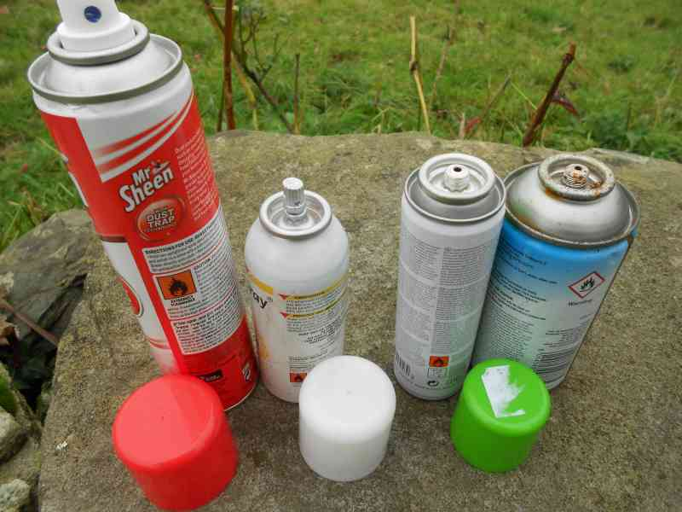
Aerosols Gas Cartridges
Justification
Safety: After use and removal from the operating device the valves on all gas cartridges (UN 2037) may not re-seal perfectly. Gas cartridges at an industrial site in Ireland were collected in a plastic drum with a removable head. On removal of the top a distinct gas smell was experienced, which indicated that a flammable atmosphere was building up inside the drum. It would serve to improve safety if the requirements for ventilation as contained in PP87 were applied to waste gas cartridges. P003, which currently applies to gas cartridges, does contain a general requirement that precautions against inadvertent release are addressed, but as gas cartridges do not contain a release mechanism, this will not alert to the possibility that used cartridges may leak. There are also the puncture type gas cartridges e.g. small camping gas cartridges, which may still contain gas residues at the time of disposal.
Enforceability:This proposal would serve to bring current practices at public amenity sites in line with the regulation and would thus improve compliance.
_____________________

