INF.23
Economic Commission for Europe
Inland Transport Committee
Working Party on the Transport of Dangerous Goods
Joint Meeting of the RID Committee of Experts and the
Working Party on the Transport of Dangerous Goods 8 March 2017
Bern, 13-17 March 2017
Item 5 (b) of the provisional agenda
Proposals for amendments to RID/ADR/ADN:
new proposals
The need to correct Chapters 1, 2, 4, 5, 6
Transmitted by the Government of the Russian Federation
Introduction
The analysis of the text of the RID/ADR-2017 has shown that there are separate paragraphs that need to be correct and clarified, since in present form, in our opinion, may lead to an erroneous interpretation or mislead the user of the Rules.
See table data:

 | Text of RID-2017 | Comment | Proposal
1 |  | The paragraph is reserved, but there is a note | Delete the brackets. Delete the word "Note". Text of the note to make the text of the paragraph
2 |  | In brackets there are subparagraphs included in the main paragraph | Delete paragraph 2.2.7.2.4, open the brackets, write the text as follows: «Packages not otherwise classified in 2.2.7.2.4.1 -2.2.7.2.4.5…»
3 |  | Reference to items that have been deleted or reserved: | Write the text as follows: «The assignment of substances and articles not mentioned by name in Table A of Chapter 3.2 to the relevant entry of that Table or of 2.2.9.3 shall be done in accordance with 2.2.9.1.4-2.2.9.1.8, 2.2.9.1.10, 2.2.9.1.11, 2.2.9.1.13, 2.2.9.1.14 below.»
4 | 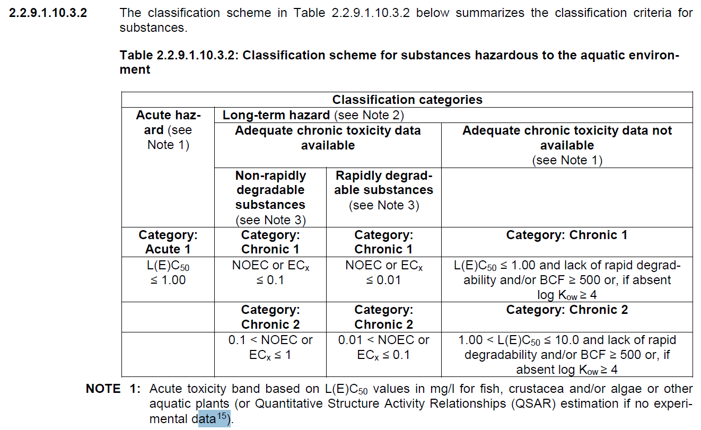 | In our opinion, the text of link 15 has a dual interpretation. | Write the text as follows: «Special guidance is provided in the GHS (paragraph 4.1.2.13 and Annex 9, Section A9.6)»
5 |  | The special provision TP3 is in paragraph 4.2.5.3: | To exclude the misconception of the user of the Rules, it is suggested to delete the last brackets.
6 |  | In the paragraph there is only a title and a note | Delete the word "Note". Text of the note to make the text of the paragraph
7 |  | The paragraph refers to itself. | Write the text as follows: "This alternative marking shall conform to specifications set in this subsection except for the provisions concerning resistance to fire mentioned in this paragraph and 5.3.2.2.2.»
8 |  | In our opinion, the text of subparagraph (b) in brackets introduces the user into confusion. | Write the text in brackets as follows: (see note to Chapter 6.3 and packing instruction P 621 of 4.1.4.1)
9 |  | Reference to item that have been reserved: | Write down the items as follows:  «…6.4.11.4-6.4.11.10, 6.4.11.12-6.4.11.14…»
10 |  |  | Write down the items as follows:  «…6.4.11.4-6.4.11.10, 6.4.11.12-6.4.11.14…»
11 |  |  | Write down the items as follows:  «…6.4.11.4-6.4.11.10, 6.4.11.12-6.4.11.14…»
12 |  |  | Write down the items as follows:  «…6.4.11.8-6.4.11.10, 6.4.11.12, 6.4.11.13…»
13 |  |  | Write down the items as follows:  «…6.4.11.8-6.4.11.10, 6.4.11.12, 6.4.11.13…»
14 |  | The paragraph is reserved, but there is a note | Delete the brackets. Delete the word "Note". Text of the note to make the text of the paragraph
15 |  | Reference to item that have been reserved: | Write as follows:  «The requirements of 6.8.2.2.1, 6.8.2.2.2, 6.8.2.2.4, 6.8.2.2.6-6.8.2.2.8 shall apply»
16 |  | In our opinion, the text of last sentence introduces the user into confusion. | Write as follows:  «Vacuum-operated waste tanks shall comply with all requirements of Chapter 6.8, with exception of requirements overtaken by a special provision in Chapter 6.8.»
17 |  | The last sentence sends to nowhere | Delete the last sentence and brackets.
18 |  | A difficult reference to the special provision TE 22, located on the same page | The text in last brackets is written as follows: «(see also special provision TE 22)»

The proposed amendments make it possible to exclude a double interpretation of the requirements of the Rules and their erroneous interpretation.

