|  |  |  |  |
| --- | --- | --- | --- |
|  | United Nations | ECE/TRANS/WP.15/AC.1/2017/42 | |
| _unlogo | **Economic and Social Council** | | Distr.: General  3 July 2017  English  Original: French |

**Economic Commission for Europe**

Inland Transport Committee

**Working Party on the Transport of Dangerous Goods**

**Joint Meeting of the RID Committee of Experts and the   
Working Party on the Transport of Dangerous Goods**

Geneva, 19-29 September 2017

Item 7 of the provisional agenda

**Reports of informal working groups**

Follow-up to the work of the informal working group on reducing the risk of a BLEVE — simulations of the behaviour of tanks exposed to fire

Transmitted by the Government of France[[1]](#footnote-1)\*,[[2]](#footnote-2)\*\*

|  |
| --- |
| *Summary* |
| **Executive summary**:Inform the Joint Meeting of the progress made by INERIS in its calculations to assess the effectiveness of systems for the protection of tanks and their behaviour in a fire. |
| **Reference documents**:Report of the Joint Meeting of the RID Committee of Experts and the Working Party on the Transport of Dangerous Goods on its spring 2017 session, ECE/TRANS/WP.15/AC.1/146, paragraphs 43-47. |
|  |

Introduction

1. At the last session of the Joint Meeting, INERIS, at the request of the Government of France, introduced a modelling tool to simulate the behaviour of a gas or flammable liquid tank when exposed to fire.

2. Following that presentation, the French delegation invited others to forward to it case studies that they would like to submit for analysis. The information may include experimental or post-accident data to improve the model developed by INERIS, or requests for specific calculations to assist in the consideration of ways to mitigate the BLEVE phenomenon.

3. France would like to thank those delegations that sent the first elements enabling it to proceed with new calculations.

4. However, because of the time taken to submit the information, a full simulation programme could not be carried out within a time frame allowing for the transmission of an official document to the Joint Meeting.

5. This document is intended to provide some of the results that have already been obtained and to announce a more comprehensive programme for further calculations.

6. Delegations wishing to do so may still send their data for inclusion in this process.

Elements sent by various delegations

7. The Netherlands and AEGPL sent information.

8. The delegation of the Netherlands submitted the following four test results.

Table 1: Configurations sent by the delegation of the Netherlands to INERIS

|  |  |  |  |  |
| --- | --- | --- | --- | --- |
|  | **Bonfire test** | | **3 m3 LPG test** | |
| **Tank dimensions** | Length: 2.6 m  Diameter: 1.25 m  Thickness: 5.1 mm | | Length: 2.68 m  Diameter: 1.25 m  Thickness: 5.1 mm | |
| **Degree of filling** | 80% LPG | 50% LPG | 80% | 50% |
| **Valve** | yes | yes | yes | yes |
| **Thermal coating** | yes | yes | yes | yes |
| **Test results** | Multiple valve openings  No explosion during the 98 minutes of the test | Multiple valve openings  No explosion during the 112 minutes of the test | Multiple valve openings  No explosion during the 98 minutes of the test | Multiple valve openings  No explosion during the 112 minutes of the test |

Figure 1: 3m3 LPG test, transmitted by the delegation of the Netherlands

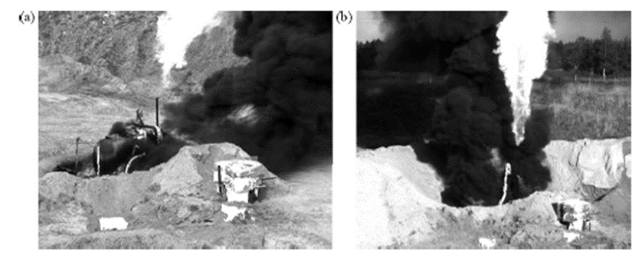

These confirm the results of other tests, including those carried out by BAM.

9. AEGPL transmitted two accident scenarios that took place in the United Kingdom.

Table 2: Data transmitted by AEGPL to INERIS

|  |  |  |
| --- | --- | --- |
|  | **Accident No. 1** | **Accident No. 2** |
| **Tank dimensions** | Length: 5.345 m  Outer diameter: 2.077 m  Convex ended, 8.3 mm thickness | Length: 5.36 m  Outer diameter: 2.22 m  Convex ended, 8 mm thickness |
| **Degree of filling** | Propane 85% | Propane 85% |
| **Valve** | yes | yes |
| **Thermal coating** | No thermal coating | No thermal coating |
| **Consequences of the accident** | Opening of the valve after 30 minutes  No explosion | Opening of the valve  No explosion |

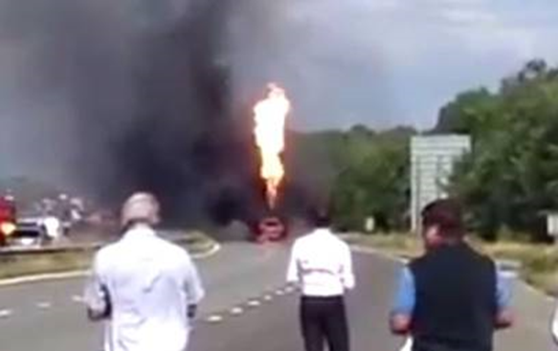Figure 2: Photograph taken at accident No. 2, sent by AEGPL

Configurations to consider for BLEVE mitigation

10. The initial modelling results presented at the March 2017 session showed that for a number of configurations, valves alone fail to provide protection of the tank from fire for a period of 60 minutes (for example, for a 30 m3 tank subjected to an engulfing fire, etc.).

On the other hand, for certain specific cases, such as that of fire on the lower side of the tank, with a degree of filling of more than 50%, the calculations show that the valve can slow or even eliminate the BLEVE phenomenon.

11. INERIS is currently studying the fire resistance of a number of tank configurations, combining all the elements listed below, in order to build upon these initial findings:

* Tanks of various dimensions (30 m3 and 60 m3);
* Fires with different characteristics: tank engulfed by fire; fire only on the lower side of the tank; torch fire on both the upper and lower parts of the tank;
* Different degrees of filling (50% and 85%);
* Types of valves (valves activated by pressure and by temperature);
* Presence or absence of a thermal insulation coating;
* The fact that the insulation coating does not cover the entire tank (owing to wear).

12. The vast majority of the configurations presented above will be calculated by September and will be covered by a more comprehensive report, submitted as an information document.

13. The calculations should make it possible to determine what protection systems are effective, as well as to what degree. The examples given below show, for example, that valves may not necessarily be effective in all fires, and specifically in the most violent ones, but that they can in some cases prevent explosions, as shown by the accident scenarios transmitted by AEGPL.

14. If the effectiveness levels of the various devices are overlayed with the various scenarios, this will give the Joint Meeting some criteria for taking decisions.

Two examples of results already calculated by INERIS

For example, INERIS dealt with two cases whose results are shown below with curves comparing the tanks’ steel resistance (stress limit, in blue) with the actually applied stress (in red):

Case No. 1

The first case concerns a 30 m3 tank filled to 50% and protected by a valve set to release at 17 bar, at any temperature of the steel, and at 9 bar if the steel temperature exceeded 150° C.

This notional valve was imagined in order to address the problem raised during the last session: in some cases, tanks ruptured before the valves opened because the pressure setting was too high.

In this model, the tank is fully engulfed in the fire. The results show that the valve makes it possible to stabilize the pressure in the jacket of the tank. However, the weakening of the steel leads to a rupture in the jacket. The opening of the valve does not limit the temperature increase of the steel.

Figure 3: Applied stress from pressure increase (in red) and limit stress of the   
tank’s steel (in blue), over time

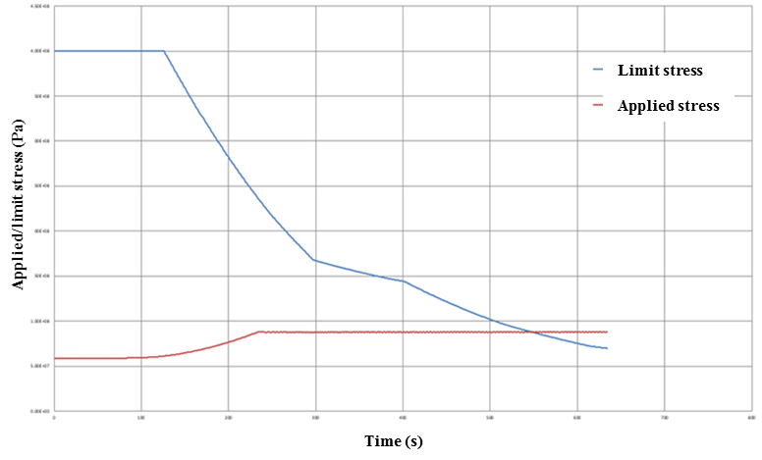

Case No. 2

The second case concerns a 30 m3 tank filled to 85% and protected by a valve set to 17 bar at any temperature of the steel. The tank is subjected to a pool fire, only on its lower face.

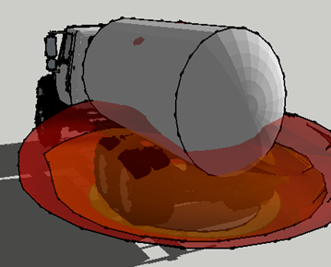Figure 4: Illustration of the fire for the second case study

The results show that the tank is capable of withstanding a fire for more than 60 minutes. This reflects the following dual phenomenon: the opening of the valve limits the pressure rise once it reaches 16 bar; at the same time, the maximum temperature on the external jacket is very limited (< 170° C), as the area of the jacket that is not in contact with the gas is not directly affected by the flame (degree of filling of 85%, with fire only in the lower part).

Figure 5: Applied stress from pressure increase (in red) and limit stress   
of the tank’s steel (in blue), over time

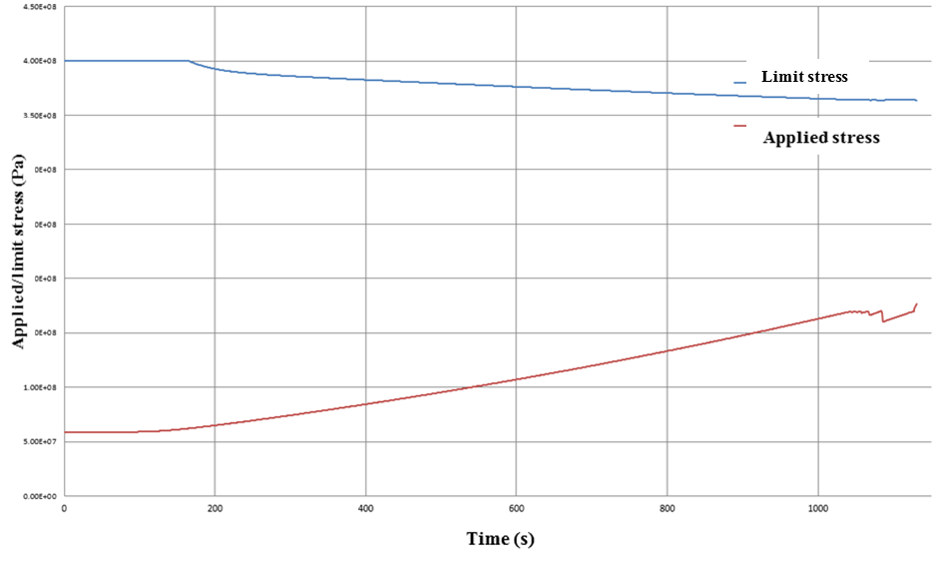

1. \* In accordance with the programme of work of the Inland Transport Committee for 2016-2017 (ECE/TRANS/2016/28/Add.1 (9.2)). [↑](#footnote-ref-1)
2. \*\* Circulated by the Intergovernmental Organisation for International Carriage by Rail (OTIF) under the symbol OTIF/RID/RC/2016/42. [↑](#footnote-ref-2)