Economic Commission for Europe
Inland Transport Committee
Working Party on the Transport of Dangerous Goods
Joint Meeting of the RID Committee of Experts and the
Working Party on the Transport of Dangerous Goods 6 September 2017
Geneva, 19–29 September 2017
Item 2 of the provisional agenda
Tanks
EN 14596 - Emergency Pressure Relief Valve (EPRV)
Transmitted by the Government of the Netherlands
Summary
Executive summary: The Netherlands is of the opinion that EN 14596 should not be referenced in ADR because of increased probability for leakage from tank vehicles after overturning.
Action to be taken: Do not include reference to EN 14596 in 6.8.2.6.
Related documents: TRANS/WP.15/AC.1/2005/21 and INF 4 (March 2005) , TRANS/WP.15/AC.1/98 Paragraph 11+ TRANS/WP.15/AC.1/98 Add 1 paragraph 6 and 2017/32.
Introduction
1. The EN 14596 – Tanks for transport of dangerous goods- service equipment for tanks- emergency pressure relief valve - will be updated based on a periodic review. The reviewed standard is up for discussion as part of the work of the Standards Working Group during the second week of this session of the Joint Meeting.
2. The original standard was not referenced in 6.8.2.6 because of safety concerns. The view of the Netherlands is that the updated version should also not be referenced in RID/ADR.
3. As the Standards Working Group merely checks for non compliances with the regulations and the change in wording from “venting device” into “breather device” we feel that a discussion on technical grounds is needed in the Working Group on Tanks prior to the discussion in the Standards Working Group.
Discussion
4. Gravity discharge tanks of 6.8.1.14 a) are mainly used for the carriage of liquid hydrocarbon fuels. In the past these tanks were all filled from the top. For filling the tank a small opening was made in the larger manhole cover and closed by the so called “fill-hole cover”. To encounter for thermal expansion of the mechanism and seating of the seal the fill-hole cover is provided with a spring to guarantee tightness. Because of the spring the fill-hole cover can lift under pressure, so that it would also act as a pressure relief device. It was said that this action offered protection against an overfill during bottom loading in case the overfill protection fails or, as claimed, protection against pressure and subsequent explosion when the tank is engulfed in flames.
5. In the past, in most cases where tank vehicles overturned it has been found out that a significant fuel leaks occurred by fill-hole covers. Mainly this was because of the low pressure of the spring that would allow lifting/opening at 0.25 bar. When the tank vehicle overturned, the sloshing of the fuel together with the static pressure of the fuel would be enough to lift the cover and let it reseat only when the pressure was reduced by the lower level of fuel after the fuel escaped into the environment.
6. This was the reason for the Netherlands in the 1980’s to require a modification in which the springs were reinforced so that they would open not below the test pressure of the tank. This modification cured most of the problem of leakage by overturning.

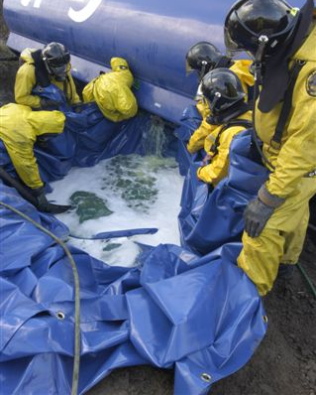
Escaping fuel from a fill hole cover

7. EN 13314 – Tanks for transport of dangerous goods- Service equipment for tanks – Fill hole cover - was introduced in ADR in 2005 and gives detailed requirements for the construction and testing of the fill-hole cover. In paragraph 6.2.2.2 of EN 13314 a tightness test is prescribed for the highest value of 65 kPa (0.65 bar) or 1.3 times the MAWP.
8. Probably because of this pressure a need for EN 14596 was felt for the same item, but with a lower opening pressure of 110% of the static head of the substances carried, this will result in 0.22 bar for a 2 meter high tank.
9. The outcome of discussions at the United Nations and in the United Kingdom in 2005 was that EN 14596 would not be referenced in ADR. At that time it was concluded that because the EPRV was found to be part of the venting system, it would require a protective device against the immediate passage of flame because the “F” in the fourth position of the tank code. From a constructional point of view this is not possible.
10. It was also experienced that in tank fires the section of the shell in the vapour phase of tanks made out of aluminum alloy would melt and collapses before a serious pressure build up would occur.

