|  |  |  |  |
| --- | --- | --- | --- |
|  | United Nations | ECE/TRANS/2017/4 | |
| _unlogo | **Economic and Social Council** | | Distr.: General  12 December 2016  Original: English |

**Economic Commission for Europe**

Inland Transport Committee

**Seventy-ninth session**

Geneva, 21-24 February 2017  
Item 4 (b) of the provisional agenda  
**Strategic questions of a horizontal policy nature**

United Nations Economic Commission for Europe (UNECE)  
analytical work on Transport

Note by the secretariat

|  |
| --- |
| *Summary* |
| This note provides a brief review of the analytical work undertaken in 2016 by the United Nations Economic Commission for Europe (UNECE) Sustainable Transport Division. The analytical work comprises studies related to specific issues on transport, analysis requested by official Groups of Experts and Task Forces, analytical papers prepared in support of activities related to the United Nations transport conventions and/or capacity-building workshops, as well as analytical studies that provide substantive groundwork for, or result from, participation in or management of different projects. The note summarizes the work done both within the programme of work of the Working Party on Transport Trends and Economics as well as in the framework of the Sustainable Transport Division. |
| The Committee is invited to **provide guidance** on future directions of the analytical work in the field of transport. |
|  |

I. Analytical Work and Capacity-building Workshops Undertaken by the Working Party on Transport Trends and Economics

1. The Working Party on Transport Trends and Economics (WP.5) provides a forum for the exchange of experiences and ideas on the progress in, and particular challenges to, the development of sustainable inland transport. Its mandate allows it to assume the unique role of a transport ‘think tank’ in the framework of the Inland Transport Committee (Committee or ITC).

2. As such, it aims to: identify the global trends and developments which may have important implications for the transport sector and the challenges that the sector is facing; conduct reviews and provide analyses on said factors based on information provided by member States; and, through consensus, make relevant policy recommendations that should lead to the development of sustainable transport systems.

A. Publications - Studies

Transport Trends and Economics 2014-2015: Financing Transport Infrastructure

3. This publication will make use of the workshops organized during the Committee session and its policy segment in 2013, as well as during the past two years of the WP.5 sessions. These were on ‘Financing Transport Infrastructure’ and on ‘Good Practices and New Tools for Financing Transport Infrastructure’. Collection of data is in progress based on a questionnaire approved by the Working Party during its 2015 session. This study will include data, analysis and presentations of pre-feasibility or feasibility studies on priority infrastructure projects received from member Governments participating in the Euro-Asian Transport Links (EATL), Trans-European Motorways (TEM) and Trans-European Railway (TER) projects and will focus, inter alia, on:

(a) Presentation of best practices or innovative models regarding financing of transport infrastructure;

(b) Presentation of best practices regarding medium and long-term scheduling, management and delivery of such projects;

(c) Presentation of specific national experiences in financing their transport infrastructure, including the illustration of specific studies for such projects, types of financing and data provided by the Governments;

(d) Presentation of international financial institutions and other donor’s investment portfolios.

B. Workshops

1. Workshop on Transport Research and Innovations

4. The workshop emphasized the importance of research on transport development and especially on creating innovation. The results of different transport research projects as well as final products and tools based on those research projects were presented. The difficulties in order to connect transport research results with markets needs were illustrated and discussed.

5. The participants:

(a) Noted transport research projects, innovations and technological developments in ECE region:

* The Belarusian Research Institute of Transport “TRANSTEKHNIKA” presented a model which enhances transport business efficiency in passenger transportation;
* Catapult Transport Systems (United Kingdom of Great Britain and Northern Ireland) illustrated methods of creating a conducive environment for transport innovation;
* The Hellenic Institute of Transport focused on existing challenges while implementing the results of transport research;
* Siemens eHighway presented the electrified heavy duty road transport and the new types of trucks which can move using electricity;
* The Institute for Ubiquitous Meteorology (UBIMET) focused its presentation on analysis of weather and illustrated different cases where high precision meteorological data has been used;
* The Regional Environmental Centre of Spain presented a methodology for the rapid assessment of climate impacts on transport corridors including an application between Madrid-Lisbon as well as the sustainable commuting initiative and the transport monitoring tool;
* The University of Helsinki presented an overview of the interdisciplinary research undertaken in sustainable transport law and business logistics;
* The Moscow State University for Transport Engineering illustrated new approaches in organizing rail freight in international traffic;
* The Democritus University of Thrace focused its presentation on a new methodology and tool in estimating the economic impacts of transport.

(b) Agreed that in order to transform ‘knowledge’ to societal benefits, work towards supporting and promoting the production of ‘innovation’ should be consistent and continuous;

(c) Noted that if research is about transforming money to knowledge then innovation is about transforming knowledge to money;

(d) Agreed that in order to transform transport research results to innovation:

* Governments should ensure political will and set the framework for transport research;
* The industry should guide research to areas that will satisfy market demands;
* The research community should produce knowledge, technologies, and other research products or services that meet societal needs in alignment and cooperation with the industry, business and market.

(e) Observed that the main reasons for failure of transforming research results to innovations and market products and services are:

* Insufficient funding for research implementation;
* A non-existent ‘implementation environment’;
* Lack of generally tested and accepted governance structures for the implementation process;
* Lack of monitoring and systematic data collection for implementation process analysis and evaluation.

(f) Observed that the existence of a connector between the market and transport research results, such as the Catapult, is essential in order to have successful transformation of research results to innovation;

(g) Noted that the development of a transport research and innovations hub is a must in order to bring together knowledge, results, and projects ideas as well as enhance cooperation and economies of scales among transport research institutes.

6. The workshop showed the complexity of the substantive issues involved in the development of transport research projects and the connection of their results with market needs.

2. Workshop on Critical Transport Infrastructure and Cybersecurity

7. The workshop was organized on the basis of the ITC mandate where the Division should continue work aimed at enhancing inland transport security, in particular, by organizing events to exchange information and share best practices. The outcome of the workshop should be a contribution to the Inland Transport Security Forum of ITC.

8. Cyberspace and its underlying infrastructure are vulnerable to a wide range of risk stemming from both physical hazards and cyber threats. Cyberspace is particularly difficult to secure due to a number of factors: the ability of malicious actors to operate from anywhere in the world, the linkages between cyberspace and physical systems, and the difficulty in complex cyber networks of reducing vulnerabilities and consequences from attacks. Of growing concern is the cyber threat to critical infrastructure, which is increasingly subject to sophisticated cyber intrusions that pose new risks. As information technology becomes increasingly integrated with physical infrastructure operations, there is increased risk for wide scale or high-consequence events that could cause harm or disrupt services upon which national economies and the daily lives of millions of people depend. Representatives from Governments and international organizations specialized on cyber security and critical transport infrastructure shared their experiences and good practices on how to further secure critical transport infrastructure.

9. The participants during the workshop:

(a) Noted that it is fundamental to adopt the best hardware solutions available, but good hardware must come with good software which is the main tool to avoid any security breach at firmware;

(b) Observed and took note that vendors usually release their firmware (software for cameras) update through dedicated webpages where anybody can have access and could possibly perform changes in the software that could impact hardware performance;

(c) Took note of the following recommendations:

* Firmware security is a critical issue while many security experts are not aware of the security risks involved;
* It has been observed that while experts buy hardware for public infrastructure, they are trying to save money by reducing long lasting technical assistance.

(d) Took note that cyberattacks could be spread quicker than its countermeasures could and, therefore, its potential consequences may be worse than those of a traditional attack;

(e) Observed that the different types of cyberattacks are:

* Cybercrime for profit;
* Activism for social-political aims;
* Industrial espionage for competition;
* Sabotage for terrorism;
* Cyberwar for international damage strategy.

(f) Agreed that business protection and homeland security depend on the integrity and resilience of information technology (IT) systems.

C. Group of Experts - Projects

1. Group of Experts on Climate Change Impacts and Adaptation for Transport Networks and nodes

10. A lot of analytical work has been undertaken, during the second phase of the Group of Experts, which has focused on replies to the questionnaire received. Three are the main objectives of this analysis:

(a) Identify and establish, if possible, inventories of transport networks in the ECE region which are vulnerable to climate change impacts, if possible in a geographic information system (GIS) environment;

(b) Use/develop models, methodologies, tools and good practices to address potential extreme hazards (e.g. high temperatures and floods) to selected inland transport infrastructure in the ECE region under different scenarios of climate change;

(c) Identification and analysis of case studies on the potential economic, social, and environmental consequences of the climate change impacts and provide a cost/benefit analysis of the adaptation options.

2. Group of Experts on Euro-Asian Transport Links

11. An analytical paper was prepared by the Scientific and Research Institute of Motor Transport on identification of cargo flows on the Euro-Asian transport links. ECE/TRANS/2017/9 includes more details about the project. Here are listed the highlights of the report:

(a) “snapshot” overview and the analysis of the current situation in transport and trade along EATL routes;

(b) review of current studies, programmes and initiatives on development Euro - Asian transport links recently undertaken at both national and international levels;

(c) identifying the main transport, trade, border-crossing, customs and transit obstacles hampering transportation and trade along EATL routes;

(d) developing the recommendations to overcome the identified barriers and further develop the trade across the EATL area.

3. Group of Experts on Benchmarking Transport Infrastructure construction costs

12. The benchmarking of transport infrastructure construction costs is a critical step for having realistic construction costs, increased governance and a stable investment programme without unexpected cost increases. The use of benchmarking of construction costs could also be useful for cost estimates as well as for control of project costs. The duration of the Group’s mandate is two years and experts are focusing their work on:

(a) Identifying models, methodologies, tools and good practices for evaluating, calculating and analysing inland transport infrastructure construction costs;

(b) Identifying and listing terminologies used in the ECE region for construction costs of inland transport infrastructure. If possible, create a glossary of agreed terminologies and related explanations;

(c) Collecting and analysing data in order to prepare a benchmarking of transport infrastructure construction costs in the ECE region for each inland transport mode — road, rail, inland waterways — including intermodal terminals, freight/logistics centres and ports;

(d) Analysing and describing the conditions / parameters on which these costs have been calculated.

II. Analytical Activities on cross-cutting issues in the Sustainable Transport Division

A. Analytical tools developed by UNECE to support transport policy choices

1. For Future Inland Transport Systems (ForFITS) tool

13. The For Future Inland Transport Systems (ForFITS) tool, an outstanding analytical product that had been developed in a capacity-building project funded the United Nations Development Account. The use of the tool can serve policy dialogues and capacity-building in addressing climate change mitigation in transport, and at the same time it can lead to studies at local, national, subregional, regional and global levels. The Sustainable Transport Division prepared a work plan for the next two years to scale up the use of the ForFITs tool and to further develop and enhance the current version of the model. All the following activities are subject to fundraising for extra budgetary projects. The work plan includes:

(a) Development of a new module on local pollutants;

(b) Development of a new module on Non-Road Mobile Machinery;

(c) Development of a new user interface;

(d) Training sessions;

(e) Specific analyses for specific countries.

14. More information for the ForFITS tool and the 2016-2018 work plan can be found in document ECE/TRANS/2017/7.

2. Safe Future Inland Transport Systems (SafeFITS) project

15. The road safety model “Safe Future Inland Transport Systems (SafeFITS)” aims to facilitate knowledge based transport policy decision making related to road casualty reduction. The SafeFITS was planned with the primary objective to assist governments and decision makers, both in developed and developing countries, to decide on the most appropriate road safety policies and measures in order to achieve tangible results in improving road safety. The model will be based on historical road safety data and relations between several road safety parameters and it is expected to provide information on results of different road safety scenarios based on the chosen policies and measures. More information on the SafeFITS project can be found at document ECE/TRANS/2017/14.

B. Publications - Studies

1. Transport for Sustainable Development: The case of Inland Transport

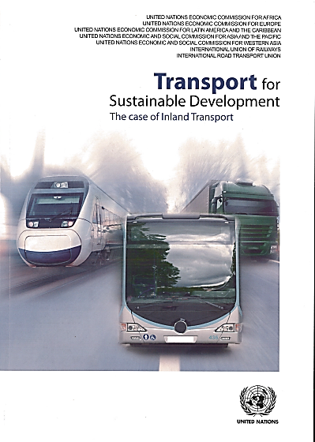16. The study ‘Transport for Sustainable Development: The case of Inland Transport’ —authorship led by UNECE — is the result of cooperation between the five Regional Commissions of the United Nations and key global stakeholders, in particular, the International Road Transport Union and the International Union of Railways.

17. The study examines issues, progress and challenges in global efforts to achieve a transition to sustainable mobility of freight and people using inland modes of transport, i.e. road, railways, inland waterways and intermodal transport. While transport is a precondition for social and economic interactions, unfortunately, it has also negative impacts, such as road crashes, air and noise pollution, and greenhouse gas emissions.

18. With a wealth of good and best practices, the study showcases results in mitigating the negative impacts, and also identifies the main challenges and opportunities to accelerate the transition to sustainability. It promotes an in-depth and real-world understanding of the five defining dimensions of sustainable transport — accessibility, affordability, safety, security and environmental performance. The study brings forth theoretical insights and best practices from all regions of the world and thus maps similarities and differences among countries of different income groups and geographical regions in their efforts towards sustainable transport.

19. The Transport Divisions of the United Nations Regional Commissions intend to continue cooperating and develop a follow-up study: ‘Transport for Sustainable Development - The Case of Maritime Transport and Hinterland Connections’. The lead author will be the Economic Commission for Latin America and the Caribbean.

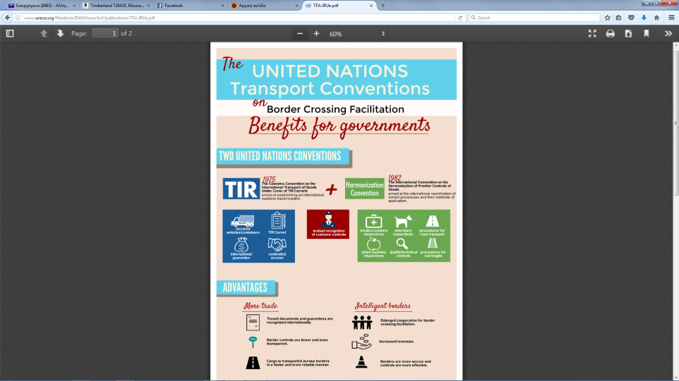 2. The United Nations Transport Conventions on border crossing facilitations - Benefits for Governments

20. This leaflet, prepared by the Sustainable Transport Division of the UNECE in cooperation with the International Road Transport Union, highlights the importance and potential benefits to Contracting Parties of the Customs Convention on the International Transport of Goods under Cover of TIR Carnets and the International Convention on the Harmonization of Frontier Controls of Goods. It makes use of graphics and visual materials to introduce, in a simplified manner, transport as a means to facilitate trade. It showcases, in particular, the relation between the two United Nations conventions and the Trade Facilitation Agreement of the World Trade Organization.

3 Child Restraint systems

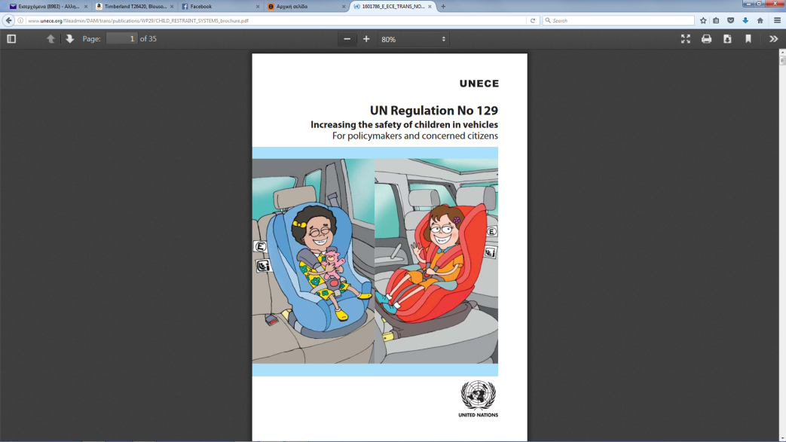21. To reduce the risk of severe injuries in the case of accidents, it is important that babies and toddlers in transport are facing opposite the driving direction. Compared to older children and adults, they have weaker neck muscles and carry a relatively large and heavy head. A premature change into a forward-facing Child Restraint System (CRS) increases the risk of severe injury to the cervical spine in case of accidents. The new UN Regulation No. 129, also known as ‘i-Size Regulation’, was developed in order to better address such issues. Developed by the Working Party on Passive Safety (GRSP), which is a subsidiary body of the World Forum for Harmonization of Vehicle Regulations (WP.29) of UNECE, GRSP aims to enhance child safety. The development of the technical contents of the UN Regulation were dealt with by an Informal Working Group, led by France, which brought together experts from ministries, research institutions, technical services, consumer testing and industry.

4. The United Nations Motorcycle Helmet Study

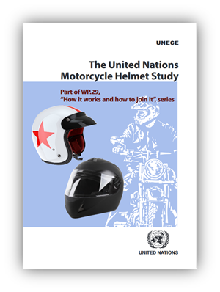22. Motorcyclists are 26 times more likely to die in a traffic crash than the drivers of passenger cars. Wearing an appropriate helmet improves their chances of survival by 42 per cent and helps avoid 69 per cent of injuries to riders. In 1972, UNECE following the implementation of the United Nations 1958 Agreement, adopted UN Regulation No.22 which covers motorcycle helmets. UN Regulation No. 22 has since been periodically updated to reflect progress in technical, medical and materials research. Now in its fifth series of amendments (with each series increasing the level of stringency and protection), UN Regulation No.22 provides uniform conditions for the approval of protective helmets for drivers and passengers of motorcycles. An important feature of UN Regulation No.22 is that it requires independent testing and product marking. This ensures that the helmet is of high quality and that it is safe. The approval mark in UN Regulation No. 22 is a key part of enforcing a helmet-wearing policy. Recognizing the value of UN Regulation No. 22, the majority of European countries, as well as many other countries in the world (42 in all), have made it part of their own legislation and have joined the United Nations type approval system. In addition, numerous countries that are not Contracting Parties to the 1958 Agreement also base their national motorcycle helmet legislation on Regulation No. 22.

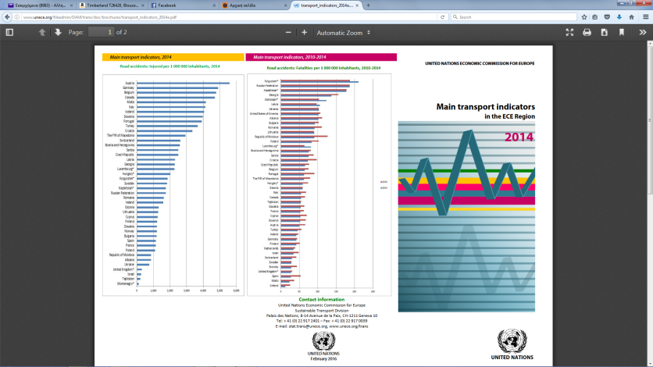 5. Main Transport Indicators in the UNECE Region - 2014

23. This brochure provides statistics on the main indicators for road, rail and inland waterways for countries in the ECE region.

C. Publications thanks to partnerships

1. 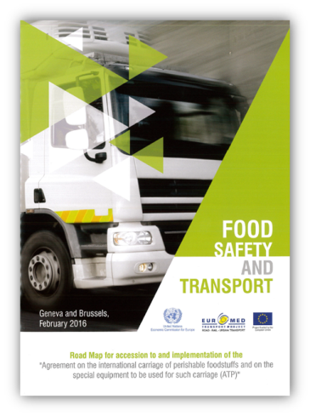Food Safety for Transport

23. This is a roadmap for accession to and implementation of the “Agreement on the international carriage of perishable foodstuffs and on the special equipment to be used for such carriage (ATP) prepared in cooperation with the EuroMed project. The EU funded EuroMed Regional Transport Project “Road, Rail and Urban Transport” aims at supporting the implementation of the Trans-Mediterranean Transport Network by developing appropriate regulatory framework and operational conditions in order to facilitate cross-border transport, enhance land transport safety and promote sustainable and efficient urban transport .

1. Road Map for the Accession to and Implementation of the European Agreement concerning the Work of Crews of Vehicles engaged in International Road Transport (AETR), of 1970

24. Driver fatigue is known to increase the risk of serious road crashes. The AETR Agreement aims at preventing drivers and crews of commercial vehicles engaged in international road transport from driving excessive hours. The Agreement also defines control devices “tachographs”, sets up technical requirements for the construction, testing, installation and inspection of these devices and for the checking of driving hours by competent authorities. However, this Agreement is open for accession to UNECE member countries only (Article 14).

25. Taking note of the vital importance of this Agreement for EuroMed countries, EuroMed RRU project conducted focused national demand driven training events in Algeria, Jordan, Morocco and Tunisia. UNECE experts contributed to these events. Following these events, Algeria, Jordan, Morocco and Tunisia expressed willingness to implement AETR and the digital tachograph in their international and domestic transport. Thus the emerging issue for EuroMed Partner countries was how to become Contracting Parties to AETR and benefit from its provisions and established widely harmonized frameworks.

26. During its ninth session, (Geneva, 27 October 2014) the UNECE Group of Experts on AETR decided to support the opening of the Agreement to Algeria, Jordan, Morocco and Tunisia by revising Article 14. The Expert Group agreed on the wording of an amendment proposal and invited an AETR Contracting Party to formally propose the amendment proposal at the earliest opportunity. At its 109th session (28 and 29 October 2014), SC.1 adopted the proposed modification of the Article 14.