|  |  |  |  |
| --- | --- | --- | --- |
|  | United Nations | ECE/TRANS/2017/7 | |
| _unlogo | **Economic and Social Council** | | Distr.: General  12 December 2016  Original: English |

**Economic Commission for Europe**

Inland Transport Committee

**Seventy-ninth session**

Geneva, 21-24 February 2017  
Item 4 (d) (ii) of the provisional agenda  
**Strategic questions of a horizontal policy nature:  
Environment, climate change and transport:   
Decarbonisation and mitigation of environmentally harmful effects of inland transport**

Use and further development of the For Future Inland Transport Systems (ForFITS) tool

Note by the secretariat

|  |
| --- |
|  |
| The Inland Transport Committee was informed at its February 2016, session that the Transport Division, at the invitation of the Environment Division, had participated in Environmental Performance Review (EPR) in Tajikistan and that the For Future Inland Transport Systems (ForFITS) tool would be used for analysis in the transport chapter of the EPR. The Committee may wish to take note of the outline of main findings from that study, as they were considered and endorsed by its sister sectoral Committee, the Committee on Environmental Policy at its January 2017 session. |
| The Committee will be further informed about plans for the further development of ForFITS. The Committee is invited to **consider expressing its support** and **provide guidance** on how it wishes to continue benefiting from and contributing to the use and development of the ForFITS tool in light of its timeliness and relevance to sustainable development and climate change mitigation, particularly in light of the results of COP21 held in Paris in December 2015. |
| The Committee is requested to consider how it wishes to continue to benefit from and contribute to the use and development of the ForFITS tool in light of its timeliness and relevance with regard to sustainable development. |

I. ForFITS application - Tajikistan

1. The ECE Environment Division carried out an Environmental Performance Review (EPR) in Tajikistan. The section on transport generated CO2 emissions and analyses led by the Sustainable Transport Division supported by local consultants. Realistic scenarios were analysed for possible reductions in CO2 emissions. The study results were annexed to the final EPR report (ECE/CEP/180).

2. The estimated well-to-wheelCO2 emissions in 2013 from the transport sector for Tajikistan showed that emissions from freight vehicles were approximately 20 percent more than those from passenger vehicles (2.5 billion kg vs 2.1 billion kg).

3. In case of no policy changes and expected economic growth, projections of CO2 emissions from the transport sector in Tajikistan showed an overall increase of more than 80 percent by 2030 from 2013, with freight vehicles still contributing higher levels of emissions of CO2.

4. Tajikistan’s challenges are that its expected future economic growth would typically result in an increase of CO2 emissions from an increased motorization rate. However, improvements in the composition of its transport fleet could mitigate these risks. The results demonstrated the potential impact of increasing the efficiency of the passenger transport sector by improving public transport infrastructure and renewing the fleet of personal cars. Projections generated by ForFITS based on these scenarios showed that pursuing such policies can reduce by 20 percent the current trend of increasingly high emissions from the transport sector in Tajikistan.

Figure

# **Projected well-to-wheel CO2 emissions for transport in Tajikistan, 2010-2030**

**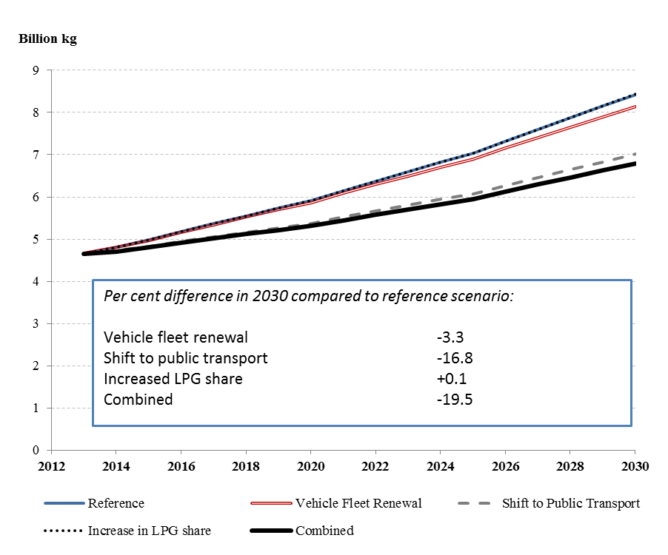**

*Notes:* Well-to-wheel = CO2 emissions from both vehicle operation and emissions from production and distribution of fuel used operation. Reference = No major policy changes. Vehicle fleet renewal = average vehicle life for personal passenger cars was reduced by one third by 2030. Shift to public transport = decrease of gap between the current and maximum values of ECE passenger transport system index by 13 per cent by 2030. Increased LPG share = the share of LPG personal passenger cars was increased to 38 per cent by 2030. Combined = combined effect of vehicle fleet renewal and shift to public transport scenarios.

5. With an aim toward mitigating the impact of future CO2 emissions from its transport sector, the Sustainable Transport Division suggested that Tajikistan may wish to further investigate the relative cost of implementing the following measures:

(a) Decreasing the average age of the passenger light-duty vehicles fleet;

(b) Creating conditions and developing infrastructure that encourage residents to use public transport.

II. ForFITS 2016-2018 work programme

6. The Sustainable Transport Division prepared a work plan for the next two years to scale up the use of the ForFITS tool and to further develop and enhance the current version of the model. All the following activities are subject to fundraising for extrabudgetary projects. All interested stakeholders are kindly invited to contact the secretariat to discuss any package including one/several/all of the following options.

A. Further development of the ForFITS model

1. Development of a new module on local pollutants

7. Air quality is a growing environmental and health concern for populations in many countries, and despite past improvements the transport sector remains an important source of pollution. Air quality is of particular concern in cities, as exposure to harmful gases and particulates is still significant all over the world, but particularly in fast growing transition economies. The addition of local pollutants to ForFITS would create a unique global tool that would cover the full range of transport emissions, greenhouse gases (GHG) and local air pollutants. Several policy measures currently assessed by ForFITS (e.g. those targeting reduction of travel demand or modal shift) impact on both CO2 and local air pollutant emissions, although only the first one is quantified by the current model. This wider scope would enable governments to implement transport policies which minimize the contribution of the transport sector to climate change and air pollution at the same time.

2. Development of a new module on Non-Road Mobile Machinery

8. The emissions of CO2 from Non-Road Mobile Machinery (NRMM), such as agricultural tractors, construction and mining machinery are usually not taken into account in the policy choices. However, they represent a sizeable amount of GHG and their contribution to total CO2 emissions may increase substantially, particularly in countries whose characteristics and economic structure favour NRMM activity. A feasibility study funded by Environment Canada confirmed that it is possible to develop a new NRMM module.

3. Development of a new user interface

9. ForFITS visibility could be improved by implementing a more user friendly and accessible interface that would offer a simple and intuitive way to introduce ForFITS inputs and to understand ForFITS outputs. For example, user definable inputs would represent the stringency of potential transport policies, with its impact on energy and CO2 emissions directly updated on the output graphs and tables.

B. Use of the existing ForFITS model

1. Training sessions

10. The Sustainable Transport Division frequently receives enquiries from ForFITS users on how to use the model. Some users need intensive training to be able to use ForFITS and produce output results. A ForFITS user manual is freely available online, although self-learning can be time consuming and laborious. The Sustainable Transport Division offers training sessions for new ForFITS users and to improve the skills of those already using the tool by maximizing the learning process in an efficient way.

2. Specific analyses for specific countries

11. Any country may contact the Sustainable Transport Division to carry out a thorough analysis, using the current version of ForFITS, to better understand the set of interventions that maximize transport CO2 emissions reduction. Data and information are required from the national/local administrations so as to facilitate an understanding of the country-specific transport and socioeconomic characteristics and to define meaningful scenarios. A final report on future transport activity, energy consumption and CO2 emissions from different economic, technology and policy scenarios would be delivered. This activity could be combined with the training sessions mentioned above so that the results of the analyses could be presented to the country in hands-on experience capacity-building workshops based on the country case.