Indian comments on GRE 2017/12

- Proposal
- Replace figure in Annex 4 , Fig 2a
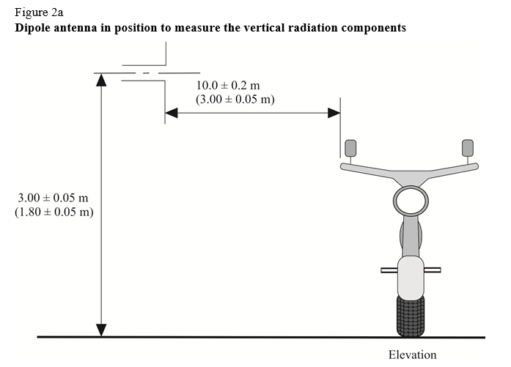
By
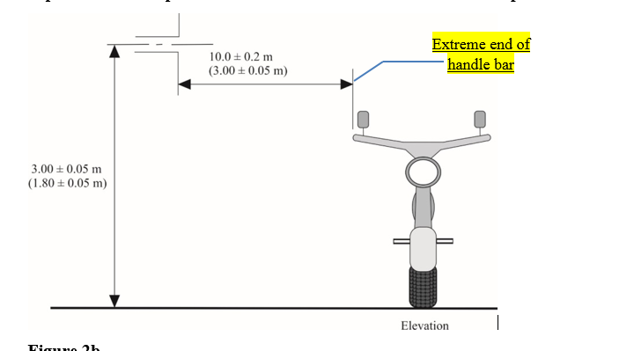
- Replace figure in Annex 4 , Fig 2b
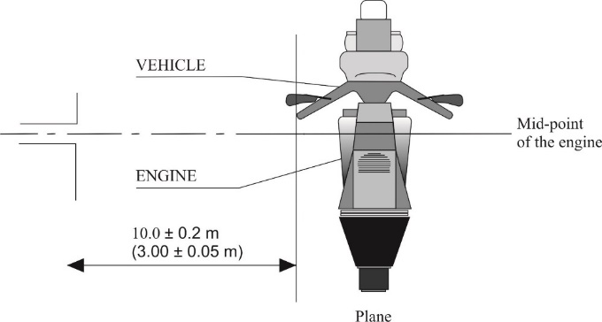
By
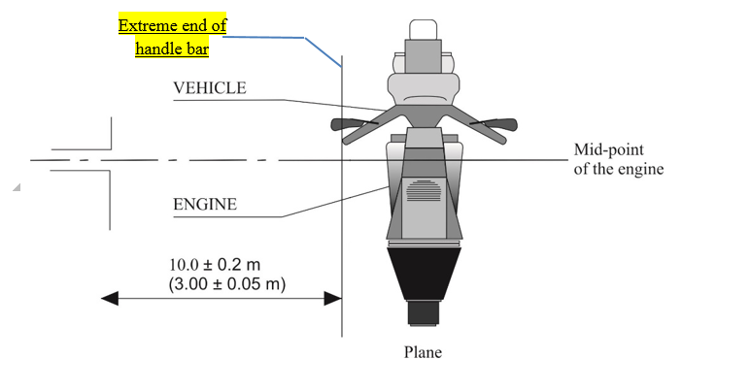

- Replace figure in Annex 6 Appendix 1 Figure 2
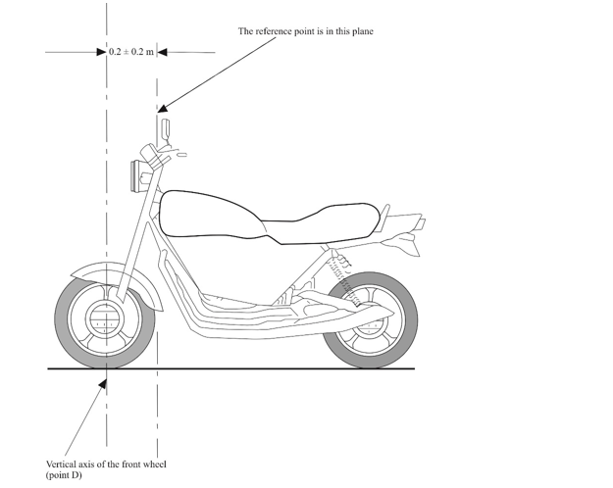
By
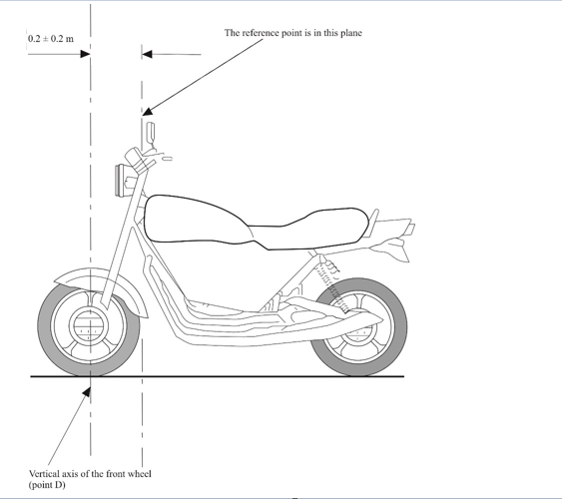

- Justification
For Sr No 1&2 : To bring in more clarity & uniformity of measurement distance between
Antenna & vehicle.
For Sr No3 : To align as per Annex 6 – Appendix 1 figure 1 “Three wheeled vehicle”

