|  |  |  |  |
| --- | --- | --- | --- |
|  | United Nations | ECE/TRANS/WP.29/GRSP/2017/13 | |
| _unlogo | **Economic and Social Council** | | Distr.: General  16 February 2017  Original: English |

**Economic Commission for Europe**

Inland Transport Committee

**World Forum for Harmonization of Vehicle Regulations**

**Working Party on Passive Safety**

**Sixty-first session**

Geneva, 8-12 May 2017

Item 13 of the provisional agenda

**Regulation No. 44 (Child restraint systems)**

Proposal for Supplement 13 to the 04 series of amendments to Regulation No. 44 (Child Restraint Systems)

Submitted by the expert from the Netherlands[[1]](#footnote-2)\*

The text reproduced below was prepared by the expert from the Netherlands, to exclude diverging interpretations of child restraint systems in UN Regulation No. 44. It is based on documents ECE/TRANS/WP.29/GRSP/2016/14 and ECE/TRANS/WP.29/2016/18 distributed during, respectively, the fifty-ninth and sixtieth session of GRSP. The modifications to the current text of the UN Regulation are marked in bold for new or strikethrough for deleted characters.

I. Proposal

*Paragraph 6.1.8*., amend to read:

"6.1.8. Child restraint systems of the "universal" category, except ISOFIX universal child restraint systems, shall have a main load-bearing contact point, between the child restraint and **the webbing of** the adult safety-belt. This point shall **not be less than 65 mm vertically above the test bench cushion and** not be less than 150mm from the Cr axis when measured with the child restraint on the dynamic test bench installed in accordance with Annex 21 to this Regulation without a dummy. **This shall be measured in a longitudinal plane making use of the Standard seat belt configuration for the fitting session described in figure 1C of Annex 13.** This shall apply to all adjustment configurations.

Additional alternative belt routes are allowed. Where an alternative belt route exists, the manufacturer shall make specific reference to the alternative route in the user instructions, as required in paragraph 15. When tested, using such alternative belt route(s), the restraint shall comply with all the requirements of the Regulation. ~~with the exception of this paragraph.~~"

*Paragraph 6.2.2*., amend to read:

"6.2.2. For groups I, II and III, all restraint devices utilizing a "lap strap" shall positively guide the "lap strap" **on both sides** to ensure that the loads transmitted by the "lap strap" are transmitted through the pelvis. The assembly shall not subject weak parts of the child's body (abdomen, crotch, etc.) to excessive stresses. **The positive guidance of loads over the pelvis shall be realized from the moment that the child is installed; the lap belt shall pass rearward on the thighs, just touching the fold with the pelvis. The angles α and β between the tangent line in which the belt touches the thighs and the horizontal shall be greater than 10**°.

The assembly shall not subject weak parts of the child's body (abdomen, crotch, etc.) to excessive stresses."

# **Figures of Strapped child**

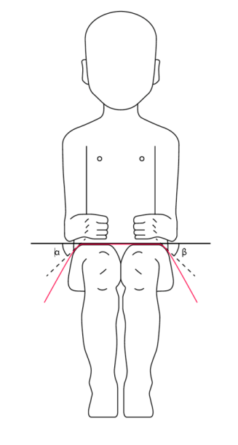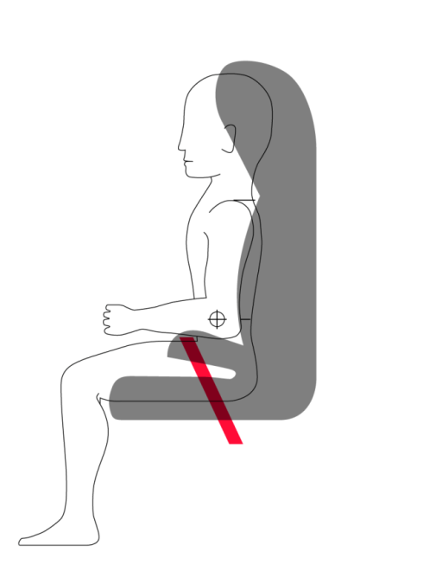

*Paragraph 6.2.12*., amend to read:

"6.2.12. In case of ~~booster cushions~~ **non-integral child restraint systems**, the ease with which the straps and tongue of an adult belt pass through the fixture points shall be examined. ~~This goes particularly for booster cushions which are designed for the front seats of cars, which may have long semi-rigid stalks.~~ The fixed buckle **+ tongue** should not be allowed to pass through the fixture points of booster seats, or to permit a lie of belt completely different from that of the test-trolley.

**This shall be tested during a separate fitting session on the test bench by replacing the central part of the standard safety belt (figure 3 of Annex 13) and the flexible strap to part A2, with respectively, a tongue and a generic buckle attached to a flexible strap with an adapted length such that, the combination of A2, adapted flexible strap buckle and tongue are projecting 150 mm outside the Cr point.**"

*Paragraph 7.2.1.1*., amend to read:

"7.2.1.1. The buckle shall be so designed as to preclude any possibility of incorrect manipulation. This means, inter/alia, that it shall not be possible for the buckle to be left in a partially closed position; it shall not be possible to exchange the buckle parts inadvertently when the buckle is being locked; the buckle shall only lock when all parts are engaged. Wherever the buckle **and /or the tongue are** ~~is~~ in contact with the child, it shall not be narrower than the minimum width of strap as specified in paragraph 7.2.4.1.1. below. This paragraph is not applicable to belt assemblies already approved according to ~~ECE~~ Regulation No. 16 or any equivalent standard in force. In the case of a "Special Needs Restraint" only the buckle on the primary means of restraint need comply with the requirements of this paragraph 7.2.1.1. to paragraph 7.2.1.9. inclusive."

*Annex 13,*

*Figure 1B*, amend to read:

"Figure 1B  
**Three-point retracting belt dynamic test**

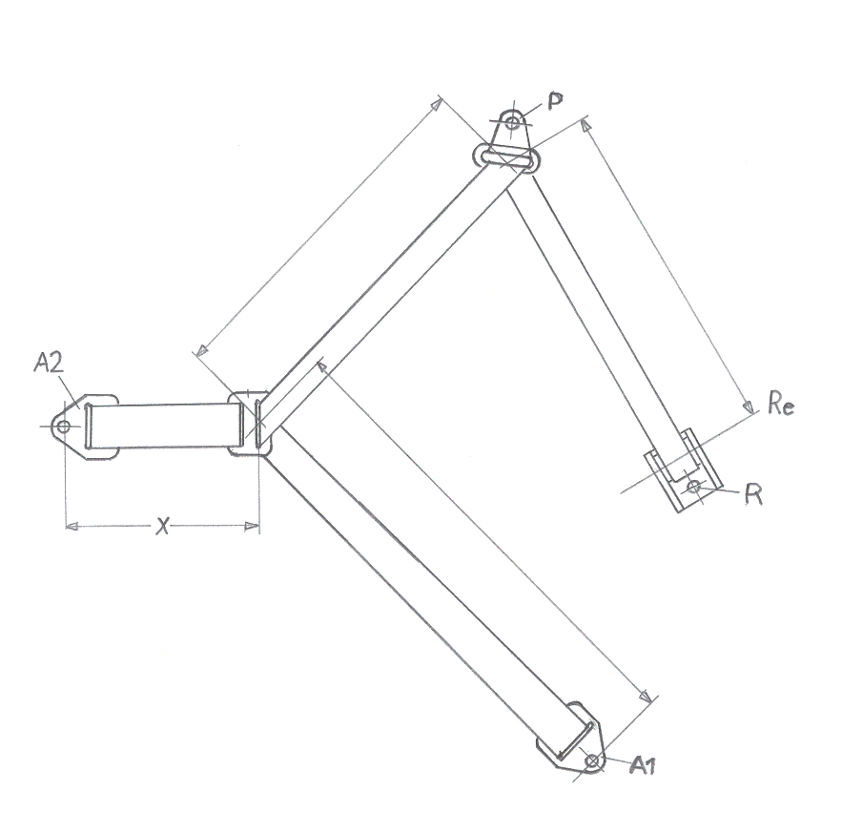"

*Insert new Figure 1C*, to read:

**Figure 1C  
Standard seat belt configuration, for fitting session of par.6.2.12.**

# 

**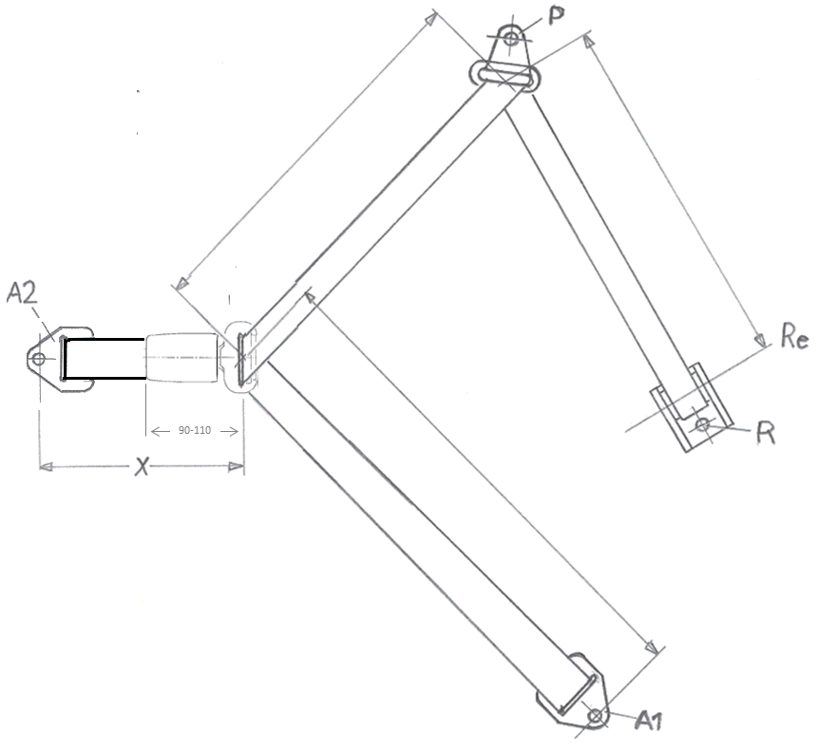**

Buckle dimensions

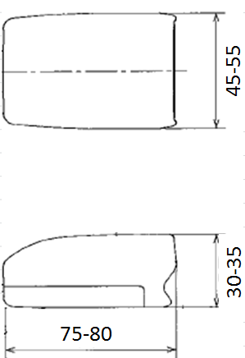

"

II. Justification

1. Requirements for car manufacturers (Regulation No. 16, Annex 17, Appendix 1, which allows a certain zone) are incompatible with requirements for Child Restraint System (CRS) manufacturers (Regulation No. 44, paragraph 6.2.12., asks for a different zone). Furthermore, the definition of main load-bearing contact point needs a more precise definition to prevent difficulties with various new concepts.
2. The type approval administration of the Netherlands is confronted with CRS in which the child will show, first, an excessive forward movement of the pelvis before the tensioning process of the pelvis actually starts; this works in opposite of the aim of car manufacturers’ approach to pre-tensioners.
3. The type approval administration of the Netherlands is confronted with a CRS that forces the lie of the adult belt in real cars completely different from the lie on the test-trolley. Regulation No. 44 mentions a judgment using buckles, but does not further specify anything about a proper judgment. To prevent incompatibilities with real cars, this paragraph aims to introduce a better check.
4. Injury to a child as a result of a high local pressure must be avoided. Such injuries cannot only be caused by twisted buckles but also by twisted tongues, therefore, the relevant paragraph is improved on this point.

1. \* In accordance with the programme of work of the Inland Transport Committee for 2016–2017 (ECE/TRANS/254, para. 159 and ECE/TRANS/2016/28/Add.1, cluster 3.1), the World Forum will develop, harmonize and update Regulations in order to enhance the performance of vehicles. The present document is submitted in conformity with that mandate. [↑](#footnote-ref-2)