|  |  |  |
| --- | --- | --- |
|  |  | **INF.23** |

**Economic Commission for Europe**

Inland Transport Committee

**Working Party on the Transport of Dangerous Goods**

**105th session 1 November 2018**

Geneva, 6-9 November 2018

Item 8 of the provisional agenda

**Any other business**

Information concerning an event occurred during carriage of dangerous goods according to 1.8.5

Transmitted by the Government of Italy

Occurrence summary

On 6 August 2018 at 1.35 pm, an event occurred at Km 4+300 of the road connection between the Motorway A1 and the Motorway A14 near the city of Bologna *(see picture 1 in Annex 1)*.

The section of the road flows over an elevated structure above the urban road network below.

Among the vehicles involved in the accidents there were two ADR vehicles.

A tractor with a semitrailer with LPG class 2 tank that was travelling in direction north, for reasons to be clarified, violently hit the column of vehicles stationary in the right lane. The driver of the LPG tank vehicle died immediately due to the impact *(see picture 2 in Annex 1)*.

The last vehicle in the row was a vehicle carrying paint solvents - class 3 flammable liquids – which, due to the impact, leaked onto the road and immediately caught fire (0.5 sec).

The fire engulfed the LPG tank quickly, initially only the front and then totally .

The flames continued to burn the LPG tank, and about 7 minutes a BLEVE occurred. *(see pictures 3,4 in Annex 1).*

Because of the energy released and therefore of the overpressure and the heat generated, the road infrastructure collapsed down and the neighbouring structures/buildings were strongly affected *(see pictures 5,6,7 in Annex 1).*

At the end, one person died (the driver of the tank vehicle) and 95 persons were injured (all were admitted to the hospitals near the area). Among the injured persons some police officers and emergency teams that rushed to the accident area. Their timely intervention have allowed clearing the area before the explosion and thus reducing damages and saving all the other people present near the scene of the accident.

Reports

After the event, the Competent Authority received the reports, from the involved carriers/consignees (as prescribed in 1.8.5.1) and from both the Police Department and the Emergency Service.

A full report to the UN Secretariat (see 1.8.5.2 and 1.8.5.4 “*Report on occurrences during the carriage of dangerous goods in accordance with RID/ADR section 1.8.5*”) with a view to informing all Contracting Parties, will be presented as soon as possible after the conclusion of the necessary checks made by the involved national authorities.

Discussion

Starting from the evidence that the accident in Bologna can be classified, beyond any reasonable doubt, as a road accident even if with serious consequences and effects both on people and on infrastructures, we propose to examine different solutions in order to avoid the repetition of such events, taking into account the scientific and technical progress in the field of vehicle equipment.

Some of the technical solutions are regulated at UN level and may be used for certain vehicles in order to avoid road accidents (e.g.: *AEB - Autonomous Emergency Braking, Radar and LiDAR, Adaptive Cruise Control, Driver Fatigue Detection, etc )*. The World Forum for Harmonization of Vehicle Regulations (WP.29) should be involved in this context.

Furthermore, as far as the relevant aspects relating to the transport of dangerous goods are concerned, it is our opinion that a specific discussion should be conducted in the context of possible solutions aimed to mitigate the effects due to the presence of hazardous materials in some way involved in the accident. The Working Party is the right place to discuss this aspects.

Annex 1



Picture 1: area of the event

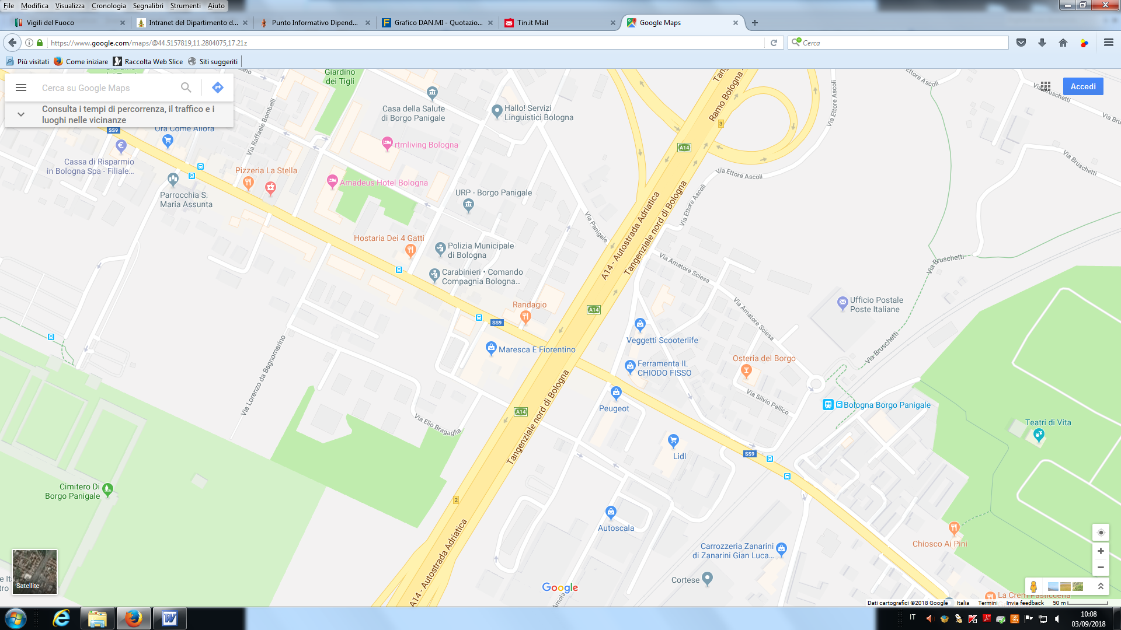

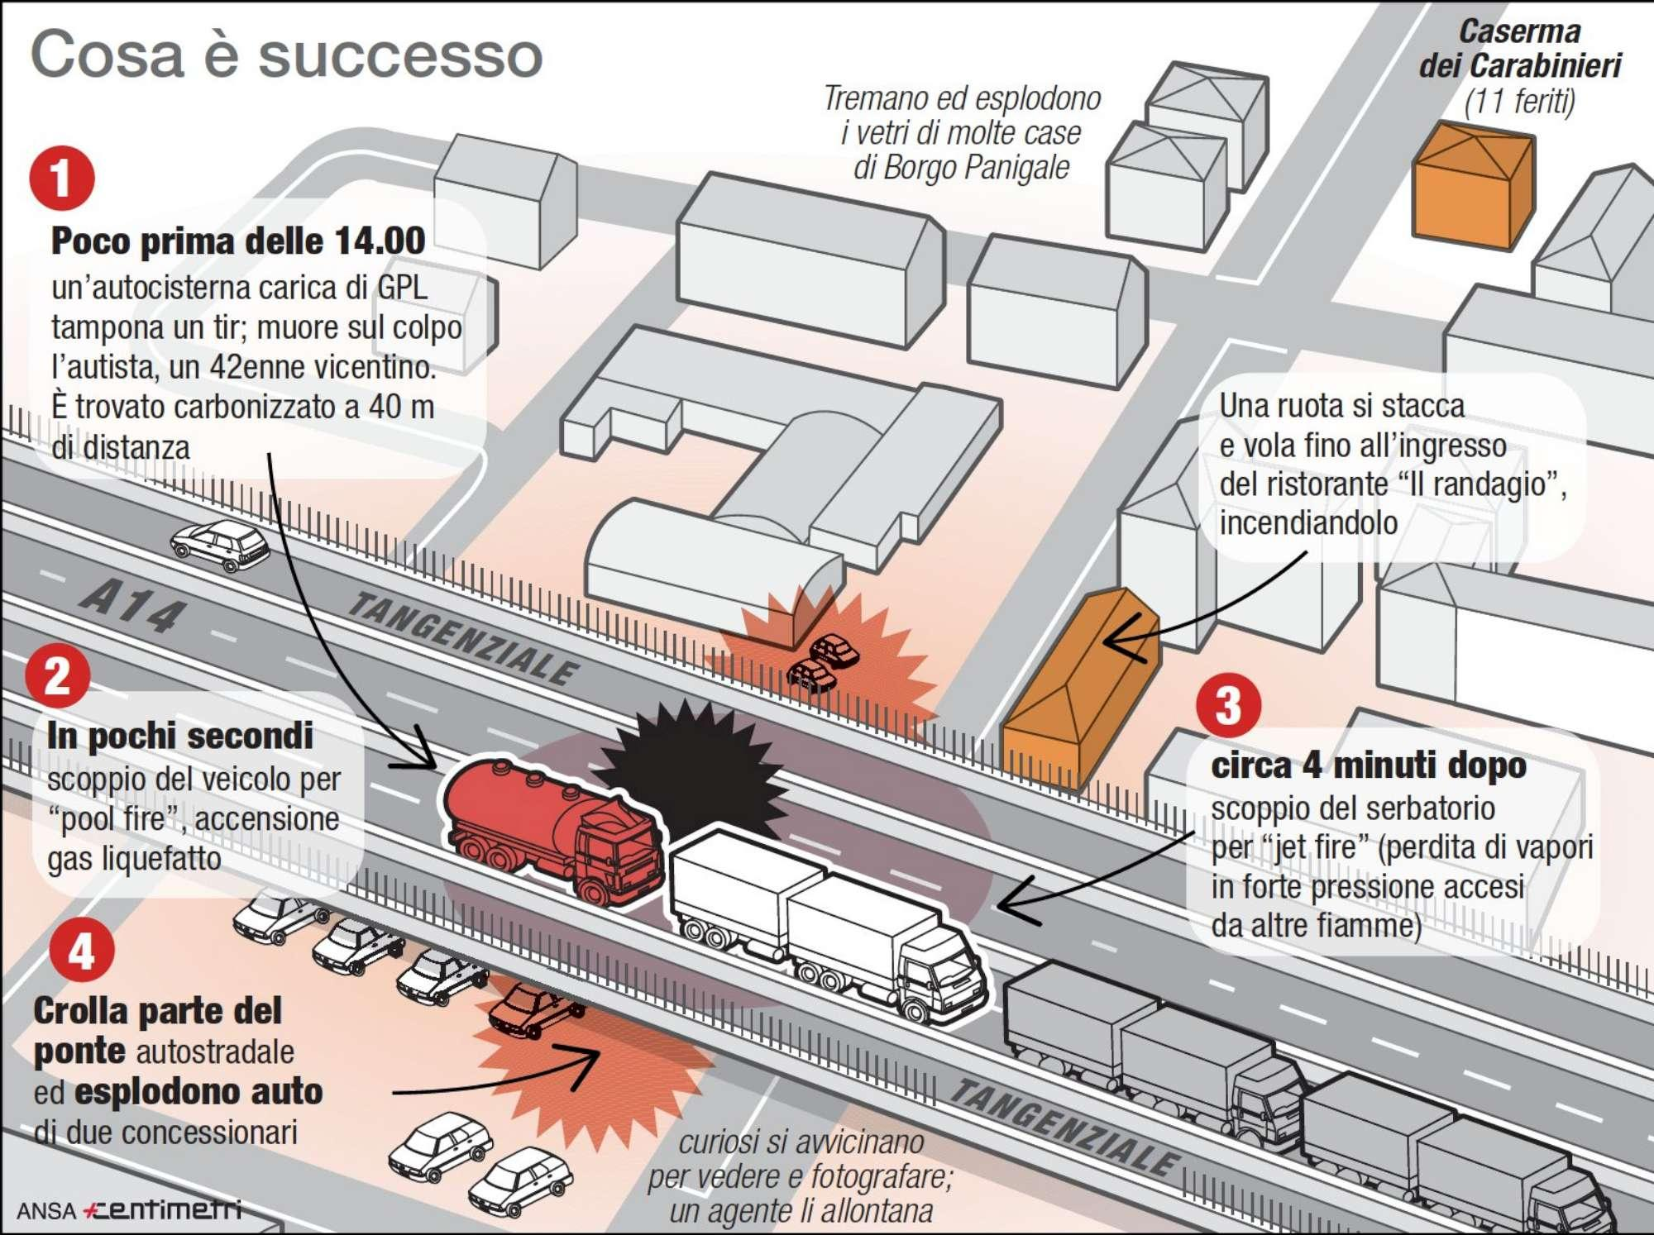

**Around 1:35 p.m.**

an LPG roadtanker collides with another truck; the driver, a man 42 yo from Vicenza, instantly dies due to the impact.

The body will be found carbonized 40 meters far away from the impact point

**In few seconds**

a pool fire takes place since the impacted truck, that was transporting chemical products, loses his load

**After several minutes**

the pool fire insisting under the LPG roadtanker causes a BLEVE

**Part of the bridge collapses**

and some cars from the nearby car dealer explode

A wheel gets projected against «Il randagio» restaurant, triggering a fire

**People** from the nearby area get close to the accident site despite the emergency situation should be clearly perceived

**Windows** explode at distance

Picture 2: The accident

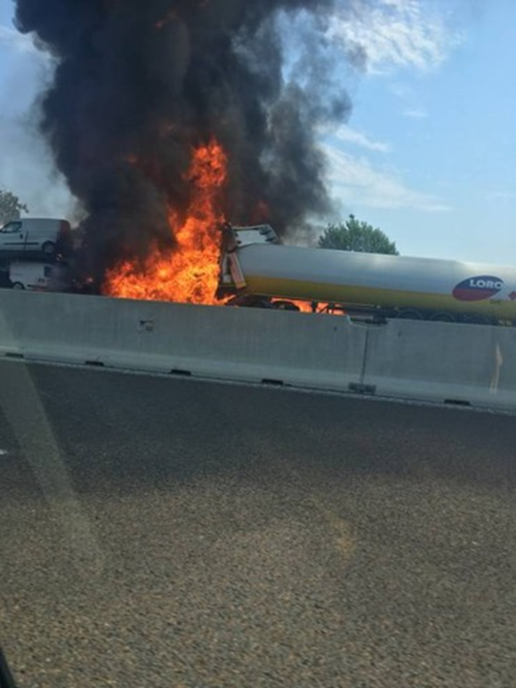

Picture 3: Fire engulfing the tank

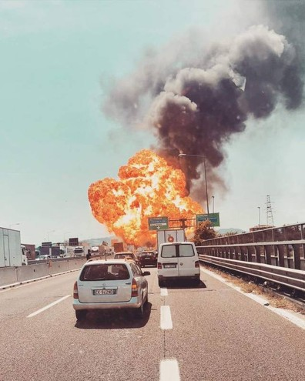

Picture 4: Explosion

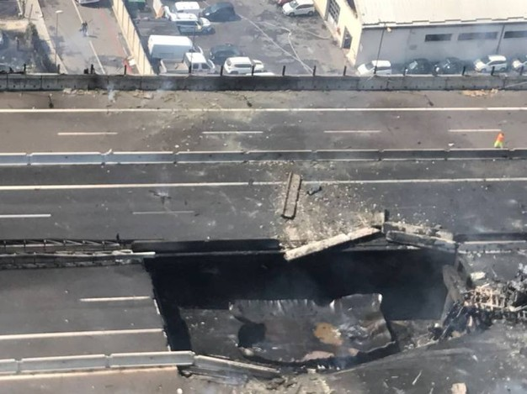

Picture 5: Fire engulfing the tank

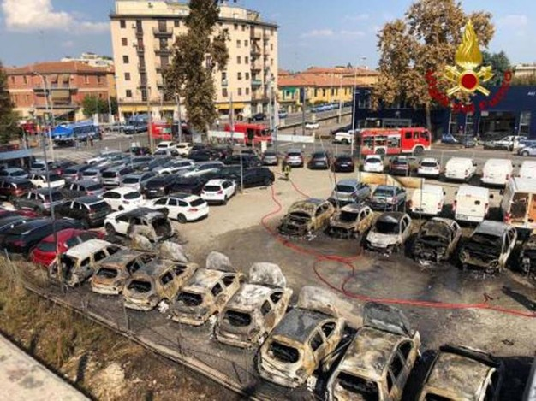

Picture 6: Car shop near the road

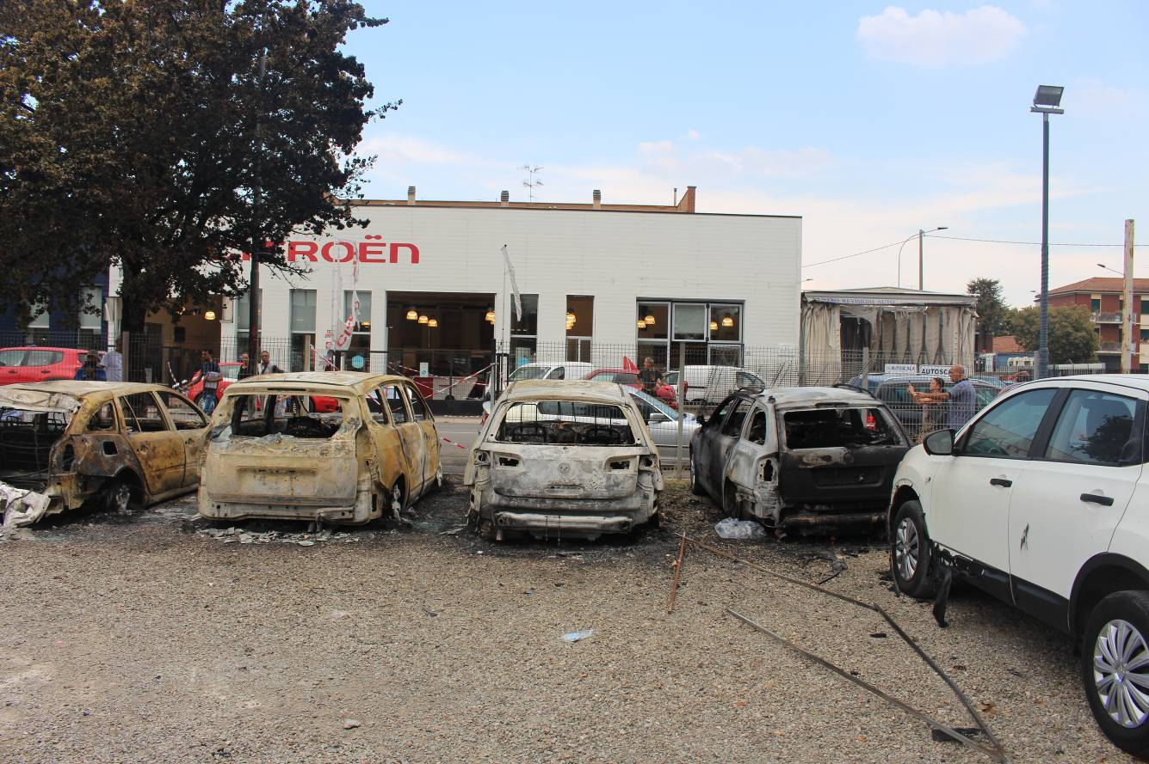

Picture 7: Car shop on the right side

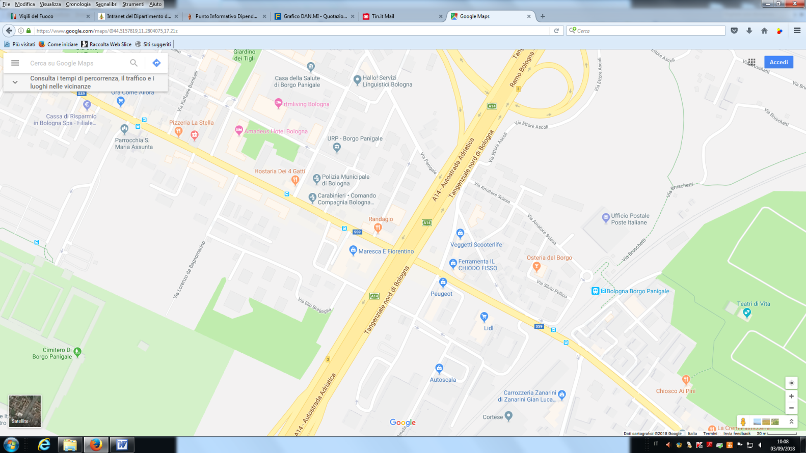

Accident