|  |  |  |  |
| --- | --- | --- | --- |
|  | United Nations | ECE/TRANS/WP.15/AC.1/2018/2 | |
| _unlogo | **Economic and Social Council** | | Distr.: General  21 December 2017  Original: English |

**Economic Commission for Europe**

Inland Transport Committee

**Working Party on the Transport of Dangerous Goods**

**Joint Meeting of the RID Committee of Experts and the**

**Working Party on the Transport of Dangerous Goods**

Bern, 12–16 March 2018

Item 5 (a) of the provisional agenda

**Proposals for amendments to RID/ADR/ADN:  
pending issues**

Specifying the requirements for the protection of valves in 4.1.6.8

Transmitted by the Government of Germany[[1]](#footnote-2)\*

|  |
| --- |
| *Summary* |
| **Executive summary:** Specifying the requirements for the protection of valves. |
| **Action to be taken:** Addition to 4.1.6.8.  **Related documents:** Informal documentINF.33 of the September 2017 session and ECE/TRANS/WP.15/AC.1/148, paragraph 71 (report of the Joint Meeting, Geneva, 19 to 29 September 2017). |
|  |

Introduction

1. 4.1.6.8 requires that valves be designed and constructed in such a way that they are inherently able to withstand damage without release of the contents or they must be protected from damage by one or more of the methods listed in (a) to (e).

2. In recent years, valves have been fitted with component parts that also remain on the valves during transport. Handling devices are an example of such components (mostly for gas cylinder valves with an integrated pressure regulator, VIPR) or adapter (e.g. for self-closing gas cylinder valves). These components are not designed or intended as protection for the valve in accordance with 4.1.6.8 (b) or (c).

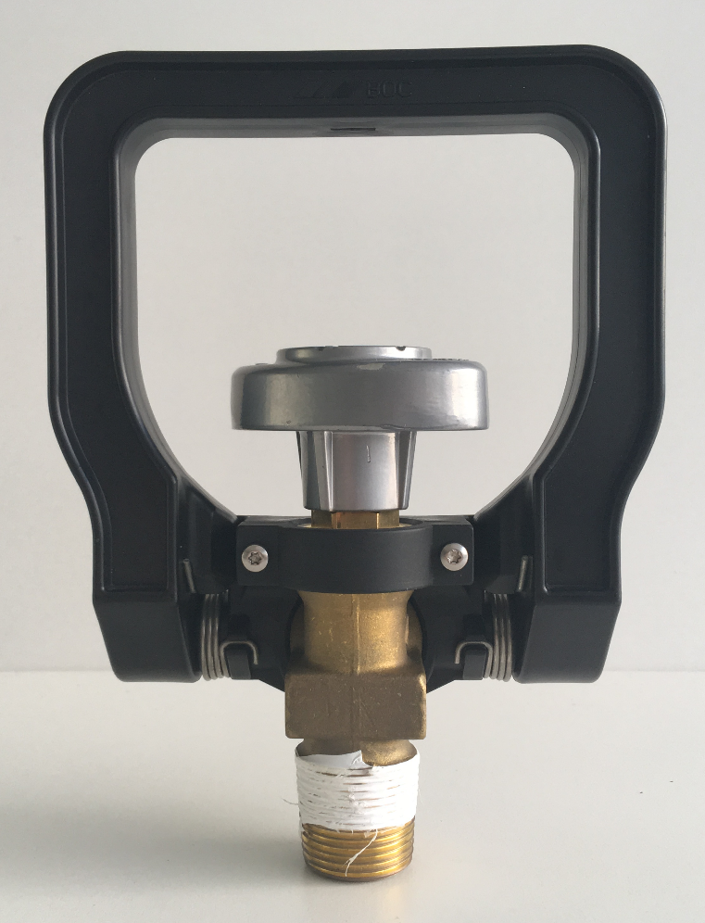

Gas cylinder valve with handling device attached



LPG gas cylinder valve with built-in filling and draw-off adapter

3. Fitting components such as these to inherently stable valves might have a detrimental effect on their inherent strength. In this respect, it must either be proved that a valve fitted with an additional component still retains its inherent strength, or one of the valve protection methods under 4.1.6.8 (a) to (e) must be used.

4. If such components are fitted to valves that are not inherently strong, and must therefore be provided with valve protection, it may be that the valve protection originally provided for valves with an additional component is no longer sufficient. As a result, it must either be proved that the valve protection on valves fitted with an additional component is still suitable, or another suitable valve protection method under 4.1.6.8 (a) to (e) must be used.

Proposal

5. It is proposed to add the following new paragraph to the end of 4.1.6.8:

“If valves are fitted with other components which are to remain in place during transport (e.g. handling device or adapter), these shall be included in the assessment.”

**Justification**: Clarification of the legal situation.

1. \* In accordance with the draft programme of work of the Inland Transport Committee for 2018-2019, (ECE/TRANS/WP.15/237, annex V, (9.2)). [↑](#footnote-ref-2)