|  |  |  |  |
| --- | --- | --- | --- |
|  | United Nations | ECE/TRANS/2018/4 | |
| _unlogo | **Economic and Social Council** | | Distr.: General  7 December 2017  Original: English |

**Economic Commission for Europe**

Inland Transport Committee

**Eightieth session**

Geneva, 20-23 February 2018  
Item 4 (b) of the provisional agenda  
**Strategic questions of a horizontal policy nature:   
United Nations Economic Commission for Europe   
analytical work on Transport**

International Transport Infrastructure Observatory

Note by the secretariat

|  |
| --- |
| *Summary* |
| A brief review is given on the development of an international transport infrastructure observatory. The observatory would be an innovative example of how government data on new transport infrastructure projects is presented to financial institutions and other donors in a transparent, comprehensive and ‘bankable’ way. The observatory is devised as an online platform where (a) governments find the data to prepare, benchmark and present their transport infrastructure projects and (b) financial institutions can consider, analyse and compare projects from a regional/international perspective and identify projects to finance. |
| The Committee is invited to **provide guidance** on future directions for the development of the observatory. |
|  |

I. Mandate

1. During the twenty-eighth session (7-9 September 2015, Geneva) of the Working Party on Transport Trends and Economics, a workshop took place on ‘Road and Rail transport corridors in Europe and Asia’. The Working Party requested the secretariat to prepare a document based on inputs received by the experts and discussions made during the workshop for consideration by the Working Party at its next session.

2. The participants at the workshop took stock of the initiatives that exist and operate between Europe and Asia on the development of transport corridors.

|  |  |
| --- | --- |
| (a) The TEN-T network where nine core network corridors are identified: a work plan was drawn up for each corridor (approved in June 2015) that sets out the current status of its infrastructure, a schedule for removing physical, technical, operational and administrative bottlenecks, and an overview of the financial resources (European Commission, international, national, regional and local, public and private); | Figure 1  **TEN-T network**    *Source:* European Union |
| Figure 2  **ECO road and rail network**    *Source:* ECO secretariat | (b) The Economic Cooperation Organization (ECO) road and rail network in Central Asia includes eight road transport corridors and six rail transport corridors. A project started in 2009 in cooperation with the Islamic Development Bank (IsDB) to ensure implementation of ECO Transit Transport Framework Agreement (TTFA); |
| (c) The Organization for Cooperation between Railways (OSJD) has identified thirteen rail transport corridors in Europe and Asia. A memorandum on cooperation in the field of technical, operational and commercial development of each railway corridor was developed to be signed by the different stakeholders; | Figure 3  **OSJD rail corridors**    *Source:* OSJD secretariat |
| Figure 4  **SEETO Road network**    *Source:* SEETO secretariat | (d) The South-East Europe Transport Observatory (SEETO) has developed a comprehensive network that is part of the TEN-T network, and includes eight road transport corridors and seven rail corridors. A transport facilitation working group was created to follow the implementation of the soft measures and specific actions are taking place for each corridor; |
| (e) The Central Asia Regional Economic Cooperation (CAREC) has identified six main transport corridors. The CAREC Transport and Trade Facilitation Strategy 2020 – Priority Projects and tasks has been prepared where 108 transport infrastructure financing projects and 49 technical assistance ones have been identified; | Figure 5  **CAREC corridors**    *Source:* CAREC secretariat |
| (f) The Black Sea Economic Cooperation (BSEC) sets as one of its goals the establishment of an efficient transport network for its member States, and it promotes the development of the Black Sea Ring Highway project which envisages a four-lane ring highway system, approximately 7,500 km long, which will connect BSEC member States; | |
| Figure 6  **TRACECA corridors**    *Source:* TRACECA secretariat | (g) The Transport Corridor Europe-Caucasus-Asia (TRACECA) where two main corridors have been identified: the TRACECA international investment forum has been established which is a standing mechanism providing direct and consistent interaction between TRACECA and investors; |
| (h) The international Road Transport Union (IRU) New Eurasian Land Transport Initiative (NELTI) where three main corridors - routes are identified: four caravans have been accomplished in these corridors with concrete results and recommendations; | Figure 7  **IRU Eurasian Land Transport Initiative**    *Source:* IRU secretariat |
| Figure 8  **CETMO transport corridors**    *Source:* CETMO secretariat | (i) The Centre for Transportation Studies for the Western Mediterranean (CETMO) where seven transport corridors were identified: six are part of the TEN-T corridors. Especially for the trans-Maghreb multimodal transport corridor an action plan with horizontal actions was developed. |

3. The secretariat during the workshop prepared the following map, which summarizes all the initiatives on transport infrastructure in Europe and Asia and highlights that all of them are working on the same region and corridors.

Figure 9

**Transport Corridors in Europe and Asia**

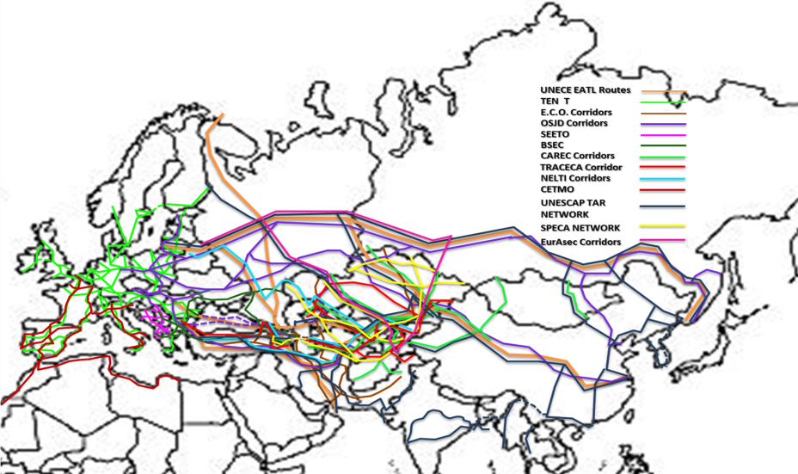

*Source:* ECE, Transport Division

4. The workshop showed the complexity of the substantive issues involved in the development of transport corridors in Europe and Asia and the need for further analysis. The importance of modern and efficient transport infrastructure as well as the implementation of soft measures and in particular the United Nations conventions to facilitate border crossings was highlighted. Furthermore, the lack of cooperation among the different stakeholders and initiatives for transport corridors development between Europe and Asia was mentioned as one of the key challenges that should be addressed.

5. During its twenty-ninth session (5-7 September 2016) the Working Party on Transport Trends and Economics decided to mandate the secretariat (ECE/TRANS/WP.5/60, para. 37) to develop an international transport infrastructure observatory for the European and Asian continents.

II. Services to be provided

6. The main objectives of this observatory are:

(a) to enhance cooperation among the different transport infrastructure initiatives in Europe and Asia;

(b) to create economies of scale and maximize efficiency by helping governments and organizations to achieve more by spending less;

(c) to provide concrete and tangible inputs to governments by hosting data and findings of different topical studies;

(d) to facilitate communication among the focal points of the initiatives in order to exchange basic information (meeting dates, agendas, reports, workshop programmes, etc.);

(e) to disseminate ad hoc knowledge, and best or good practices including information about vendors, consultants, etc.;

(f) to exchange information about projects and other initiatives/proposals;

(g) to seek cooperation on specific transport infrastructure projects/tasks/studies and researches decided during their secretariat sessions.

7. However, since the observatory will be developed on a sophisticated Geographical Information System (GIS) platform the services that will be provided to users and especially to governments and the international financial institutions are beyond those mentionned above. It would permit all users to find and analyse:

(a) data about all transport networks and nodes (road, rail, inland waterways, ports, airports, intermodal terminals, logistics centres and border crossing points). This data will include any kind of information from technical specifications such as number of lanes, electrified lines, etc. to operational details such as opening hours, number of lanes for TIR trucks, etc.

(b) data on transport corridors (length, services, missing links, time schedules, tariffs). This data will include information about block trains for instance that operate on specific corridors, number of border crossings and waiting times, real time monitoring of services (time schedules, stops, etc.), and intermodal tariffs calculations (door to door delivery). In a later stage, and in cooperation with the railway undertaking, the block trains can be equipped with GPS providing to their users, through the observatory, an online real-time track and trace of train trips, and therefore of their cargoe;

(c) data about new transport infrastructure projects. Government focal points will have the possibility if they wish to provide information on new transport infrastructure projects either with secured or not secured funding to be evaluated for funding by the International Financial Institutions (IFIs) and other donors. The real value for the governments and especially the IFIs while evaluating these new projects will be that they would have the opportunity to see and analyse the projects in a broader geographical and socioeconomic context by adding or reducing GIS layers. For instance, there is critical information that a bank should know before deciding to finance a new project. For example this information for a new project that is part of a transport corridor includes the number of border crossing points and their waiting times until cargo will reach the first port, as well as the existing and forecasted trade flows along the corridor.

(d) data about traffic and cargo / goods flows; the traffic and goods flows indicate the level of criticality of an artery compared to the whole network. It is the parameter that could characterize a new transport infrastructure project as viable and sustainable or not;

(e) data about international conventions / agreements ratification and implementation: at a glance, and by adding a GIS layer, users could see which countries have signed and ratified which international conventions and agreements and the level of their implementation. This information is critical indicator for the conditions of transport and trade facilitation that exist in a region and therefore for the viability and sustainability of a future transport infrastructure project;

(f) results of different regional studies such as:

(i) Benchmarking transport infrastructure construction costs: A group of experts already exists with this mandate. If the findings of this group are incorporated in the observatory, then governments and banks will know by adding a GIS layer how much other governments in the region pay to construct a similar, for instance, bridge, road, etc. and is valuable input to prepare ‘bankable’ project proposals and to evaluate the actual cost of a new project;

(ii) Climate Change impacts and adaptation for transport networks and nodes: A group of experts already exists with this mandate. If the findings of this group are incorporated in the observatory, then governments and banks will have by adding a GIS layer a full climate change impacts hot spots map for the region. The hot spots map would be the result of matching together the forecasts provided by IPCC on different climatic factors (precipitation, temperature, etc.) with the critical transport infrastructure. For instance, if based on this hot spots map the suggested construction area risks to be flooded, then either the governments/banks should suggest additional technical measures to adapt to this climate change impacts or maybe they could reconsider building in the area;

(iii) Good practices and innovative solutions in financing transport infrastructure: the observatory will work as an ‘electronic library’ that will incorporate all good and best practices, tools and methodologies to finance transport infrastructure.

8. International financial institutions need to have access to reliable data and to analytical tools to ensure the financing of transport infrastructure projects that efficiently improve regional and international connectivity. The international transport infrastructure observatory would be an innovative example of how government data on new transport infrastructure projects is presented to financial institutions and other donors in a transparent, comprehensive and bankable way. The observatory is devised as an online platform where (a) governments find the data to prepare, benchmark and present their transport infrastructure projects and (b) financial institutions can consider, analyse and compare projects from a regional/international perspective and identify projects to finance

Figure 10

**International Transport Infrastructure Observatory Components**

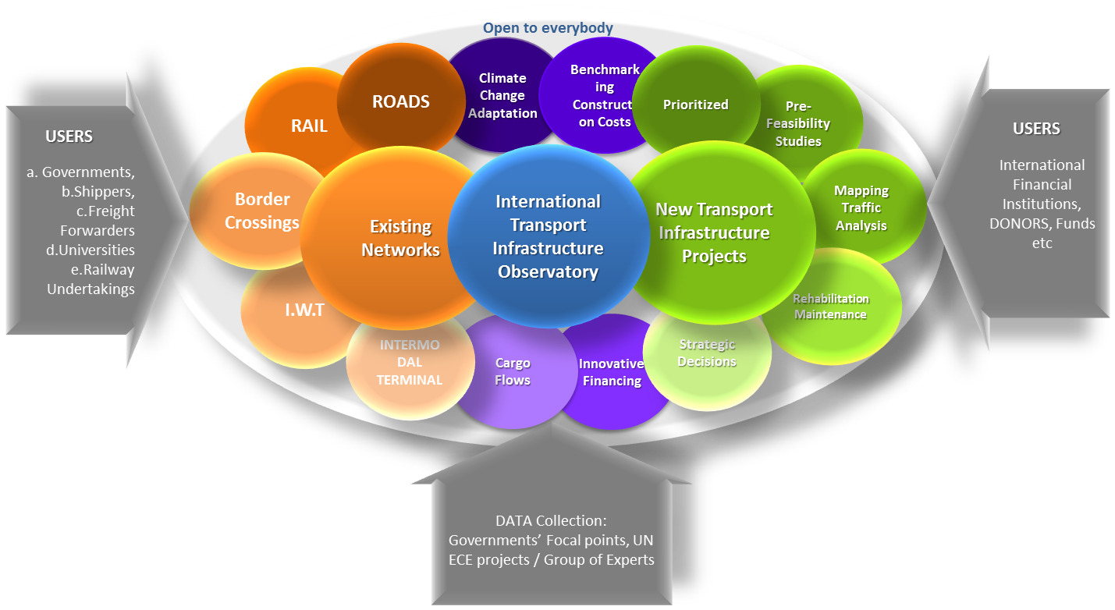

9. The following are some illustrations from the observatory.

Figure 11

**Rail Networks and Investment Projects**

**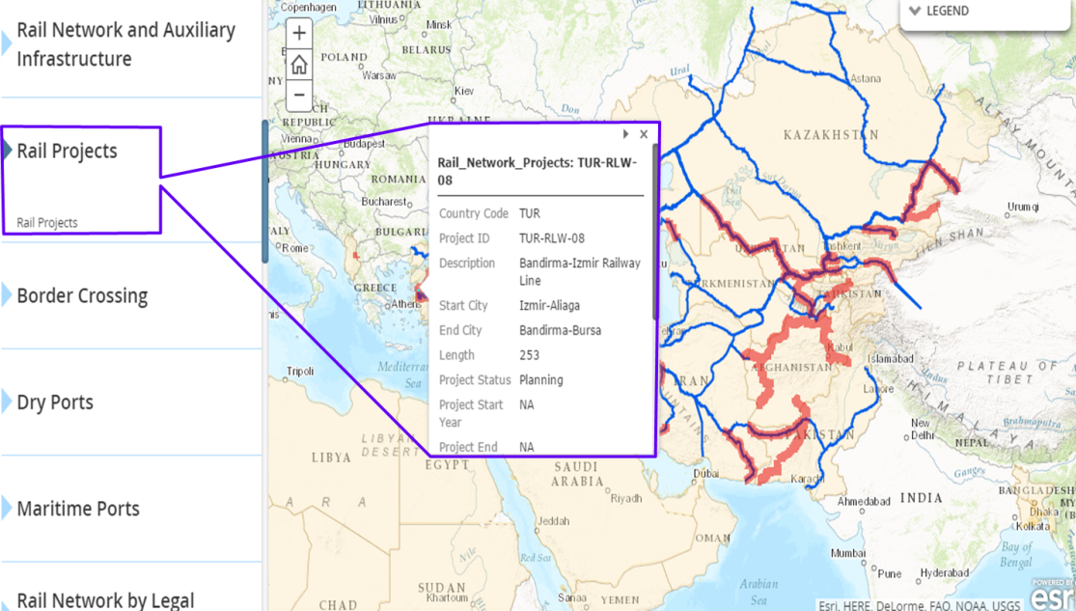**

Figure 12

**Intermodal Transport Network**

**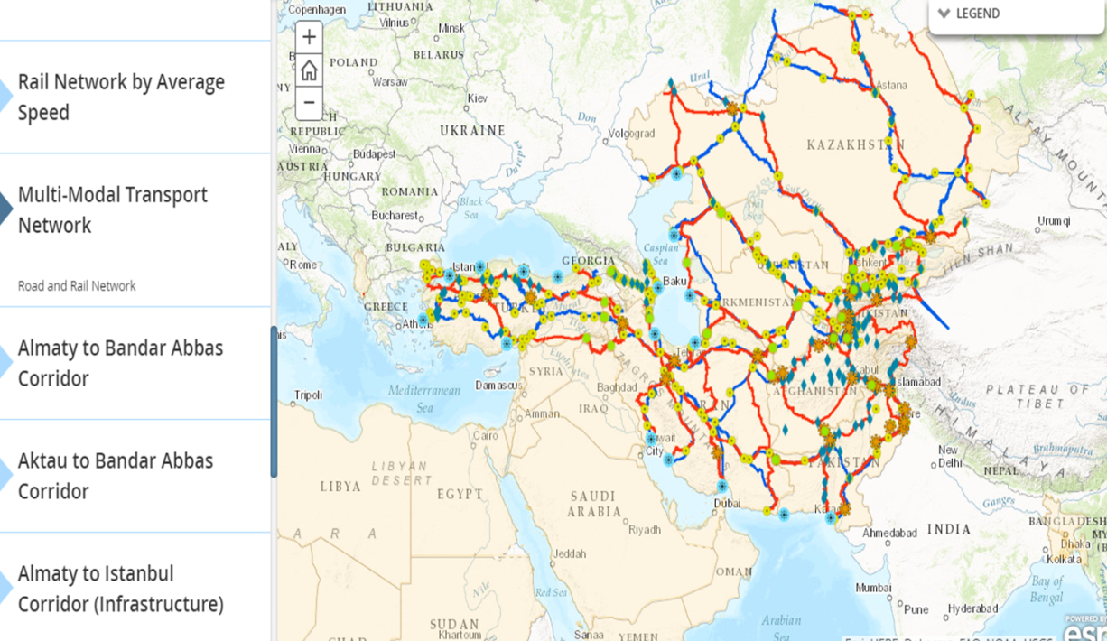**

Figure 13

**Hotspots Map: Critical transport infrastructure and projections for temperature**

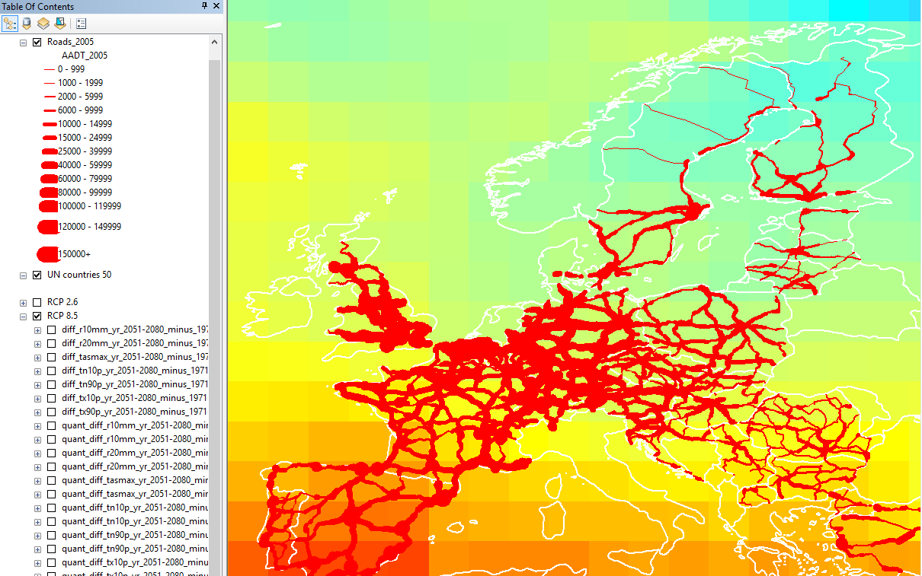

III. Funding

10. In 2011, a memorandum of understanding (MOU) between IsDB, ECO and ECE was signed. The main objective of the MOU was to promote the development of an international intermodal transport and logistics system for ECO member countries, which will contribute to the promotion of economic development and social progress in the ECO region as a cross road for corridors connecting Asia and Europe.

11. As a follow-up to the MOU, a project was agreed on in 2016 between the Sustainable Transport Division and IsDB to enhance regional connectivity through GIS. The bank provides the funds to ECE to procure the GIS software needed for the development of the transport infrastructure observatory and to hire the consultants to customize the software based on the needs of ECE/bank and to collect the relevant data.

12. The project has already started. The secretariat has already bought the software and has hired the consultants to collect the relevant data. Based on the initial project plan, the first phase of the observatory will be ready and operational in September 2018.

13. Other development banks and United Nations regional commissions and agencies have already shown interest in participating in this observatory.

IV. Guidance

14. The Inland Transport Committee may wish to consider the above and provide guidance to the secretariat on the development of the international transport infrastructure observatory.