|  |  |  |  |
| --- | --- | --- | --- |
|  | United Nations | ECE/TRANS/WP.29/2018/9 | |
| Description: _unlogo | **Economic and Social Council** | | Distr.: General  28 December 2017  Original: English |

**Economic Commission for Europe**

Inland Transport Committee

**World Forum for Harmonization of Vehicle Regulations**

**174th session**

Geneva, 13-16 March 2018

Item 4.7.1 of the provisional agenda

**1958 Agreement:  
Consideration of draft amendments**

**to existing UN Regulations submitted by GRRF**

Proposal for Supplement 15 to the 11 series of amendments to UN Regulation No. 13 (Heavy vehicle braking)

**Submitted by the Working Party on Brakes and Running Gear**[[1]](#footnote-2)\*

The text reproduced below was adopted by the Working Party on Brakes and Running Gear (GRRF) at its eighty-fourthsession (ECE/TRANS/WP.29/GRRF/84, para. 15). It is based on ECE/TRANS/WP.29/GRRF/2017/2, ECE/TRANS/WP.29/GRRF/2017/11, ECE/TRANS/WP.29/GRRF/2017/12 and Annex V to the report. It is submitted to the World Forum for Harmonization of Vehicle Regulations (WP.29) and to the Administrative Committee AC.1 for consideration at their March 2018 sessions.

Supplement 15 to the 11 series of amendments to UN Regulation No. 13 (Heavy vehicle braking)

*Footnote 12*, amend to read:

"

12 Off-road vehicles, special purpose vehicles (e.g. mobile plant using nonstandard vehicle chassis, mobile cranes, hydro-static driven vehicles in which the hydraulic drive system is also used for braking and auxiliary functions, vehicles having a non-standard chassis where the installation of sensor(s) for values of lateral acceleration and/or yaw rate, necessary for the function of the stability control, cannot be installed within the specified area close to the center of gravity of the vehicle without compromising its special purpose),N2 vehicles which have all of the following features: a gross vehicle mass between 3.5 and 7.5 tonnes, a non-standard low-frame chassis, more than two axles and hydraulic transmission, Class I and Class A buses of categories M2 and M3, articulated buses and coaches, N2 tractors for semi-trailer with a gross vehicle mass (GVM) between 3.5 and 7.5 tonnes shall be excluded from this requirement."

*Annex 5,*

*Paragraph 2.2. and 2.2.1.*, shall be deleted

*Paragraphs. 2.3. to 2.4.1.* *(former),* shall be renumber as paragraphs 2.2. to 2.3.1.

*Annex 12,*

*Paragraphs 2.3.10. and 2.3.11.,* shall be deleted.

*Paragraph 2.3.12. (former),* amend to read and renumber:

"2.3.10. scd Maximum differential travel that the compensator is capable to accommodate, due to its geometric and constructive properties, when only one brake operates in the forward direction and the other in reverse direction, while allowing equal tension in both cables/rods.

(See Figure 5A of appendix 1)"

*Footnote 1*, shall be deleted.

*Paragraph 8.1.2.,* amend to read:

"8.1.2. Drawing details are to be provided to demonstrate that the compensator articulation is sufficient to ensure equal cable tension is applied to each of the rear cables. The compensator needs to have sufficient distance across the width to facilitate the differential travels left to right. The jaws of the yokes also need to be deep enough relative to their width to make sure that they do not prevent articulation when the compensator is at an angle.

Differential travel at compensator (scd) shall be derived from:

Scd ≥ 1.2 • Sr"

*Annex 12, Appendix 1,**Figure 5A*, amend to read:

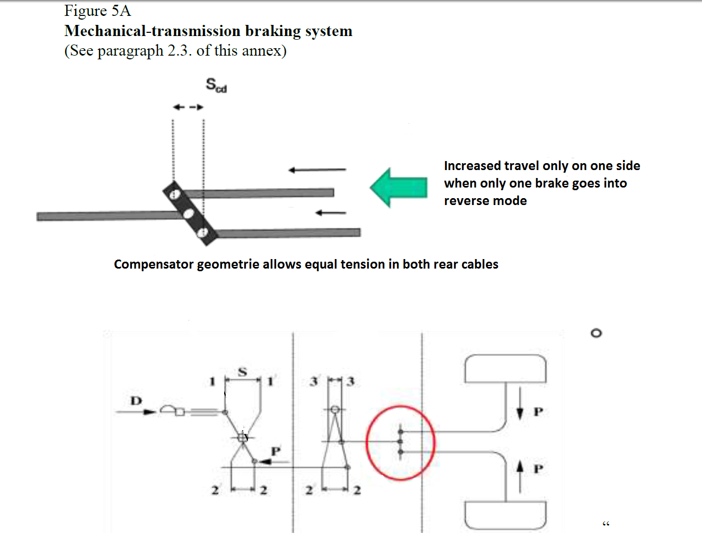

*Annex 12, Appendix 4,*

*Paragraphs 6.1.1. to 6.1.3.,* shall be deleted

*Insert new paragraphs 6.1.1. and 6.1.2.,* to read:

"6.1.1. Maximum possible differential compensator travel capacity   
scd= mm

6.1.2. Ratio 1.2 \* sR = \_\_\_\_\_\_\_\_\_\_\_ mm  
 (shall not be greater than scd)"

1. \* In accordance with the programme of work of the Inland Transport Committee for 2016–2017 (ECE/TRANS/254, para. 159 and ECE/TRANS/2016/28/Add.1, cluster 3.1), the World Forum will develop, harmonize and update UN regulations in order to enhance the performance of vehicles. The present document is submitted in conformity with that mandate. [↑](#footnote-ref-2)