|  |  |  |  |
| --- | --- | --- | --- |
|  | United Nations | ECE/TRANS/WP.29/2018/38 | |
| _unlogo | **Economic and Social Council** | | Distr.: General  9 April 2018  Original: English |

**Economic Commission for Europe**

Inland Transport Committee

**World Forum for Harmonization of Vehicle Regulations**

**175th session**

Geneva, 19-22 June 2018

Item 4.6.2 of the provisional agenda

**1958 Agreement:  
Consideration of draft amendments**

**to existing UN Regulations submitted by GRSP**

Proposal for Supplement 3 to the 05 series of amendments to UN Regulation No. 22 (Protective helmets)

**Submitted by the Working Party on Passive Safety**[[1]](#footnote-2)\*

The text reproduced below was adopted by the Working Party on Passive Safety (GRSP) at its sixty-second session (ECE/TRANS/WP.29/GRSP/62, para. 18). It is based on   
GRSP-62-04 and GRSP-62-10 as reproduced in Annex V to the report. It is submitted to the World Forum for Harmonization of Vehicle Regulations (WP.29) and to the Administrative Committee AC.1 for consideration at their June 2018 sessions.

Supplement 3 to the 05 series of amendments to UN Regulation No. 22 (Protective helmets)

*Insert a new paragraph 5.1.8.,* to read:

"5.1.8. The approval marks prescribed in paragraphs 5.1.4., 5.1.5. and 5.2.4. above may not be replaced by an Unique Identifyer (UI) as referred to in Schedule 5 of the 1958 Agreement."

*Paragraphs 5.1.8. to 5.1.13.*, renumber as paragraphs 5.1.9. to 5.1.14.

*Annex 12*, amend to read:

"**Annex 12**

Type approval scheme (Flow chart)

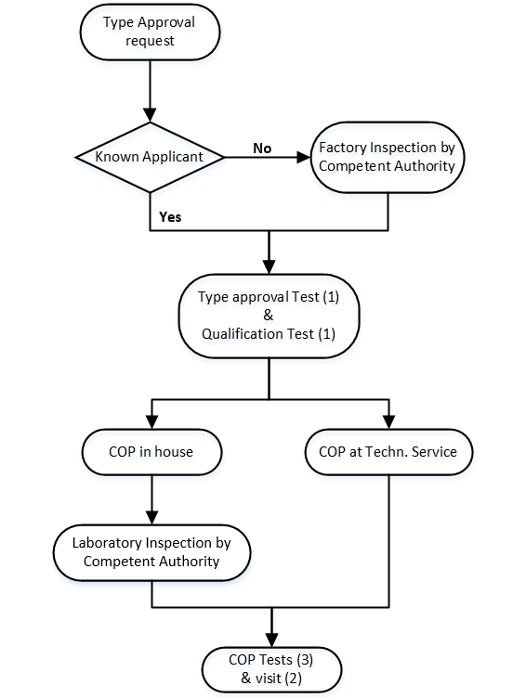

(1) To be carried out at the same technical service or the same accredited independent laboratory.

(2) Visit of the manufacturer for inspection and random sampling by the authority or technical service:

(a) If there is no ISO 9002[[2]](#footnote-3)\* or an equivalent standard: 1 time~~s~~ a year

(b) If there is an ISO 9002\* or an equivalent standard: 1 time every 1 to 2 years, depending on the results of the inspection.

(3) Tests in accordance to paragraph 10.5 and/or 10.6 on samples taken out of the production:

(a) If there is no ISO 9002\*: of the authority or technical service during the visit of footnote 2 a) of the manufacturer between the visits of footnote 2 a)

(b) If there is an ISO 9002\*: taken by the manufacturer, procedure checked during visit of footnote 2 b)"

1. \* In accordance with the programme of work of the Inland Transport Committee for 2018–2019 (ECE/TRANS/274, para. 123 and ECE/TRANS/2018/21/Add.1, cluster 3.1), the World Forum will develop, harmonize and update UN Regulations in order to enhance the performance of vehicles. The present document is submitted in conformity with that mandate. [↑](#footnote-ref-2)
2. \* Or an equivalent standard, i.e. one that delivers the same or better levels of quality. [↑](#footnote-ref-3)