Amendments to the Proposal for a draft Resolution on road surface labelling (ECE/TRANS/WP.29/GRB/2018/8) and Background information (ECE/TRANS/WP.29/GRB/2018/8)

Note: The text below is prepared by the expert from the Netherlands. Modifications to both documents are marked in bold characters for new or as strikethrough for deleted text.

Amendments to the Proposal for a draft Resolution on road surface labelling (ECE/TRANS/WP.29/GRB/2018/8)
Annex I
Classification of road surface characteristics

2. Skid resistance
Table 2
Skid resistance (SR) classes
Skid resistance (SR)
in friction coefficient
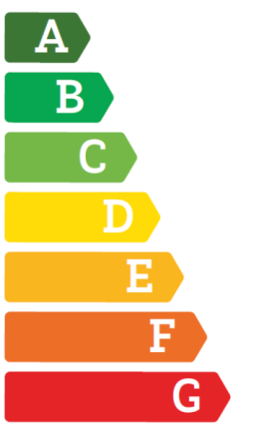 | SR ≥ 1.14 0.83  0.68 0.91 ≤ SR < 1.14 0.83  0.59 0.78 ≤ SR < 0.91 0.68  0.50 0.64 ≤ SR < 0.78 0.59  0.42 0.52 ≤ SR < 0.64 0.50  0.33 0.38 ≤ SR < 0.52 0.42  SR < 0.38 0.33

Annex III
Determination of skid resistance
The skid resistance (SR) should be determined at 80 km/h in accordance with technical test specifications (in German) [TP Griff-StB 07 (SKM): Technische Prüfvorschriften für Griffigkeitsmessungen im Straßenbau; Teil: Seitenkraftmessverfahren (SKM), Ausgabe 2007, FGSV Köln DE], within 2-9 months after opening to traffic.
The skid resistance (SR) should be determined at 70 km/h in accordance to the procedures detailed in this Annex. Other methods may be used if they provide the same results, within the accuracy of the original method.
For contract tendering, i.e. before constructing a road surface, indicative values of the skid resistance may be based on laboratory testing. However, the values of the in-situ performance, as determined according to this Annex, are decisive.
The Skid Resistance (SR) is defined as the longitudinal coefficient of friction (COF) between wetted road surface and tyre, as determined at 70 km/h using a standardised measurement tyre in a standardised friction tester, after the applicable corrections, in accordance to the procedures detailed in this Annex.

1. Measurement system

The measurement system consist of a towing vehicle, containing a controller and data acquisition system and a water supply system, coupled to a measurement trailer according to CEN/TS 15901-9:2009 or equivalent. This trailer contains a measurement wheel, the axis of which is parallel to the road surface and perpendicular to the driving direction. The measurement wheel is connected to one of the bearing wheels of the trailer through a single-gear box. The measurement wheel is subjected to 86% slip ratio, meaning that the circumferential velocity of the measurement wheel is 14% of that of the freely rotating bearing wheels (of the same circumference as the measurement wheel).
The measurement wheel is fitted with a smooth PIARC measurement tyre (165 R 15) inflated to 200 ± 10 kPa. Measurement tyres should only be used between 12 and 36 months after their production date. Before first use, a measurement tyre should be ‘broken in’ for at least 25 km on a road surface with a SR between 0.40 and 0.60. Tyres must not be used if they are damaged or excessively worn (wear indicator less than 2 mm deep).
The measurement wheel is loaded though a spring/damper system by such a mass, that the static normal force (F_{Nst}) - measured on a horizontal plane - equals1962 ± 9.81 N.
The dynamic longitudinal force (F_{x}) on the measurement tyre, when dragged along the road surface, caused by the friction, is measured with a force transducer with an inaccuracy of not more than 0,2% and a maximum deviation of 9.81 N. The force must be measured and recorded at least once for each 0.5 m travelled distance.
The system supplies a water film on the road surface, (the outflow opening of the nozzle is located 0,41 m in front of the measurement tyre axis), of at least 0.15 m width and a nominal thickness of 0.5 mm, calculated on a theoretical smooth surface without texture. The system measures the average water flow and average driving speed during the friction measurement. If the average water flow deviates more than 10% from the theoretical value for the average driving speed, this must be reported with the measurement results.
If the amount of water in the water tank in the towing vehicle has such an influence on the pitch of the vehicle (and hence of the friction force F_{x}) that the COF can change by more than 0.01, the COF has to be corrected. To determine this correction (c_{w}), the suspension characteristics of the towing vehicle must be taken into account.
The inaccuracy of the measurement of travelled distance may not be more than 1%.

3. Execution of measurements

For road surface labelling the measurements should be executed for each lane required by the client (but at least the slow lane). For right-hand driving countries, the measurements should be executed in the right wheel path, i.e. with the centre of the measurement wheel at a distance of 0.6 m to the left of the inside of the right lane marking. For left driving countries, the measurements should be executed in the left wheel path, i.e. with the centre of the measurement wheel at a distance of 0.6 m to the right of the inside of the left lane marking.
For road surface labelling, the friction measurement for acceptance testing of a road surface should be executed either before 24 hours after opening to traffic, or between 6 and 20 weeks after opening to traffic.
For road surface labelling, the measurements should be executed at a speed of 70 ± 3.5 km/h. For other purposes other speeds may be used, with an accuracy of ± 5%. If the speed deviates more than specified, this deviation must be reported with the measurement results.
At the start of the measurement section, the measurement tyre must have a stable temperature. Therefore, the measurement tyre must be warmed up by lowering the tyre onto the wetted road surface at a distance before the measurement section, specified in Table 1.

Table 1
Warming-up length, depending on time since previous measurement
Time since previous measurement | Warming-up length
T < 10 minutes | ≥ 100 m
10 ≤ T < 20 minutes | ≥ 300 m
20 ≤ T < 30 minutes | ≥ 500 m
T ≥ 30 minutes | ≥ 1000 m

Air temperature and road surface temperature should be measured for each measurement location or at least twice a day, with an accuracy of 1°C.
Measurements should not be performed at an air temperature below 2°C or over 30°C, and at road surface temperature below 2°C or over 45°C.

4. Calculation

4.1. Measured Coefficient of Friction

The measured Coefficient of Friction (COF_{meas}) is determined by:
${COF}_{meas}= {A+B*(\left(F_{x}+c_{w}\right)}/{F_{Nst})}$
where:
F_{x} = the measured longitudinal friction force on the measurement wheel [N]
c_{w} = the correction for pitch of the towing vehicle, derived from the amount of water in the water tank [N]
F_{Nst} = the static normal force (1962 N)
A, B = correction constants depending on road surface category (“porous” or “dense”, see below), taking into account differences between production years of the PIARC measurement tyres. For production year 2016, for “porous” surfaces A = 0 and B = 1, for “dense” surfaces A = 0.110 and B = 0.830. For other years the constants have to be determined by statistic comparison to the 2016 tyres. (Actually the present corrections refer back to the 1998 production year.)
“Porous” surfaces are capable of draining water below the road surface, through the bulk of the surface layer. These include Porous Asphalt, Silent Thin Surfacings with over 14% void content, Porous Cement Concrete. “Dense” surfaces can only drain water in the surface macro texture. These include Asphalt Concrete, Stone Mastic Asphalt, Cement Concrete, Slurry Seals and Chip Seals.
The COF_{meas} must be calculated, with a resolution of three decimal places, at least once for each 0.5 m travelled distance. From these values, per 100 m the average COF_{meas} per 5 m and per 100 m are calculated to at least three decimal places.

4.2. Seasonal correction

The average COF_{meas} per 5 m and per 100 m can be corrected for the influence of the measurement season using the following formula:
$${COF}_{season}= {COF}_{meas}-0.022*sin\left(\left(360/365\right)*\left(N_{day}+60\right)\right)$$
where:
COF_{season} = the COF corrected for seasonal influences [-]
0.022 = the amplitude of seasonal influence [-]
Nday = the day number of the measurement date within a year (January 1st is 1, February 1st is 32, etc.)
60 = the phase shift in days
The argument of the sine function is in degrees.
The COF_{season} should be calculated with a resolution of at least three decimal places.

4.3. Determination of SR

For labelling of new road surfaces, up to 12 months old, the SR is defined as the COF_{meas} as determined in section 4.1.
For labelling of road surfaces, more than 12 months old, the SR is defined as the COF_{season} as determined in section 4.2

5. Reporting

Reporting is done per measurement section of 100 m and should contain the following data:
General data:
- Location of the measurement (road, carriageway, lane, transverse position within lane, chainage or length from a specified zero point)
- Direction of measurement relative to normal driving direction, if not identical
- The category of road surface, including specification of either “porous” (Porous Asphalt, Silent Thin Surfacings with over 14% void content, Porous Cement Concrete) or “dense” (Asphalt Concrete, Stone Mastic Asphalt, Cement Concrete, Slurry Seals and Chip Seals).
- Measurement date (time optional) and measurement number within that date or within a project.
- Target driving speed
- A note whether or not seasonal correction is applied
- Measured air temperature
- Measured road surface temperature
- A note if the average water flow and/or average driving speed deviates more from the target values than specified in sections 2 and 3 above.
Friction data
- The average SR (COF_{meas} or COF_{season}) for each 100 m length, rounded to two decimal places
- The average SR (COF_{meas} or COF_{season}) for each 5 m length, which is below a customer-specified threshold value, rounded to two decimal places
Data which are constant over all 100m-sections of a contiguous measured length may be reported only once for that measured length.
If a measurement length is not an integer multiple of 100 m, the remaining shorter section(s) at the beginning and/or end of the measurement length are treated as 100m-sections.

6. Accuracy
6.1. Calibrations
The system must be checked and calibrated on the following aspects at least once a year and as often as necessary:
- Static calibration of friction force transducer;
- Static calibration of the skid resistance trailer on a calibration plateau (horizontal force on the measurement wheel);
- Static vertical calibration of wheel load;
- Distance calibration;
- Water flow meter calibration.
6.2. Round Robin Tests
Measurement systems must prove their accuracy (repeatability and deviation of group average) at least 5 times per year in a round robin test with at least one other similar measurement system. Repeatability is a measure of variation between repeated runs on the same road section for one system with the same tyre and driver within short intervals (less than half an hour). Deviation from group average is a measure of bias of a system relative to the group of systems.
In the round robin test, two straight measurement sections (one with a dense surface and one with a porous), each of 500 m length, must be tested, using three different measurement tyres per measurement system. Per section all systems must first perform a ‘washing’ measurement run, the data of which are discarded. After ‘washing’, all systems should perform four measurement runs with their first tyre on both sections, then four runs on both sections with their second tyre, and then four runs with their third tyre.
For each section-system-tyre combination, the repeatability is determined as 2.77 times the square root of the average over all five 100m-sections of the variance of COF_{meas} over all four runs per 100m-section. This repeatability should be ≤ 0.040.
Furthermore, for each section-system-tyre combination, the average (COF_{sys}) of COF_{meas} over the entire 500m length and all five runs is determined. Also, the average (COF_{ave}) over all system-tyre combinations for each section is calculated, taking account only system-tyre combinations that meet the repeatability requirements. For both sections, the deviation from group average (|COF_{sys} – COF_{ave}|) should be ≤ 0.020.
For each section separately, a system-tyre combination that doesn’t meet the requirements for maximum deviation from the group average must be removed from the COF_{ave} calculation, starting with the system-tyre combination with the largest deviation. After this step a new calculation must be made and once again the above mentioned procedure must be followed until all remaining system-tyre combinations meet the requirements. When more than half of the system-tyre combinations do not meet the requirements, a new round robin test must be performed.
If a section-system-tyre combination does not meet both requirements (repeatability and deviation from group average), the system-tyre combination must not be used for measurements on the surface category (dense or porous) of that section.

Annex VI
Format of the label
The layout of the road surface label should comply with the example below, with the black class indicators indicating the proper class for each performance criterion.

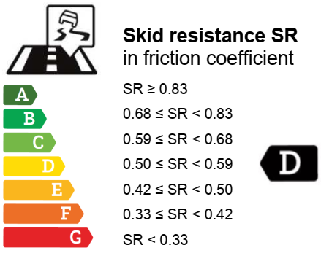
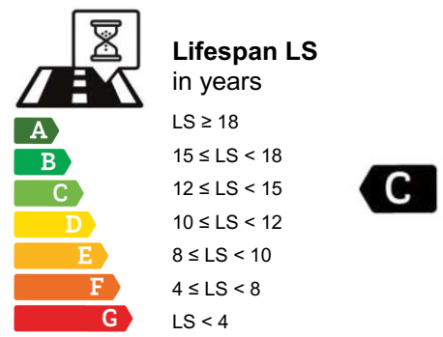
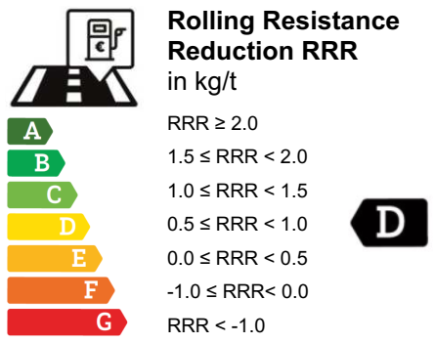
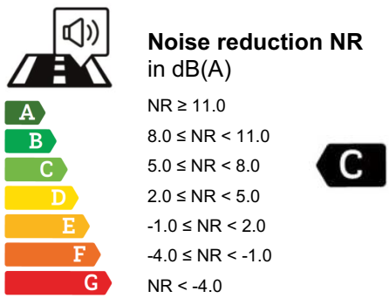
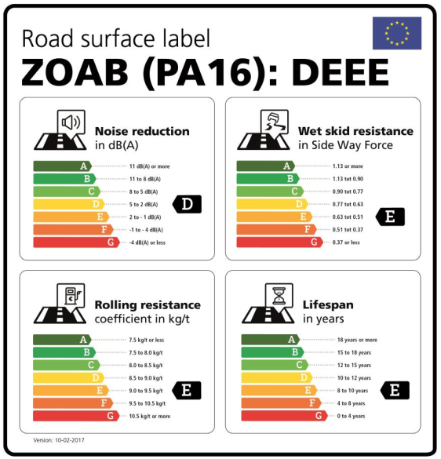
Skid resistance (SR)
in friction coefficient
Noise reduction (NR)
in dB(A)
Lifespan (LS)
in years
Rolling resistance
reduction (RRR)
in kg/t
Road surface label
[Identification of road surface]

Skid resistance (SR)
in friction coefficient
Noise reduction (NR)
in dB(A)
Lifespan (LS)
in years
Rolling resistance
reduction (RRR)
in kg/t
Road surface label
[Identification of road surface]

Amendments to the Background information for the draft Resolution on road surface labelling (ECE/TRANS/WP.29/GRB/2018/9)

4. Discussion of the road surface labelling concept and
examples

4.3.2. The German SKM (SeitenKraftMessung in German, Sideways Force Measurement) and British SCRIM (Sideways force Coefficient Routine Investigation Machine) device [CEN/TS 15901-8 and -6, and prEN 13036-2a] are very similar and the most commonly used in Europe. However, procedures for measurement (and correction for temperature and season) differ between the United Kingdom [Design Manual for Roads and Bridges (DMRB) - HD 28/15 Skidding Resistance] and Germany [TP Griff-StB 07 (SKM)]).
4.3.2. The skid resistance trailer according to CEN/TS 15901-9 is a compact, robust and versatile measurement system for longitudinal wet skid resistance (Braking Force Coefficient), enabling full-length skid resistance evaluation.
4.3.3. Many other devices and procedures exist to measure wet skid resistance, but on road pavements in Europe, none are more widespread than SCRIM/SKM.
4.3.3. Unfortunately, the measurement procedure for determining wet grip of tyres for the tyre label is not suited for in-situ assessment of road pavements, as it requires deceleration of the test vehicle from 80 to 20 km/h and is therefore not applicable in in-traffic conditions.
4.3.54. For conversion between different traffic speeds, a constant loss of 0.05 per 20 km/h speed increase can be used for practical purposes, although not being fully correct.
4.3.65. For several types of pavements, especially asphalt mixes but also Portland Cement Concrete, wet skid resistance may fluctuate significantly in the first weeks or months of traffic loading, because of the traffic wearing off any cement coat, grittings, and/or bituminous mastic covering the surface of the mineral aggregate. The label scale for skid resistance is based on the skid resistance value obtained after 2-9 months of traffic, after the initial fluctuations, and at the beginning of long-term skid resistance decline due to polishing. The initial fluctuations are outside the scope of the label, and should be covered separately in contract specifications, e.g. by minimum requirements, if desired.
4.3.76. Over time the skid resistance of the road surface may decrease to in-situ values below the label class. This should be kept in mind when using the label in long-term contract specifications.
4.3.87. Prediction of in-situ wet skid resistance, based on laboratory-made road surface specimens, is still very challenging. However the Friction after Polishing test [EN 12697-49:2014] provides a relative ranking of road surfaces that correlates well with in-situ ranking. Also, previous European research (project SKIDSAFE) developed a laboratory machine to characterise skid resistance in the laboratory (SR-ITD, skid resistance interface testing device).

Justification: The Proposal for a draft Resolution on Road surface labelling should be a self-explanatory document for users e.g. road authorities and road builders. In the draft proposal for a Resolution Annex III on the determination of skid resistance, just a reference is made to a German publication. At the time of submitting the draft proposal and its background document to the Secretariat it was not yet possible to write down a full English text. This informal document intends to replace Annex III. Replacement of Annex III subsequently needed some further amendments to both the draft proposal and its background document.

