Evaluation of the Questionnaire:
Evocative or Suggestive or Figurative Apparent surfaces

The evaluation below was prepared by the experts from FRANCE & GERMANY to submit the feedback of the questionnaire for the consideration of GRE members in order to have a coordinated and common view on this subject.

Feedback:

- Response from 13 Contracting Parties (CP’s) and two others.
- All responses and comments were transferred to an evaluation sheet.
- Only the responses of the CP’s were considered for evaluation, because the questionnaire was only addressed to CP’s.

Results for discussion:

The following results can be taken of the questionnaire:

- Is the advertising lighting installed on vehicles allowed at the national level in your country, regarding to its influence on road safety and distraction?
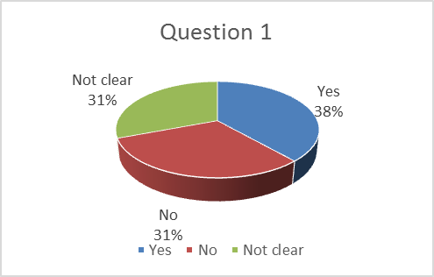
No clear result. However, the need for regulation appears necessary.

- Is the advertising lighting installed on vehicles allowed at the national level in your country for the aftermarket, regarding to its influence on road safety and distraction?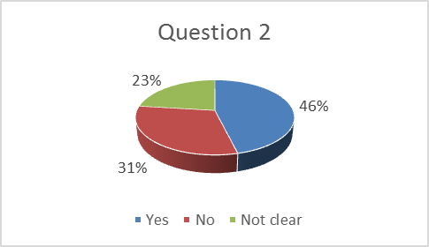
Again no clear result. Retrofitted lighting installations for advertising purposes are more often prohibited in the CP’s.

- Do you consider an apparent surface, whose shape is the logo of a brand manufacturer or other brand-identifying figures, as an advertising lighting?

62 % of the CP’s consider an apparent surface, whose shape is the logo of a brand manufacturer or other brand-identifying figures, as an advertising lighting.

- Do you see a problem if the shape of the apparent surface includes the symmetrical logo of
  - the concerned vehicle manufacturer brand ?
Nearly the same number of CP’s sees (54%) and don’t see (46%) a problem if the shape of the apparent surface includes the symmetrical logo of the concerned vehicle manufacturer brand.

- Do you see a problem if the shape of the apparent surface includes the symmetrical logo of
- the concerned lamp supplier brand?

Nearly the same number of CP’s sees (54%) and don’t see (46%) a problem if the shape of the apparent surface includes the symmetrical logo of the concerned lamp supplier brand

- Do you see a problem if the shape of the apparent surface includes the symmetrical logo of
- any other symmetrical brand-identifying figures?

Nearly the same number of CP’s sees (54%) and don’t see (46%) a problem if the shape of the apparent surface includes other symmetrical brand-identifying figures.

- Do you see a problem if the shape of the apparent surface includes the unsymmetrical words or logos?
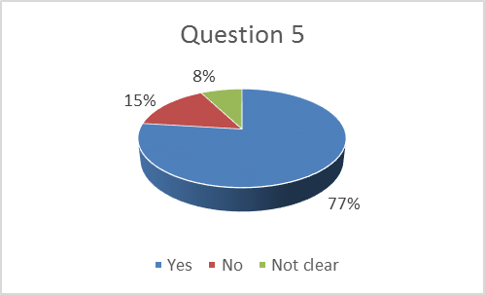

77% of the CP’s see a problem if the shape of the apparent surface includes the unsymmetrical words or logos.

- Do you support the prohibition of unsymmetrical words or logos within the shape of the apparent surface?
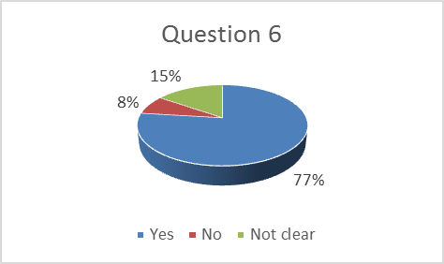
There is support of the CP’s in principle for the prohibition of unsymmetrical words or logos within the shape of the apparent surface (77 % supports).

- Do you support a modification of the vehicle installation regulations (R 48, R 53, R 74, R 86) with the aim of prohibiting asymmetrical words or lettering?
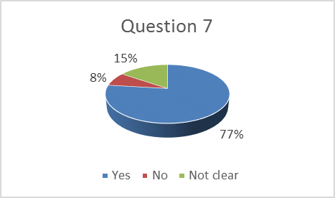
There is support of the CP’s for a modification of the vehicle installation regulations (R 48, R 53, R 74, R 86) with the aim of prohibiting asymmetrical words or lettering (77% support).

- Do you support a modification of the vehicle installation regulations (R48, R53, R74, R86) with the aim of précising the symmetry criterias of logos or words/lettering?
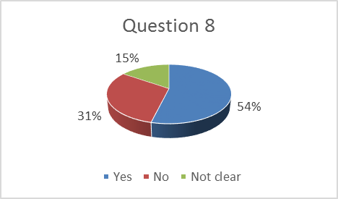
There is no real support of the CP’s for a modification of the vehicle installation regulations (R48, R53, R74, R86) with the aim of précising the symmetry criteria’s of logos or words/lettering (54% support).

- Would you support the idea of creating a new “logo lamp”, which won’t be type approved as a part of any current existing lighting function from LSD/RID/RRD regulations, but as a new separate lamp to be defined?
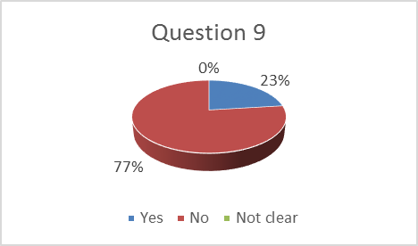

77 % of the CP’s wouldn’t support the idea of creating a new “logo lamp”, which won’t be type approved as a part of any current existing lighting function from LSD/RID/RRD regulations, but as a new separate lamp to be defined.

- Do you see a problem if the shape of the apparent surface can be the same as an evocative/suggestive figure?
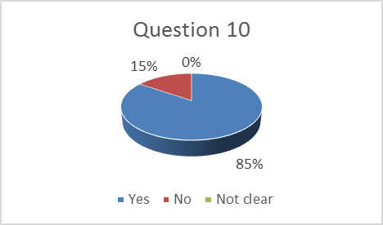

85% of the CP’s see a problem if the shape of the apparent surface can be the same as an evocative/suggestive figure.

- Do you see a problem if it is an informative figure such as a road traffic sign (e.g. warning triangle or a pedestrian)?
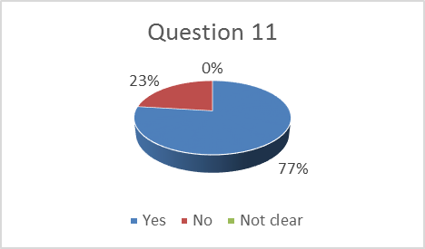
77% of the CP’s see a problem if it is an informative figure such as road traffic sign (e.g. warning triangle or a pedestrian).
- For such road traffic informative figures, do you support the need of modifying the current devices regulations (LSD, RID, RRD) and vehicle installation regulations (R48, R53, R74, R86) to take into account standardized pictograms?
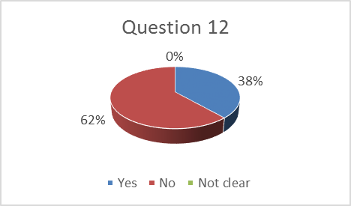
62% of the CP’s wouldn’t support (the need of) modifying the current devices regulations (LSD, RID, RRD) and vehicle installation regulations (R48, R53, R74, R86), to take into account standardized pictograms for road traffic informative figures.

- Would you support the idea of creating a new lamp with a road sign informative figure (e.g. a pedestrian), which won’t be type approved as a part of any current existing lighting function from LSD/RID/RRD regulations, but as a new separate lamp to be defined?
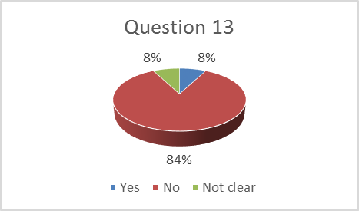
85% of the CP’s wouldn’t support the idea of creating a new lamp with a road sign informative figure (e.g. a pedestrian), which won’t be type approved as a part of any current existing lighting function from LSD/RID/RRD regulations, but as a new separate lamp to be defined.

Possible conclusions for discussion:

Following some comments: Create a simple compromise solution for allowed logos.

- Logo shall be type-approved as being part of a current existing signalling function (i.e. front position lamp, rear position lamp)
- Location of logo : at the front or at the rear of vehicle
- Number of logo :
  - 2 logos at the rear with only 1 on each side, and 2 logos at the front with only 1 on each side
  - no central logo considering unexpected distractions lighting issues. (new requirements for a minimum distance between the both front/rear position lamps to discuss?)
- Size : maximum light-emitting surface of logo : less than [100mm] diameter, so that to avoid being considered as lighting advertisement (considering the national laws)
- Only logo of the vehicle manufacturer (included manufacturer in a multistage vehicle type approval)
- Not allowed for logo of equipment suppliers
- Symmetry:
  - only symmetrical logos allowed,
    - except (for any distortion of competition reason) if incorporated in a symmetrical shape, and if light-emitting surface of logo is less than [100mm] diameter
  - logo incorporating words/lettering not allowed,
    - except (for any distortion of competition reason) if word is incorporated in a symmetrical shape (i.e. Ford or Fiat), and if light-emitting surface of logo is less than [100mm] diameter

