|  |  |  |  |
| --- | --- | --- | --- |
|  | United Nations | ECE/TRANS/WP.29/GRSP/2018/28 | |
| _unlogo | **Economic and Social Council** | | Distr.: General  25 September 2018  Original: English |

**Economic Commission for Europe**

Inland Transport Committee

**World Forum for Harmonization of Vehicle Regulations**

**Working Party on Passive Safety**

**Sixty-fourth session**

Geneva, 11-14 December 2018

Item 19 of the provisional agenda

**UN Regulation No. 129 (Enhanced Child Restraint Systems)**

Proposal for Supplement 9 to the 00 series of amendments, Supplement 6 to the 01 series of amendments, Supplement 5 to the 02 series of amendments and Supplement 2 to the 03 series of amendments to UN Regulation No. 129

Submitted by the expert from the European Association of Automotive Suppliers[[1]](#footnote-2)\*

The text reproduced below was prepared by the expert from the European Association of Automotive Suppliers (CLEPA) to clarify that certain information for users is displayed sufficiently. The modifications to the current text of UN Regulation No. 129 are marked in bold for new or strikethrough for deleted characters.

I. Proposal

*Paragraph 4.5*., amend to read:

"4.5. ~~In the case of~~ Integral Enhanced Child Restraint Systems that can be used forward **and rearward** facing, ~~it~~ shall have the following label permanently attached on the part hosting the child and visible to the person installing an Enhanced Child Restraint System in the vehicle:

The manufacturer shall be permitted to include the word "months" to explain the symbol "M" in the label. The word "months" should be in a language commonly spoken in the country or countries where the product is sold. More than one language is allowed.

Minimum label size 40 x 40 mm

**All text black on yellow or amber background**

**Top symbol white on black background**

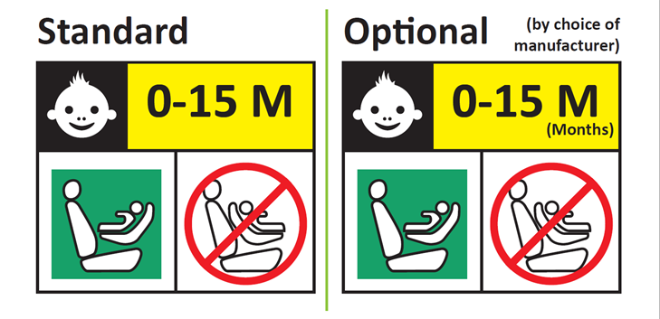

**Background white**

**Square - green**

**Forbidden sign – red**

**Background white**

**Label outline, vertical and horizontal lines black**

"

**Integral Enhanced Child Restraint Systems that can be used forward facing only shall have the following label permanently attached on the part hosting the child and visible to the person installing an Enhanced Child Restraint System in the vehicle:**

**The manufacturer shall be permitted to include the word "months" to explain the symbol "M" in the label. The word "months" should be in a language commonly spoken in the country or countries where the product is sold. More than one language is allowed.**

**Minimum label size 40 x 40 mm**

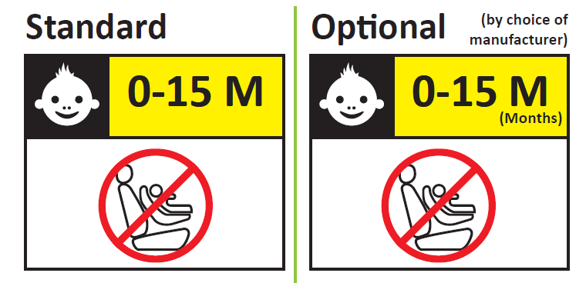”

*Paragraph 14.3.3*., amend to read:

"14.3.3. For **integral** forward facing Enhanced Child Restraint Systems, the following information shall be clearly visible on the exterior of the packing:

"IMPORTANT – DO NOT USE ~~FORWARD FACING~~ BEFORE THE CHILD’S AGE EXCEEDS 15 MONTHS (Refer to instruction)".

**For integral Enhanced Child Restraint Systems that can be used forward and rearward facing, the following information shall be clearly visible on the exterior of the packing:**

**"IMPORTANT – DO NOT USE FORWARD FACING BEFORE THE CHILD’S AGE EXCEEDS 15 MONTHS (Refer to instruction)".**

"

II. Justification

1. The label defined in paragraph 4.5. warns parents against the use of a forward-facing Child Restraint Systems (CRS) for children aged 0 to 15 months. It includes a green pictogram of a child in a rear-facing CRS alongside a pictogram of a forward-facing CRS with a red ‘forbidden’ sign. The label is currently required on all Enhanced Child Restraint Systems (ECRS) with a forward-facing installation. This means that an ECRS with only a forward-facing installation must carry a label that includes a rear-facing CRS. This is potentially misleading and may lead parents to try to install their ECRS rear-facing, against the manufacturer’s instructions

2. This proposal specifies the label be used for convertible ECRS only. It defines a new label for ECRS with a forward-facing installation only that emphasised the ECRS should not be used by children under 15 months.

3. Currently the information from paragraph 14.3.3. is required to be on the packing of every forward facing ECRS. As this is only appropriate for integral ECRSs the wording of this paragraph should be amended as proposed.

4. The current wording of this information might be misleading for child seats which are only usable forward facing. Therefore, it is proposed to have separate information for different configurations.

1. \* In accordance with the programme of work of the Inland Transport Committee for 2014–2018 (ECE/TRANS/240, para. 105 and ECE/TRANS/2014/26, programme activity 02.4), the World Forum will develop, harmonize and update UN Regulations in order to enhance the performance of vehicles. The present document is submitted in conformity with that mandate. [↑](#footnote-ref-2)