|  |  |  |  |
| --- | --- | --- | --- |
|  | United Nations | ECE/TRANS/WP.29/GRSP/2018/31 | |
| _unlogo | **Economic and Social Council** | | Distr.: General  27 September 2018  Original: English |

**Economic Commission for Europe**

Inland Transport Committee

**World Forum for Harmonization of Vehicle Regulations**

**Working Party on Passive Safety**

**Sixty-fourth session**

Geneva, 11-14 December 2018

Item 19 of the provisional agenda

**UN Regulation No. 129 (Enhanced Child Restraint Systems)**

Proposal for Supplement 5 to the 02 series of amendments and Supplement 2 to the 03 series of amendments to UN Regulation No. 129

Submitted by the expert from the European Association of Automotive Suppliers[[1]](#footnote-2)\*

The text reproduced below was prepared by the expert from the European Association of Automotive Suppliers (CLEPA). It proposes a supplement to the 02 series of amendments to UN Regulation No. 129 to clarify the definition of the "door panel geometry". Modifications to the text of the 02 series of amendments to UN Regulation No. 129 are marked in bold for new characters and strikethrough for deleted characters.

I. Proposal

*Annex 6 – Appendix 3,*

*Paragraph 1*, *Figure 2*, shall be deleted

*Insert new figures 2A and 2b,* to read:

Figure 2A   
Door panel geometry for testing integral ECRS with ISOFIX – side view (tolerance general: ±2 mm and ±1 degree)

**This door panel shall be used when the Integral ECRS under test is installed with ISOFIX.**

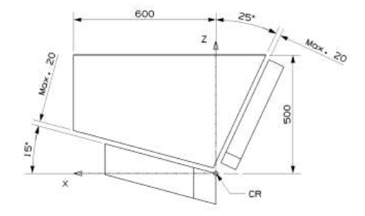

Figure 2B  
Door panel geometry for testing non-integral ECRS – side view (tolerance general: ±2 mm and ±1 degree)

**This door panel shall be used when the ECRS under test is installed with the adult seat belt.**

**Tests to extend the type-approval of Integral ISOFIX ECRS may also use this door, provided it was used for the original type-approval.**

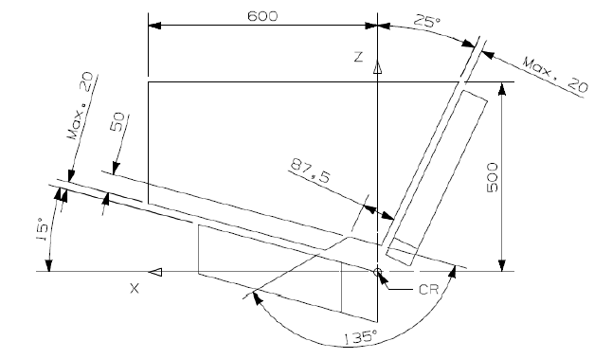

II. Justification

1. The 01 series of amendments to UN Regulation No. 129 amended the door panel geometry to create a small opening, close to the seat bight. This was done to protect the panel from interaction with the anchorage of the adult seat belt on the test bench (which would be added later in the 02 series). Integral ISOFIX Enhanced Child Restraint Systems (ECRS) were also required to use this new door panel geometry, despite the belt not being used for these ECRS.

2. This proposal amends the 02 series of amendments to UN Regulation No. 129 to require Integral ISOFIX ECRS to use the original door panel geometry with no opening (except during extensions of approvals in which the new panel geometry was used).

3. The proposal will ensure that ISOFIX ECRS designs cannot use the opening to mitigate loads to the ECRS and dummy. Integral belted and non-integral ECRS will continue to use the panel with an opening.

1. \* In accordance with the programme of work of the Inland Transport Committee for 2014–2018 (ECE/TRANS/240, para. 105 and ECE/TRANS/2014/26, programme activity 02.4), the World Forum will develop, harmonize and update UN Regulations in order to enhance the performance of vehicles. The present document is submitted in conformity with that mandate. [↑](#footnote-ref-2)