Submitted by the expert from France | Informal document GRSP-63-04  (63rd GRSP, 14-18 May 2018,  agenda item 9)

Proposal for Supplement 11 to the 06 Series of amendments and Supplement 4 to the 07 series of amendments to UN Regulation No. 16 (Safety-belts, Isofix and I-size)

The text reproduced below was prepared by the experts from France. It proposes supplements to UN Regulation No. 16 to include update on safety-belt installation table from annex XVI. The modifications to the current text of UN Regulation No. 16 are marked in bold for new characters and strikethrough for deleted characters.

I. Proposal

Annex XVI, amend to read :

Minimum requirements for safety-belts and Retractors
Vehicle category | Forward facing seating positions |  |  |  |  |  | Rearward-facing  seating positions | Side-facing seating position
 | Outboard seating positions |  |  | Centre seating position
 | Front |  | Other than front | Front |  | Other than front
M₁ | Ar4m |  | Ar4m | Ar4m |  | Ar4m | B, Br3, Br4m | -
M₂ < 3.5 t | Ar4m, Ar4Nm |  | Ar4m, Ar4Nm | Ar4m, Ar4Nm |  | Ar4m, Ar4Nm | Br3, Br4m, Br4Nm | -
M₂ > 3.5 t | Br3, Br4m, Br4Nm, or Ar4m or Ar4Nm ● |  | Br3, Br4m, Br4Nm, or Ar4m or Ar4Nm ● | Br3, Br4m, Br4Nm or Ar4m or Ar4Nm ● |  | Br3, Br4m, Br4Nm or Ar4m or Ar4Nm ● | Br3, Br4m, Br4Nm | -
M₃ | Br3, Br4m, Br4Nm, or Ar4m or Ar4Nm ●  See para. 8.1.7. for conditions when a lap belt is permitted |  | Br3, Br4m, Br4Nm, or Ar4m or Ar4Nm ●  See para. 8.1.7. for conditions when a lap belt is permitted | Br3, Br4m, Br4Nm or Ar4m or Ar4Nm ●  See para. 8.1.7. for conditions when a lap belt is permitted |  | Br3, Br4m, Br4Nm or Ar4m or Ar4Nm ●  See para. 8.1.7. for conditions when a lap belt is permitted | Br3, Br4m, Br4Nm | B, Br3, Br4m, Br4Nm
N₁ | Ar4m, Ar4Nm |  | Ar4m, Ar4Nm, Br4m, Br4Nm Ø | B, Br3, Br4m, Br4Nm or A, Ar4m, Ar4Nm* ¹ |  | B, Br3, Br4m, Br4Nm | B, Br3, Br4m, Br4Nm | -
 |  |  | Para. 8.1.2.1. lap belt permitted if seat is inboard of a passageway | Para. 8.1.6. lap belt permitted if the windscreen is not in the reference zone
N₂ | Br3, Br4m, Br4Nm orAr4m, Ar4Nm*  Para. 8.1.6. lap belt permitted if the windscreen is outside the reference zone and for the driver's seat |  | B, Br3, Br4m, Br4Nm | B, Br3, Br4m, Br4Nm, or A, Ar4m, Ar4Nm*  Para. 8.1.6. lap belt permitted if the windscreen is not in the reference zone |  | B, Br3, Br4m, Br4Nm | B, Br3, Br4m, Br4Nm | -
N₃ | Br3, Br4m, Br4Nm orAr4m, Ar4Nm*  Para. 8.1.6. lap belt permitted if the windscreen is outside the reference zone and for the driver's seat |  | B, Br3, Br4m, Br4Nm | B, Br3, Br4m, Br4Nm, or A, Ar4m, Ar4Nm*  Para. 8.1.6. lap belt permitted if the windscreen is not in the reference zone |  | B, Br3, Br4m, Br4Nm | B, Br3, Br4m, Br4Nm | -
A: three-point (lap and diagonal) belt  3: automatically locking retractor |  | B: 2-point (lap) belt  4: emergency locking retractor |  |  | r: retractor  N: higher response threshold |  | m: emergency locking retractor with multiple sensitivity
*: Refers to para. 8.1.6. of this Regulation ² |  | Ø: Refers to para. 8.1.2.1. of this Regulation |  |  | ●: refers to para. 8.1.7. of this Regulation² |  | (see Regulation No. 16, paras. 2.14.3. and 2.14.5.)
¹ Erratum to Supplement 12 to the 04 series of amendments, applicable "ab initio."
² Erratum to Revision 4, applicable "ab initio."
Note: In all cases all S-type belts may be fitted in place of all possible A or B type belts, provided their anchorages comply with Regulation No. 14.
Where a harness belt has been approved as a S-type belt according to this Regulation, using the lap belt strap, the shoulder belt straps and possibly one or more retractors, one or two additional crotch straps including their attachments for their anchorages may be provided by the manufacturer/applicant. These additional anchorages need not meet the requirements of Regulation No. 14 (Erratum to Supplement 14 to the 04 series of amendments, applicable "ab initio.")."

II. Justification

When initially initiated in Supplement 08 Series 04, table from annex XVI didn’t include separation line between M2 > 3,5 tonnes and M3 categories and all required seat-belts were for both vehicle applications.
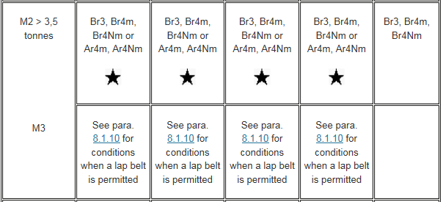

When the separation line appeared the associated required seat-belts were not distinguished. It was corrected in Supplement 08 to Series 06 except for rearward-facing seating positions.
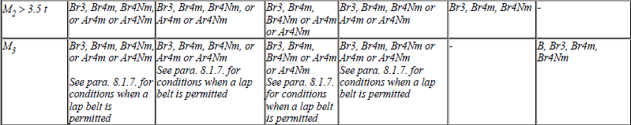

In term of safety, minimum 2-point (lap) belt required for M2 seems to be also the minimum to be required for M3 application.

__________

