Proposal for supplement 04 to the 01 series of amendments to Regulation No. 21 (Interior fittings)

Submitted by the experts from France

The text reproduced below was prepared by the experts from France. It proposes an amendment to UN Regulation No. 21 to clarify rounded edges requirements for opening roof parts. The modifications to the current text of UN Regulation No. 21 are marked in bold for new characters and strikethrough for deleted characters.

I. Proposal
Text of the Regulation,
Paragraph 5.5.1.2, amend to read:
"5.5.1.2. In addition, the manual opening and operating devices shall : […]"
II. Justification
1. Opening roof operation devices shall fulfill the requirement of § 5.5.1.2.2. (radius above 5mm). The other control levers (non structural parts) implemented on the roof are under the specifications of § 5.3.4.1. (radius above 3,2mm).
2. When an electric opening roof operating device includes other functions, as for example shadowing curtain control, it shall comply with the requirements of both paragraphs. § 5.5.1.2.2. was initially defined to specify adapted requirements for manual opening roof crank handle. Specifications of § 5.3.4.1. are more adapted to electronic control devices, for opening operation or other functions.

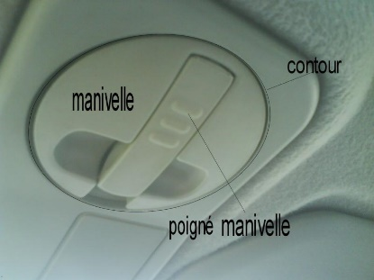
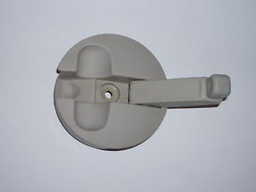

Manual : requirements of § 5.5.1.2.2. applicable

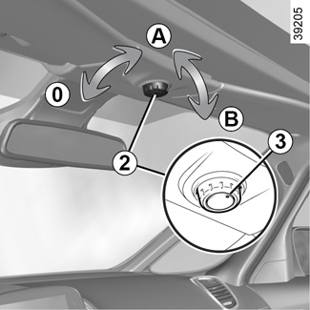

Electric including other functions : requirements of § 5.5.1.2.2. and § 5.3.4.1. are applicable.

By keeping only manual devices under paragraph 5.5.1.2., these electrical devices (with one or more functions) are only under paragraph 5.3. requirements without geometrical compatibility issue and safety use is kept.

