**Proposal for Amendment 3 to UN GTR No. 9 - PEDESTRIAN SAFETY**

The text reproduced below has been prepared by the expert from Germany to amend the definitions and general requirements.

The modifications to the current text of the Regulation are marked in bold for new or strikethrough for deleted characters.

1. **Proposal**

**Amendment of the preamble:**

**It was discussed how to consider active suspensions or other systems changing the vehicle height for pedestrian protection. Conclusion was made that the manufacturer providing such systems has to ensure that the protection of pedestrians is given for all possible vehicle heights for and at vehicle speeds between [25 km/h] and 40 km/h. For this, adjustments of more than [20 mm] shall be considered.**

**II. Justification**

GTR No. 9 addresses impacts with a pedestrian up to 40 km/h. Therefore, an impact velocity of 11.1 m/s (40 km/h) has been chosen to address a large amount of MAIS 1+ pedestrian accidents (see diagram below).

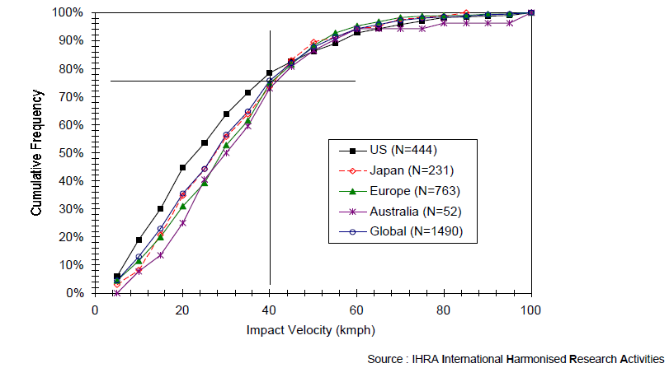

Source: Informal Group on Pedestrian Safety – 1st meeting (4-5 September 2002). INF GR / PS / 3. IHRA accident study,

Since active suspensions are available, it is possible to realise a system, which could change the vehicle height while driving (up to a defined driving speed e.g. up to 39 km/h). With such a system it is possible to raise up the suspension for driving offroad (SUVs mostly) or driving in a car park (sportscars). In this context, there have been discussions with some manufacturers about the relevance to pedestrian protection. Since the vehicle height has an influence on the headform test area (WAD) and on the test results for legform tests, all possible vehicle heights up to a driving speed of 11.1 m/s (40 km/h) should be considered to be relevant for the impact with a pedestrian. The proposal is a clarification on this issue.

This proposal is the basis of the proposal for collective amendments to 00, 01 and 02 series of amendments of UN Regulation No. 127.