 | INF.31
Economic Commission for Europe  Inland Transport Committee  Working Party on the Transport of Dangerous Goods  Joint Meeting of Experts on the Regulations annexed to the  European Agreement concerning the International Carriage  of Dangerous Goods by Inland Waterways (ADN)  Thirty-fifth session  Geneva, 26-30 August 2019  Item 4 (b) of the provisional agenda  Proposals for amendments to the Regulations annexed to ADN:  other proposals |  | August 19, 2019  English
Request for discussion on entries in Table C where remark 44 is indicated
Transmitted by CEFIC and FuelsEurope
Summary
Executive Summary: Table C can be made simpler by eliminating double entries, where the only difference is the Explosion group in column (16) and the reference to remark 44 in Column (20).
Action to be taken: Start a discussion within a working group.
Related documents: ECE/TRANS/WP.15/AC.2/68 – report of the thirty-third session, Item VI, C, 74-77.
ECE/TRANS/WP.15/AC.2/2018/44, Item F, 32-38, report of the tenth session of the informal working group on “Substances”.
I. Introduction
1. The introduction of remark 44 came after extensive discussion in the Safety Committee and the Informal Working Group on Substances and has now been implemented in ADN 2019. A proposal by the informal Working Group to modify the text of remark 44 effective 2021 was adopted by the Safety Committee during its thirty-third session.
2. For a number of entries in Table C of ADN column (20) reports remark 44. In fact all those entries are exact duplication of other entries, with only a difference that column (16) on the Explosion group, see example below.

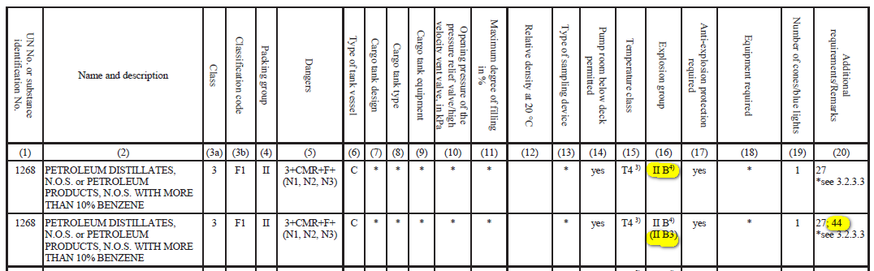

3. CEFIC and FuelsEurope are of the opinion that the duplicate entries which have no remark 44 could be merged to one which has remark 44 if the text for remark 44 would be slightly modified and the same level of safety can be achieved if this duplication is avoided.
II. Request to the ADN Safety Committee
4. CEFIC and FuelsEurope invites the ADN Safety Committee to take note of the above and to give an opinion.
5. The Safety Committee is further invited to mandate the informal working group on substances to investigate the options for this simplification (i.e. by modifying remark 44), taking into account other proposed ADN 2021 changes to this remark as referred to in above mentioned related document.

